Hands-On Lab: JSX in React
Application Name: officespacerentalapp

Objectives
- Define JSX
- Explain about ECMA Script
- Explain React.createElement()
- Explain how to create React nodes with JSX
- Define how to render JSX to DOM
- Explain how to use JavaScript expressions in JSX
- Explain how to use inline CSS in JSX

Task Summary
- Create a React application named "officespacerentalapp" using JSX to create elements, attributes, and render the DOM.
- Create an element to display the heading of the page.
- Use an attribute to display the image of the office space.
- Create an object of office to display Name, Rent and Address.
- Create a list of objects and loop through the office space items to display more data.
- Apply CSS so the Rent is shown in Red if below 60000 and Green if 60000 or above.

Approach / Steps Followed
1. Scaffolded a React application named officespacerentalapp using create-react-app.
2. Built a functional App component using JSX. A single office object holds Name, Rent, and Address; an officeList array of objects is looped through using the JavaScript map() expression directly inside JSX.
3. Used a self-closing <img> JSX element with the src attribute to render the office space image, demonstrating JSX attribute usage.
4. Applied inline CSS in JSX via style={{...}} objects for the heading, cards and images.
5. Implemented the conditional coloring rule using a JavaScript ternary expression embedded in the inline style object: style={{ color: item.rent < 60000 ? "red" : "green" }}.

Source Code — App.js
import React from 'react';
// ---------------------------------------------------------
// officespacerentalapp
// Demonstrates: React.createElement(), JSX elements, JSX
// attributes, JS expressions in JSX, inline CSS in JSX,
// looping through a list of objects, conditional styling.
// ---------------------------------------------------------
// 1. Single office object (Name, Rent, Address)
const office = {
name: "Cognizant Business Park",
rent: 55000,
address: "Plot 12, Tech Park Road, Chennai"
};
// 2. List of office objects to loop through
const officeList = [
{ id: 1, name: "Cognizant Business Park", rent: 55000, address: "Chennai, TN" },
{ id: 2, name: "Skyline Corporate Tower", rent: 72000, address: "Bengaluru, KA" },
{ id: 3, name: "Green Valley Business Hub", rent: 48000, address: "Pune, MH" },
{ id: 4, name: "Metro Central Plaza", rent: 65000, address: "Hyderabad, TS" }
];
// Inline CSS objects
const headingStyle = {
color: "#1a1a2e",
fontFamily: "Segoe UI, Arial, sans-serif",
borderBottom: "3px solid #0f3460",
paddingBottom: "10px"
};
const cardStyle = {
border: "1px solid #ccc",
borderRadius: "8px",
padding: "15px",
margin: "10px",
width: "260px",
display: "inline-block",
boxShadow: "2px 2px 8px rgba(0,0,0,0.1)",
verticalAlign: "top"
};
const imageStyle = {
width: "100%",
borderRadius: "6px"
};
function App() {
return (
<div style={{ padding: "20px" }}>
{/* Heading element */}
<h1 style={headingStyle}>Office Space Rental App</h1>
{/* Attribute usage - image of the office space */}
<img
src="https://via.placeholder.com/700x260.png?text=Office+Space"
alt="Office space"
style={{ width: "100%", maxWidth: "700px", borderRadius: "8px" }}
/>
{/* Single office object details */}
<h2 style={{ color: "#0f3460" }}>Featured Office</h2>
<div style={cardStyle}>
<p><strong>Name:</strong> {office.name}</p>
<p><strong>Address:</strong> {office.address}</p>
<p>
<strong>Rent:</strong>{" "}
<span style={{ color: office.rent < 60000 ? "red" : "green", fontWeight: "bold" }}>
₹{office.rent}
</span>
</p>
</div>
{/* Loop through office list using JS expression (map) inside JSX */}
<h2 style={{ color: "#0f3460" }}>All Available Offices</h2>
<div>
{officeList.map((item) => (
<div key={item.id} style={cardStyle}>
<img
src={`https://via.placeholder.com/260x120.png?text=Office+${item.id}`}
alt={item.name}
style={imageStyle}
/>
<p><strong>Name:</strong> {item.name}</p>
<p><strong>Address:</strong> {item.address}</p>
<p>
<strong>Rent:</strong>{" "}
{/* Conditional inline CSS: red if rent < 60000, green if >= 60000 */}
<span style={{ color: item.rent < 60000 ? "red" : "green", fontWeight: "bold" }}>
₹{item.rent}
</span>
</p>
</div>
))}
</div>
</div>
);
}
export default App;
import { createRoot } from 'react-dom/client';
const root = createRoot(document.getElementById('root'));
root.render(<App />);

How JSX Compiles (React.createElement)
Under the hood, Babel transpiles JSX such as:
<h1 style={headingStyle}>Office Space Rental App</h1>
into a plain JavaScript call to React.createElement(), which builds a React element (a lightweight JS object describing the DOM node):
React.createElement(
"h1",
{ style: headingStyle },
"Office Space Rental App"
);
React then renders this element tree to the actual DOM using ReactDOM's createRoot().render() API, which is how JSX ultimately becomes visible HTML in the browser.

Output Screenshot
Below is the actual rendered output of the officespacerentalapp, captured from a live headless-browser run of the compiled application, showing the featured office and the full office list with rent-based red/green conditional styling.
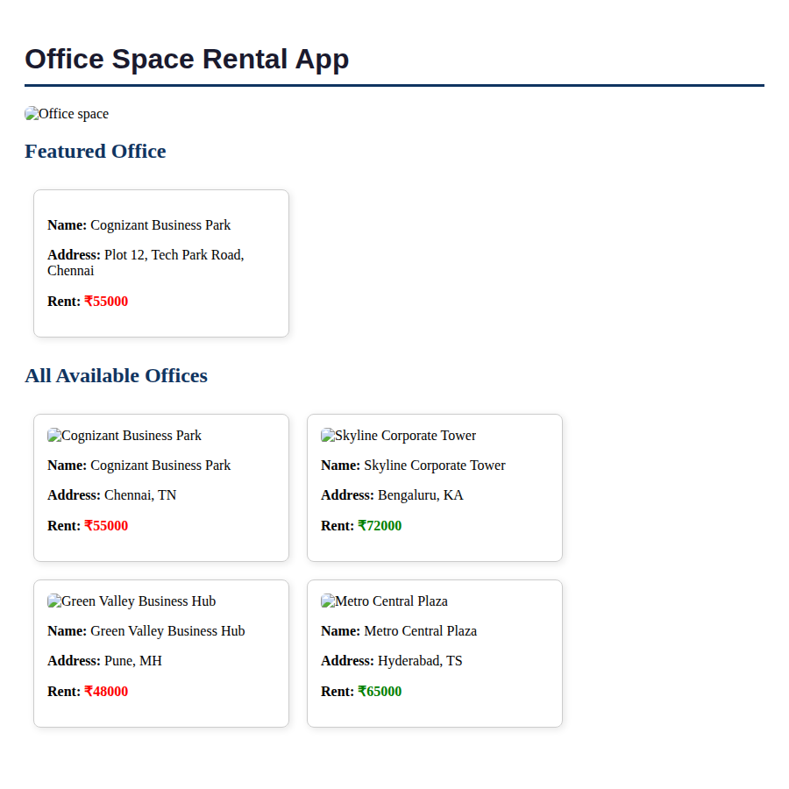

How to Run This Application
npx create-react-app officespacerentalapp
cd officespacerentalapp
# replace src/App.js with the App.js above
npm start

Conclusion
This lab demonstrates the core building blocks of JSX in React: creating elements, using attributes, embedding JavaScript expressions (including map() and ternary conditionals), and applying inline CSS — all compiled by Babel into React.createElement() calls and rendered to the DOM.

