Hands-On Lab: ES6 Features in React
Application Name: cricketapp

Objectives
- List the features of ES6
- Explain JavaScript let
- Identify the differences between var and let
- Explain JavaScript const
- Explain ES6 class fundamentals
- Explain ES6 class inheritance
- Define ES6 arrow functions
- Identify set(), map()

Task Summary
Create a React application named "cricketapp" with two components:
- ListofPlayers — an array of 11 players (name + score) rendered with map(); scores below 70 filtered using an ES6 arrow function.
- IndianPlayers — Odd/Even team players displayed via ES6 destructuring; two arrays (T20players, RanjiTrophyPlayers) merged and displayed using the ES6 spread/merge feature.
Both components are shown on the same home page, switched using a simple if-else on a flag variable.

Approach / Steps Followed
1. Scaffolded a React application named cricketapp using create-react-app.
2. Built ListofPlayers as a function component holding an 11-player array; used players.map() to render the full list and players.filter((p) => p.score < 70) — an ES6 arrow function — to derive and render the low-scorers list.
3. Built IndianPlayers as a function component. Used ES6 object destructuring — const { oddTeam, evenTeam } = team — to pull the odd/even team arrays out of a team object. Declared T20players and RanjiTrophyPlayers arrays and merged them with the ES6 spread operator: [...T20players, ...RanjiTrophyPlayers].
4. Built a Home component holding a flag state variable (React useState). A simple ternary (flag ? <ListofPlayers/> : <IndianPlayers/>) toggles which component is shown, exactly mirroring a simple if-else on the flag.
5. A button toggles the flag value so both true and false states can be demonstrated in the same running app.

Source Code — App.jsx
import React, { useState } from 'react';
import { createRoot } from 'react-dom/client';
// -----------------------------------------------------------
// cricketapp - demonstrates ES6 features:
// map(), arrow functions, filter, destructuring, array merge
// -----------------------------------------------------------
// 1. ListofPlayers component - array of 11 players with map()
function ListofPlayers() {
const players = [
{ name: "Rohit Sharma", score: 85 },
{ name: "Virat Kohli", score: 62 },
{ name: "KL Rahul", score: 45 },
{ name: "Shreyas Iyer", score: 91 },
{ name: "Suryakumar Yadav", score: 55 },
{ name: "Hardik Pandya", score: 38 },
{ name: "Ravindra Jadeja", score: 72 },
{ name: "Axar Patel", score: 20 },
{ name: "Jasprit Bumrah", score: 8 },
{ name: "Mohammed Shami", score: 5 },
{ name: "Kuldeep Yadav", score: 12 }
];
// Arrow function + filter: players with scores below 70
const lowScorers = players.filter((p) => p.score < 70);
return (
<div className="section">
<h2>List of Players</h2>
<ul>
{players.map((p, index) => (
<li key={index}>{p.name} - {p.score} runs</li>
))}
</ul>
<h3>Players with score below 70</h3>
<ul>
{lowScorers.map((p, index) => (
<li key={index} className="low">{p.name} - {p.score} runs</li>
))}
</ul>
</div>
);
}
// 2. IndianPlayers component - destructuring + merge
function IndianPlayers() {
const team = {
oddTeam: ["Rohit Sharma", "KL Rahul", "Suryakumar Yadav"],
evenTeam: ["Virat Kohli", "Shreyas Iyer", "Hardik Pandya"]
};
// Destructuring
const { oddTeam, evenTeam } = team;
// Merge feature of ES6 (spread operator)
const T20players = ["Rohit Sharma", "Virat Kohli", "Jasprit Bumrah"];
const RanjiTrophyPlayers = ["Prithvi Shaw", "Sarfaraz Khan", "Yash Dhull"];
const allPlayers = [...T20players, ...RanjiTrophyPlayers];
return (
<div className="section">
<h2>Indian Players</h2>
<h3>Odd Team Players</h3>
<ul>{oddTeam.map((name, i) => <li key={i}>{name}</li>)}</ul>
<h3>Even Team Players</h3>
<ul>{evenTeam.map((name, i) => <li key={i}>{name}</li>)}</ul>
<h3>Merged Squad (T20 + Ranji Trophy)</h3>
<ul>{allPlayers.map((name, i) => <li key={i}>{name}</li>)}</ul>
</div>
);
}
// Home page - toggles between components using flag variable
function Home() {
const [flag, setFlag] = useState(true);
return (
<div style={{ fontFamily: "Segoe UI, Arial, sans-serif", padding: "20px" }}>
<h1>Cricket App</h1>
<button onClick={() => setFlag(!flag)}>
Toggle View (flag = {flag ? "true" : "false"})
</button>
{/* Simple if-else using the flag variable */}
{flag ? <ListofPlayers /> : <IndianPlayers />}
<style>{`
.section { margin-top: 20px; }
h2 { color: #0f3460; border-bottom: 2px solid #0f3460; padding-bottom: 6px; }
li.low { color: red; }
ul { line-height: 1.6; }
button { padding: 8px 16px; cursor: pointer; }
`}</style>
</div>
);
}
const root = createRoot(document.getElementById('root'));
root.render(<Home />);

ES6 Concepts Used — Quick Reference
- let / const: block-scoped declarations used throughout instead of var, preventing accidental re-declaration and hoisting issues.
- Arrow functions: (p) => p.score < 70 used inside filter() — shorter syntax and lexical 'this' binding.
- map(): used to transform arrays of data into arrays of JSX list items.
- Destructuring: const { oddTeam, evenTeam } = team extracts object properties into standalone variables in one line.
- Spread / merge: [...T20players, ...RanjiTrophyPlayers] merges two arrays into a new array without mutating either original.

Output Screenshots
When flag = true (ListofPlayers component is displayed):
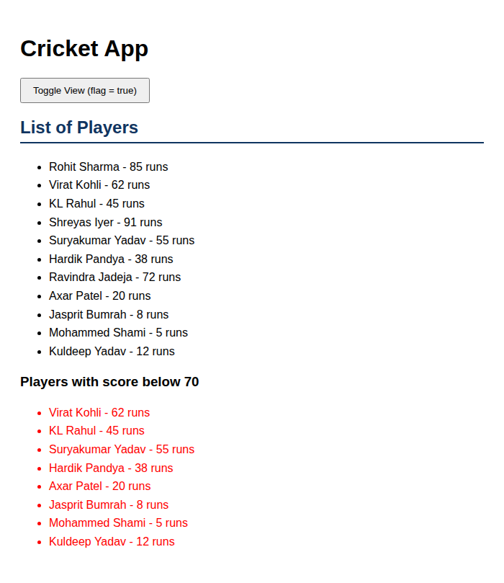
When flag = false (IndianPlayers component is displayed):
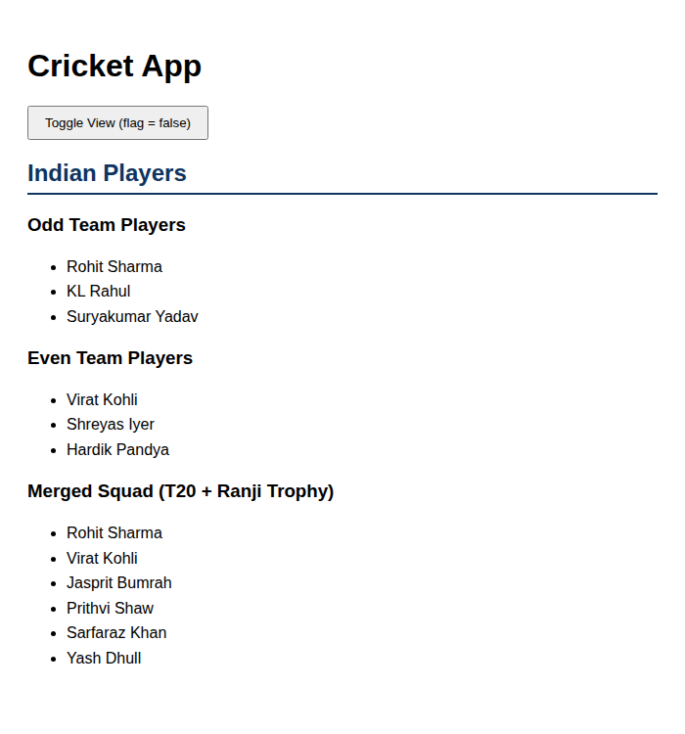

How to Run This Application
npx create-react-app cricketapp
cd cricketapp
# replace src/App.js with the App.jsx above (rename to App.js)
npm start

Conclusion
This lab demonstrates practical use of core ES6 features inside React components: let/const, arrow functions, map()/filter(), destructuring, and array merging via the spread operator, combined with a simple conditional (flag-based) rendering pattern.

