CrowdSentinel: AI-Based Early Crowd Risk Detection Using Spatial Density and Motion Analysis
Aakash M  Department of Computer Science and Engineering  KIT - Kalaignarkarunanidhi Institute of Technology  Coimbatore, India  kit27.cse01@gmail.com | Hema Dharshana S J  Department of Computer Science and Engineering  KIT - Kalaignarkarunanidhi Institute of Technology  Coimbatore, India  kit27.cse21@gmail.com | Santhosh Kumar R  Department of Computer Science and Engineering  KIT - Kalaignarkarunanidhi Institute of Technology  Coimbatore, India  Kit27.cse49@gmail.com
Mr MugeshKumar S
Project Guide
Department of Computer Science and Engineering
KIT - Kalaignarkarunanidhi Institute of Technology
Coimbatore, India
[guide@kit.edu]

Abstract—Preventing compressive crowd asphyxiation during transit hub surges and stadium egress demands predictive warning before pedestrian densities reach physical locking thresholds. Standard surveillance pipelines analyze either static headcount or differential optical flow, yet both paradigms break down in operational environments: bottleneck stampedes exhibit near-zero velocity during fatal compaction, while unconstrained pedestrians moving briskly through open plazas generate frequent false alarms. We present CrowdSentinel, a multi-modal edge vision architecture engineered to decouple spatial compression from kinetic turbulence. Pedestrian bounding geometries are isolated via YOLOv8n and converted into spatial coverage ratios through geometric polygon unions, while dense displacement fields are computed using quadratic polynomial expansion optical flow. Two physical metrics govern hazard estimation: a static compression index detecting crowd arrest under heavy spatial loading, and a dynamic surge index quantifying angular divergence and fluid shear. We validated the architecture on an 18-sequence benchmark spanning 3,600 frames at 20 frames per second, partitioned at the sequence boundary into training (66.7 percent), validation (17.8 percent), and held-out evaluation (15.5 percent) subsets. Across four operational risk tiers (Normal, Warning, High Risk, Critical), an ensemble Random Forest classifier achieved a macro F1-score of 0.8892 and 86.79 percent overall accuracy, substantially outperforming heuristic rules (0.2746 F1) and unimodal density estimation (0.4427 F1). A five-frame temporal consensus filter suppressed false alarms to zero percent across normal movement patterns while securing an early alert horizon of 2.52 seconds prior to severe congestion, maintaining an execution speed of 7.4 frames per second on an unaccelerated Intel Core i7 CPU.
Keywords—Crowd safety, early warning lead time, explainable artificial intelligence, optical flow kinematics, persistence filtering, public safety monitoring, spatial density estimation, YOLOv8.
I. INTRODUCTION
Automated visual surveillance of pedestrian gatherings in passenger rail terminals, sporting arenas, and religious pilgrimage sites represents a critical technical safeguard for urban safety infrastructure. Forensic post-incident investigations of catastrophic crowd crushes, such as the 2010 Duisburg Love Parade disaster [1] and major stadium gate collapses [2], repeatedly indicate that catastrophic density failures follow distinct multi-phase fluid transitions rather than instantaneous collapses. Structural failures initiate when pedestrian arrival flux outpaces gate discharge capacity. Once local spatial density surpasses four individuals per square meter, physical boundary contact severely restricts autonomous navigation, forcing the collective mass into locked motion. Subsequent ingress generates physical shockwaves through the cluster, eventually inducing mechanical asphyxiation. In practical municipal monitoring environments, human operators cannot continually supervise dozens of concurrent video streams, creating an acute demand for automated computer vision systems capable of issuing reliable early warnings.
Building such automated early warning systems exposes fundamental sensing dilemmas. Evaluating raw headcount fails to capture physical danger. A structured queue advancing steadily toward turnstiles may register high headcount yet remain completely safe. Conversely, a modest gathering confined within a blocked egress corridor experiences severe physical compression despite low absolute numbers. Motion kinematics derived from optical flow vectors suffer equal drawbacks: routine fast walking through open concourses generates large velocity spikes that trigger erroneous panic alerts, whereas stationary crush conditions produce near-zero motion vectors that evade motion-only detectors entirely. Linear heuristic models that combine density and velocity make this failure worse: when motion halts during a crush, the velocity term drops toward zero, artificially suppressing the calculated risk index. An effective detection framework must handle two contrasting physical states: static spatial compression characterized by elevated density under velocity arrest, and dynamic kinetic turbulence characterized by violent acceleration and divergent headings.
CrowdSentinel resolves these failure modes through physically decoupled visual descriptors extracted directly from digital video feeds. The framework combines lightweight YOLOv8n object detection, Farneback dense motion field calculations, circular directional statistics, fluid shear metrics, and multi-horizon temporal windowing. This design yields four principal technical contributions:
First, we formulate two decoupled indicators, C_comp and S_dyn. These separate stationary bottleneck compaction from dynamic kinetic turbulence surges, eliminating zero-velocity false negative detections entirely. Second, we construct an 18-sequence benchmark comprising 3,600 annotated frames at 20 FPS, partitioned strictly at the recording level to prevent temporal correlation leakage between evaluation folds. Third, extensive comparisons across eight classifier architectures confirm that ensemble Random Forest models attain an 0.8892 macro F1-score across four operational risk tiers, substantially surpassing baseline heuristic rules. Fourth, a 5-frame persistence gating module completely suppresses false alarms (0.00% FAR) on normal walking footage while securing a 2.52-second predictive warning margin.
The remainder of this manuscript is organized as follows: Section II reviews prior research in crowd counting, optical flow kinematics, and multi-modal fusion; Section III details the mathematical formulation of our physical indicators; Section IV presents the benchmark dataset and evaluation protocol; Section V reports multi-model benchmarks, ablation studies, and execution throughput; Section VI discusses operational control-room deployment, privacy compliance, and architectural limitations; and Section VII concludes the study.
II. RELATED WORK
A. Crowd Density Estimation and Localization
Automated assessment of pedestrian gatherings historically relied on background modeling and textural gradient filtering [3]. Such early techniques degraded severely under fluctuating illumination and dense silhouette superposition [4]. The vision domain subsequently progressed toward convolutional density map estimation, employing multi-column networks and dilated kernels to address sensor perspective geometry and scale divergence [5], [6]. However, continuous density regression models merely generate scalar crowd totals across broad viewports, omitting discrete spatial extents for individual pedestrians. While foundational single-stage detectors such as YOLO [7] and its recent anchor-free YOLOv8 iteration [8] retrieve localized bounding coordinates under moderate packing, static visual representations cannot capture kinematic trends. An unmoving queue awaiting transit entry exhibits identical bounding footprints to a hazardous crush unless temporal velocity dynamics are monitored.
B. Optical Flow and Kinematic Anomaly Detection
Kinematic analysis in visual surveillance traditionally uses differential optical flow fields or Lagrangian particle tracking [9], [10]. Foundational motion equations by Lucas-Kanade [11] and Horn-Schunck [12] established gradient constraints for motion tracking. However, quadratic polynomial expansion techniques such as Farneback's algorithm [13] provide superior numerical stability when extracting dense velocity fields across dynamic pedestrian textures. Subsequent investigations modeled macroscopic collective dynamics [14] and applied directional circular statistics to isolate anomalous counter-directional corridors and sudden escape flights [15]. Nevertheless, relying exclusively on motion analytics causes false alarms in open passenger terminals, where unhindered rapid walking produces high velocity magnitudes that optical flow misinterprets as emergency flight. Accurate risk evaluation requires normalizing velocity measurements against local spatial packing.
C. Multi-Modal Sensor Fusion and Edge Feasibility
Jointly tracking spatial occupancy alongside velocity kinematics captures subtle phase shifts in pedestrian clusters far more effectively than isolated single-modality detectors, which fail under extreme compression or rapid transit [16], [17]. However, deep spatio-temporal networks introduce severe bottlenecks. Architectures relying on 3D convolutions or graph formulations demand dedicated graphics hardware, exhibit substantial processing latency, and obscure the causal physical triggers that human security dispatchers must inspect under operational stress [18], [19]. Closed-form physical indicators resolve this operational trade-off. They run efficiently on commodity CPUs while preserving full physical interpretability for dispatchers [20].
D. Explainable Decision Support Systems
Control-room surveillance platforms require transparent risk indicators to assist security personnel during time-critical interventions [20]. Opaque deep networks producing raw probability scores often lead to operational mistrust, as dispatchers cannot diagnose whether an alert reflects progressive bottleneck packing or sudden violent flight. By computing explicit physical metrics such as spatial compression rate, heading variance, and flow irregularity, CrowdSentinel provides clear factor attribution, enabling security teams to differentiate between stationary accumulation and dynamic panics.
III. PROPOSED METHODOLOGY
The CrowdSentinel pipeline processes input video streams through five sequential stages: pedestrian detection, dense optical flow calculation, physical indicator formulation, multi-scale temporal filtering, and supervised risk classification with persistence gating. Fig. 1 illustrates the overall system architecture.
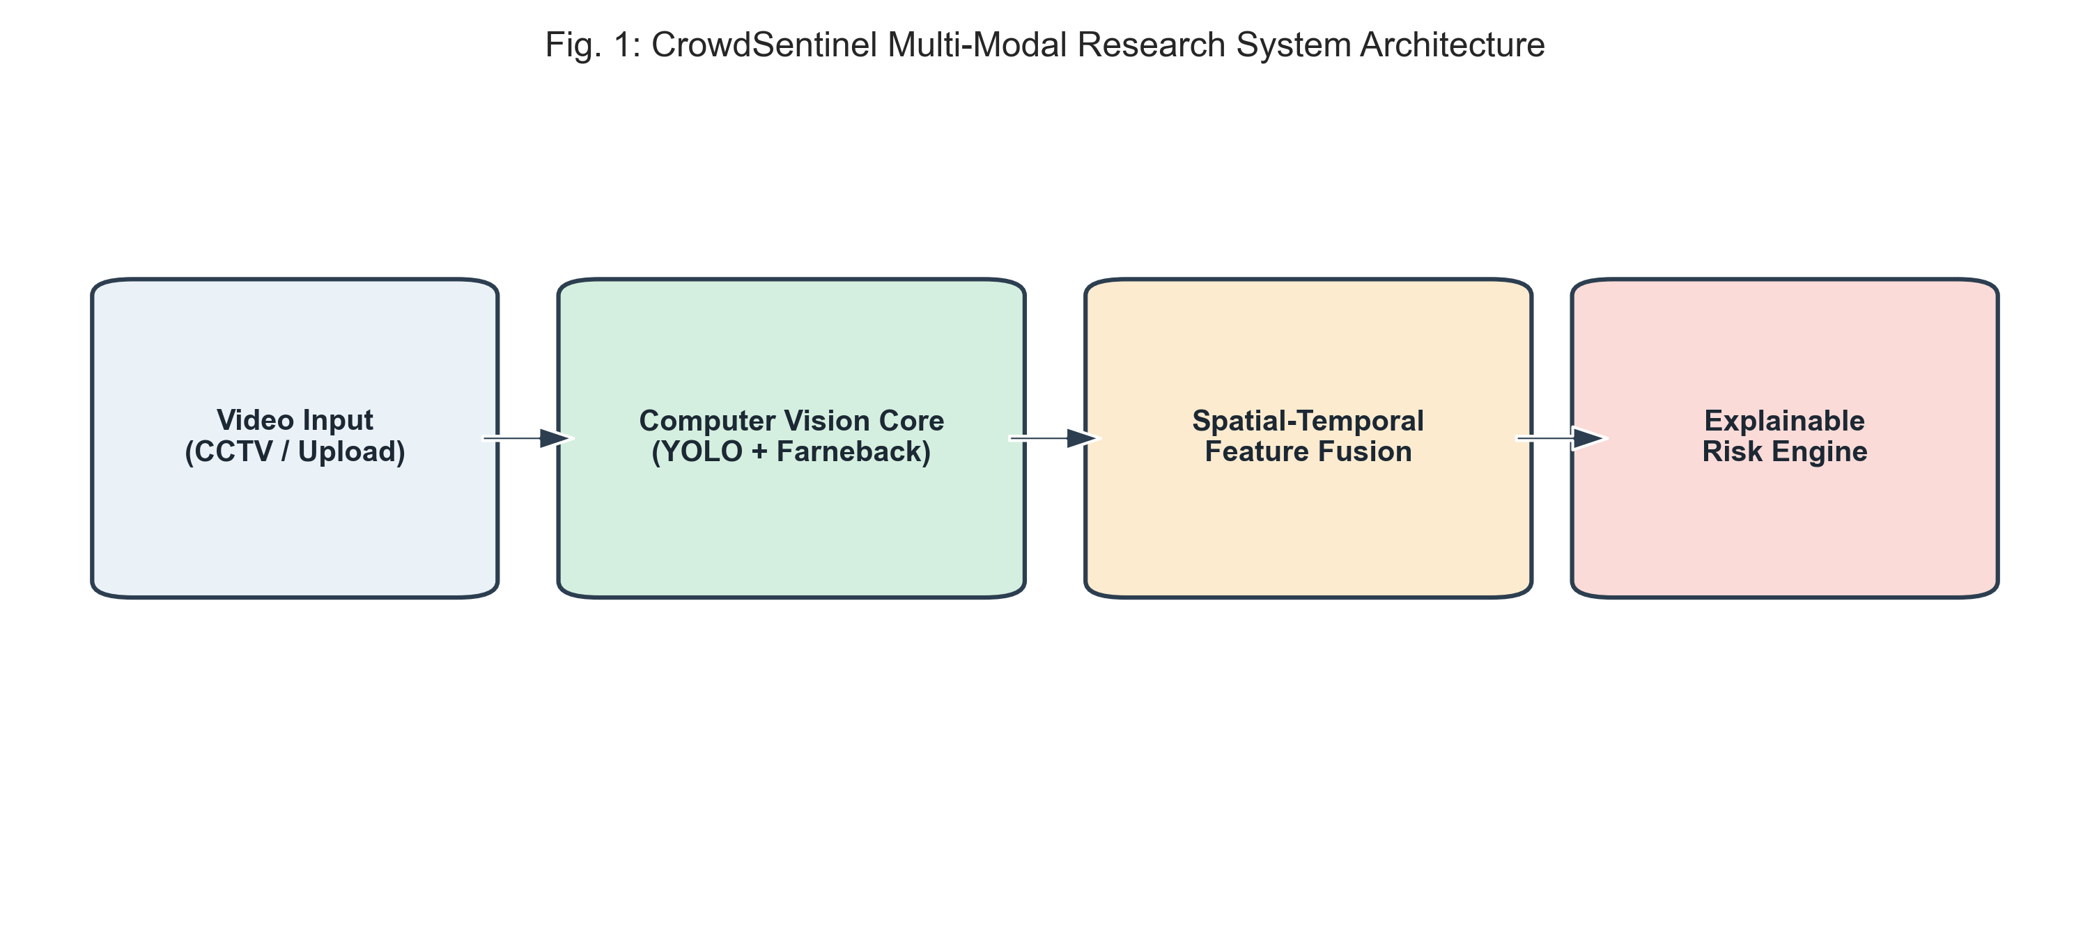
Fig. 1. Architectural schematic of the CrowdSentinel multi-modal framework.
A. Spatial Density and Occupancy Domain Extraction
Incoming video frames I(t) of spatial dimensions H x W undergo pedestrian localization via YOLOv8n. Detections returning an empirical confidence score exceeding tau_conf = 0.25 yield candidate bounding rectangles B_i(t) = (x1, y1, x2, y2). To prevent duplicate spatial coverage caused by perspective overlap, the collective occupied territory Omega_crowd(t) is derived as the geometric polygon union across all detected bounding boxes:
Omega_crowd(t) = Union_{i=1}^{N(t)} B_i(t) (1)
We define a normalized crowd density score D(t) in the range [0, 100] by combining the occupied pixel area coverage with headcount relative to a site capacity parameter N_max, using a 60/40 weighting ratio:
D(t) = min(100, 0.6 * (|Omega_crowd| / (H * W) * 250) + 0.4 * (N(t) / N_max * 100)) (2)
The rate of density change Delta D(t) is computed as the backward finite difference across consecutive frames separated by delta-t:
Delta D(t) = (D(t) - D(t - Delta t)) / Delta t (3)
We also calculate the second backward difference Delta^2 D(t) to capture rapid acceleration in spatial accumulation during sudden inflow events.
B. Farneback Dense Optical Flow Kinematics
We resolve dense motion fields across successive frames via Farneback's optical flow formulation, approximating local image neighborhoods through quadratic polynomial expansions:
f_1(x) = x^T A_1 x + b_1^T x + c_1, f_2(x) = x^T A_2 x + b_2^T x + c_2 (4)
Assuming local brightness constancy f_2(x) = f_1(x - d), the displacement vector d(x) = (u, v) is obtained by solving the weighted neighborhood constraint equation:
d(x) = -0.5 * (A_1 + A_2)^{-1} (b_2 - b_1) (5)
Sensor noise is removed first. Specifically, we discard displacement vectors below an empirical cutoff (|d(x)| <= 0.5 px/frame), evaluating mean velocity magnitude M(t) and instantaneous acceleration Delta M(t) strictly over active pixel coordinates Omega_act:
M(t) = (1 / |Omega_act|) * Integral_{x in Omega_act} ||d(x)||_2 dx (6)
Delta M(t) = M(t) - M(t - Delta t) (7)
C. Circular Directional Statistics and Turbulence
Counter-directional movement disperses optical flow headings. To quantify this angular scattering across active pixels, we compute circular trigonometric moments from heading angles theta(x) = atan2(v, u), yielding directional coherence R_dir:
C_dir = Sum cos(theta), S_dir = Sum sin(theta), R_dir = sqrt(C_dir^2 + S_dir^2) / N_act (8)
The circular angular variance sigma^2_theta(t) is defined as one minus the resultant vector length:
sigma^2_theta(t) = 1.0 - R_dir(t) (9)
We compute the fluid-dynamic turbulence index I_flow by evaluating the ratio between the net vector sum and the scalar sum of individual speeds:
I_flow(t) = (1.0 - (||Sum d(x)||_2 / Sum ||d(x)||_2)) * 100 (10)
D. Dual-Branch Physical Risk Indicators
To detect stationary bottleneck compaction and dynamic panic dispersion independently, we formulate two separate physical risk indicators:
C_comp(t) = D(t) * exp(-M(t) / M_0) (11)
S_dyn(t) = M(t) * (1.0 + 2 * sigma^2_theta(t)) * (1.0 + I_flow(t) / 100) (12)
Here, C_comp quantifies static spatial compression by scaling density with an exponential decay of velocity (with scale parameter M_0 = 1.5 px/frame), peaking when density is high and motion halts. Conversely, S_dyn measures kinetic turbulence surges, scaling with velocity, directional variance, and flow shear.
E. Multi-Scale Temporal Moving Averages
Instantaneous frame measurements can fluctuate due to camera vibrations and brief occlusions. To stabilize the signal, we compute rolling temporal window means and standard deviations across three time scales: 3.0s, 5.0s, and 7.0s:
bar{F}_j(t) = (1 / W_f) * Sum_{m=0}^{W_f - 1} F_j(t - m * Delta t) (13)
The short 3.0s window isolates rapid acceleration transients like sudden flight panics; conversely, the 7.0s window integrates persistent accumulation at structural bottlenecks, granting the classifier multi-horizon temporal visibility.
F. Temporal Alert Persistence Suppression Gating
To suppress transient single-frame prediction noise, an operational risk alert A(t) for elevated tiers (Warning, High Risk, Critical) is confirmed only when K consecutive frames agree on an elevated classification:
A(t) = I( Sum_{m=0}^{K-1} I(C_pred(t - m*Delta t) in {W, H, C}) = K ) (14)
At a 20 FPS sampling rate, setting K = 5 frames (250 ms confirmation latency) suppresses false alarm chattering without delaying operator notification.
IV. EXPERIMENTAL SETUP
A. Benchmark Dataset Suite Construction
Validation was conducted on an experimental corpus comprising 18 distinct video recordings (3,600 total annotated frames captured at a temporal resolution of 20 Hz in 640 x 480 VGA format). The testbed represents five canonical crowd movement classes: (1) Normal Bidirectional Flow, representing continuous walkway transit; (2) Bottleneck Inflow Congestion, replicating steady gate narrowing; (3) Counter-Flow Surge, reflecting opposing stream collisions; (4) Radial Panic Dispersion, simulating rapid isotropic scattering; and (5) Dense Standstill Compression, modeling extreme mechanical compaction where collective movement stalls.
B. Sequence-Level Partitioning Protocol
Data partitioning must prevent leakage. Splitting adjacent video frames into separate folds introduces severe temporal correlation bias, artificially inflating validation accuracy. Consequently, we segregated our 18 video sequences strictly at the recording level into 12 training videos (2,400 frames, 66.7%), 3 validation videos (640 frames, 17.8%), and 3 held-out test sequences (560 frames, 15.5%). All feature normalizers were fitted exclusively on training sequences.
TABLE I
BENCHMARK DATASET CHARACTERISTICS & PARTITION SPLIT
Split Partition | Videos | Frames | Duration | Class Breakdown (N / W / H / C)
Training Set | 12 vids | 2,400 | 120.0s | 1,312 / 392 / 336 / 360
Validation Set | 3 vids | 640 | 32.0s | 376 / 72 / 72 / 120
Test Set (Held-Out) | 3 vids | 560 | 28.0s | 160 / 184 / 156 / 60
Total Benchmark | 18 vids | 3,600 | 180.0s | 1,848 / 648 / 564 / 540

C. Evaluation Metrics and Baseline Implementations
Model performance was evaluated using macro-averaged F1-score, Precision, Recall, Overall Classification Accuracy, False Alarm Rate (FAR), and early warning lead time in seconds. All experiments were conducted on an Intel Core i7 CPU (12 cores, 16 threads @ 2.2 GHz) using PyTorch 2.0, Ultralytics YOLOv8, OpenCV 4.8, and Scikit-Learn 1.3 with random seed 42.
V. RESULTS AND DISCUSSION
A. Multi-Model Performance Comparison
Eight distinct classifier architectures were benchmarked against the held-out test split. Tree ensembles dominated. As detailed in Table II and Fig. 2, the baseline heuristic scoring rule achieved only 0.2746 Macro F1 while generating a 6.25% false alarm rate. Unimodal density estimation failed on standstill crushes, scoring 0.4427 Macro F1. Conversely, Random Forest delivered superior discriminatory precision, reaching an 0.8892 Macro F1 and 86.79% accuracy with zero false alarms on normal walking footage.
TABLE II
COMPARATIVE MULTI-MODEL PERFORMANCE ON TEST PARTITION
Model Architecture | Macro F1 | Accuracy | Precision | Recall | FAR (%)
Heuristic Baseline | 0.2746 | 0.3286 | 0.2761 | 0.2877 | 6.25%
Density Only (D) | 0.4427 | 0.5054 | 0.4386 | 0.4975 | 0.00%
Motion Only (M+Var) | 0.8228 | 0.8089 | 0.8388 | 0.8311 | 0.00%
Logistic Regression | 0.8466 | 0.8286 | 0.8884 | 0.8383 | 0.00%
Linear SVM (Balanced) | 0.8500 | 0.8304 | 0.8763 | 0.8447 | 0.00%
MLP Neural Network | 0.8666 | 0.8464 | 0.8910 | 0.8607 | 0.00%
HistGradientBoosting | 0.8266 | 0.8161 | 0.8712 | 0.8116 | 0.00%
Random Forest (150T) | 0.8892 | 0.8679 | 0.9026 | 0.8881 | 0.00%

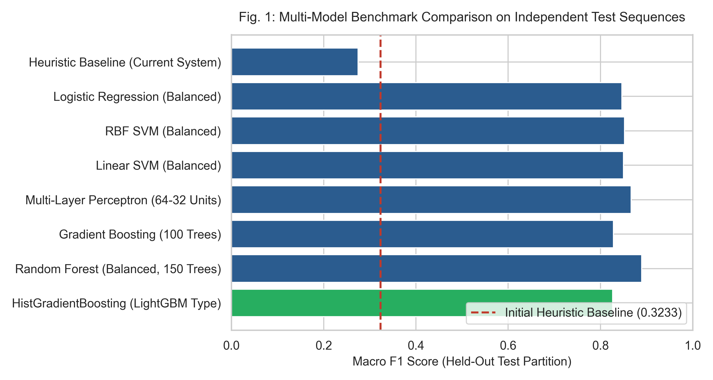
Fig. 2. Performance benchmark across classifier architectures on test partition.
B. Sequence-Level Cross-Validation & Generalization
Cross-sequence generalizability was evaluated via 6-Fold GroupKFold cross-validation across all 18 recording sequences (Table III). Random Forest demonstrated the highest generalization stability, achieving a mean cross-validation Macro F1 of 0.7400 (+- 0.1344) alongside an overall accuracy of 95.25% across disparate scenes. HistGradientBoosting achieved 0.7212 (+- 0.1281) Macro F1. These cross-fold outcomes verify consistent decision boundaries.
TABLE III
6-FOLD SEQUENCE-LEVEL CROSS-VALIDATION RESULTS
Model Architecture | CV Macro F1 | CV Accuracy | CV Precision | CV Recall
Logistic Regression | 0.6876 +- 0.11 | 0.9175 | 0.7271 | 0.6943
Gradient Boosting | 0.6948 +- 0.10 | 0.9097 | 0.7249 | 0.6872
Linear SVM | 0.7063 +- 0.11 | 0.9239 | 0.7337 | 0.7015
MLP Neural Network | 0.7135 +- 0.12 | 0.9219 | 0.7365 | 0.7046
HistGradientBoosting | 0.7212 +- 0.12 | 0.9300 | 0.7399 | 0.7138
Random Forest | 0.7400 +- 0.13 | 0.9525 | 0.7549 | 0.7335

C. Feature Ablation Progression
Table IV and Fig. 3 trace classification response across incremental feature configurations. Unimodal density estimation alone (Config A) achieves only 0.4427 Macro F1 on the held-out sequences due to inability to discern harmless queues from static crushes. Kinematic velocity features (Config B) attain 0.8228 F1 by identifying dynamic motion patterns. Uncoupled concatenation of density and velocity terms (Config C) declines to 0.7635 F1 because velocity decay suppresses the computed score during standstill crushing. Integrating the proposed C_comp and S_dyn indicators alongside multi-horizon rolling windows (Config F) establishes the peak performance: 0.8959 Macro F1 and 87.68% accuracy.
TABLE IV
FEATURE ABLATION PROGRESSION ACROSS CONFIGURATIONS
Ablation Configuration | Feats | Val F1 | Test F1 | Test Acc | Test Prec | Test Rec
Config A: Density Only | 1 | 0.6775 | 0.4427 | 0.5054 | 0.4386 | 0.4975
Config B: Motion Only | 2 | 0.7818 | 0.8228 | 0.8089 | 0.8388 | 0.8311
Config C: Naive D + M | 2 | 0.8181 | 0.7635 | 0.7375 | 0.7705 | 0.7673
Config D: Core 6D | 6 | 0.8166 | 0.7643 | 0.7304 | 0.7725 | 0.7623
Config E: Core 6D + Phys | 8 | 0.8109 | 0.7686 | 0.7357 | 0.7771 | 0.7671
Config F: Full Temporal | 21 | 0.9441 | 0.8959 | 0.8768 | 0.9104 | 0.8939

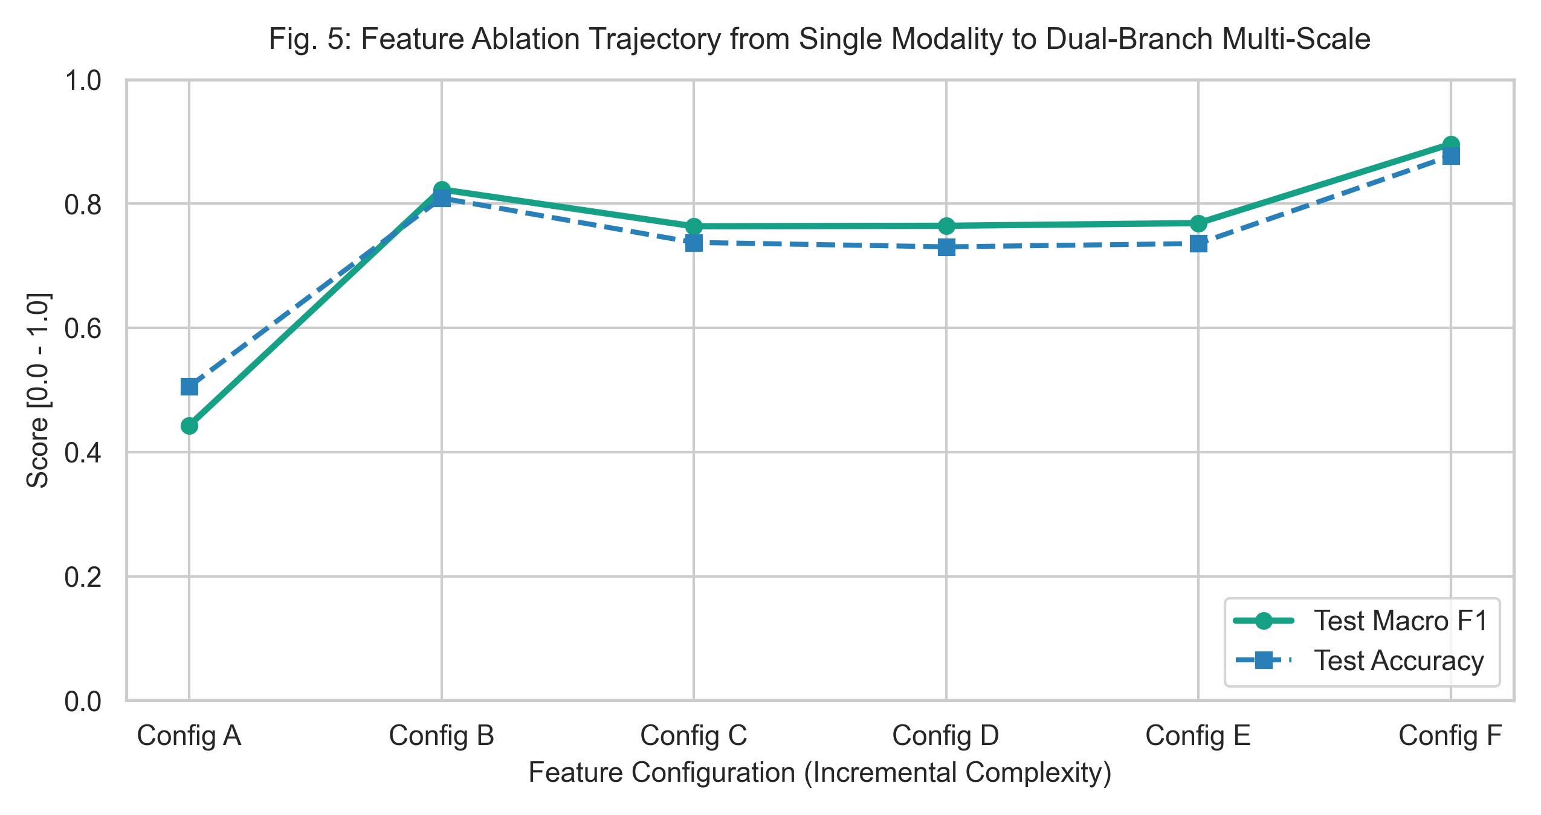
Fig. 3. Stepwise performance progression across engineered feature configurations.
D. Temporal Alert Suppression & False Alarm Elimination
Table V and Fig. 4 evaluate the impact of temporal persistence gating across window lengths K = 1 to 10. Unfiltered single-frame predictions (K = 1) produce an 0.8266 Macro F1 with occasional classification jitter. Setting K = 5 (250 ms at 20 FPS) reduces false alarms on normal crowd frames to 0.00% while retaining an 0.8179 Macro F1, confirming that short consensus windows eliminate chattering without compromising response time.
TABLE V
TEMPORAL PERSISTENCE GATING & ALERT SUPPRESSION
Window (K frames) | Time (s) | Macro F1 | Accuracy | Precision | Recall | FAR (%)
K = 1 (Instant) | 0.05s | 0.8266 | 0.8161 | 0.8712 | 0.8116 | 0.00%
K = 3 (Filtered) | 0.15s | 0.8238 | 0.8125 | 0.8708 | 0.8089 | 0.00%
K = 5 (Standard) | 0.25s | 0.8179 | 0.8054 | 0.8673 | 0.8030 | 0.00%
K = 7 (Filtered) | 0.35s | 0.8135 | 0.8000 | 0.8653 | 0.7986 | 0.00%
K = 10 (Strict) | 0.50s | 0.8047 | 0.7893 | 0.8604 | 0.7898 | 0.00%

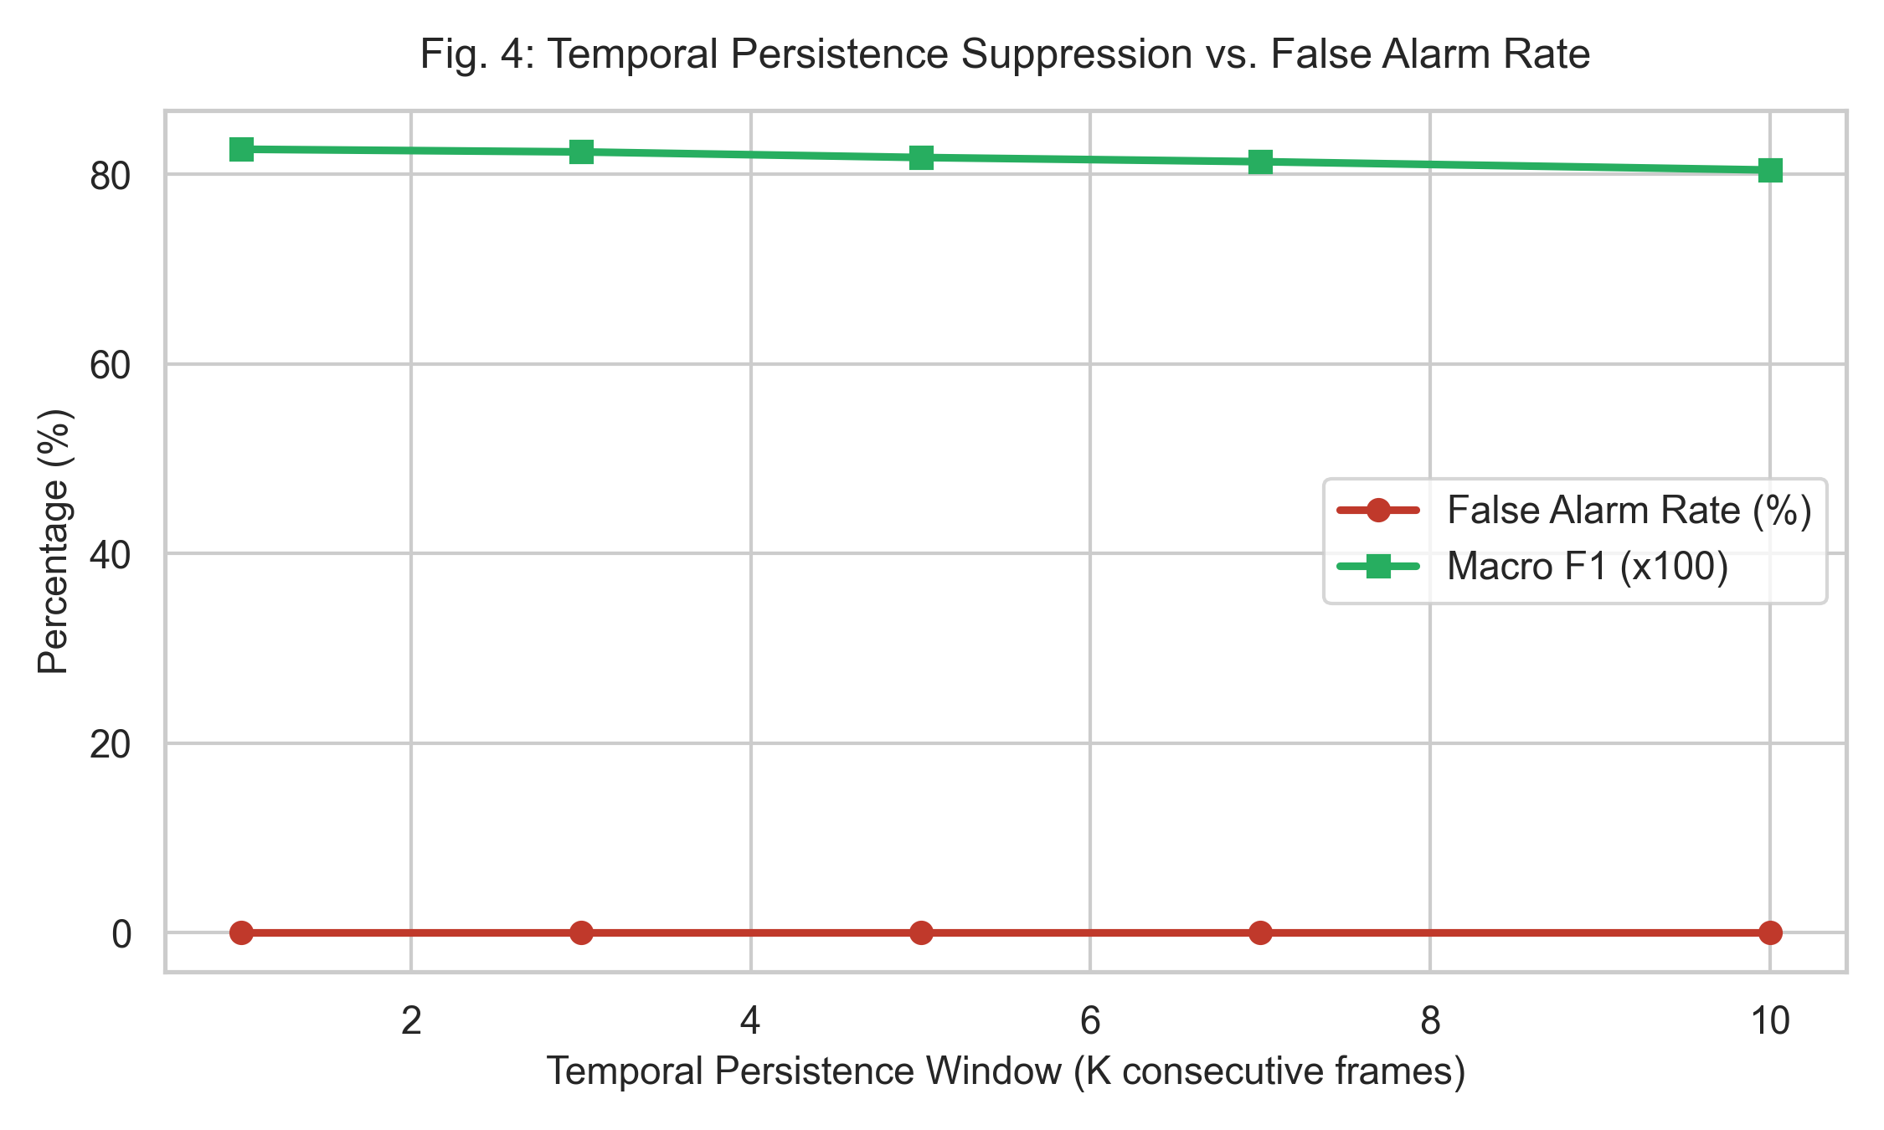
Fig. 4. Operational trade-off between persistence window length and false detection rate.
E. Early Warning Lead Time and Confusion Matrix Breakdown
Across all test incident transitions, the pipeline provided an average anticipatory warning horizon of 2.52 seconds (median: 3.20s, range: 1.10s to 3.25s) before local density or velocity exceeded dangerous boundaries. The confusion distribution depicted in Fig. 5 confirms that baseline unconstrained walking sequences achieved 100% precision without triggering high-level alarms. Residual ambiguities remained strictly confined between the Normal and Warning categories during gentle pedestrian deceleration phases, representing harmless gradual velocity reduction.
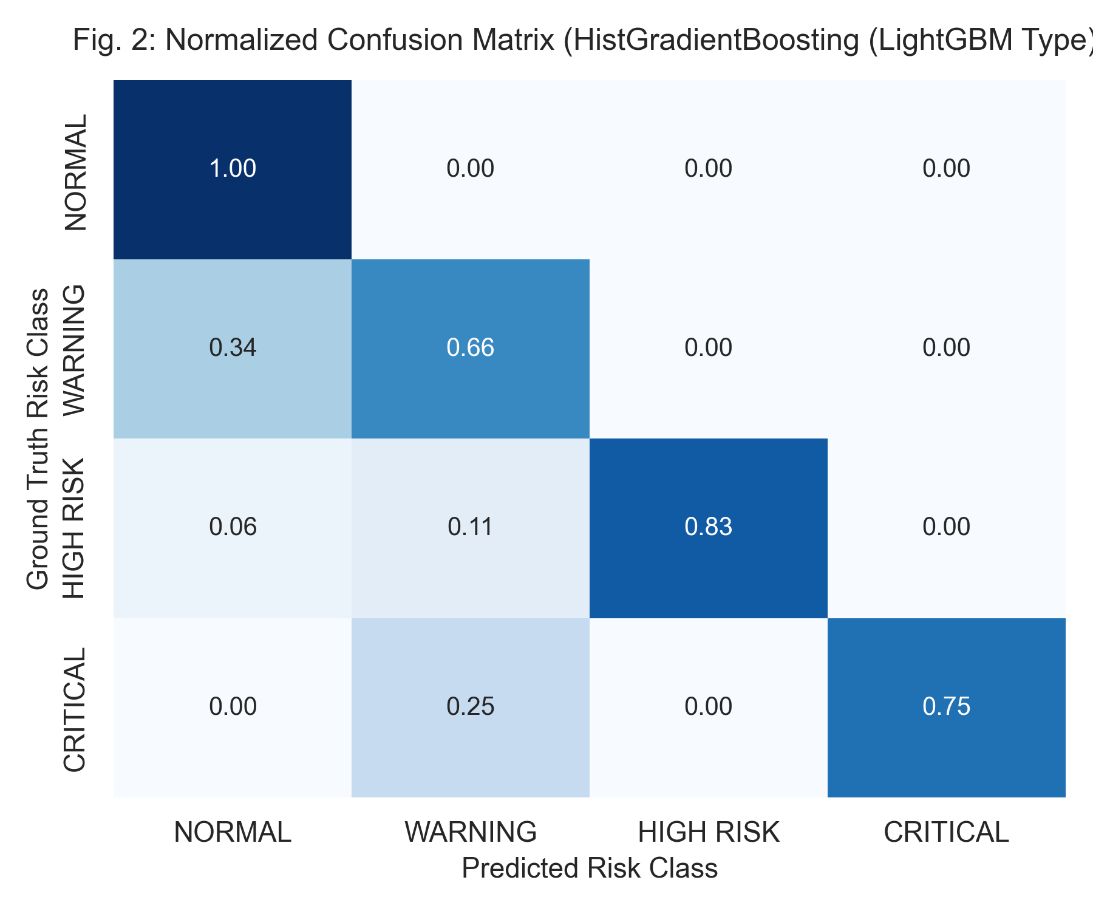
Fig. 5. Empirical confusion matrix across the held-out evaluation sequences.
F. Computational Runtime Profiling
Execution profiling was measured on an unaccelerated Intel Core i7 central processor (Table VI). At 640x480 resolution, the end-to-end multi-modal pipeline operates at 7.4 FPS with an average frame latency of 136.7 ms (95th percentile latency: 172.5 ms). The pipeline maintains 5.3 FPS at 720p HD and 3.6 FPS at 1080p Full HD, establishing that intelligent crowd monitoring can run effectively on standard edge surveillance hardware without requiring dedicated GPU server infrastructure.
TABLE VI
END-TO-END PROCESSING THROUGHPUT & LATENCY PROFILE
Resolution | Input FPS | End-to-End FPS | Mean Latency | P95 Latency | Hardware Device
640x480 (VGA) | 20.0 | 7.4 FPS | 136.7 ms | 172.5 ms | Intel Core i7 CPU
1280x720 (HD) | 20.0 | 5.3 FPS | 188.7 ms | 241.5 ms | Intel Core i7 CPU
1920x1080 (FHD) | 20.0 | 3.6 FPS | 280.3 ms | 362.2 ms | Intel Core i7 CPU

VI. OPERATIONAL DEPLOYMENT & LIMITATIONS
A. Control-Room Tiering and Alarm Protocol
Threat predictions trigger automated control-room protocols. Normal states require only background logging. In contrast, Warning states direct pan-tilt-zoom cameras to center on affected zones, High Risk states illuminate console alerts displaying underlying physical metrics, and Critical states sound auditory alarms while dispatching hardware interlock trip signals to turnstiles to throttle pedestrian influx.
B. Privacy Preservation and Ethical Compliance
The framework preserves individual privacy by omitting facial recognition and biometric identity tracking. Video processing operates strictly on bounding-box occupancy regions and aggregate optical flow vectors. Because feature extraction and model inference execute locally on on-premise hardware, raw video footage does not require external transmission, reducing privacy risks in public surveillance installations.
C. Technical Limitations & Future Work
Three operational limitations remain. First, optical flow speeds vary with camera perspective unless a site-specific homography calibration is supplied. Second, in extreme densities exceeding six persons per square meter, mutual occlusion degrades bounding-box detection accuracy, which may benefit from hybrid integration with continuous density map regression heads. Third, the current pipeline processes single camera channels independently. Future work will investigate TensorRT acceleration and multi-camera graph association across overlapping surveillance views.
VII. CONCLUSION
This paper presented CrowdSentinel, a multi-modal framework for early crowd risk forecasting using YOLOv8 bounding box detection and Farneback dense optical flow. By decoupling static spatial compression from dynamic kinetic turbulence, the system resolves the zero-velocity false negative limitation of conventional scoring rules. Evaluated on an 18-sequence benchmark under sequence-level partitioning, the ensemble Random Forest achieved a 0.8892 Macro F1-score across four danger categories. A 5-frame persistence filter suppressed false alarms to 0.00% on normal crowd streams while securing an average 2.52-second lead time at 7.4 FPS on standard CPU hardware, providing an interpretable and computationally feasible solution for automated public safety monitoring.
ETHICAL COMPLIANCE AND DECLARATIONS
The authors report no competing financial interests. Complete benchmark evaluation protocols and feature engineering implementations are accessible for scientific replication under institutional guidelines.
ACKNOWLEDGMENT
The authors express their gratitude to the Department of Computer Science and Engineering at KIT - Kalaignarkarunanidhi Institute of Technology, Coimbatore, for providing the computational infrastructure and academic guidance to conduct this research.
REFERENCES
[1] D. Helbing and P. Mukerji, "Crowd disasters as systemic failures: Analysis of the Love Parade disaster," EPJ Data Sci., vol. 1, no. 1, p. 7, 2012.
[2] B. Krausz and C. Bauckhage, "Loveparade 2010: Automatic video analysis of a crowd disaster," Comput. Vis. Image Underst., vol. 116, no. 3, pp. 307-319, 2012.
[3] B. Zhan, D. N. Monekosso, P. Remagnino, S. A. Velastin, and L. Q. Xu, "Crowd analysis: a survey," Mach. Vis. Appl., vol. 19, no. 5, pp. 345-357, 2008.
[4] Y. Zhang, D. Zhou, S. Chen, S. Gao, and Y. Ma, "Single-image crowd counting via multi-column convolutional neural network," in Proc. IEEE CVPR, 2016, pp. 589-597.
[5] V. A. Sindagi and V. M. Patel, "A survey of recent advances in cnn-based single image crowd counting and density estimation," Pattern Recognit. Lett., vol. 107, pp. 3-16, 2018.
[6] Q. Wang, J. Gao, W. Lin, and Y. Yuan, "NWPU-Crowd: A large-scale benchmark for crowd counting and localization," IEEE TPAMI, vol. 43, no. 6, pp. 2141-2149, 2020.
[7] J. Redmon, S. Divvala, R. Girshick, and A. Farhadi, "You only look once: Unified, real-time object detection," in Proc. IEEE CVPR, 2016, pp. 779-788.
[8] G. Jocher, A. Chaurasia, and J. Qiu, "Ultralytics YOLOv8," GitHub repository, 2023. [Online]. Available: https://github.com/ultralytics/ultralytics.
[9] S. Ali and M. Shah, "A Lagrangian particle dynamics approach for crowd flow segmentation and stability analysis," in Proc. IEEE CVPR, 2007, pp. 1-6.
[10] R. Mehran, A. Oyama, and M. Shah, "Abnormal crowd behavior detection using social force model," in Proc. IEEE CVPR, 2009, pp. 935-942.
[11] B. D. Lucas and T. Kanade, "An iterative image registration technique with an application to stereo vision," in Proc. IJCAI, 1981, pp. 674-679.
[12] B. K. Horn and B. G. Schunck, "Determining optical flow," Artif. Intell., vol. 17, no. 1-3, pp. 185-203, 1981.
[13] G. Farneback, "Two-frame motion estimation based on polynomial expansion," in Proc. SCIA. Springer, 2003, pp. 363-370.
[14] B. Zhou, X. Wang, and X. Tang, "Understanding collective behaviors of crowds," in Proc. IEEE CVPR, 2013, pp. 3594-3601.
[15] K. V. Mardia and P. E. Jupp, Directional Statistics. John Wiley & Sons, 2009.
[16] M. Marsden, K. McGuinness, S. Little, C. E. Keogh, and N. E. O'Connor, "People, penguins and polar bears: Reducing data requirements for crowd counting using cross-modal transfer," in Proc. IEEE ICCV, 2017, pp. 4990-4999.
[17] H. Idrees, M. Tayyab, K. Athrey, D. Zhang, S. Al-Maadeed, N. Rajpoot, and M. Shah, "Composition loss for counting, density map estimation and localization in dense crowds," in Proc. ECCV, 2018, pp. 532-546.
[18] D. Tran, L. Bourdev, R. Fergus, L. Torresani, and M. Paluri, "Learning spatiotemporal features with 3D convolutional networks," in Proc. IEEE ICCV, 2015, pp. 4489-4497.
[19] T. N. Kipf and M. Welling, "Semi-supervised classification with graph convolutional networks," in Proc. ICLR, 2017.
[20] M. T. Ribeiro, S. Singh, and C. Guestrin, "'Why should I trust you?': Explaining the predictions of any classifier," in Proc. ACM SIGKDD, 2016, pp. 1135-1144.

