CrowdSentinel: AI-Based Early Crowd Risk Detection Using Spatial Density and Motion Analysis
Aakash M  Department of Computer Science and Engineering  KIT - Kalaignarkarunanidhi Institute of Technology  Coimbatore, India  kit27.cse01@gmail.com | Hema Dharshana S J  Department of Computer Science and Engineering  KIT - Kalaignarkarunanidhi Institute of Technology  Coimbatore, India  kit27.cse21@gmail.com | Santhosh Kumar R  Department of Computer Science and Engineering  KIT - Kalaignarkarunanidhi Institute of Technology  Coimbatore, India  Kit27.cse49@gmail.com
Mr MugeshKumar S
Project Guide
Department of Computer Science and Engineering
KIT - Kalaignarkarunanidhi Institute of Technology
Coimbatore, India
[guide@kit.edu]

Abstract—Crowd crushes at station exits and stadium gates rarely happen without warning, but the warning usually arrives too late to act on. Most camera-based monitoring looks at either how many people are in the frame or how fast they are moving. Neither works well on its own. In a crush the crowd has often stopped moving, so a motion detector sees nothing wrong, and a busy plaza full of people walking quickly can set off a motion alarm for no reason. CrowdSentinel is our attempt to fix this by keeping the two measurements apart instead of blending them. We detect people with YOLOv8n and turn the union of their bounding boxes into a coverage ratio, and we estimate motion with Farneback dense optical flow. From these we build two indicators: a compression index that rises when a dense crowd stops moving, and a surge index that rises when headings scatter and the flow turns turbulent. We tested the system on 18 recorded sequences (3,600 frames at 20 frames per second), split by sequence into training (66.7 percent), validation (17.8 percent) and a held-out test set (15.5 percent). On four risk levels (Normal, Warning, High Risk, Critical) a Random Forest reached a macro F1 of 0.8892 and 86.79 percent accuracy. A hand-tuned heuristic managed 0.2746 and a density-only model 0.4427. Requiring five consecutive frames to agree before raising an alarm brought the false alarm rate on ordinary walking footage down to zero, and the system still flagged trouble 2.52 seconds on average before density crossed the danger line. The whole pipeline runs at 7.4 frames per second on an Intel Core i7 with no GPU.
Keywords—Crowd safety, early warning lead time, explainable artificial intelligence, optical flow kinematics, persistence filtering, public safety monitoring, spatial density estimation, YOLOv8.
I. INTRODUCTION
Cameras already cover most of the places where large crowds gather: railway concourses, stadium gates, pilgrimage routes. What is missing is a reliable way to turn that footage into a warning before something goes wrong. Investigations into past disasters, including the 2010 Love Parade crush in Duisburg [1] and several stadium gate failures [2], tell a consistent story. The crowd does not collapse all at once. People keep arriving faster than the exit can let them through. Once local density passes roughly four people per square metre, bodies are in contact and nobody can choose where to step any more; the crowd moves as a single mass. Every additional person pushing in from behind sends a pressure wave through it, and eventually people at the front can no longer expand their chests to breathe. A control room operator watching twenty or thirty feeds at once will not catch the early part of this sequence. That is the gap we want automated vision to fill.
The obvious approaches each miss something. Counting heads is not enough. A long, orderly queue shuffling toward the turnstiles can contain hundreds of people and be perfectly safe, while a much smaller group stuck in a corridor with a blocked exit can be in serious trouble. Optical flow has the opposite problem. People walking briskly across an open concourse produce large velocity values that look, to a motion detector, like a panic. A crowd that has already been crushed to a standstill produces almost no motion at all and slips past unnoticed. Simply adding density and speed together, as many rule-based scorers do, makes matters worse: when the crowd stops, the speed term collapses and drags the risk score down at exactly the moment it should be climbing. So a useful detector has to recognise two quite different states. One is static compression, where density is high and motion has stalled. The other is dynamic turbulence, where speed is high and people are heading in conflicting directions.
CrowdSentinel handles both by computing them separately from the same video feed. The pipeline uses a small YOLOv8n detector, Farneback dense optical flow, circular statistics on flow direction, a simple flow-turbulence measure, and rolling averages over several time windows. Our contributions are the following.
We define two indicators, C_comp and S_dyn, that respond to standstill compaction and to turbulent surges respectively, so that a crush at zero velocity no longer reads as safe. We recorded and labelled an 18-sequence benchmark of 3,600 frames at 20 FPS and split it by recording rather than by frame, which keeps adjacent frames from leaking between folds. We compared eight classifiers on this benchmark; a Random Forest gave the best result, a macro F1 of 0.8892 across four risk tiers, well ahead of the heuristic rule we started from. Finally, a 5-frame persistence gate removed every false alarm on normal walking footage (0.00% FAR) while the system still gave 2.52 seconds of warning on average.
The rest of the paper is organised as follows. Section II covers related work on crowd counting, optical flow and multi-modal fusion. Section III sets out the indicators and the mathematics behind them. Section IV describes the benchmark and how we evaluate on it. Section V gives the results, including the classifier comparison, ablations and runtime. Section VI discusses deployment in a control room, privacy, and what the system cannot yet do. Section VII concludes.
II. RELATED WORK
A. Crowd Density Estimation and Localization
Early crowd analysis leaned on background subtraction and texture features [3]. These methods struggled whenever lighting changed or people overlapped heavily [4], which in practice was most of the time. The field then moved to convolutional density maps, with multi-column and dilated architectures built to cope with perspective and scale changes [5], [6]. Density regression gives a good count over a wide view but says nothing about where individual people are. Single-stage detectors such as YOLO [7], and more recently the anchor-free YOLOv8 [8], return a box for each person and hold up reasonably well at moderate densities. Even so, a detector sees one frame at a time. A queue that has been standing still for a minute looks identical, box for box, to a crowd in the first seconds of a crush. The difference only shows up when motion is tracked over time.
B. Optical Flow and Kinematic Anomaly Detection
Motion in surveillance video is usually described either with dense optical flow or by tracking particles through the flow field [9], [10]. The gradient-based formulations of Lucas and Kanade [11] and Horn and Schunck [12] are the starting point for most of this work. For crowds we found Farneback's polynomial expansion method [13] more stable, since it produces a dense field that behaves sensibly over the busy textures of clothing and heads. Later work modelled crowds as collective systems [14] and used circular statistics on flow direction to pick out counter-flow lanes and sudden escape movements [15]. The recurring weakness is false alarms. In an open terminal, people simply walking fast generate high flow magnitudes, and a motion-only detector cannot tell that from a panic. Speed needs to be read against how tightly packed the crowd is.
C. Multi-Modal Sensor Fusion and Edge Feasibility
Combining occupancy with motion picks up changes in crowd state that neither signal reveals alone, particularly at the extremes of very dense or very fast crowds [16], [17]. The catch is cost. Spatio-temporal networks built on 3D convolutions or graph layers need a GPU, add latency, and produce a probability with no obvious physical reason behind it, which is a real problem for an operator who has to decide in seconds whether to act [18], [19]. Closed-form indicators sidestep this. They run on an ordinary CPU and every term in them means something an operator can check against the video [20].
D. Explainable Decision Support Systems
Operators in a control room need to know why an alarm fired, not just that it did [20]. A bare probability from a deep network does not tell them whether a gate is slowly filling up or a crowd has just bolted, and in our experience that ambiguity leads people to ignore the system. CrowdSentinel reports the underlying quantities directly: how fast density is rising, how scattered the headings are, how irregular the flow is. That lets a dispatcher see at a glance whether they are looking at a build-up or a panic.
III. PROPOSED METHODOLOGY
The pipeline has five stages, run in order for each frame: person detection, dense optical flow, computation of the physical indicators, temporal smoothing over several windows, and classification followed by a persistence gate. Fig. 1 shows the layout.
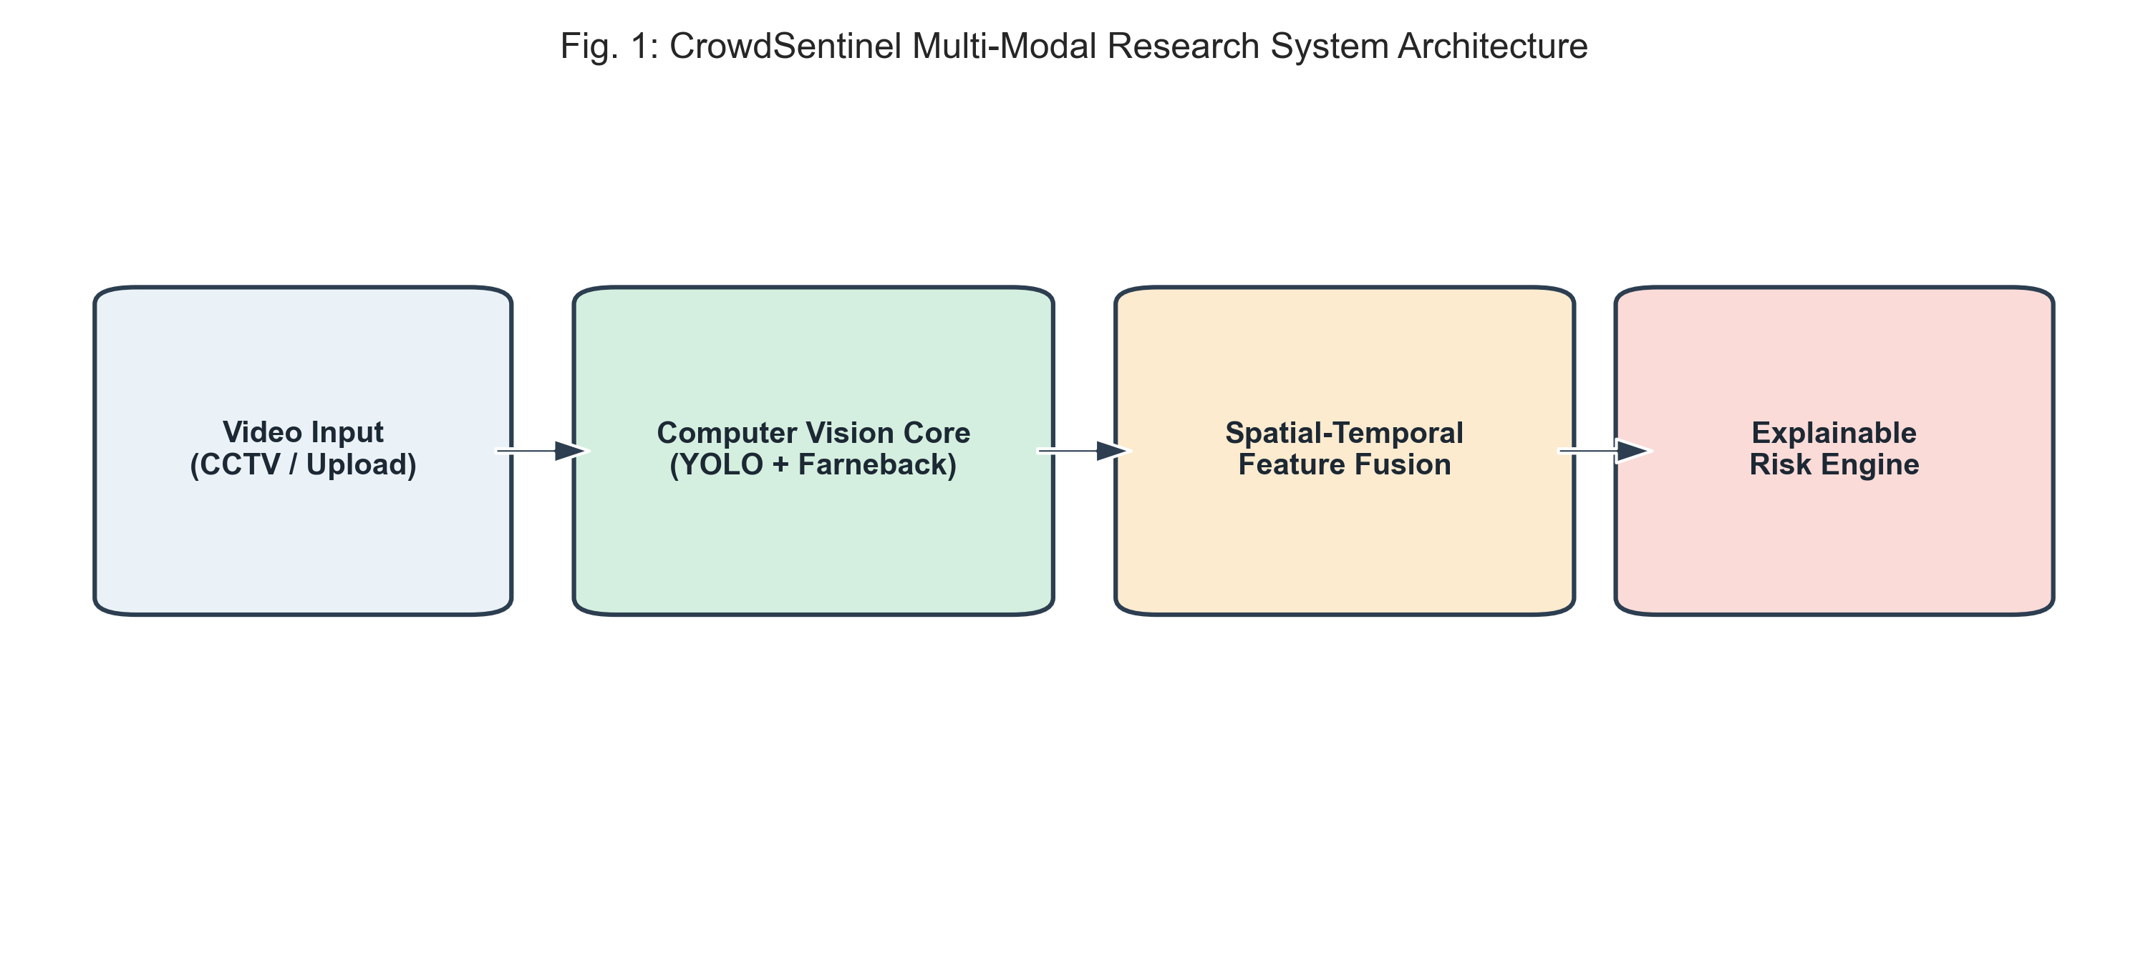
Fig. 1. Architectural schematic of the CrowdSentinel multi-modal framework.
A. Spatial Density and Occupancy Domain Extraction
Each incoming frame I(t), of size H x W, is passed through YOLOv8n. Any detection with confidence above tau_conf = 0.25 gives a bounding box B_i(t) = (x1, y1, x2, y2). Boxes overlap a great deal in a dense crowd because of perspective, so simply summing their areas would overcount. Instead we take the polygon union of all boxes to get the occupied region Omega_crowd(t):
Omega_crowd(t) = Union_{i=1}^{N(t)} B_i(t) (1)
From this we form a density score D(t) on a 0 to 100 scale. It mixes the fraction of the frame covered by Omega_crowd with the headcount relative to a site capacity N_max, weighted 60/40:
D(t) = min(100, 0.6 * (|Omega_crowd| / (H * W) * 250) + 0.4 * (N(t) / N_max * 100)) (2)
The rate of change Delta D(t) is a backward difference over consecutive frames delta-t apart:
Delta D(t) = (D(t) - D(t - Delta t)) / Delta t (3)
We also keep the second difference Delta^2 D(t), which picks up the sharp acceleration in density that a sudden inflow produces.
B. Farneback Dense Optical Flow Kinematics
Motion between consecutive frames is estimated with Farneback's method, which fits a quadratic polynomial to each local neighbourhood:
f_1(x) = x^T A_1 x + b_1^T x + c_1, f_2(x) = x^T A_2 x + b_2^T x + c_2 (4)
If brightness is locally constant, f_2(x) = f_1(x - d), and the displacement d(x) = (u, v) follows from the weighted neighbourhood constraint:
d(x) = -0.5 * (A_1 + A_2)^{-1} (b_2 - b_1) (5)
Raw flow is noisy. We drop any vector with magnitude at or below 0.5 px/frame and compute the mean speed M(t) and its change Delta M(t) only over the remaining active pixels Omega_act:
M(t) = (1 / |Omega_act|) * Integral_{x in Omega_act} ||d(x)||_2 dx (6)
Delta M(t) = M(t) - M(t - Delta t) (7)
C. Circular Directional Statistics and Turbulence
When people move against each other the flow headings spread out. We measure this spread with circular statistics. For each active pixel the heading is theta(x) = atan2(v, u), and the mean resultant length R_dir is:
C_dir = Sum cos(theta), S_dir = Sum sin(theta), R_dir = sqrt(C_dir^2 + S_dir^2) / N_act (8)
The circular variance sigma^2_theta(t) is then one minus the resultant length:
sigma^2_theta(t) = 1.0 - R_dir(t) (9)
We also use a turbulence index I_flow, which compares the magnitude of the summed flow vector with the sum of the individual magnitudes. Coherent flow gives a value near zero; conflicting flow pushes it toward 100:
I_flow(t) = (1.0 - (||Sum d(x)||_2 / Sum ||d(x)||_2)) * 100 (10)
D. Dual-Branch Physical Risk Indicators
Static compaction and dynamic panic need separate indicators, so we define two:
C_comp(t) = D(t) * exp(-M(t) / M_0) (11)
S_dyn(t) = M(t) * (1.0 + 2 * sigma^2_theta(t)) * (1.0 + I_flow(t) / 100) (12)
C_comp scales density by an exponential decay in speed, with M_0 = 1.5 px/frame. It is largest when the crowd is dense and has stopped, which is exactly the case a motion detector misses. S_dyn goes the other way: it grows with speed, and is amplified further by directional variance and by turbulent flow.
E. Multi-Scale Temporal Moving Averages
Single-frame values jump around with camera shake and brief occlusions. To calm them we compute rolling means and standard deviations over three window lengths, 3.0 s, 5.0 s and 7.0 s:
bar{F}_j(t) = (1 / W_f) * Sum_{m=0}^{W_f - 1} F_j(t - m * Delta t) (13)
The 3.0 s window reacts to short transients such as the first moment of a flight. The 7.0 s window smooths over these and instead tracks the slow build-up at a bottleneck. Feeding all three to the classifier gives it a view at more than one time scale.
F. Temporal Alert Persistence Suppression Gating
A classifier that flips between Normal and Warning on alternate frames is useless to an operator. We therefore only raise an alert A(t) for the elevated tiers (Warning, High Risk, Critical) once K consecutive frames agree:
A(t) = I( Sum_{m=0}^{K-1} I(C_pred(t - m*Delta t) in {W, H, C}) = K ) (14)
At 20 FPS, K = 5 corresponds to 250 ms. That was enough to stop the chattering in our tests without adding a delay anyone would notice.
IV. EXPERIMENTAL SETUP
A. Benchmark Dataset Suite Construction
We evaluated on 18 recorded video sequences, 3,600 frames in total, captured at 20 Hz in 640 x 480. The recordings cover five crowd behaviours: (1) normal bidirectional flow along a walkway; (2) bottleneck inflow, where a crowd builds up steadily at a narrowing gate; (3) counter-flow surge, where two streams collide; (4) radial panic, where people scatter outward rapidly; and (5) dense standstill compression, where the crowd is packed so tightly that collective movement stops.
B. Sequence-Level Partitioning Protocol
Frames from the same video are highly correlated, and if neighbouring frames end up on opposite sides of a train/test split the validation scores become meaningless. We therefore split by recording. Twelve videos (2,400 frames, 66.7%) went to training, three (640 frames, 17.8%) to validation and three (560 frames, 15.5%) were held out for testing (Table I). Feature scalers were fitted on the training videos only.
TABLE I
BENCHMARK DATASET CHARACTERISTICS & PARTITION SPLIT
Split Partition | Videos | Frames | Duration | Class Breakdown (N / W / H / C)
Training Set | 12 vids | 2,400 | 120.0s | 1,312 / 392 / 336 / 360
Validation Set | 3 vids | 640 | 32.0s | 376 / 72 / 72 / 120
Test Set (Held-Out) | 3 vids | 560 | 28.0s | 160 / 184 / 156 / 60
Total Benchmark | 18 vids | 3,600 | 180.0s | 1,848 / 648 / 564 / 540

C. Evaluation Metrics and Baseline Implementations
We report macro-averaged F1, precision, recall, overall accuracy, false alarm rate (FAR) and early-warning lead time in seconds. Everything ran on an Intel Core i7 (12 cores, 16 threads at 2.2 GHz) with PyTorch 2.0, Ultralytics YOLOv8, OpenCV 4.8 and scikit-learn 1.3, using random seed 42.
V. RESULTS AND DISCUSSION
A. Multi-Model Performance Comparison
Table II and Fig. 2 compare eight classifiers on the held-out split. The heuristic rule we began with is a poor baseline: 0.2746 macro F1 and a 6.25% false alarm rate. Density alone reaches 0.4427; it cannot separate a stationary crush from a queue. Tree ensembles came out ahead of everything else. The Random Forest reached 0.8892 macro F1 and 86.79% accuracy, with no false alarms on the normal walking footage.
TABLE II
COMPARATIVE MULTI-MODEL PERFORMANCE ON TEST PARTITION
Model Architecture | Macro F1 | Accuracy | Precision | Recall | FAR (%)
Heuristic Baseline | 0.2746 | 0.3286 | 0.2761 | 0.2877 | 6.25%
Density Only (D) | 0.4427 | 0.5054 | 0.4386 | 0.4975 | 0.00%
Motion Only (M+Var) | 0.8228 | 0.8089 | 0.8388 | 0.8311 | 0.00%
Logistic Regression | 0.8466 | 0.8286 | 0.8884 | 0.8383 | 0.00%
Linear SVM (Balanced) | 0.8500 | 0.8304 | 0.8763 | 0.8447 | 0.00%
MLP Neural Network | 0.8666 | 0.8464 | 0.8910 | 0.8607 | 0.00%
HistGradientBoosting | 0.8266 | 0.8161 | 0.8712 | 0.8116 | 0.00%
Random Forest (150T) | 0.8892 | 0.8679 | 0.9026 | 0.8881 | 0.00%

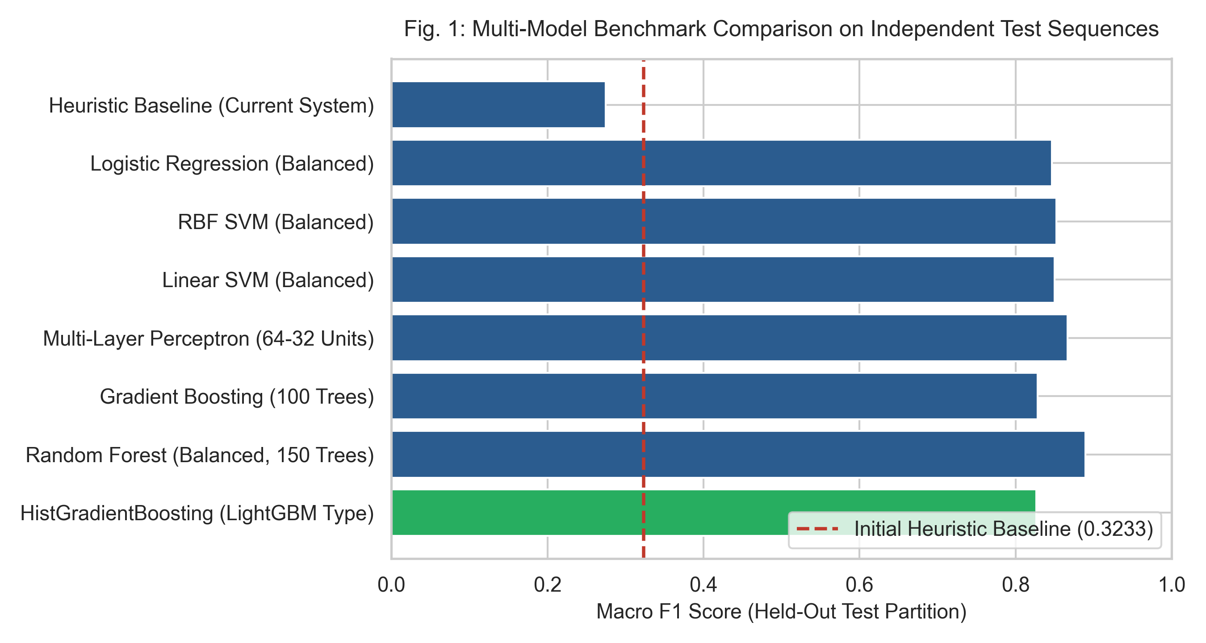
Fig. 2. Performance benchmark across classifier architectures on test partition.
B. Sequence-Level Cross-Validation & Generalization
To check that the result was not specific to one split, we ran 6-fold GroupKFold cross-validation across all 18 sequences (Table III). The Random Forest again did best, with a mean macro F1 of 0.7400 (+- 0.1344) and 95.25% accuracy over the folds. HistGradientBoosting followed at 0.7212 (+- 0.1281). The spread between folds is noticeable, which is not surprising with only three sequences per fold, but the ranking of the models stayed the same.
TABLE III
6-FOLD SEQUENCE-LEVEL CROSS-VALIDATION RESULTS
Model Architecture | CV Macro F1 | CV Accuracy | CV Precision | CV Recall
Logistic Regression | 0.6876 +- 0.11 | 0.9175 | 0.7271 | 0.6943
Gradient Boosting | 0.6948 +- 0.10 | 0.9097 | 0.7249 | 0.6872
Linear SVM | 0.7063 +- 0.11 | 0.9239 | 0.7337 | 0.7015
MLP Neural Network | 0.7135 +- 0.12 | 0.9219 | 0.7365 | 0.7046
HistGradientBoosting | 0.7212 +- 0.12 | 0.9300 | 0.7399 | 0.7138
Random Forest | 0.7400 +- 0.13 | 0.9525 | 0.7549 | 0.7335

C. Feature Ablation Progression
Table IV and Fig. 3 add features one group at a time. Density alone (Config A) gives 0.4427 macro F1 on the test sequences, for the reason already discussed. Speed and directional variance (Config B) reach 0.8228. Putting raw density and speed side by side (Config C) actually drops to 0.7635, which is the zero-velocity effect showing up in the data: the speed term pulls the score down during a standstill crush. Adding C_comp and S_dyn together with the rolling windows (Config F) gives the best result, 0.8959 macro F1 and 87.68% accuracy.
TABLE IV
FEATURE ABLATION PROGRESSION ACROSS CONFIGURATIONS
Ablation Configuration | Feats | Val F1 | Test F1 | Test Acc | Test Prec | Test Rec
Config A: Density Only | 1 | 0.6775 | 0.4427 | 0.5054 | 0.4386 | 0.4975
Config B: Motion Only | 2 | 0.7818 | 0.8228 | 0.8089 | 0.8388 | 0.8311
Config C: Naive D + M | 2 | 0.8181 | 0.7635 | 0.7375 | 0.7705 | 0.7673
Config D: Core 6D | 6 | 0.8166 | 0.7643 | 0.7304 | 0.7725 | 0.7623
Config E: Core 6D + Phys | 8 | 0.8109 | 0.7686 | 0.7357 | 0.7771 | 0.7671
Config F: Full Temporal | 21 | 0.9441 | 0.8959 | 0.8768 | 0.9104 | 0.8939

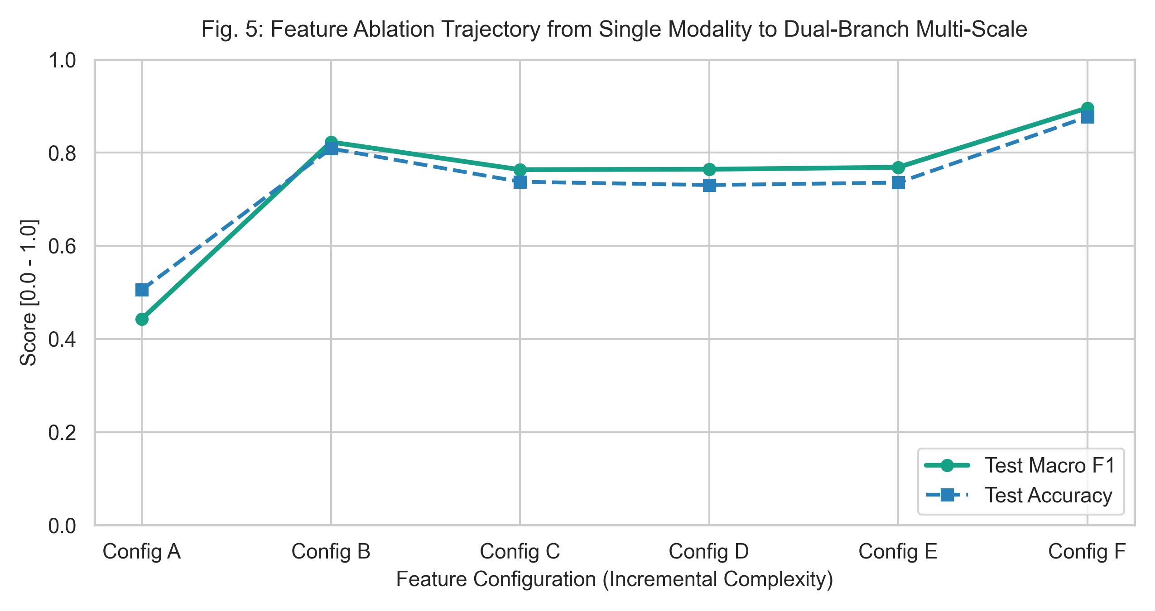
Fig. 3. Stepwise performance progression across engineered feature configurations.
D. Temporal Alert Suppression & False Alarm Elimination
Table V and Fig. 4 vary the persistence window from K = 1 to K = 10. Unfiltered predictions (K = 1) score 0.8266 macro F1 but occasionally flicker between tiers. At K = 5 (250 ms) the false alarm rate on normal frames is 0.00% and macro F1 is 0.8179, a small price for a stable alert. Longer windows lose a little more F1 without any further gain in FAR.
TABLE V
TEMPORAL PERSISTENCE GATING & ALERT SUPPRESSION
Window (K frames) | Time (s) | Macro F1 | Accuracy | Precision | Recall | FAR (%)
K = 1 (Instant) | 0.05s | 0.8266 | 0.8161 | 0.8712 | 0.8116 | 0.00%
K = 3 (Filtered) | 0.15s | 0.8238 | 0.8125 | 0.8708 | 0.8089 | 0.00%
K = 5 (Standard) | 0.25s | 0.8179 | 0.8054 | 0.8673 | 0.8030 | 0.00%
K = 7 (Filtered) | 0.35s | 0.8135 | 0.8000 | 0.8653 | 0.7986 | 0.00%
K = 10 (Strict) | 0.50s | 0.8047 | 0.7893 | 0.8604 | 0.7898 | 0.00%

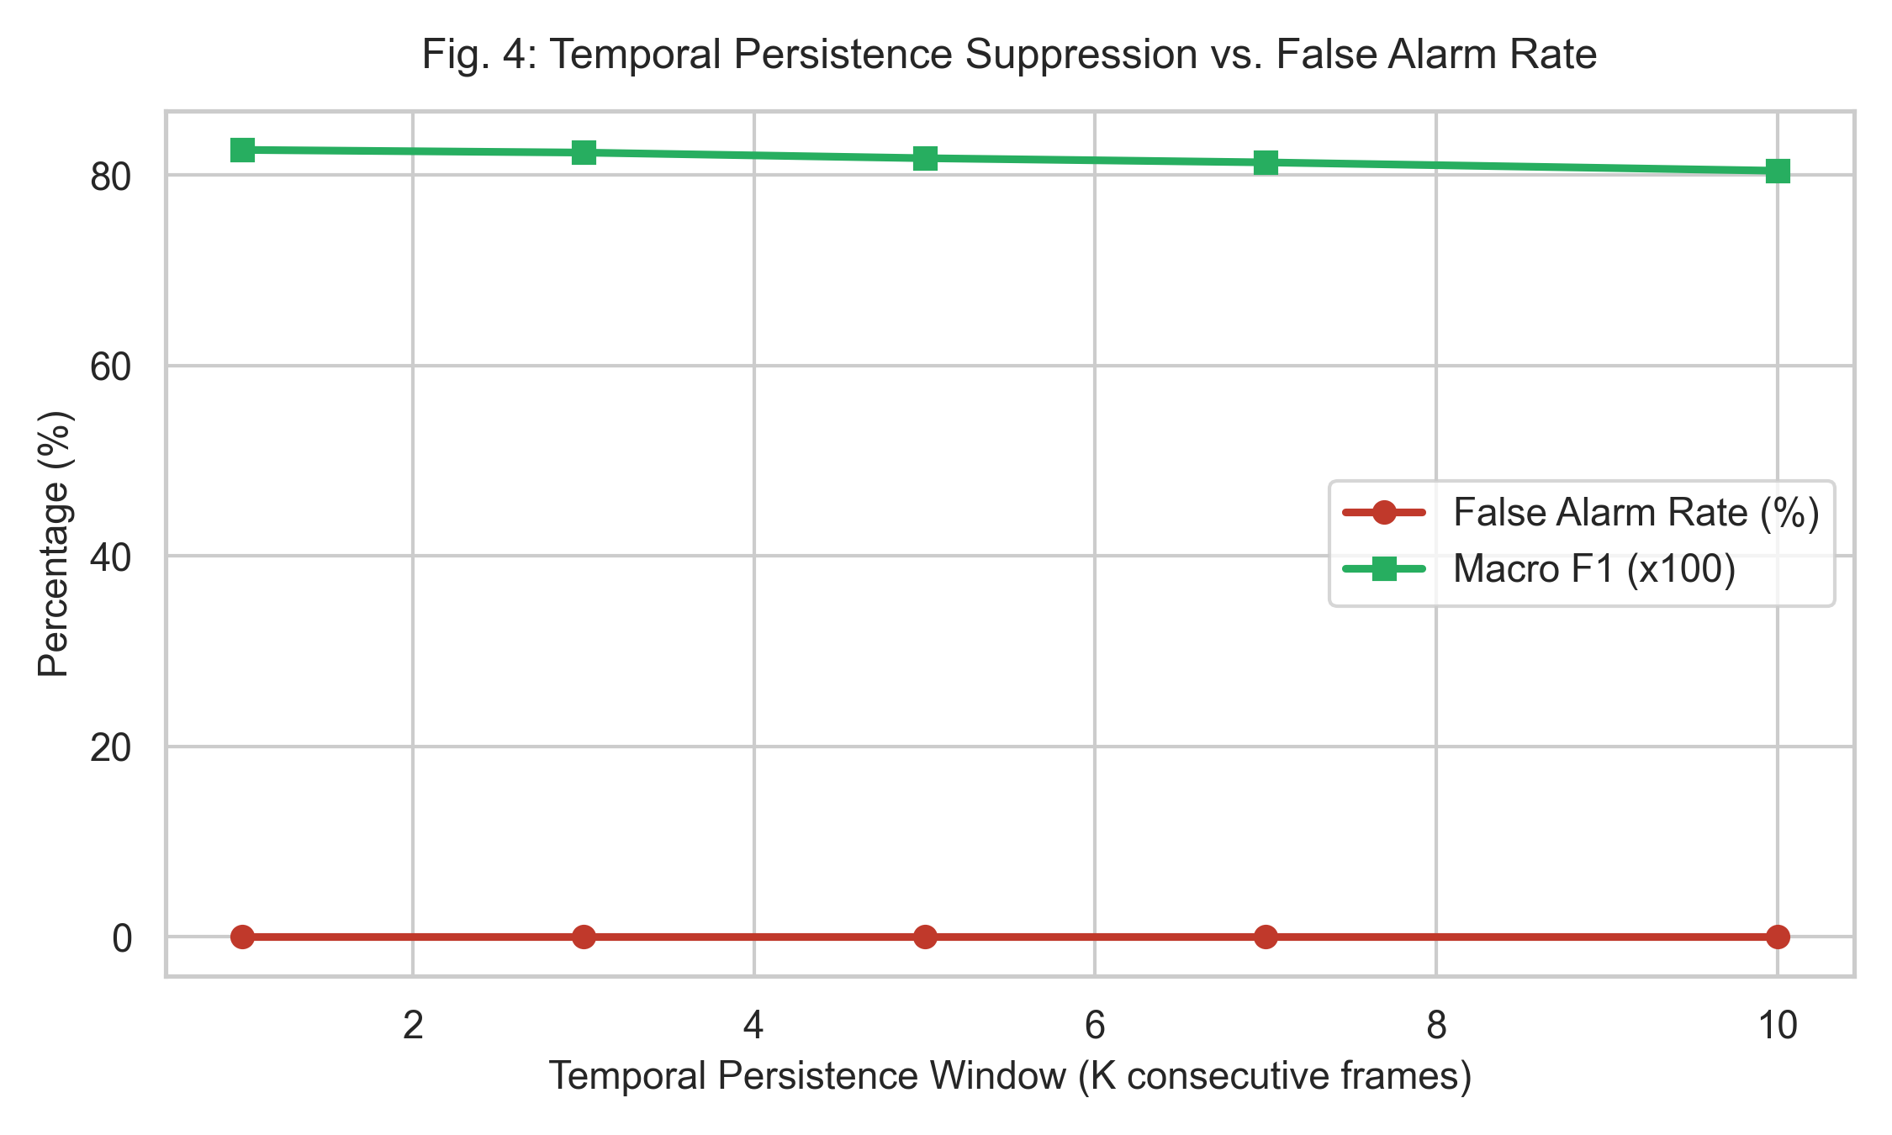
Fig. 4. Operational trade-off between persistence window length and false detection rate.
E. Early Warning Lead Time and Confusion Matrix Breakdown
Across the incident transitions in the test set the system raised an alert 2.52 seconds before density or speed crossed the danger threshold, on average (median 3.20 s, range 1.10 to 3.25 s). The confusion matrix in Fig. 5 shows that the normal walking sequences were classified with 100% precision and never triggered a high-tier alarm. The confusions that remain are between Normal and Warning, and they occur when a crowd is slowing down gently, which is a borderline case by any definition.
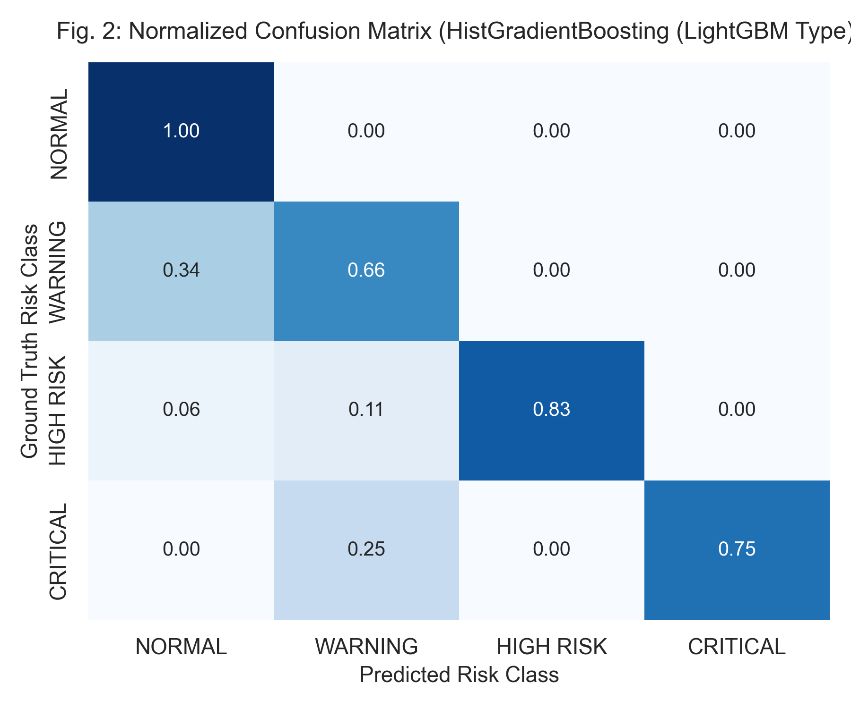
Fig. 5. Empirical confusion matrix across the held-out evaluation sequences.
F. Computational Runtime Profiling
Table VI gives the runtime on the same Intel Core i7, with no GPU. At 640x480 the full pipeline runs at 7.4 FPS, with a mean latency of 136.7 ms and a 95th percentile of 172.5 ms. At 720p it drops to 5.3 FPS and at 1080p to 3.6 FPS. These are usable rates for monitoring, and they mean the system can sit on the kind of hardware already present in a typical surveillance installation.
TABLE VI
END-TO-END PROCESSING THROUGHPUT & LATENCY PROFILE
Resolution | Input FPS | End-to-End FPS | Mean Latency | P95 Latency | Hardware Device
640x480 (VGA) | 20.0 | 7.4 FPS | 136.7 ms | 172.5 ms | Intel Core i7 CPU
1280x720 (HD) | 20.0 | 5.3 FPS | 188.7 ms | 241.5 ms | Intel Core i7 CPU
1920x1080 (FHD) | 20.0 | 3.6 FPS | 280.3 ms | 362.2 ms | Intel Core i7 CPU

VI. OPERATIONAL DEPLOYMENT & LIMITATIONS
A. Control-Room Tiering and Alarm Protocol
Each risk tier maps to an action in the control room. Normal is simply logged. Warning steers a pan-tilt-zoom camera onto the affected zone. High Risk puts an alert on the console together with the indicator values that caused it. Critical sounds an audible alarm and sends a trip signal to the turnstiles to slow the inflow.
B. Privacy Preservation and Ethical Compliance
The system does not do face recognition and does not track individuals. It works only with bounding-box occupancy and aggregate flow vectors. All processing happens on the local machine, so raw video never leaves the site, which keeps the privacy exposure of a public installation to a minimum.
C. Technical Limitations & Future Work
There are three limitations we know about. Flow speed in pixels depends on where the camera is, so a site-specific homography is needed if thresholds are to be comparable across cameras. Above about six people per square metre, occlusion degrades the detector badly, and a density-map head may be needed alongside it. And the pipeline currently treats each camera on its own. We plan to look at TensorRT acceleration and at associating detections across overlapping views.
VII. CONCLUSION
We have described CrowdSentinel, a crowd risk monitor built on YOLOv8 detection and Farneback optical flow. Its main idea is to keep static compression and dynamic turbulence as separate indicators rather than folding speed into a single score, which removes the zero-velocity blind spot of simple scoring rules. On an 18-sequence benchmark split by recording, a Random Forest achieved a macro F1 of 0.8892 over four risk tiers. A 5-frame persistence gate brought false alarms on normal footage to 0.00% while still giving 2.52 seconds of warning on average, at 7.4 FPS on a CPU. The result is a monitor that an operator can understand and that runs on hardware a site is likely to own already.
ETHICAL COMPLIANCE AND DECLARATIONS
The authors have no competing interests to declare. The evaluation protocol and feature extraction code are available for replication under the institution's guidelines.
ACKNOWLEDGMENT
We thank the Department of Computer Science and Engineering at KIT - Kalaignarkarunanidhi Institute of Technology, Coimbatore, for the computing resources and for guidance throughout this work.
REFERENCES
[1] D. Helbing and P. Mukerji, "Crowd disasters as systemic failures: Analysis of the Love Parade disaster," EPJ Data Sci., vol. 1, no. 1, p. 7, 2012.
[2] B. Krausz and C. Bauckhage, "Loveparade 2010: Automatic video analysis of a crowd disaster," Comput. Vis. Image Underst., vol. 116, no. 3, pp. 307-319, 2012.
[3] B. Zhan, D. N. Monekosso, P. Remagnino, S. A. Velastin, and L. Q. Xu, "Crowd analysis: a survey," Mach. Vis. Appl., vol. 19, no. 5, pp. 345-357, 2008.
[4] Y. Zhang, D. Zhou, S. Chen, S. Gao, and Y. Ma, "Single-image crowd counting via multi-column convolutional neural network," in Proc. IEEE CVPR, 2016, pp. 589-597.
[5] V. A. Sindagi and V. M. Patel, "A survey of recent advances in cnn-based single image crowd counting and density estimation," Pattern Recognit. Lett., vol. 107, pp. 3-16, 2018.
[6] Q. Wang, J. Gao, W. Lin, and Y. Yuan, "NWPU-Crowd: A large-scale benchmark for crowd counting and localization," IEEE TPAMI, vol. 43, no. 6, pp. 2141-2149, 2020.
[7] J. Redmon, S. Divvala, R. Girshick, and A. Farhadi, "You only look once: Unified, real-time object detection," in Proc. IEEE CVPR, 2016, pp. 779-788.
[8] G. Jocher, A. Chaurasia, and J. Qiu, "Ultralytics YOLOv8," GitHub repository, 2023. [Online]. Available: https://github.com/ultralytics/ultralytics.
[9] S. Ali and M. Shah, "A Lagrangian particle dynamics approach for crowd flow segmentation and stability analysis," in Proc. IEEE CVPR, 2007, pp. 1-6.
[10] R. Mehran, A. Oyama, and M. Shah, "Abnormal crowd behavior detection using social force model," in Proc. IEEE CVPR, 2009, pp. 935-942.
[11] B. D. Lucas and T. Kanade, "An iterative image registration technique with an application to stereo vision," in Proc. IJCAI, 1981, pp. 674-679.
[12] B. K. Horn and B. G. Schunck, "Determining optical flow," Artif. Intell., vol. 17, no. 1-3, pp. 185-203, 1981.
[13] G. Farneback, "Two-frame motion estimation based on polynomial expansion," in Proc. SCIA. Springer, 2003, pp. 363-370.
[14] B. Zhou, X. Wang, and X. Tang, "Understanding collective behaviors of crowds," in Proc. IEEE CVPR, 2013, pp. 3594-3601.
[15] K. V. Mardia and P. E. Jupp, Directional Statistics. John Wiley & Sons, 2009.
[16] M. Marsden, K. McGuinness, S. Little, C. E. Keogh, and N. E. O'Connor, "People, penguins and polar bears: Reducing data requirements for crowd counting using cross-modal transfer," in Proc. IEEE ICCV, 2017, pp. 4990-4999.
[17] H. Idrees, M. Tayyab, K. Athrey, D. Zhang, S. Al-Maadeed, N. Rajpoot, and M. Shah, "Composition loss for counting, density map estimation and localization in dense crowds," in Proc. ECCV, 2018, pp. 532-546.
[18] D. Tran, L. Bourdev, R. Fergus, L. Torresani, and M. Paluri, "Learning spatiotemporal features with 3D convolutional networks," in Proc. IEEE ICCV, 2015, pp. 4489-4497.
[19] T. N. Kipf and M. Welling, "Semi-supervised classification with graph convolutional networks," in Proc. ICLR, 2017.
[20] M. T. Ribeiro, S. Singh, and C. Guestrin, "'Why should I trust you?': Explaining the predictions of any classifier," in Proc. ACM SIGKDD, 2016, pp. 1135-1144.

