**Gunicorn**

**What is Gunicorn?**

Gunicorn (Green Unicorn) is a WSGI (Web Server Gateway Interface) server implementation commonly used to run python web applications and implements PEP 3333 server standard specifications, therefore, it can run web applications that implement application interface. Web applications written in Django, Flask, Bottle etc for implements application interface.

**Requirements.**

1. Python 3.5 or higher
2. A python framework
3. And gunicorn

**How to deploy Gunicorn in Django?**

* What is Django?

Django is a python web framework used for developing web applications. It is fast, secure and scalable.

How to install Django?

Syntax: pip install django

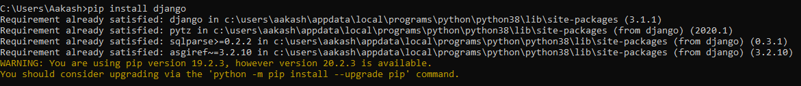

* Installation of gunicorn

Command

Pip/pip3 install gunicorn

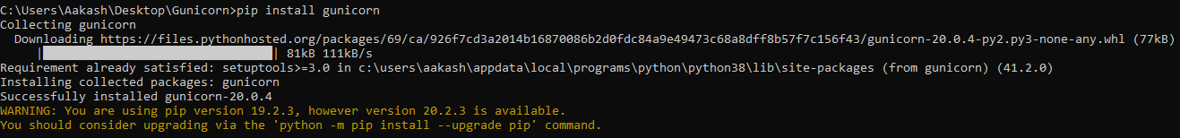

**Working of gunicorn with framework**

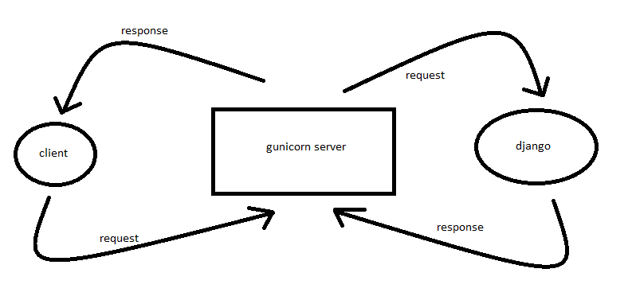

Practical time

1. Create a project to show demo with Gunicorn I am using Django for this we can also use other framework of python
2. Create a Django project using

django-admin startproject Gunicorn_demo

syntax : django-admin startproject foldername



1. After create project in Django we will see some file present in the folder (Gunicorn_demo)

