**Nginx**

**What is web server?**

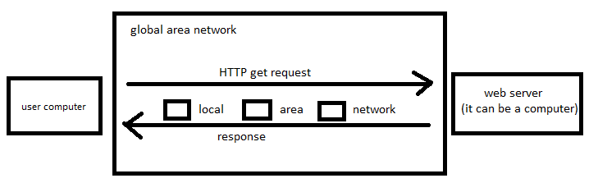

Web server are computer which deliver’s the requested web pages. Every web server has an IP address and a Domain name for identification.

**Example:**

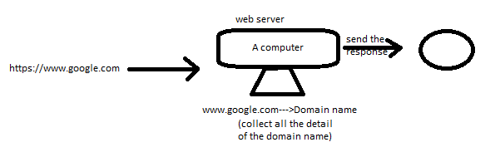

**Examples of web server?**

1. XAMPP
2. Apache
3. Nginx
4. Microsoft IIS (is used in Microsoft studio eg: asp.net)
5. NetBeans (?)
6. Etc

**What is Nginx?**

* An open source software which is used as web server and proxy.
* Web server for reverse proxy, caching and loading balancing.
* Provides HTTP server capabilities.
* Designed for maximum performance and stability.
* Function as proxy server for email (IMAP, POP3 & SMTP).
* Uses as non-threaded and event-driven architecture.
* In short terms Nginx is a web server which reduce the loading time of web page and also work as proxy.

**What is Nginx architecture?**

It use Master slave architecture by supporting event-driven, asynchronous and non-blocking model.

This master slave is a simple for understanding and working with advanced level working.

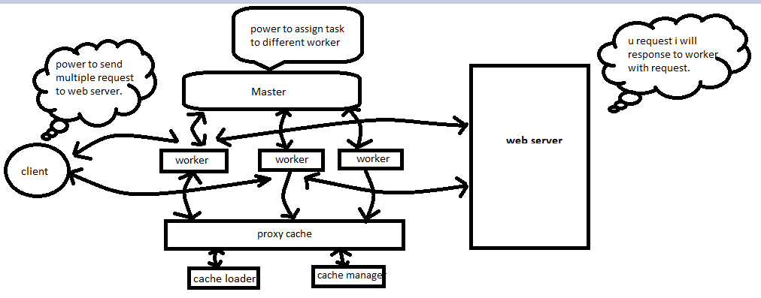

* Where master handle the worker for to assign different task / reading and processing control for multiple task.
* What is cache loader and cache manager?

It is used for storing the first time visited web page which helps to load the details again in faster way.

**Key features of Nginx?**

* Ease for installation and maintenance
* Improves performance (which stop traffic on web page/server)
* Offers scalability (normal web server has a limit of request on web page after that the server get down and it take lots of time but in case of Nginx it can handle multiple request in sim eg: 20000 request)
* Reduce the waiting time for multiple user
* Load balancing
* On fly upgrade (easily can be upgrade)

**In Nginx we use configuration setting**

(The core setting of Nginx are mainly configured in the nginx.cof file. The configuration file is mainly structure into context (event, Http context))

**File of Nginx**

* work_processes (define the number of workers [cpu core=workers])
* work_connections
* access_log and error_log (it store the error log and also which can help it for debugging)
* gzip

**Installation of Nginx**

**Steps for Ubuntu**

* Install Nginx
* Adjust firewall
* Check your server
* Manage the Nginx process

**Command line steps**

* sudo apt.get install nginx
* sudo ufw enable (for firewall)
* nginx –v
* sudo ufw app list (Nginx full, Nginx HTTP, Nginx HTTPs)
* sudo ufw allow ‘app list name’
* sudo ufw status
* sudo systemctl status nginx

**Practical time**