Assessing the Reliability of Machine-Learning Atmospheric Retrievals with Real Solar-System Spectra
July 2026

Abstract
Machine-learning retrieval is often proposed as a fast substitute for Bayesian atmospheric inference, but almost every published model is trained and tested only on synthetic spectra, so its behaviour on real observations is unknown. We evaluate six neural architectures (520000 to 36000000 parameters) trained on a synthetic library of terrestrial reflected-light spectra and tested, without retraining, on real telescope spectra of 19 Solar-System bodies. Every accuracy figure is reported at two operating points: a noiseless ceiling and a realistic single exposure ($α=1$, an 8 h integration). The best model reaches a covered-gas $R^{2}$ of $0.78$ at the ceiling but $0.13$ at $α=1$, a factor-of-six gap. On the real spectra the models detect methane as well as a one-parameter physics ruler, but assign more oxygen to the airless Moon than to Earth, a fabrication we trace to the training-set label prior rather than to any architecture. Model size does not improve accuracy, transfer to a different simulator degrades, and calibrated uncertainty holds only in-distribution. We frame the study around these limitations: synthetic accuracy is a weak predictor of real-world reliability, and physical controls such as airless-body false-positive tests and continuum nulling are needed to tell the two apart.

1 Introduction
Characterising the atmospheres of rocky planets is central to the search for life beyond the Solar System. The gases present in an atmosphere, their abundances, and the chemical disequilibria between them are the primary remote evidence for whether a planet’s surface chemistry could be biological. Oxygen and its photochemical product ozone, together with methane, are the canonical targets: their simultaneous presence is hard to sustain without a continual biological source. That same importance makes them the most costly to get wrong. An abiotic process, or an analysis artefact, that mimics oxygen would register as a false detection of life, so the reliability of a retrieval matters as much as its nominal accuracy.
Future direct-imaging missions are expected to rely on reflected-light spectroscopy, one of the few routes to Earth-like planets around Sun-like stars that transit spectroscopy cannot easily reach [1, 2]. Interpreting such spectra, a task known as atmospheric retrieval, is traditionally posed as Bayesian inference: a forward model is evaluated repeatedly against the observation until the posterior over atmospheric parameters is characterised. The approach is statistically principled but expensive. Nested-sampling retrievals typically need between 20000 and 60000 forward-model evaluations, and Bayesian schemes more generally require ${10}^{5}$ to ${10}^{6}$ evaluations, corresponding to hours of wall-clock time per spectrum [9, 8]. As direct-imaging surveys begin to return larger samples of candidate planets, this cost becomes a bottleneck.
Supervised machine learning offers a faster route. A model learns the mapping from spectrum to composition from a synthetic training library and then analyses a new observation in a single forward pass, reducing per-spectrum inference from CPU-hours to milliseconds [3, 4, 5]. A common limitation runs through this literature: with few exceptions the models are trained and evaluated on synthetic spectra produced by a single forward model, so strong performance on held-out synthetic data measures self-consistency with the simulator rather than fidelity to nature. This paper takes that limitation as its subject. Using frozen, already-trained models, and without any retraining, we ask four questions. How large does a retrieval model need to be before accuracy saturates? How does the reported accuracy depend on exposure time and spectral resolution? How does a model behave on spectra from a different simulator? And, most importantly, how does it behave on real telescope spectra whose ground truth is known independently of any simulator?
To answer the last question we assemble a real-data validation set of 19 Solar-System bodies observed in reflected light, including 11 airless bodies that serve as a false-positive control. The main finding is a gap: a model can post a strong synthetic benchmark and still fail on real spectra, most starkly by reporting abundant oxygen on bare rock. The remaining results characterise where and why learned retrieval breaks down, and what inexpensive controls expose the failure. Throughout, we report every accuracy figure at two operating points, a noiseless ceiling and a realistic single exposure, so that the optimism of the synthetic-only number is visible directly rather than hidden.

2 Related work
Learned atmospheric retrieval has progressed steadily from simple to expressive models. Waldmann [3] introduced deep networks for recognising spectral patterns; Márquez-Neila et al. [4] used a random forest to retrieve a hot-Jupiter atmosphere and compared its posterior against a Bayesian one; Soboczenski et al. [5] and Cobb et al. [7] added Bayesian deep networks and ensembles to attach uncertainty to terrestrial retrievals. Generative and simulation-based methods followed, including generative adversarial networks [6] and neural posterior estimation with normalizing flows, the latter winning the 2023 Ariel Data Challenge [10, 11]. Nixon & Madhusudhan [8] showed that, given enough training data, supervised models can match nested-sampling parameter estimates at a fraction of the cost, and Ardévol Martínez et al. [9] compared convolutional networks against nested sampling on transmission spectra.
Two threads matter for the present work. First, uncertainty tends to be under-dispersed: learned posteriors are often narrower than the Bayesian reference [4], which motivates the calibrated intervals we adopt. Second, real-data validation is rare. Most studies remain within a single simulator, so the domain shift to real observations, which includes instrumental systematics, geometry, and cloud, is left untested. Table [tab:related] places our study among representative prior work; it differs chiefly in being validated on real telescope spectra with independent ground truth.
Study | Model family | Data regime | Real data?
Waldmann (2016) | Deep belief network | Synthetic transmission | No
Márquez-Neila et al. (2018) | Random forest | Single hot Jupiter | Partial
Soboczenski et al. (2018) | Bayesian DNN (MC dropout) | Synthetic terrestrial (PSG) | No
Cobb et al. (2019) | Ensemble of Bayesian NNs | Synthetic terrestrial | No
Nixon & Madhusudhan (2020) | Multiple supervised models | Synthetic, cross-compared | No
Ardévol Martínez et al. (2022) | CNN vs. nested sampling | Synthetic transmission | Partial
Vasist et al. (2023) | Normalizing-flow NPE | Synthetic (Ariel) | No
This work | Six architectures (0.52–36M) | Synthetic PSG + Solar System | Yes (19 bodies)

3 Data

3.1 Synthetic training library
Training uses the INARA library [13], a set of reflected-light spectra of rocky planets generated with the NASA Planetary Spectrum Generator (PSG) [12], the forward model behind the reference terrestrial data sets in this field. We use 99305 spectra, split 88271 for training and 11034 for a held-out test set. Each spectrum spans $0.2$–$2.0$ $μ$m at native resolving power $R​≈​1900$ (4378 wavelength bins) and carries a 12-species volume-mixing-ratio (VMR) label on the simplex ($H_{2}O$, $CO_{2}$, $O_{2}$, $N_{2}$, $CH_{4}$, $N_{2}O$, CO, $O_{3}$, $SO_{2}$, $NH_{3}$, $C_{2}H_{6}$, $NO_{2}$). Five of these, $H_{2}O$, $CO_{2}$, $O_{2}$, $CH_{4}$, and $O_{3}$, produce measurable absorption in the reflected-light band, and we refer to them as the covered gases; headline $R^{2}$ values average over these five unless stated otherwise. To probe whether a model has memorised the idiosyncrasies of one simulator, we also generate held-out sets of 2000 spectra each with two independent forward models, TauREx and petitRADTRANS (pRT), on the same wavelength grid (Section 5.5).

3.2 Real validation set
The validation data are the focus of this work. We use the Solar-System reflectance catalogue of Madden & Kaltenegger [14], which provides disc-integrated geometric-albedo spectra $A_{g}(λ)$ for 19 bodies whose atmospheric compositions are known independently, from decades of in-situ and remote study rather than from any simulator. This makes them a clean external test of models trained only on synthetic data: the answer key was never seen in training and does not share the simulator’s biases. We group the bodies to probe distinct failure modes.
Terrestrial bodies with atmospheres (Earth, Venus, Mars, Titan) test whether known gases are recovered. Giant planets (Jupiter, Saturn, Uranus, Neptune) test behaviour on atmospheres far outside the rocky training distribution. Airless bodies (the Moon, Mercury, and nine icy or rocky moons and dwarf planets) are a false-positive control: a body with no atmosphere that is nonetheless assigned a gas abundance exposes fabrication directly, since the model must then be reciting its training prior rather than reading absorption features. The catalogue also contains a matched Earth/Moon pair observed on the same night with the same instrument at the same resolving power, which isolates composition from every observational confound and is the single cleanest test in the set.
The bodies span a wide range of native resolving power, from $R​≈​12$ to $R​≈​867$. Because reflected-light features blend below a threshold, we record each body’s effective $R$ and treat quantitative abundance retrieval as valid only where $R​≥​400$; below that we restrict the analysis to detection statistics. This is not a modelling choice but a physical limit, and it makes some bodies (Venus and Mars at $R​≈​22$) unusable for quantitative retrieval regardless of the method.

4 Methodology

4.1 Input representation and noise
The models operate on the planet-to-star contrast rather than on absolute flux, which removes the dependence on stellar luminosity and system distance and lets the network learn atmospheric properties rather than observational scaling. The stellar flux is recovered from the combined star-planet spectrum and the isolated planetary spectrum, and the noiseless contrast is $C(λ)=F_{p}(λ)/F_{⋆}(λ)$.
The INARA library ships a per-wavelength $1σ$ noise column, a realistic LUVOIR-class photon-noise estimate. Most prior work discards it and trains on noiseless spectra, which is one reason synthetic accuracy overstates real performance: a model tuned on noiseless data is never asked to cope with the photon budget it will face in practice. We instead build our noise model on this column. Rather than fixing a single noisy data set, we inject noise dynamically during training. With a nominal exposure $t_{nom}=8$ h (a LUVOIR-class integration), we define an exposure factor and draw a fresh noisy realisation each epoch,
$$α=\sqrt{t_{exp}/t_{nom}}, \tilde{C}(λ)=C(λ)+\frac{σ_{C}(λ)}{α} N(0,1),$$
where $σ_{C}(λ)=σ_{noise}(λ)/F_{⋆}(λ)$, so that the noise falls as $1/α$ with integration time in accordance with photon-counting statistics. Here $α=1$ is a single realistic 8 h exposure; $α≫1$ mimics stacking many exposures and approaches the noiseless limit. Because a model trained across a range of $α$ sees the same atmosphere at many noise levels, sweeping $α$ at test time traces the entire photon-limited accuracy curve. The practical consequence is that every accuracy number must be quoted with its $α$: the same network can look strong or weak depending only on the assumed exposure, and reporting the noiseless value alone is the central source of optimism this paper warns against.
Each spectrum is presented as two channels: the noisy contrast $\tilde{C}(λ)$, and the stellar signal-to-noise ratio ${SNR}_{⋆}(λ)=α F_{⋆}(λ)/σ_{noise}(λ)$, which tells the network how trustworthy each wavelength is. Both channels are compressed with the inverse hyperbolic sine, $x_{norm}=asinh(x)=ln(x+\sqrt{x^{2}+1})$, which tames the roughly 13-decade dynamic range while preserving low-intensity structure. The full 4378-bin spectrum is passed to the neural networks; a 64-bin pooled representation is used only for the classical baselines (Section 4.5).
For real spectra the catalogue provides geometric albedo, whereas the models expect the two-channel contrast input. For each body we convert $A_{g}(λ)$ to a planetary contrast under an explicit Earth-analogue geometry (1 AU orbit, Solar-type host, full phase) and place it on the training wavelength grid. The SNR channel is set to the nominal $α=1$ stellar profile, identical for all bodies, so no per-body information leaks through it. This conversion is an assumption, not a measurement, and we treat it as part of the test: any retrieval that depends sensitively on it is flagged, and detection statistics are computed at matched resolution so that resolving power cannot act as a confound.

4.2 Training and evaluation setup
All tracks are trained under one harness and a shared budget: the same optimiser, batch size, learning rate, and a 48-epoch schedule, with fresh photon noise drawn each epoch as above. Except for the deliberately large convolutional baseline, every model is kept below 2M parameters so that the family can be trained and audited on modest hardware and compared on an equal footing. Results in this paper come from single-seed runs; we note where that limits the strength of a conclusion, and a multi-seed study is left to future work. Unless stated, all numbers are computed from frozen checkpoints with no retraining, including every real-data and inference-time-correction result.

4.3 Architectures
We evaluate five distinct architectures; a sixth track is byte-identical to the convolutional baseline and is reported only for continuity. The models are summarised briefly here, and the counterfactual model is described separately in Section 4.4.

4.3.0.1 Large CNN baseline (original1dcnn, 36M).
A deliberately large model. Prior terrestrial-retrieval networks used millions of parameters (Soboczenski et al. $∼$18M; other studies exceed 5M), so we reproduce a 36M-parameter deep 1-D CNN with a large fully connected head. Its role is to test directly whether brute-force capacity is what drives accuracy, and it anchors the upper end of the size range.

4.3.0.2 Compact CNN (optimized1dcnn, 1.2M).
A 1-D CNN with batch normalisation, progressive kernel sizes, and adaptive pooling, giving a receptive field comparable to the large baseline at a fraction of the size.

4.3.0.3 Transformer backbone (transformerarch, 0.52M).
A convolutional down-sampling stem ($×8$) feeds a two-layer Transformer encoder, global average pooling, and an MLP head (Figure 1). The causal track shares this exact backbone and differs only in training objective, so comparing the two isolates the effect of the augmentation.

4.3.0.4 Wide causal net (causal_xl, 2M).
A wider, deeper counterfactual backbone, included to test whether extra capacity on the causal track helps.
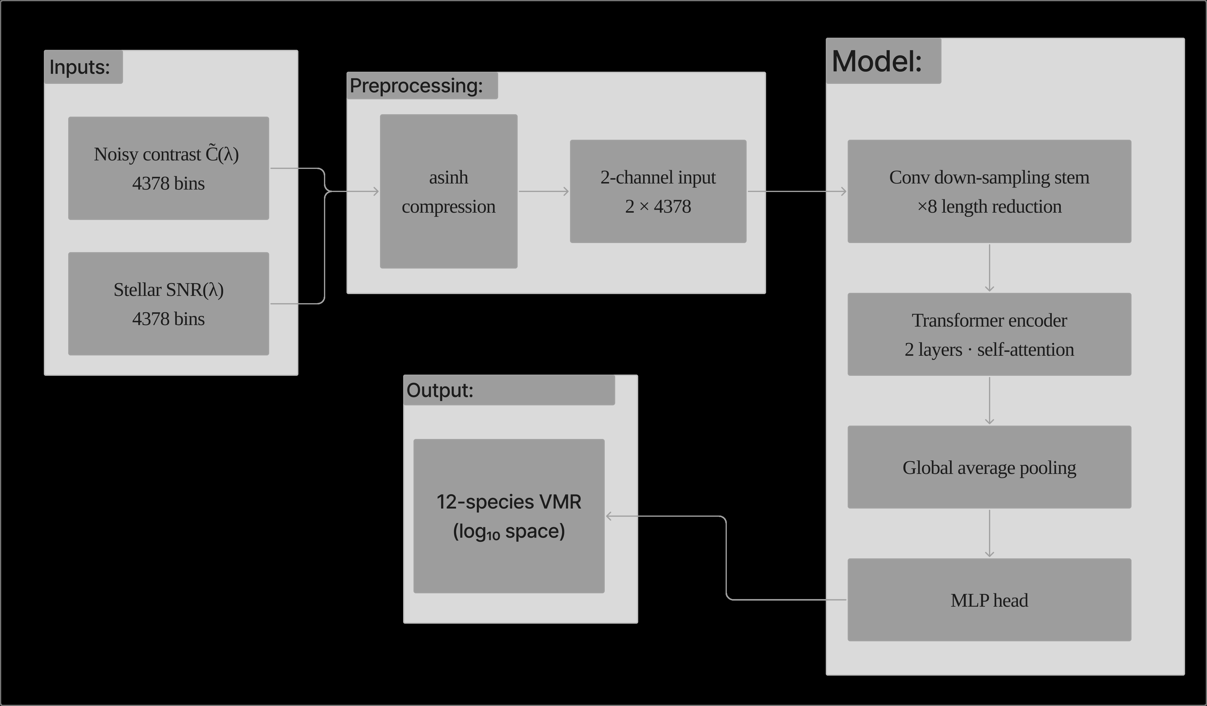
Transformer backbone shared by the transformerarch and causal tracks. The two-channel contrast/SNR input (each $4378$ bins) is asinh-compressed, then passes through a convolutional down-sampling stem ($×8$ length reduction), a two-layer Transformer encoder, global average pooling, and an MLP head that outputs the 12-species VMR vector.

4.4 Counterfactual (causal) model
Treat composition $a$ and observing environment $e$ (host star, distance, noise) as independent causes of a spectrum $x=g(a,e)$. The atmosphere is the quantity of interest; the environment is a nuisance that a reliable retrieval should ignore. A counterfactual applies the intervention $do(e=e_{j})$, holding the atmosphere of planet $i$ fixed while substituting the environment of planet $j$,
$$x_{i}^{do(e=e_{j})}=g(a_{i},e_{j}),$$
constructed by re-pairing the star-free albedo of $i$ with the stellar and noise profile of $j$. Training penalises any change in prediction under this intervention,
$$L=L_{task}+λ ∥f(x_{i})−f​\left(x_{i}^{do(e=e_{j})}\right)∥^{2},$$
so the network is rewarded for invariance to the environment while retaining the atmospheric signal (Figure 2). Because the counterfactual re-pairs existing components rather than generating new ones, the augmentation introduces no synthetic artefacts and cannot leak label information.
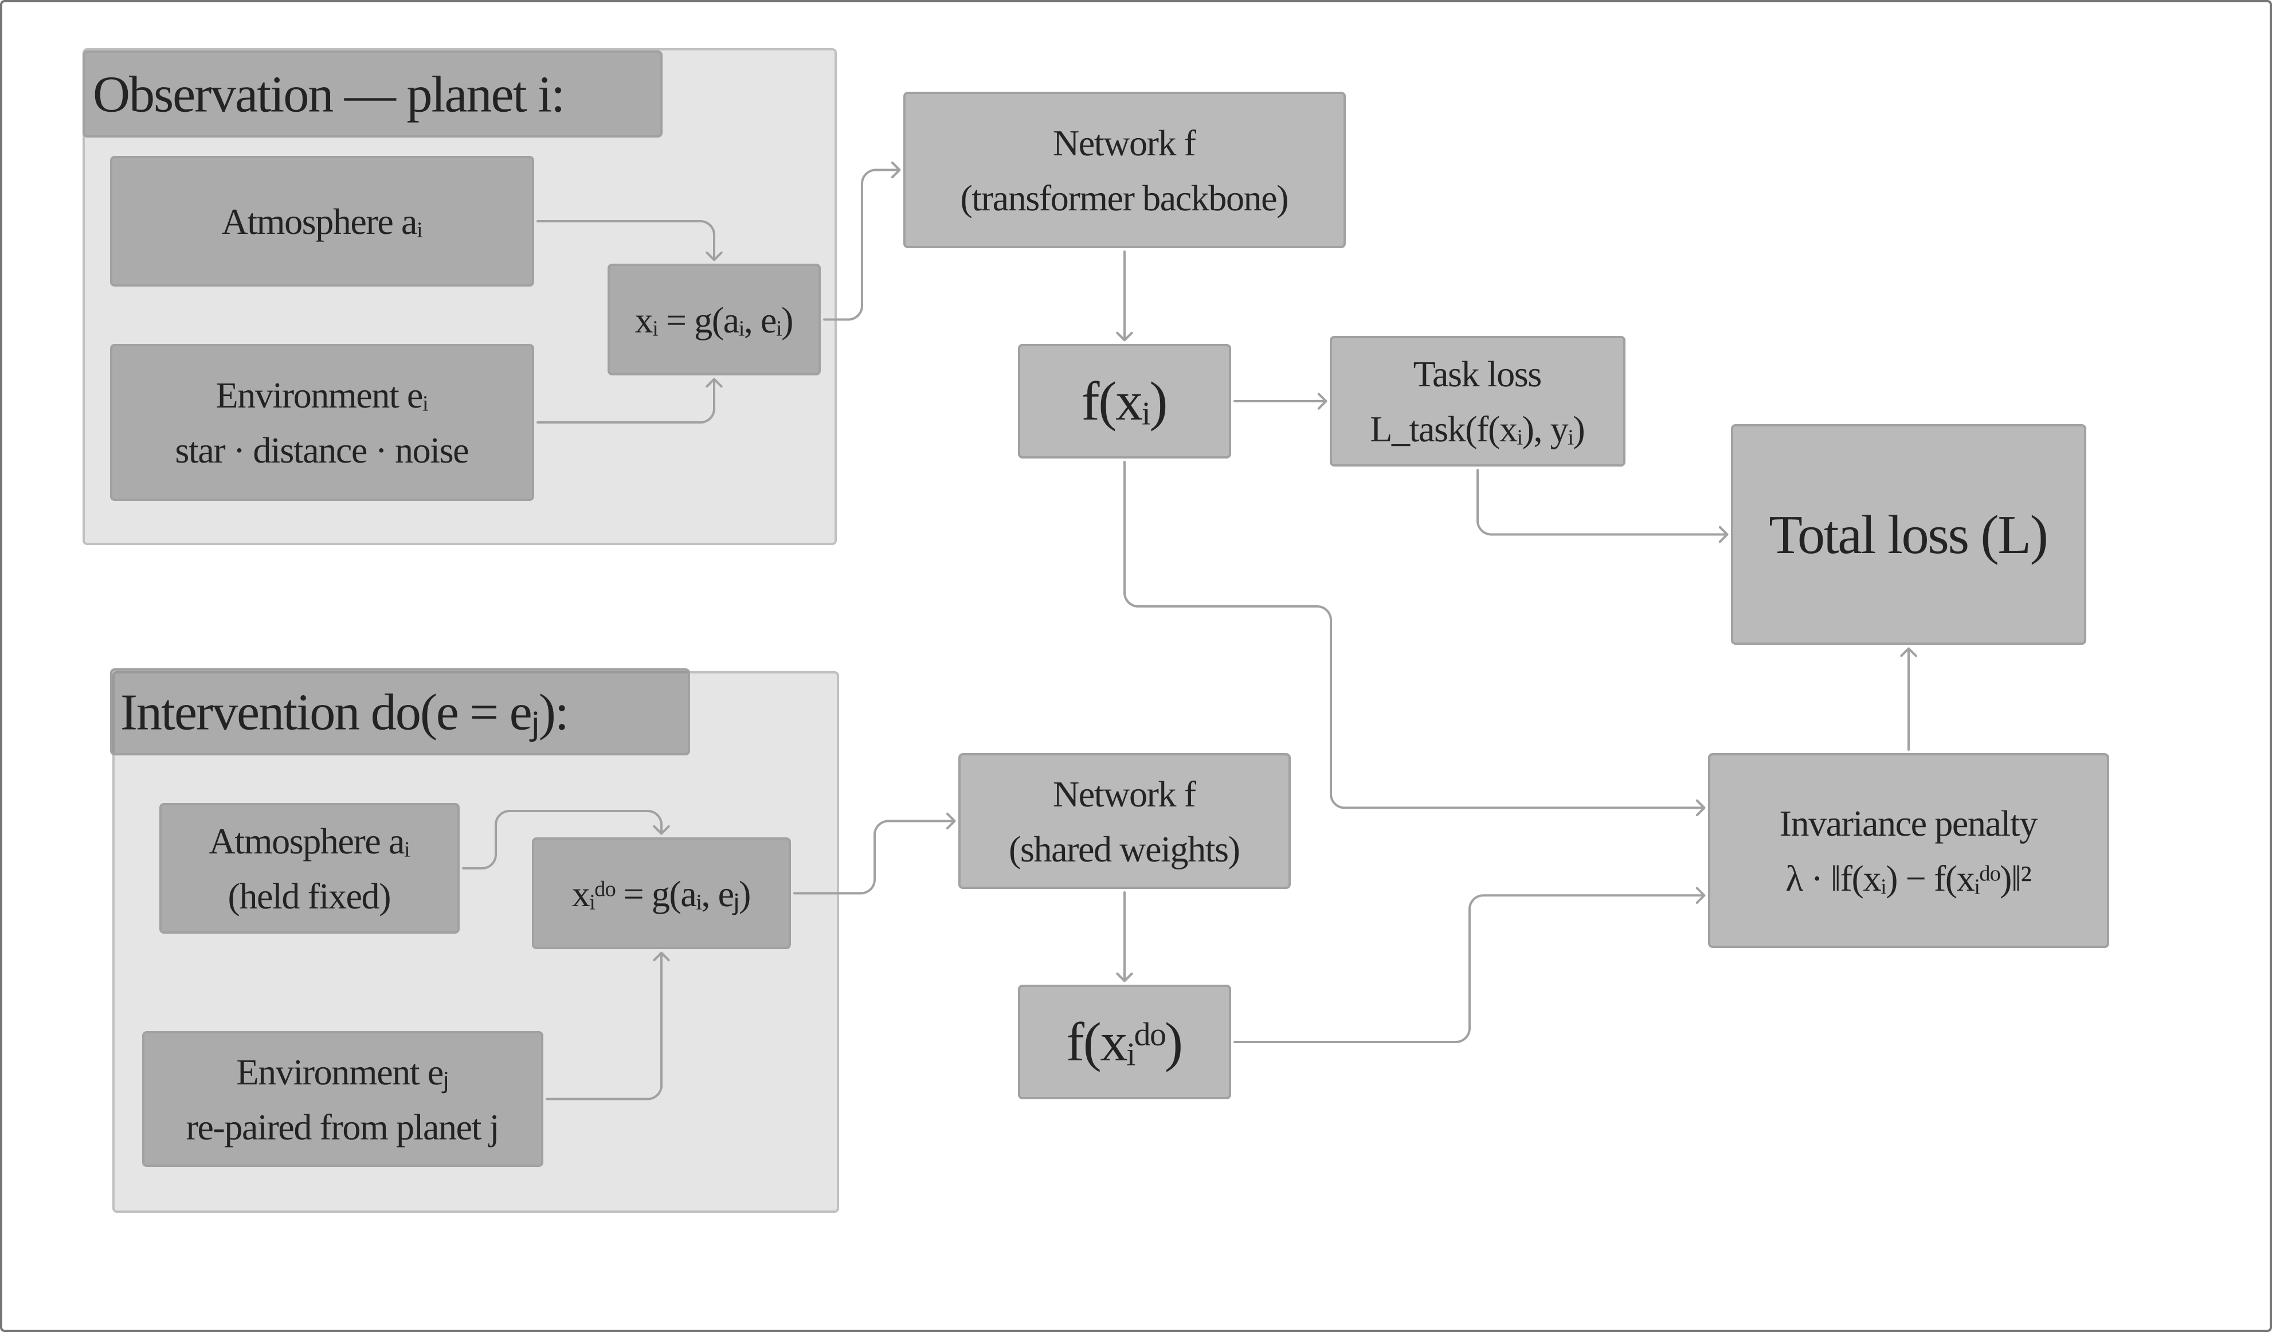
Counterfactual augmentation. The atmosphere of planet $i$ is re-paired with the observing environment of planet $j$ to form an interventional spectrum, and the shared network is penalised for any change in its prediction between the two.

4.5 Classical and physics baselines
To gauge what the networks add, we include three simulator-agnostic baselines, evaluated at $α=1$ on the full 12-species target: a prior-mean predictor (the training-set mean, ignoring the spectrum entirely), ridge regression, and a random forest, the latter two on features formed by average-pooling each channel to 64 wavelength bins. For the real-data methane test we also use a hand-built band-depth ruler, a one-parameter physics statistic that measures absorption depth in the $CH_{4}$ bands relative to the local continuum, with no learned parameters. The ruler is a deliberately transparent yardstick: if a network cannot beat it, the network has added nothing on that task.

4.6 Inference-time bias correction
Two corrections are applied to already-trained models, with no retraining. Let $x$ be a spectrum and $x_{c}$ its continuum twin, obtained by low-pass filtering away molecular absorption. The prior-driven offset is common to both, so subtracting the twin prediction cancels the per-body baseline while preserving the feature-driven response,
$${\hat{y}}_{null}=f(x)−f(x_{c}).$$
Separately, we stack the frozen architectures through a per-species ordinary-least-squares fit on one half of the synthetic validation set, scored on the other. Because the architectures make different errors, the stack is more stable than any single model.

4.7 Neural de-clouding
Clouds mute atmospheric absorption and degrade retrieval. A separate network $d$ of about 1M parameters reconstructs a pseudo-clear spectrum from a cloudy one, trained on grey (wavelength-independent) cloud pairs by $\min_{d}\left\|d(x_{cloudy})−x_{clear}\right\|$ and evaluated on held-out cloud morphologies (non-grey haze, band-selective, and Earth-like patchy clouds). We report it as a negative result (Section 5.10).

4.8 Uncertainty and metrics
We compare two uncertainty estimates: the spread of a small architecture ensemble, and split-conformal prediction, which calibrates per-species intervals on a held-out split to reach a target coverage by construction. Both are tested under spectral-resolution shift, and we introduce a resolution-conditioned conformal variant that recomputes quantiles at the target resolving power without retraining. Retrieval accuracy is the coefficient of determination $R^{2}$ in $\log_{10}$-VMR space, the space in which trace gases contribute proportionately; we also report RMSE and MAE in dex. Detection on real data uses the area under the ROC curve (AUROC) with 95% bootstrap confidence intervals over the test bodies. Every accuracy figure is quoted at the noiseless ceiling, at $α=1$, or both.

5 Results

5.1 Accuracy, model size, and the causal ablation
Accuracy does not increase with model size (Table 1, Figure 3). The 520k-parameter causal model reaches the highest ceiling ($R^{2}=0.781$), level with the 36M-parameter convolutional baseline ($0.779$) despite being roughly $70×$ smaller. What mattered was the input representation (dimensionless contrast plus an SNR channel) and the exposure-aware noise model, not the parameter count. On the identical 520k-parameter backbone, adding counterfactual augmentation raises the ceiling from $0.568$ (transformerarch) to $0.781$ (causal), a gain of $+0.213$ attributable to the training objective alone, since the two tracks share architecture, budget, and data. Enlarging the causal backbone did not help (causal_xl, $0.173$), consistent with the compact model already saturating the information available at this resolution.
Two caveats bound the ablation. It is measured at the noiseless ceiling and from single-seed runs. At the realistic single exposure, all architectures collapse toward a common photon-limited floor ($R^{2}​≈​0.05$ to $0.13$), where the ceiling gap is no longer resolvable, so the augmentation buys accuracy in the high-signal regime rather than rescuing a photon-starved observation. A per-gas linear stack of the six frozen models raises the ceiling to $0.849$ (Figure 4), above both the best single model ($0.777$) and a naive six-model mean ($0.637$). The apparent architecture ceiling near $0.78$ was therefore complementary error across models, not an information limit of the data.
Architecture comparison at the noiseless ceiling (covered-gas $R^{2}$, $\log_{10}$-VMR). causal and transformerarch share the same 520k backbone and differ only in training objective.
Model | Params | Ceiling | $α=1$
causal | 0.52M | 0.781 | 0.128
original1dcnn | 36M | 0.779 | –
optimized1dcnn | 1.2M | 0.728 | –
transformerarch | 0.52M | 0.568 | –
causal_xl | 2M | 0.173 | –
Per-gas stack (6 models) | – | 0.849 | –
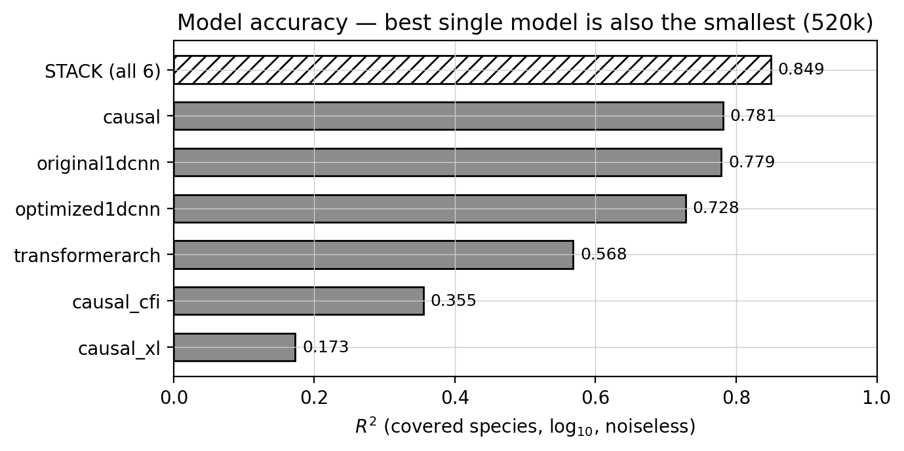
Accuracy across architectures at the noiseless ceiling: flat with respect to model size, with the compact causal model matching the 36M-parameter baseline.
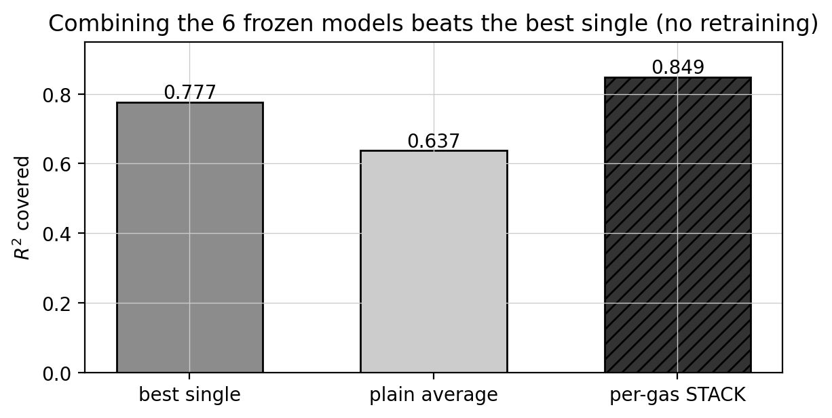
Per-gas linear stacking of frozen models beats the best single model and a naive average, indicating the ceiling was complementary error.

5.2 Exposure time and per-gas accuracy
Retrieval is photon-limited across the entire practical range (Table 2, Figure 5). At the realistic single exposure the covered-gas $R^{2}$ is only $0.13$, and the $0.78$ ceiling is approached only near ${10}^{4}×$ nominal exposure, far beyond any feasible integration. This is the clearest single illustration of the paper’s theme: the number that looks impressive (the ceiling) and the number that describes a real observation ($α=1$) differ by a factor of six, and only the latter predicts what a telescope would return.
Per-gas behaviour shows the same split (Table 3, Figure 6). Ceilings of $0.72$ to $0.86$ for the covered gases fall to $0.03$ to $0.33$ at $α=1$, with ozone the most resilient because its broad Chappuis band survives noise better than narrow features. Nitrogen has no reflected-light features, so no model retrieves it; its $R^{2}$ is negative at both operating points ($≈−0.06$), and we report that value rather than omit it, since an honest null is itself informative. The derived carbon-to-oxygen (C/O) ratio, an indicator of formation history, reaches $R^{2}=0.81$ at the ceiling (median error $0.05$ dex) but falls to $0.10$ at $α=1$, so a quantity often quoted as a headline product is essentially unconstrained at realistic exposure. Temperature and metallicity are not retrieval targets of the INARA data set and are not reported.
Covered-gas $R^{2}$ (causal) versus exposure factor. $α=1$ is the realistic single exposure; the ceiling is reached only at extreme integration.
$t_{exp}/t_{nom}$ | 0.09 | 1 | 9 | 100 | 900 | ${10}^{4}$ | $9×{10}^{4}$
$R^{2}$ | $−0.02$ | 0.13 | 0.35 | 0.56 | 0.70 | 0.79 | 0.83
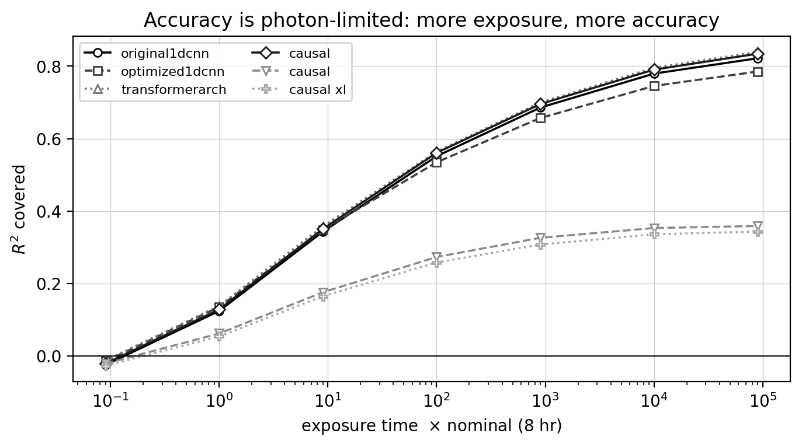
Accuracy versus exposure time: set by the photon budget rather than by the model across the practical range.
Per-gas accuracy (causal) at the noiseless ceiling and at $α=1$, with realistic-exposure RMSE. $N_{2}$ is spectrally invisible in this band.
Gas | Ceiling | $α=1$ | RMSE $α=1$ (dex)
$H_{2}O$ | 0.72 | 0.06 | 0.44
$CO_{2}$ | 0.73 | 0.03 | 0.36
$O_{2}$ | 0.80 | 0.12 | 0.36
$CH_{4}$ | 0.79 | 0.11 | 0.42
$O_{3}$ | 0.86 | 0.33 | 0.48
$N_{2}$ | $−0.06$ | $−0.06$ | –
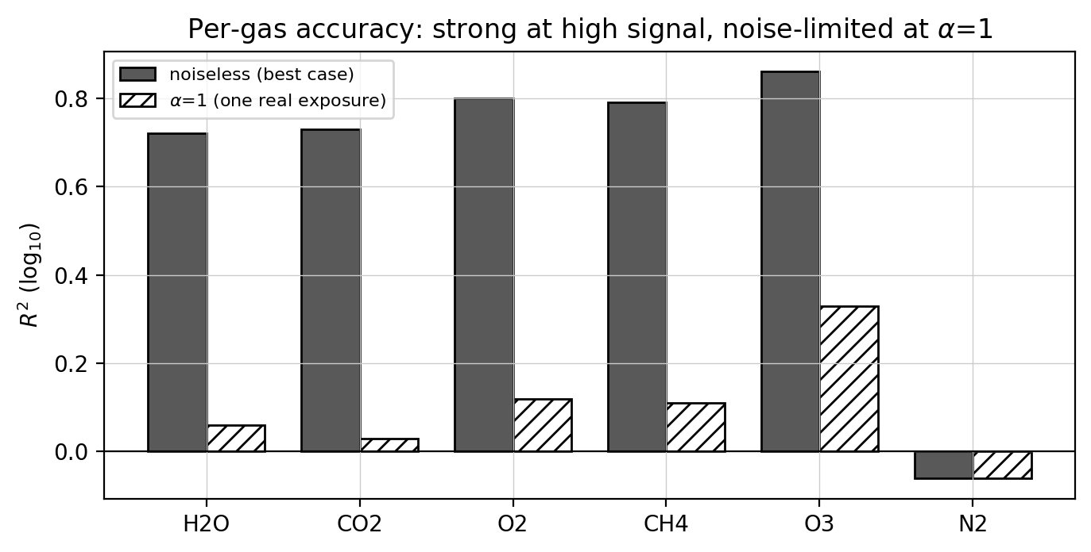
Per-gas accuracy at the two operating points. Ozone is the most exposure-robust species; nitrogen is unretrievable by construction.

5.3 Classical baselines
At the realistic single exposure the simulator-agnostic baselines set the bar the networks must clear (Table 4, Figure 7). The prior-mean predictor scores $R^{2}=−0.06$ on the 12-species target, so predicting the training mean alone carries no skill. Ridge regression and a random forest reach $0.03$ and $0.01$. The neural model reaches $0.13$ on covered gases at the same $α=1$, a genuine improvement over the classical methods, but a small absolute number that underlines how little quantitative information survives realistic photon noise. The gap between this and the ceiling is not a modelling deficiency to be engineered away; it is the photon budget.
Classical baselines at $α=1$ (12-species overall $R^{2}$, $\log_{10}$-VMR). The neural model reaches $0.13$ on covered gases at the same exposure.
Baseline | $R^{2}$ | RMSE (dex) | MAE (dex)
Prior mean | $−0.059$ | 0.474 | 0.325
Ridge | $0.031$ | 0.452 | 0.312
Random forest | $0.013$ | 0.456 | 0.314
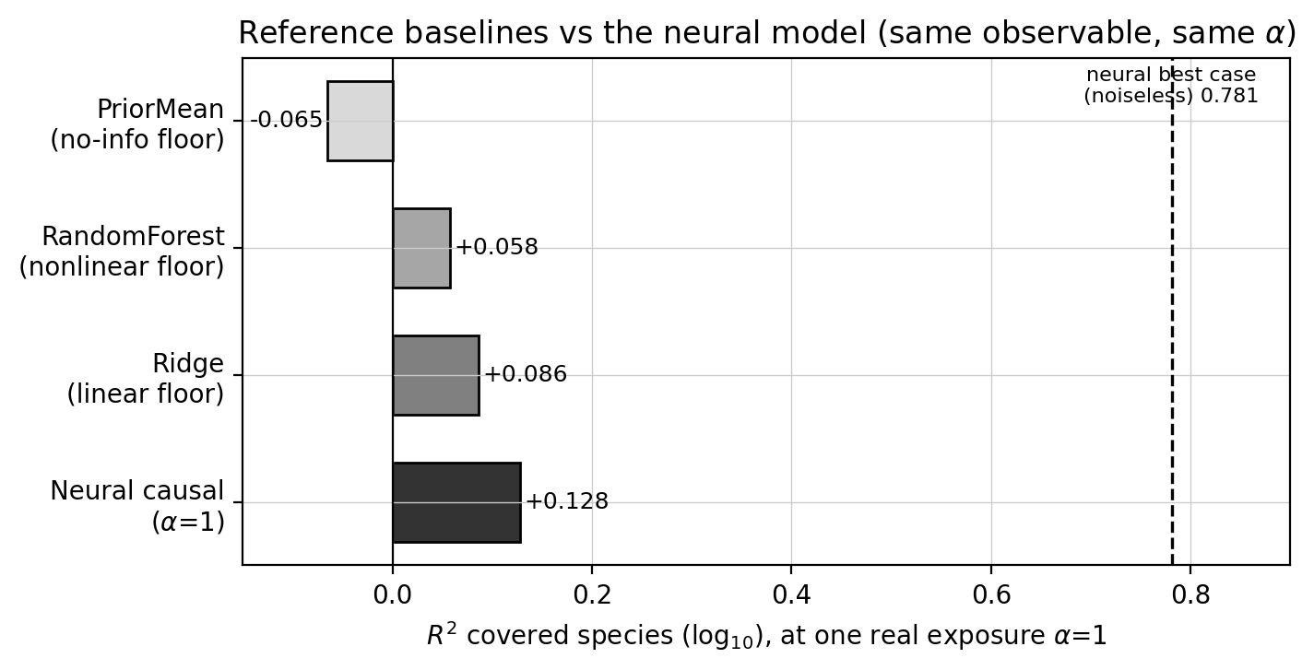
Neural retrieval versus classical baselines at $α=1$. The network adds value over ridge and random forest, but all three sit far below the ceiling.

5.4 Spectral resolution
Resolving power controls which gases are retrievable at all (Table [tab:resolution], Figure 8). Ozone retains $R^{2}=0.80$ down to $R=22$, whereas $CO_{2}$ degrades sharply below $R=200$ and cannot be recovered at $R=22$ even with affine recalibration: at that resolution the information is destroyed, not merely miscalibrated, and no post-hoc correction can restore it. Most other gases become recalibratable from about $R=50$. This has a direct real-data consequence. Venus and Mars are observed at $R​≈​22$ in the catalogue, so their retrieval failure is imposed by physics rather than by the model, and it would be a mistake to read their poor numbers as evidence about the network.
$R$ | $H_{2}O$ | $CO_{2}$ | $O_{2}$ | $CH_{4}$ | $O_{3}$
22 | $−0.24$ / $0.36$ | $−1.87$ / $0.11$ | $−0.15$ / $0.33$ | $0.32$ / $0.34$ | $0.27$ / $0.80$
50 | $0.48$ / $0.54$ | $−4.37$ / $0.09$ | $0.26$ / $0.53$ | $0.50$ / $0.56$ | $0.55$ / $0.85$
100 | $0.55$ / $0.61$ | $−1.82$ / $0.22$ | $0.53$ / $0.69$ | $0.64$ / $0.68$ | $0.67$ / $0.87$
200 | $0.64$ / $0.67$ | $0.39$ / $0.52$ | $0.71$ / $0.76$ | $0.74$ / $0.76$ | $0.76$ / $0.88$
400 | $0.60$ / $0.68$ | $0.68$ / $0.68$ | $0.78$ / $0.78$ | $0.79$ / $0.81$ | $0.81$ / $0.89$
870 | $0.59$ / $0.70$ | $0.70$ / $0.70$ | $0.80$ / $0.79$ | $0.80$ / $0.82$ | $0.83$ / $0.89$
native | $0.71$ / $0.74$ | $0.74$ / $0.74$ | $0.80$ / $0.84$ | $0.78$ / $0.83$ | $0.83$ / $0.89$
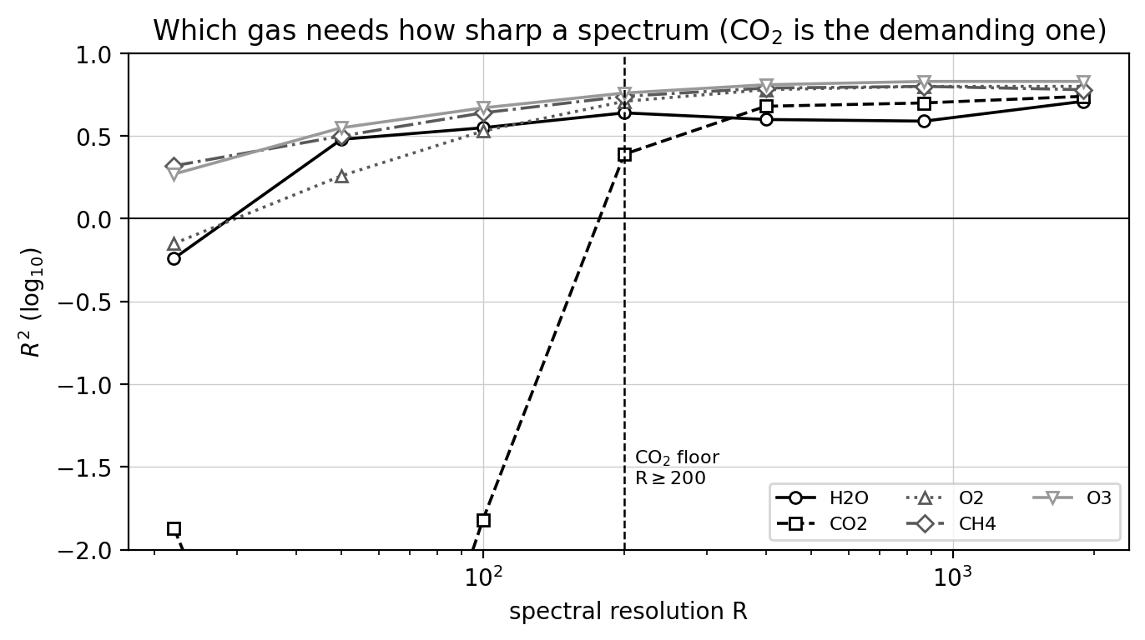
Accuracy versus resolving power. $CO_{2}$ needs $R​≥​200$; $O_{3}$ remains usable to $R=22$.

5.5 Cross-simulator generalisation
Applied without adaptation to spectra from a different forward model, every model loses accuracy (Table [tab:crosssim], Figure 9). This is expected. pRT and TauREx use different radiative-transfer engines and target regimes, and TauREx in particular is tuned for gaseous giants rather than the rocky atmospheres of INARA, so their spectral statistics differ from PSG. An attempt to train jointly across two such sets did not produce a shared improvement, because the differences are in the generators rather than in the underlying physics of any one planet. Adaptive Batch Normalisation, which re-estimates normalisation statistics on unlabelled target spectra with no retraining, removes most of the gap, and a light affine calibration brings it close to zero, which points to covariate shift rather than lost information. Among the models the causal track was the least affected. We do not read the near-zero adapted values as positive transfer; they represent graceful recovery, and cross-simulator generalisation remains an open problem.
Model | PSG (native) | TauREx | pRT | pRT + AdaBN | pRT + affine
causal | 0.781 | $−0.33$ | $−3.05$ | – | $∼$0
optimized1dcnn | 0.728 | $−0.27$ | $−3.74$ | $−0.16$ | $−0.04$
original1dcnn | 0.779 | $−0.37$ | $−5.56$ | – | $−0.03$
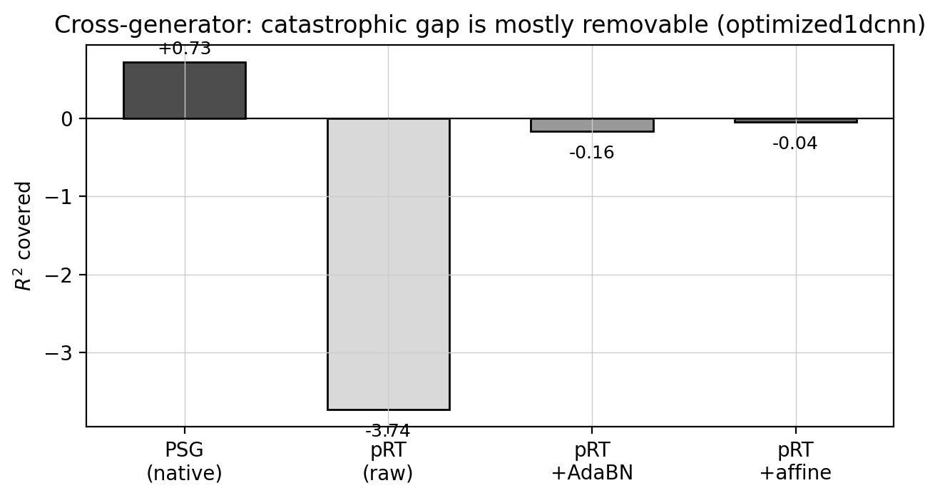
Cross-simulator accuracy before and after Adaptive Batch Normalisation. Most of the collapse is removable covariate shift.

5.6 Predictive uncertainty
Uncertainty estimates from the architecture ensemble are badly overconfident: empirical 68% coverage ranges from $0.08$ to $0.36$ against a $0.68$ target, so the ensemble spread cannot be trusted as an error bar. Split-conformal intervals are valid in-distribution (coverage $0.67$ to $0.71$, widths $0.13$ to $0.20$ dex), and these are the estimate we recommend. Both, however, break under resolution shift: at $R=22$ the nominal intervals collapse to $0.16$ to $0.41$ coverage, which the resolution-conditioned conformal variant repairs by widening the intervals appropriately (for $CO_{2}$, from $0.15$ to $0.58$ dex) with no retraining (Table 5, Figure 10). The lesson generalises: an uncertainty estimate is reliable only within the distribution on which it was calibrated, and a calibrated interval on synthetic data does not automatically transfer to a real observation at a different resolution.
Per-gas conformal intervals (causal): native width and 68% coverage, coverage under an uncorrected $R=22$ shift, and the width required for correct coverage there.
Gas | Width | Cov nat. | Cov $R=22$ | Req. width
$H_{2}O$ | 0.20 | 0.71 | 0.36 | 0.45
$CO_{2}$ | 0.15 | 0.71 | 0.20 | 0.58
$O_{2}$ | 0.13 | 0.67 | 0.26 | 0.37
$CH_{4}$ | 0.16 | 0.67 | 0.41 | 0.32
$O_{3}$ | 0.18 | 0.67 | 0.16 | 0.57
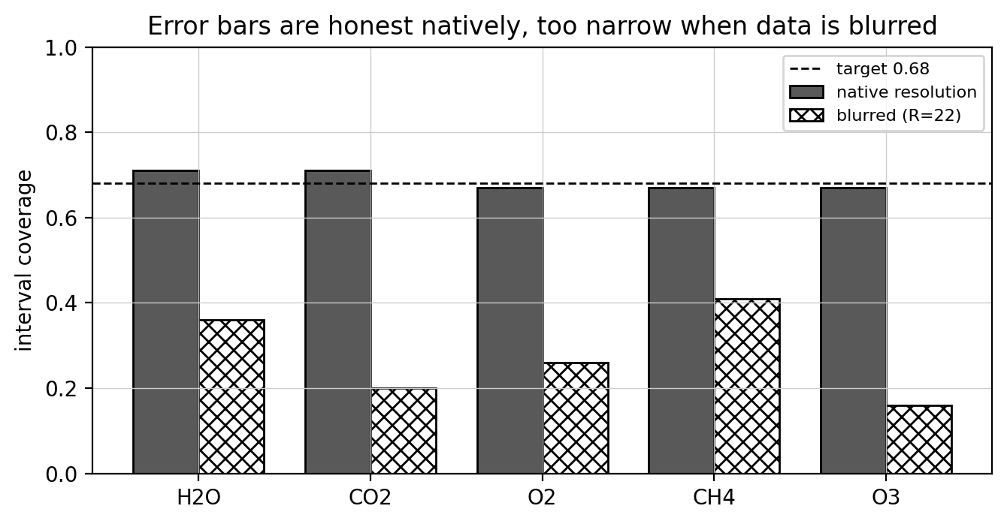
Coverage of predictive intervals. The ensemble is overconfident; split-conformal is calibrated in-distribution but must be resolution-conditioned under shift.

5.7 Comparison with Bayesian retrieval
The motivation for learned retrieval is cost, so the relevant baseline is Bayesian inference. A nested-sampling retrieval of a single spectrum typically requires 20000 to 60000 forward-model evaluations and hours of wall-clock time [9, 8], whereas the neural models here return a retrieval in a single sub-second forward pass, a speed-up of several orders of magnitude. The price of that speed is reliability. The network’s accuracy is bounded by its training distribution, and it fabricates oxygen on out-of-distribution inputs (Section 5.8) in a way a physics-based retrieval, which evaluates a forward model against the actual data, would not. Our findings are consistent with the literature on accuracy and calibration: Nixon & Madhusudhan [8] report that supervised models match nested-sampling estimates given enough training data, and Márquez-Neila et al. [4] obtain posteriors consistent with Bayesian retrieval but under-dispersed, the same under-dispersion we see in our ensemble and remedy with conformal intervals. A full nested-sampling retrieval on the same real spectra, matched to our forward model, is the natural next step and is beyond the present scope.

5.8 Real Solar-System spectra

5.8.0.1 Methane detection succeeds.
At matched resolution across bodies, four of the six architectures achieve $AUROC=1.00$ (95% bootstrap CI $[1.00,1.00]$) for separating methane-bearing atmospheres, such as Titan’s, from airless bodies; the remaining two score $0.88$ and $0.76$ (Figure 11). Two controls establish that this reflects genuine spectral evidence. First, an occlusion test: blanking the $CH_{4}$ absorption bands drops the AUROC to $0.88$, whereas blanking equally wide control bands leaves it at $1.00$, so the models are reading methane rather than an incidental correlate. Second, the hand-built band-depth ruler also scores $1.00$, so the networks match, but do not exceed, a transparent one-parameter physics statistic on this task. One caveat is statistical: the positive class contains few bodies, so an AUROC of $1.00$ certifies clean separation on this sample rather than a tight population estimate.
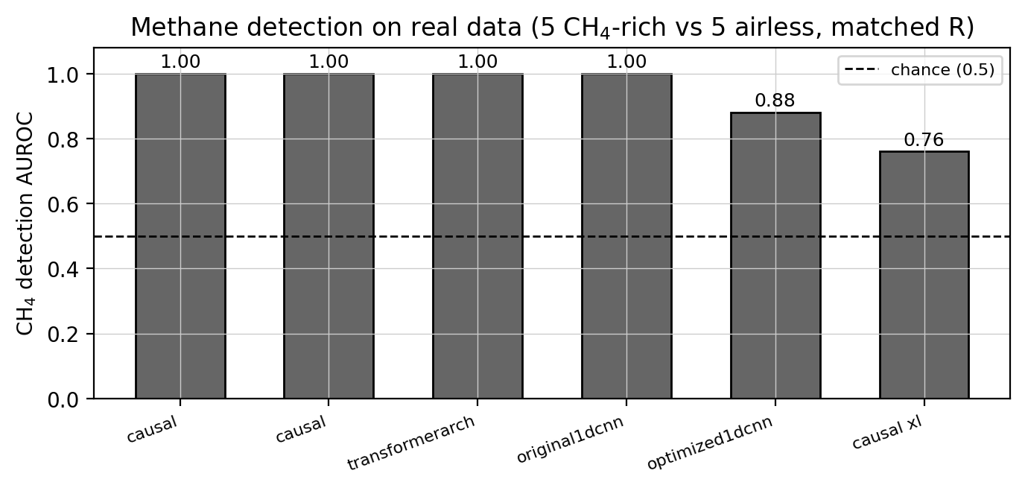
Methane detection on real spectra at matched resolution. Four of six models, together with a physics ruler, separate methane-bearing from airless bodies perfectly.

5.8.0.2 Oxygen detection fails.
Every model assigns substantial oxygen (about 30 to 46% predicted VMR) to airless bodies. In the cleanest test, the matched Earth/Moon pair observed on the same night with the same instrument at the same resolution, five of six models give the airless Moon more oxygen than Earth (Table 6), inverting the one contrast that matters for a biosignature. The cause is not architecture but the training label prior: the INARA library has a mean $O_{2}$ VMR near $0.30$, and on any unfamiliar input the models recite it. Earth’s true $O_{2}$ A-band is not even measurable in this catalogue, so there is no feature to override the prior (Figures 12, 13). A model can thus pass its synthetic benchmark and still report the single most important biosignature on bare rock.

5.8.0.3 The whole catalogue tells the same story.
Table [tab:perbody] lists the per-body retrievals for the causal model. Among the bodies where retrieval is physically possible ($R​≥​400$), the dominant gas is rarely correct, and every airless body is assigned a combined $O_{2}$+$O_{3}$ abundance comparable to or above Earth’s. The giants, whose real atmospheres are hydrogen and helium and lie entirely outside the training distribution, are labelled oxygen- or carbon-dioxide-dominant. Venus is nominally correct ($CO_{2}$-dominant), but this is a stopped clock rather than a success: it is observed at $R=22$, below the usable threshold, and the same model calls many airless rocks $CO_{2}$-dominant, so the one right answer comes from the prior, not from the spectrum. The airless bodies are what expose this, which is exactly why they are in the set.
Body | Class | $R$ | Usable | True dominant | Predicted | Pred. $O_{2}$+$O_{3}$
Earth | terrestrial | 867 | yes | $N_{2}$ ($O_{2}$-rich) | $O_{2}$ | 0.41
Venus | terrestrial | 22 | no | $CO_{2}$ | $CO_{2}$* | 0.18
Mars | terrestrial | 22 | no | $CO_{2}$ | $O_{2}$ | 0.41
Titan | terrestrial | 829 | yes | $N_{2}$ | $CO_{2}$ | 0.33
Jupiter | giant | 865 | yes | $H_{2}/He$ | $O_{2}$ | 0.31
Saturn | giant | 867 | yes | $H_{2}/He$ | $O_{2}$ | 0.38
Uranus | giant | 867 | yes | $H_{2}/He$ | $O_{2}$ | 0.32
Neptune | giant | 867 | yes | $H_{2}/He$ | $CO_{2}$ | 0.32
Moon | airless | 867 | yes | none | $O_{2}$ | 0.45
Mercury | airless | 43 | no | none | $O_{2}$ | 0.46
Enceladus | airless | 526 | yes | none | $CO_{2}$ | 0.15
Dione | airless | 829 | yes | none | $CO_{2}$ | 0.26
Rhea | airless | 866 | yes | none | $CO_{2}$ | 0.31
Ceres | airless | 866 | yes | none | $O_{2}$ | 0.42
Io | airless | 12 | no | none | $O_{2}$ | 0.39
Europa | airless | 25 | no | none | $CO_{2}$ | 0.33
Ganymede | airless | 31 | no | none | $CO_{2}$ | 0.29
Callisto | airless | 21 | no | none | $O_{2}$ | 0.41
Pluto | airless | 100 | no | none | $CO_{2}$ | 0.31
Predicted $O_{2}$ on the matched Earth/Moon pair (same night, instrument, and resolution; true Earth $O_{2}$$=0.21$, Moon$=0.00$). Five of six models give the airless Moon more oxygen than Earth.
Model | Earth | Moon | Earth$−$Moon
original1dcnn | 0.455 | 0.461 | $−0.006$
optimized1dcnn | 0.517 | 0.536 | $−0.019$
transformerarch | 0.392 | 0.465 | $−0.073$
causal | 0.404 | 0.446 | $−0.043$
causal_cfi | 0.312 | 0.305 | $+0.007$
causal_xl | 0.311 | 0.313 | $−0.002$
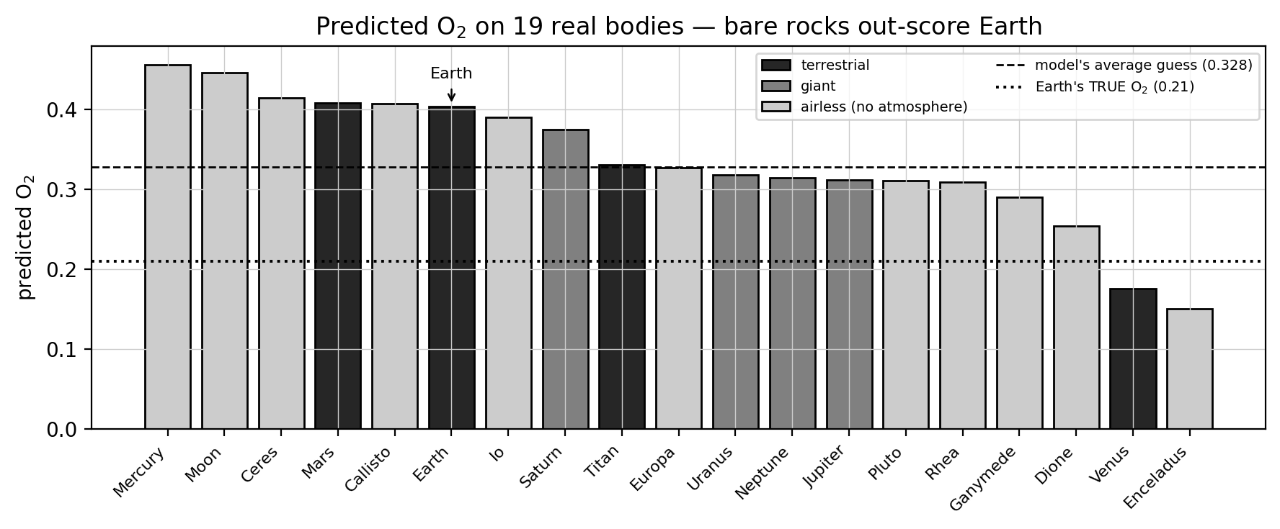
Fabricated oxygen. Airless bodies are assigned oxygen abundances at or above Earth’s, driven by the training-set label prior.
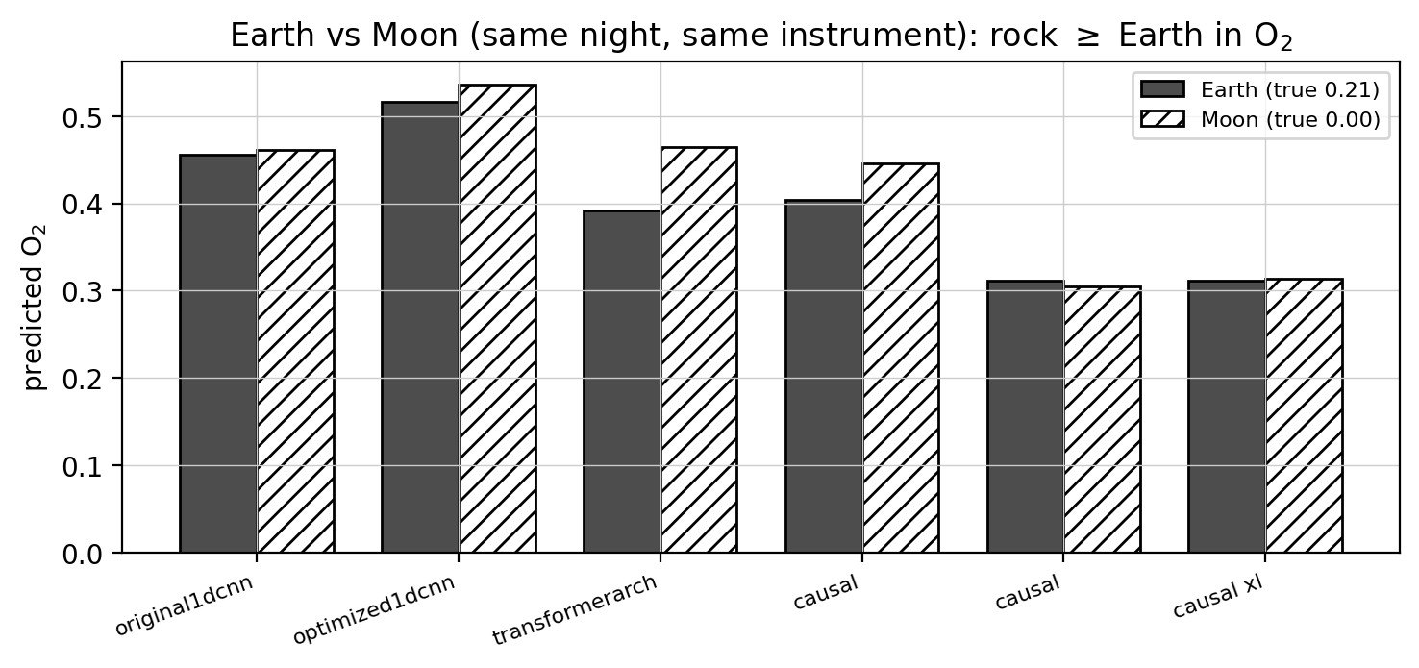
The matched Earth/Moon control. Most models fail to give Earth more oxygen than its airless companion.

5.9 Inference-time correction
Continuum-twin nulling suppresses the fabrication without retraining (Table 7, Figure 14). Subtracting the featureless-twin prediction shrinks the mean fabricated abundances on airless bodies by a factor of 20 to 80 ($O_{2}$: $0.341$ to $0.016$; $CO_{2}$: $0.351$ to $0.013$), raises the Earth-versus-rock $O_{2}$ AUROC from $0.64$ to $0.91$, and leaves methane detection nearly intact ($1.00$ to $0.92$). The correction removes the prior-driven baseline while preserving the feature-driven signal, and it needs no labels, so it can be applied to any frozen model. It is a mitigation, not a cure: the underlying model still encodes the biased prior, and the correction only cancels its effect at the point of use.
Continuum-twin nulling on airless bodies (causal). Fabricated abundances collapse, while methane survives.
Quantity | Raw | Nulled
Mean $|$$O_{2}$$|$ on rocks | 0.341 | 0.016
Mean $|$$CO_{2}$$|$ on rocks | 0.351 | 0.013
$O_{2}$ AUROC (Earth vs. rock) | 0.64 | 0.91
$CH_{4}$ AUROC | 1.00 | 0.92
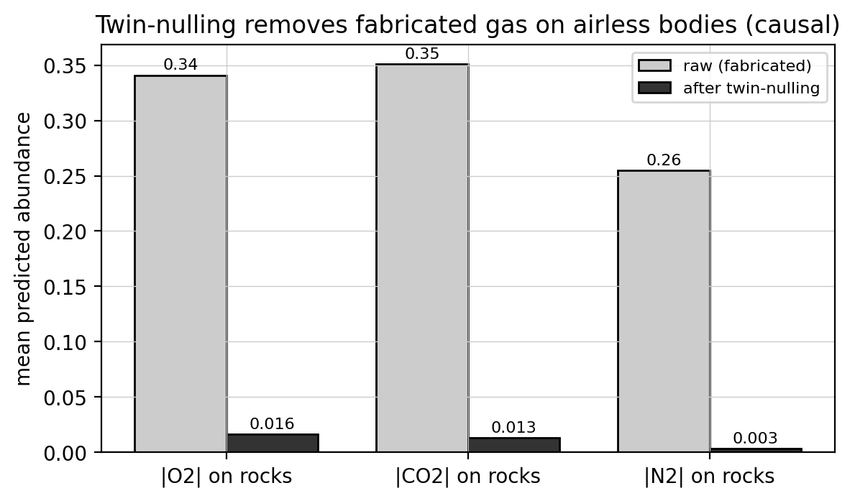
Continuum-twin nulling: prior-driven fabrication cancels per body while genuine absorption survives.

5.10 Neural de-clouding: a negative result
The de-clouding module recovers 24 to 46% of the accuracy lost to cloud contamination, and it does so for held-out cloud morphologies it never saw in training (Figure 15), which is encouraging in isolation. As a usable component, however, it failed. It is not identity-safe: applied to genuinely clear spectra it degrades accuracy, because it assumes clouds are present and removes structure that is real, so it cannot be left always-on. Its training clouds were parametric rather than physical, so the reconstructions did not match the statistics of observed cloudy spectra, and, separately, folding cloud contamination directly into retrieval training reduced accuracy rather than improving robustness. We report the module as a negative result and keep cloud removal separate from retrieval, applied only to spectra already known to be cloudy.
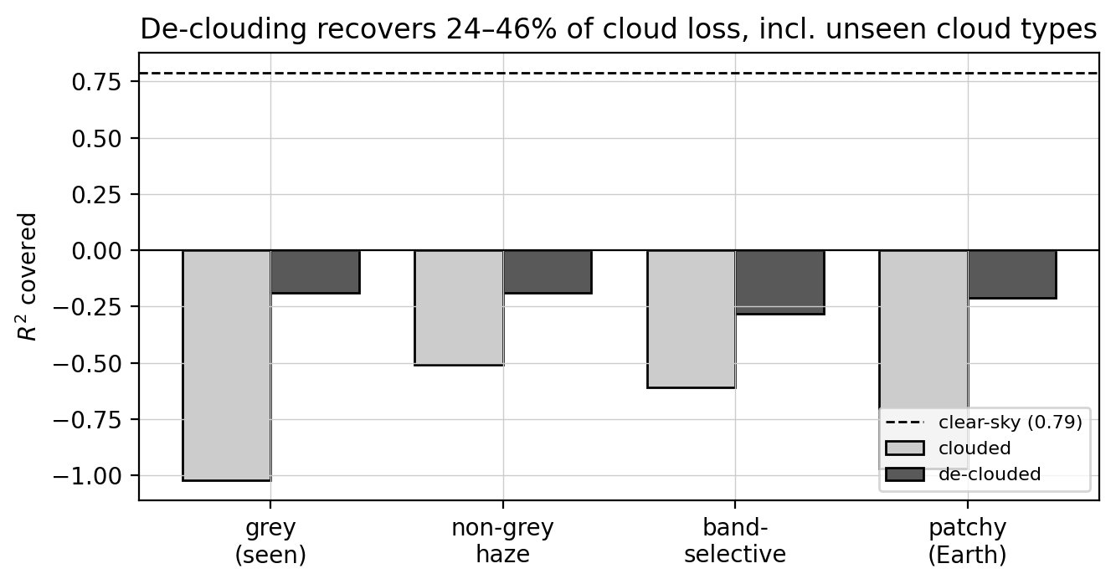
De-clouding under seen (grey) and unseen cloud families. Accuracy is partially recovered, but the module must not be applied to clear spectra.

6 Discussion
The results are best read as a catalogue of the limitations of learned retrieval, and of the controls that make those limitations visible.

6.0.0.1 Model size is not the lever.
Increasing capacity did not improve accuracy: a 520k-parameter model matched a 36M-parameter one at the ceiling, and enlarging the causal backbone hurt. What mattered was the input representation and the training objective. Compact models are therefore preferable, being cheaper to train, to audit, and to deploy, and effort is better spent on inputs, objectives, and calibration than on scale. The causal augmentation gives the best ceiling and robustness in our study, but the $+0.213$ gain is single-seed and measured at the noiseless ceiling; at realistic exposures all architectures converge to a photon-limited floor, so the augmentation buys accuracy only where signal-to-noise is high.

6.0.0.2 Physics is a hard baseline on real data.
The one task the models reliably perform on real spectra, methane detection, is matched by a one-parameter band-depth ruler. For a single strong feature at high resolution, transparent physics is competitive, and it should be the baseline any learned method is measured against. The network’s advantage is expected where the ruler cannot easily go, in multi-gas joint retrieval, at lower resolution and lower signal-to-noise, and in breaking degeneracies among correlated species. We have characterised those regimes on synthetic data, but cannot yet demonstrate the advantage on real spectra for want of suitable observations, and establishing it is a defining goal for follow-up work.

6.0.0.3 Metrics must be read with physics.
The oxygen result is the clearest warning. A model that fabricates the most important biosignature on airless rock can still post a respectable aggregate $R^{2}$, because that metric rewards reproducing the label distribution. Reliability requires pairing statistical performance with physical controls, the airless-body false-positive test, the occlusion check, and continuum nulling, and with honest uncertainty that, as we show, holds only in-distribution. Much of the contribution of this paper is this evaluation methodology rather than any single accuracy number, and the controls are inexpensive: they reuse frozen models and require no new training.

6.0.0.4 The gap to real observations is wider than the cross-simulator gap.
The cross-simulator collapse proved to be mostly removable covariate shift, correctable by Adaptive Batch Normalisation without retraining, though a physics residual remains. This is encouraging for transfer between simulators, but it does not close the gap to real observations, whose domain shift also includes instrumental systematics, viewing geometry, and cloud that no simulator contains. The albedo-to-contrast conversion we use is itself an assumption; our detection results are designed to be insensitive to it, but quantitative real-data retrieval will require forward-modelling the observing conditions explicitly.

6.0.0.5 Recommendations.
For practitioners we draw three practical points. Report accuracy at a realistic exposure, not only at a noiseless ceiling, and state the assumed integration with every number. Include a false-positive control, ideally airless bodies or otherwise featureless inputs, so that prior-driven fabrication is caught before it is reported as a detection. And treat uncertainty as valid only where it was calibrated, re-conditioning it under any shift in resolution or noise. None of these require larger models or more training.

6.0.0.6 Limitations.
Several caveats bound our own conclusions. The architecture and ablation numbers are single-seed, and at the shared budget some tracks are undertrained, so the ceiling gaps should be confirmed with multiple seeds at full budget. The real-data sample is small, 19 bodies with few of them methane-bearing, so the detection AUROCs certify separation on this sample rather than a population estimate. The cloud model is a parametric approximation, not observed cloud physics. And we compare against Bayesian retrieval on cost and on published accuracy, not yet by running nested sampling on the same real spectra. None of these change the central, qualitative finding: synthetic accuracy overstates real-world reliability, and physical controls are needed to detect the difference.

7 Conclusion
We evaluated a family of six neural reflected-light retrieval models not only on held-out synthetic spectra but on real telescope observations of 19 Solar-System bodies, reporting accuracy at both a noiseless ceiling and a realistic single exposure. The two differ by a factor of six, model size does not help, cross-simulator transfer degrades, and the models fabricate oxygen on airless bodies while detecting methane no better than a one-parameter physics ruler. A compact counterfactually-augmented model achieves the best accuracy ceiling while remaining far smaller than a conventional convolutional network, and a per-gas ensemble of frozen models raises the ceiling further; continuum-twin nulling suppresses the oxygen fabrication at inference time, without retraining and while methane survives. The broader message is one of limitation rather than triumph: machine-learning retrievals should be judged against physics and real observations, with calibrated uncertainty, not against synthetic accuracy alone. Running full Bayesian retrievals on the same real spectra, and confirming the architecture and causal-augmentation effects across seeds and exposures, are the priorities for future work.

Data and code availability
The synthetic library derives from INARA/PSG [13, 12], and the real-data catalogue is the public Solar-System reflectance set of Madden & Kaltenegger [14]. All results were obtained from frozen model checkpoints without retraining.

References
[1] Gilbert-Janizek, B., et al. (2024). Reflected-light characterisation of habitable-zone planets with future direct-imaging missions.
[2] Damiano, M., & Hu, R. (2020). Reflected-light spectroscopy retrievals of terrestrial exoplanets. AJ, 159, 175.
[3] Waldmann, I. P. (2016). Dreaming of atmospheres. ApJ, 820, 107.
[4] Márquez-Neila, P., Fisher, C., Sznitman, R., & Heng, K. (2018). Supervised machine learning for analysing spectra of exoplanetary atmospheres. Nature Astronomy, 2, 719.
[5] Soboczenski, F., et al. (2018). Bayesian deep learning for exoplanet atmospheric retrieval. NeurIPS Workshop on Bayesian Deep Learning.
[6] Zingales, T., & Waldmann, I. P. (2018). ExoGAN: retrieving exoplanetary atmospheres using deep convolutional generative adversarial networks. AJ, 156, 268.
[7] Cobb, A. D., et al. (2019). An ensemble of Bayesian neural networks for exoplanetary atmospheric retrieval. AJ, 158, 33.
[8] Nixon, M. C., & Madhusudhan, N. (2020). Assessment of supervised machine learning for atmospheric retrieval of exoplanets. MNRAS, 496, 269.
[9] Ardévol Martínez, F., Min, M., Kamp, I., & Palmer, P. I. (2022). Convolutional neural networks as an alternative to Bayesian retrievals for interpreting exoplanet transmission spectra. A&A, 662, A9.
[10] Vasist, M., et al. (2023). Neural posterior estimation for exoplanetary atmospheric retrieval. A&A, 672, A147.
[11] Aubin, M., et al. (2023). Simulation-based inference for exoplanet atmospheric retrieval: winning the Ariel Data Challenge 2023 with normalizing flows. NeurIPS ML4PS / ECML-PKDD.
[12] Villanueva, G. L., et al. (2018). Planetary Spectrum Generator. JQSRT, 217, 86.
[13] Zorzan, et al. (2025). INARA: a machine-learning-ready data set of synthetic reflected-light spectra for rocky exoplanets.
[14] Madden, J. H., & Kaltenegger, L. (2018). A catalog of Solar-System reflectance spectra for use as exoplanet analogues. Astrobiology, 18(12), 1559.

