 

**Placement Empowerment Program**

***Cloud Computing and DevOps Centre***

**Use Cloud Storage**

Create a storage bucket on your cloud platform and upload/download files. Configure access permissions for the bucket.

**Name: AAKASH RAMADURAI B Department : MECHANICAL ENGINEERING**



**Introduction and Overview**

In this project, we’ll use **AWS S3 (Simple Storage Service)** to learn how it works as a secure and reliable cloud storage solution. Here’s what we’ll do:

1. **Create an S3 Bucket**: Set up a storage space in the cloud.

2. **Upload and Download Files**: Add files to the bucket and retrieve them.

3. **Manage Access**: Control who can view or edit the files using permissions.

4. **Test Public Access**: Create public links for files and test access.

5. **Set Bucket Policies**: Define rules to manage file access and security.

By the end, you’ll understand S3’s key features like **scalability, security**, and **cost-efficiency**, and gain hands-on experience with cloud storage.

**Objective**

The goal of this project is to:

1. **Learn S3 Basics**: Create and manage an S3 bucket for cloud storage.

2. **Work with Files**: Practice uploading, downloading, and organizing files in the bucket.

3. **Control Access**: Set permissions and policies to manage who can access the data securely or publicly.

**Importance of Storage Bucket(S3)**

**Foundation for Advanced Use Cases**: Learning S3 is a key step to mastering cloud computing and building large-scale apps.

**Hands-On Learning of Cloud Storage**: AWS  S3 lets you practice creating buckets, uploading/downloading files, and managing data efficiently.

**Data Security and Access Control**: Set permissions and policies to control who can access your data, keeping it safe.

**Step-by-Step Overview**

Step1:

Go to the AWS Management Console, Search for and click on S3

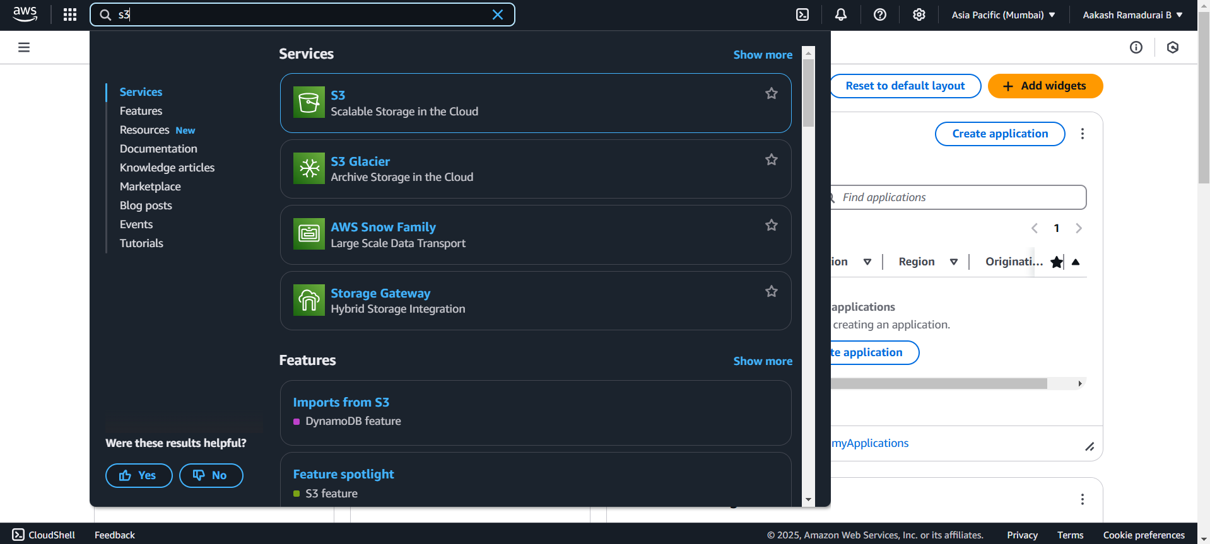

Step 2 :

Click the "Create bucket" button.

Enter a unique bucket name (e.g., my-storage-bucket-123).

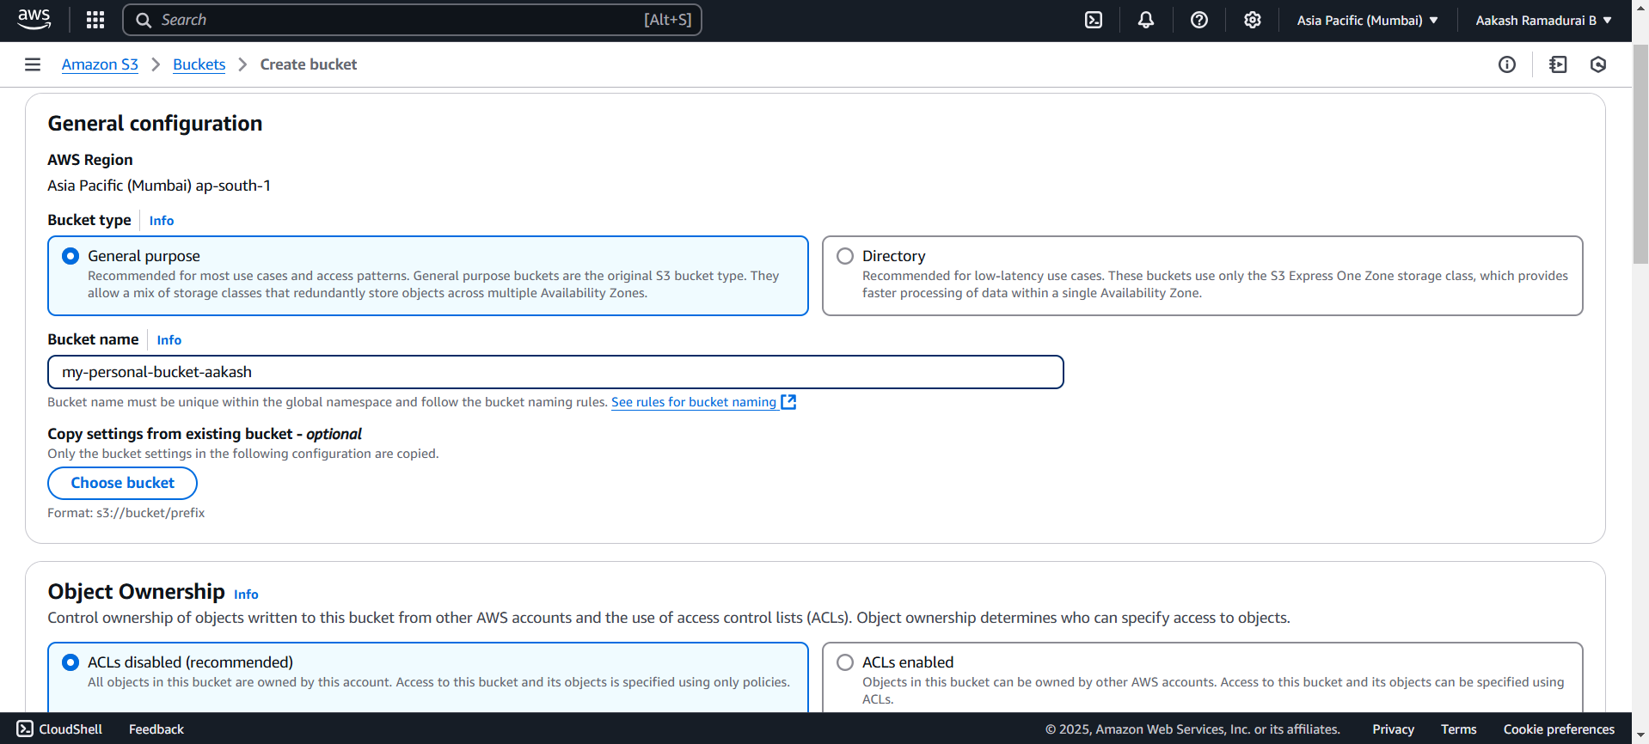

Step 3 :

"Block all public access" disabled and acknowledge.

Step 4 :

Click "Create bucket".

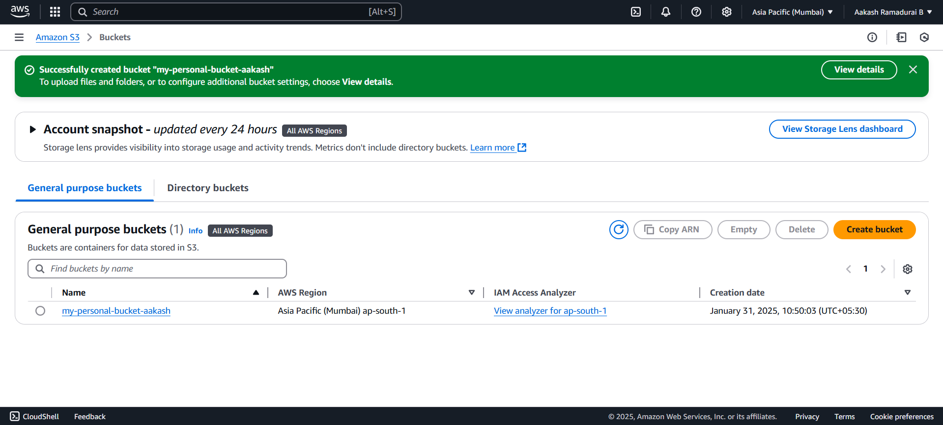

Step 5 :

Open your newly created bucket from the S3 console.

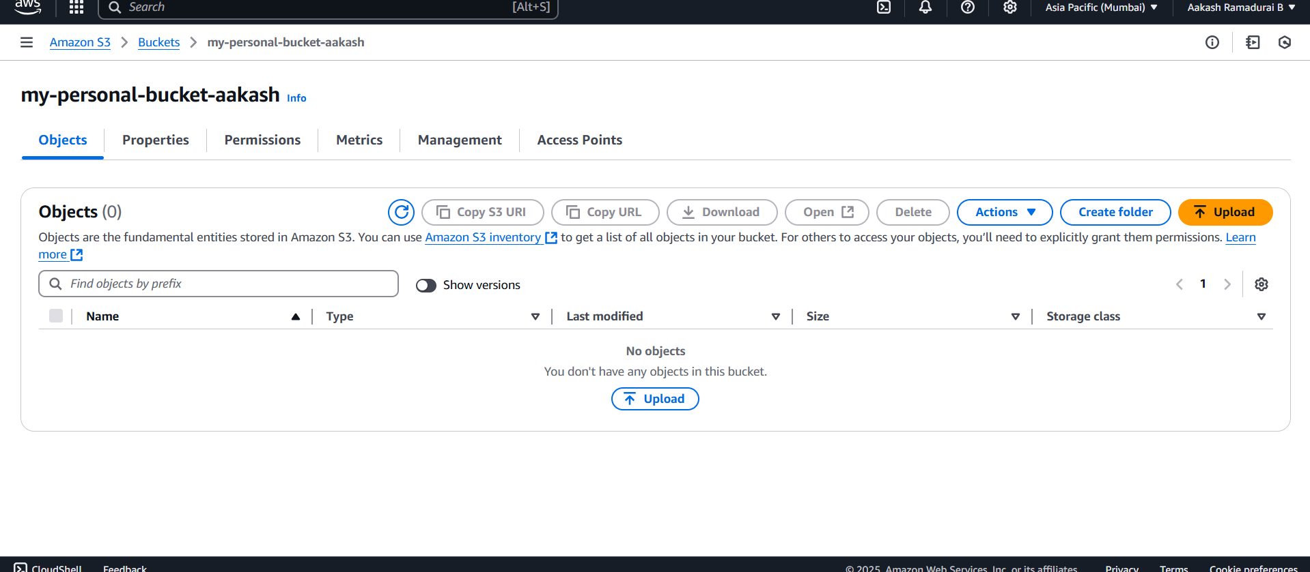

Step 6 :

Click "Upload" and then,

Drag and drop your file(s) or use the Add files button.Click Upload to complete. 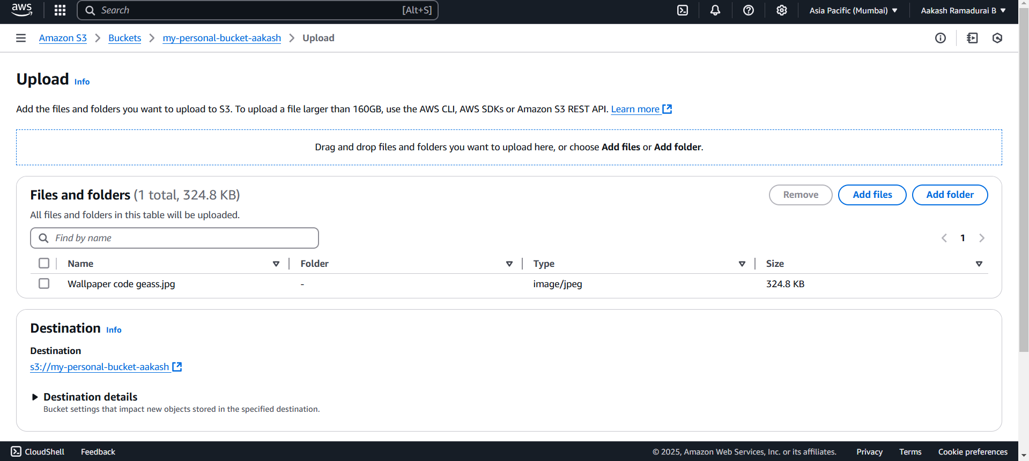

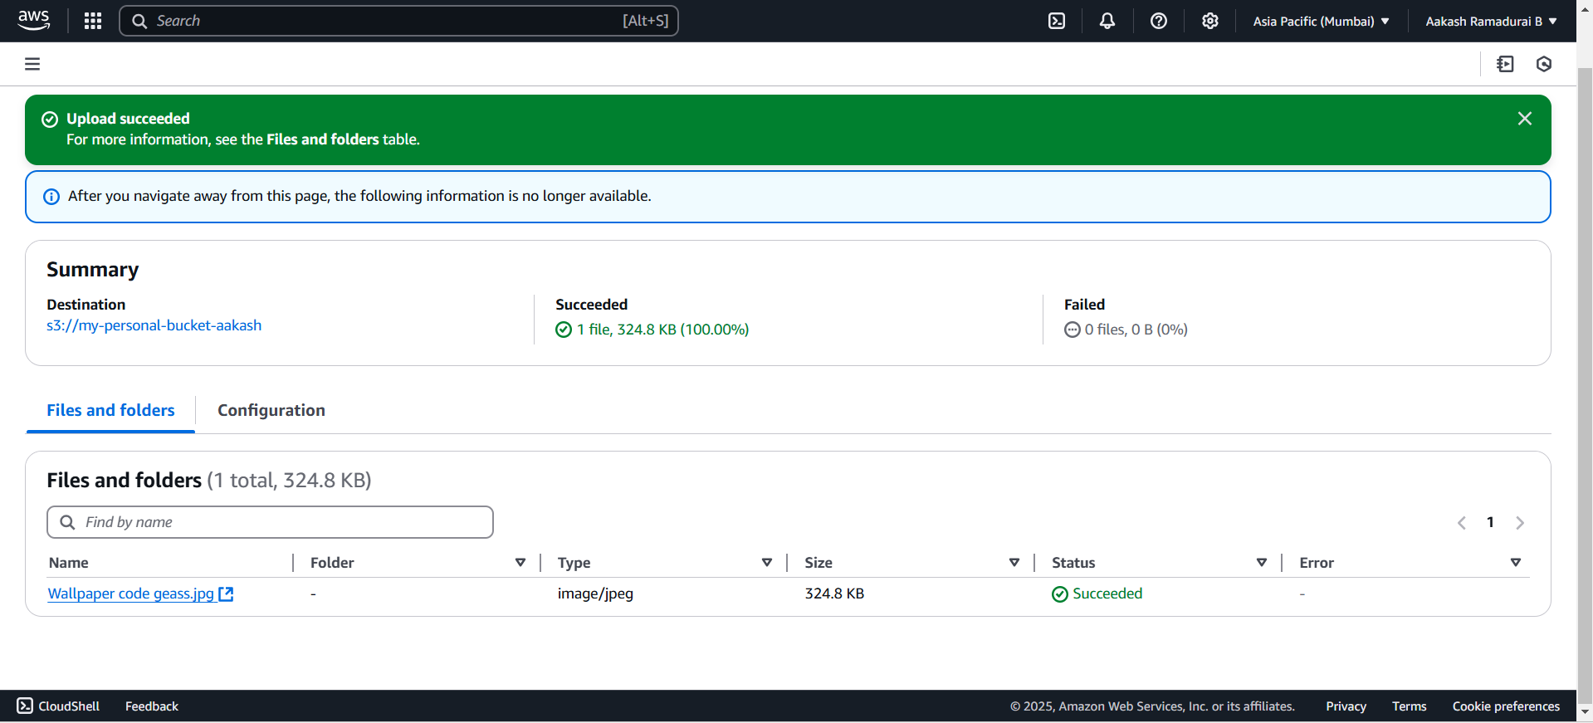

Step 7 :

Go to the uploaded file in your bucket. Click the file name to open its details. Select Download to save the file locally.

Step 8 :

Open your bucket and navigate to the "Permissions" tab.

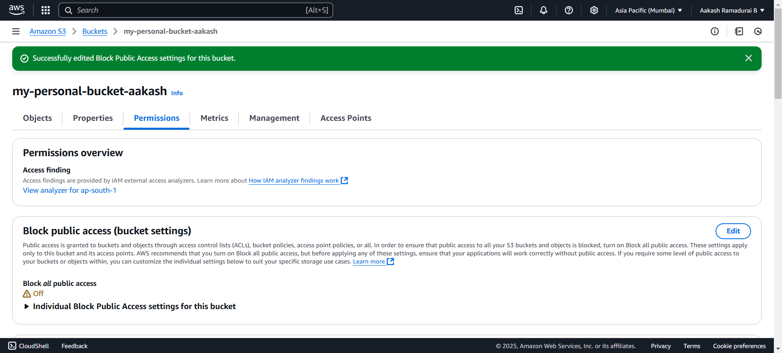

Step 9 :

In the "Permissions" tab, scroll to Bucket Policy and click Edit.Replace your-bucket-name with your actual bucket name.Save changes.

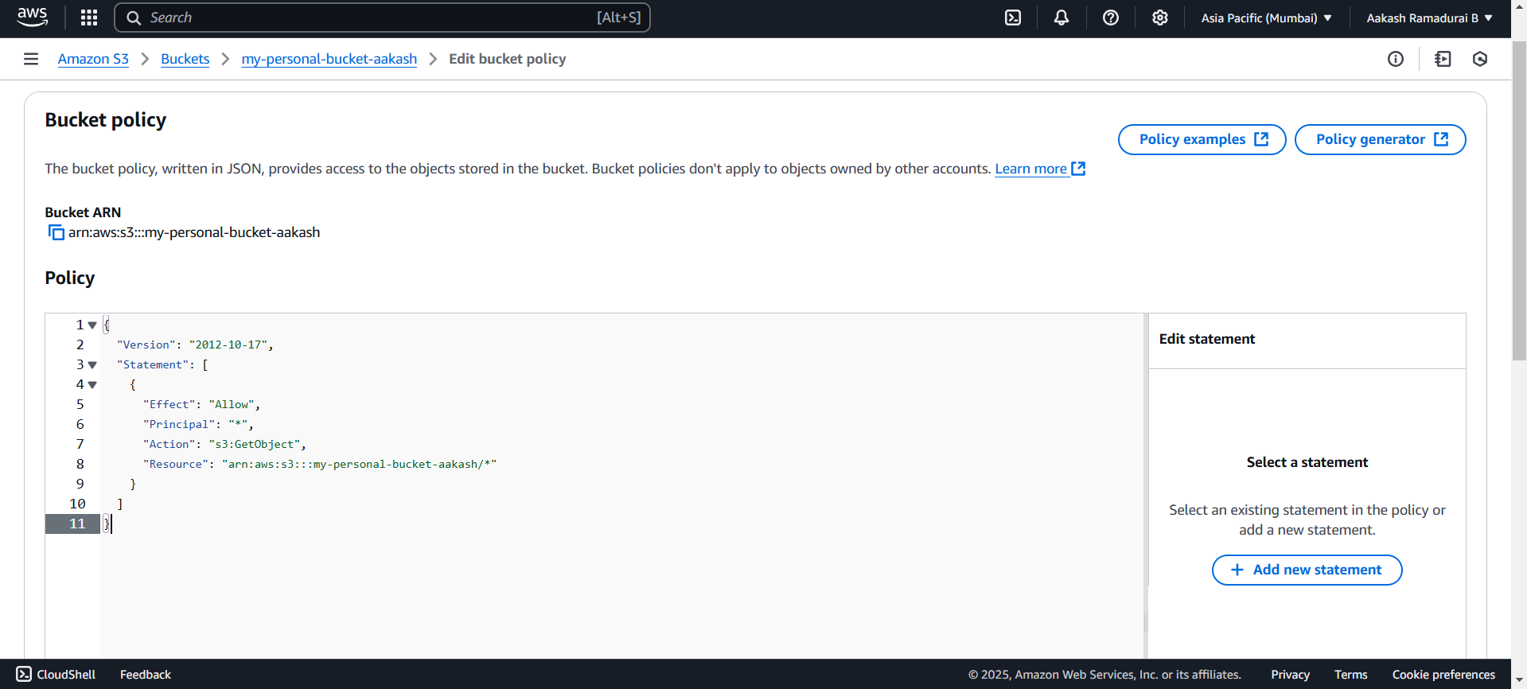

Step10:

Use the S3 bucket URL or public file URL to test access permissions.

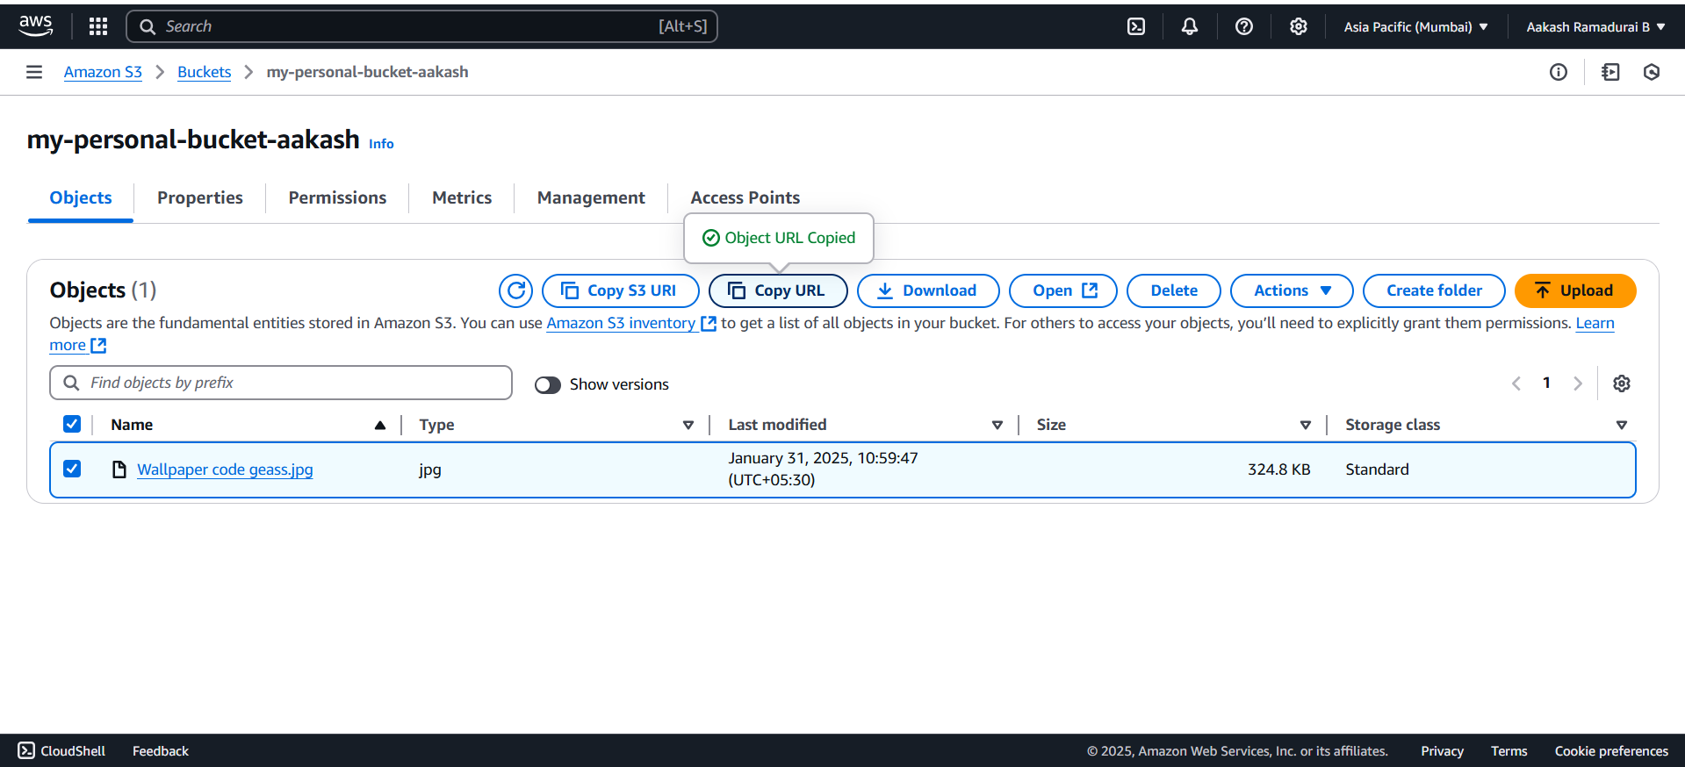

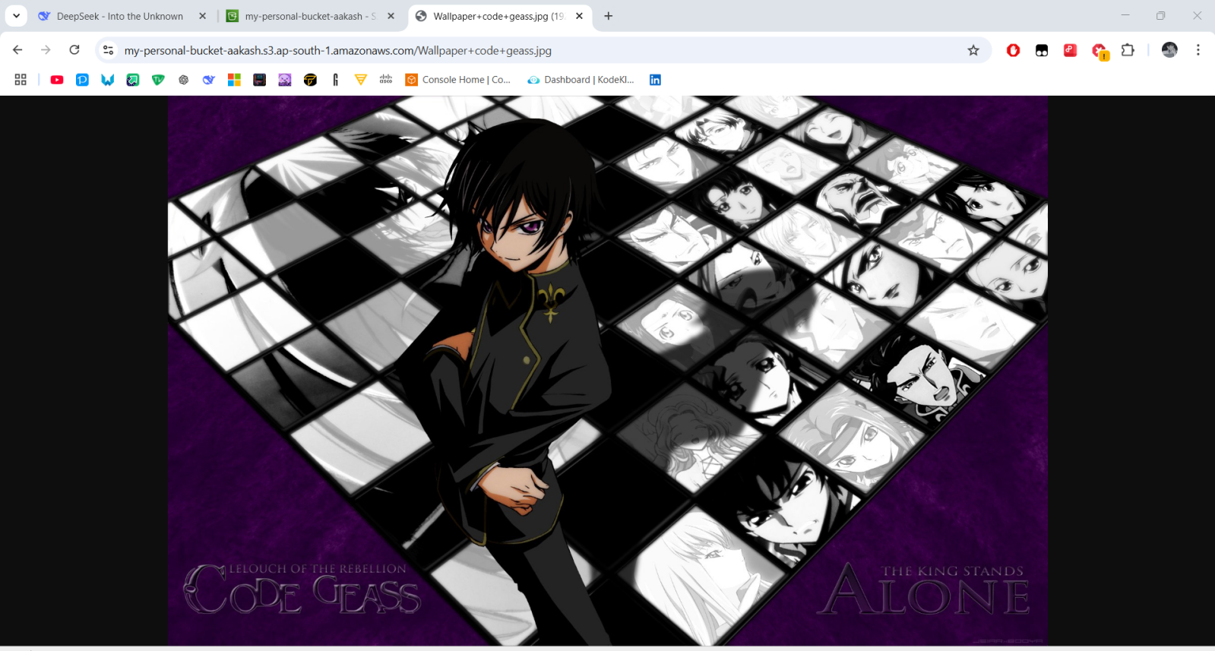

**Expected Outcome**

By finishing this project, you will:

1. Create an S3 bucket and upload/download files.
2. Set up access permissions to control who can view or use the files.
3. Learn how S3 works and how to use it for real-world cloud projects.

THANK YOU!