

**Placement Empowerment Program**

***Cloud Computing and DevOps Centre***

Automate File Copying with a Script

Create a script to copy files from one folder to another automatically.

Name: AAKASH RAMADURAI B

Department: MECHANICAL ENGINEERING



**Introduction**

### Automating tasks like copying files can save time, reduce mistakes, and make things run smoother. This is helpful for things like backing up files, organizing them, or syncing data between folders. This simple script will show you how to automatically copy files from one folder to another in an easy and effective way. ****Overview****

The script automatically copies files from one folder to another. It makes sure all files are moved correctly and safely. You can customize it to copy only certain files, like those of a specific type, size, or date. The script can be written in languages like Python, Shell scripting, or PowerShell, depending on your system.  
**Objectives**

The main goals of this automation task are:

1. **Simplify File Management**: Make it easier to move or copy files without doing it manually.

2. **Improve Efficiency**: Save time and work faster by automating the process.

3. **Ensure Data Integrity**: Copy files correctly without any errors or loss.

4. **Customizable Workflow**: Make it flexible so you can choose which files to copy (e.g., by type or date).

5. **Scalable Solution**: Make sure the script can handle lots of files without issues.

**Importance**

1. **Saves Time**: Automation removes the need for manual work, saving hours.

2. **Fewer Mistakes**: Reduces errors like missing files or overwriting important ones.

3. **Better Organization**: Keeps files and backups neat and consistent.

4. **Versatile Use**: Helpful for IT professionals, businesses, or anyone who often moves or backs up files.

5. **Reusable and Scalable**: The script can be used again and adjusted for bigger or more complex tasks.

**Step-by-Step Overview**

Step 1

Create two folders named Source and Destination



Step 2

Store some files inside it to automate it

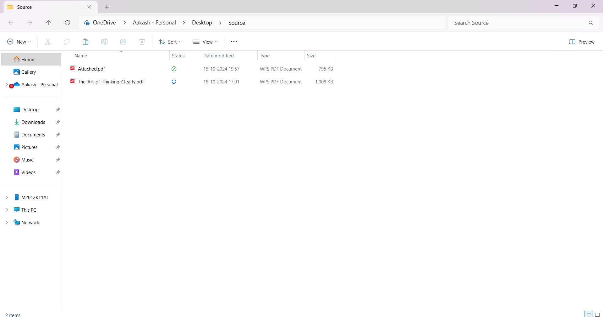

Step 3

Open the note pad and type the code and make sure that in set SOURCE give your Source folder address and in set DESTINATION give your Destination Folder address

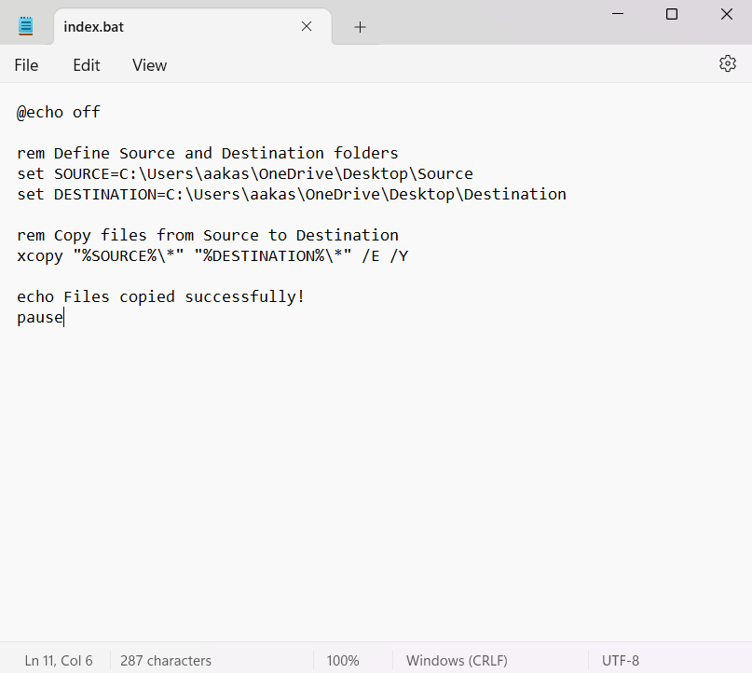

Step 4

Then save the file in desktop with .bat extension (eg : index.bat) so the file looks like this



Step 5

Press **Win + R** on your keyboard.

A small "Run" dialog box will pop up.

Type **taskschd.msc** (without quotes) in the Run box.

Press Enter or click OK.This will open the Task Scheduler window.

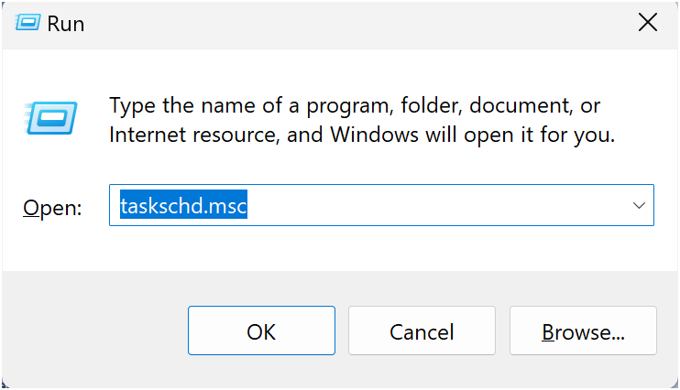

Step 6

In the Task Scheduler window, look to the right-hand side for a button called **"**Create Basic Task**"**.

Click it.

A wizard will open to guide you through the setup.

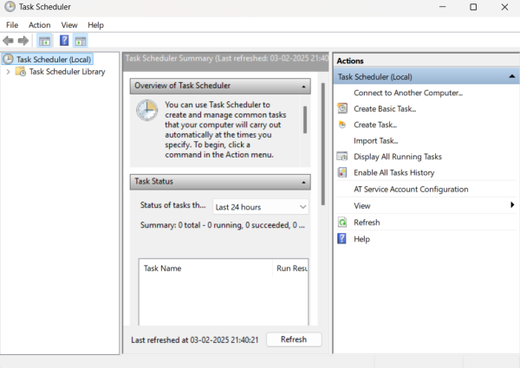

Step 7

1. Enter a Name for the Task:

For example: "Automate File Copying".(This can be anything that helps you remember what the task does.)

Optionally, you can add a description like "Copies files from folder A to folder B".

1. Click Next to continue.

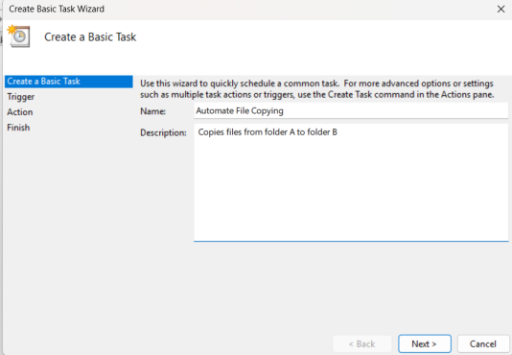

Step 8

Choose a Schedule:

You will see options like:

Daily (runs every day).

Weekly (runs once a week).

One time (runs only once at a specific time).

Choose what works for you (e.g., Daily) and click Next.

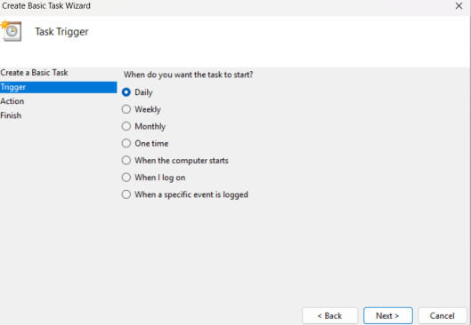

Step 9

Set the Time and Frequency:

If you chose Daily, specify:

The start date (it defaults to today).

The time (e.g., 10:00 AM).

Click Next to move on.

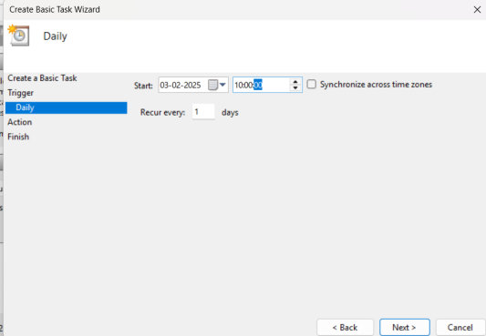

Step 10

Set the Action

Now, we tell Task Scheduler what to do when it runs.

Select "Start a Program":

On the "Action" screen, select the option **"**Start a Program**"** and click Next.

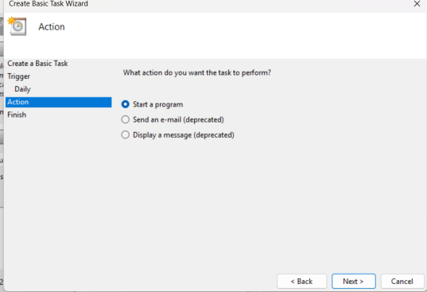

Step 11

Point to the Program or Script:

In the Program/script field, click **Browse** and navigate to the location of your .bat file.

Example: If your script is named index.bat and saved on the desktop, navigate to that file and select it.

Click Next.

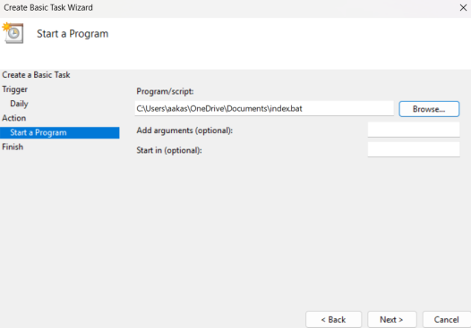

Step 12

Review and Finish

Click **Finish** to save and schedule the task.

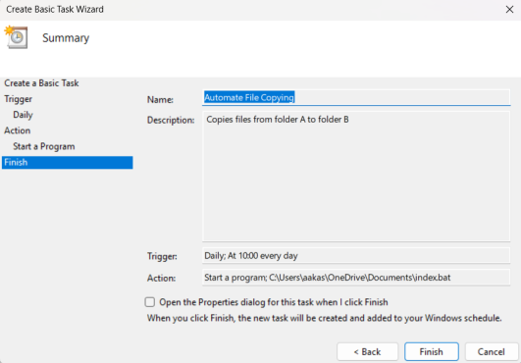

Step 13

In Task Scheduler, go to the **Task Scheduler Library** (on the left-hand side).

Find your task (it should have the name you gave it, e.g., "Automate File Copying").

Right-click the task and select **Run**.

This will manually trigger the task immediately.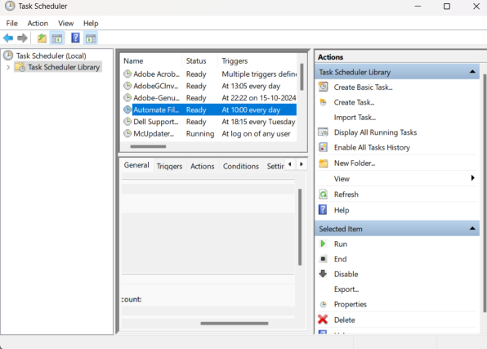

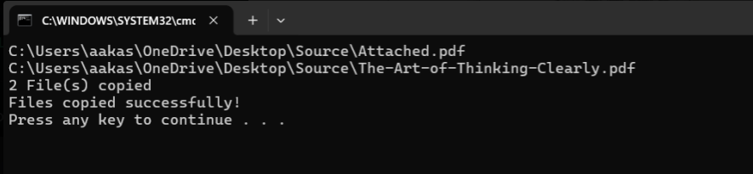

Step 14

If your task was set up to copy files, go to the destination folder and confirm that the files have been copied.

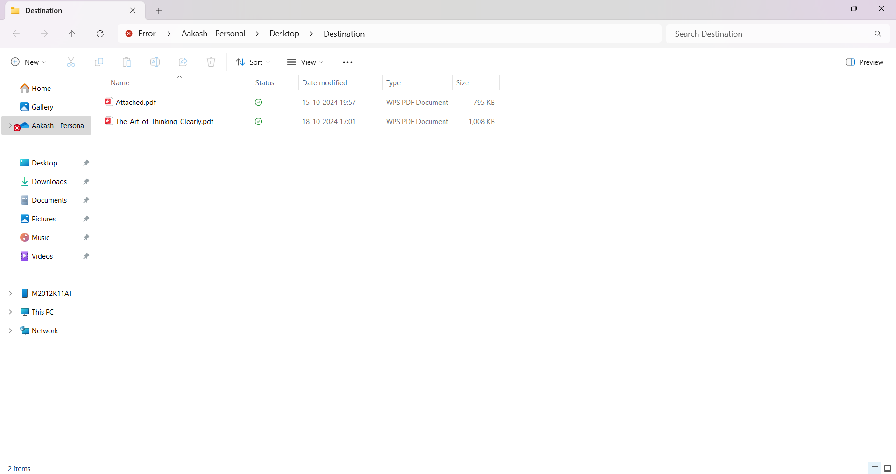

**Outcome**

By finishing this Proof of Concept (PoC) for automation using Task Scheduler, you will:

1. Set up a task that runs automatically on a schedule or when you start it manually.

2. Use a batch script to copy files from one folder to another without doing it yourself.

3. Learn how Task Scheduler can automate repetitive tasks on Windows.

4. Get comfortable with setting triggers, actions, and conditions in Task Scheduler.

5. Save time and make sure file tasks are done consistently without manual work.

6. Test the task to confirm it works as planned.

7. Improve your skills in automating workflows with real practice.  
  
  
  
 THANK YOU!