 

***Placement Empowerment Program***

***Cloud Computing and DevOps Centre***

**Write the shell Script to Monitor logs**

**Name: AAKASH RAMADURAI B**

**Department: MECHANICAL ENGINEERING**



### **INTRODUCTION**

Ensuring a server runs smoothly requires regular monitoring of log files for errors or suspicious activity. Automating this process with a shell script allows system administrators to detect and resolve potential problems before they affect performance. The script can be set up to track specific log files, such as system or application logs, and scan for predefined error patterns or keywords. If any anomalies are found, it can trigger an alert to inform the administrator, facilitating prompt action and troubleshooting. This method enhances server stability and boosts overall system reliability.

**OBJECTIVE OF THIS TASK**

The purpose of developing a shell script for server log monitoring is to automate error detection and alert notifications. By consistently scanning logs for predefined error patterns or anomalies, the script enables system administrators to detect potential issues in advance. Its main aim is to promptly identify and report critical problems, ensuring quick intervention and reducing the chances of downtime or performance issues. This automation improves system stability, minimizes the need for manual monitoring, and enhances the overall efficiency of server management.

**Step-by-step process:**

**Step 1:** Create a folder in your desktop or wherever you like to.



**Step 2:** Open “NOTEPAD” and type the following lines and save it as .log extension.

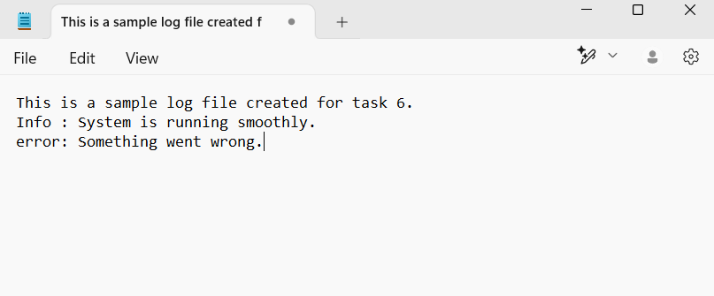

**Step 3:** Open the “NOTEPAD” again and type the following powershell cmd, and save it as .ps1 extension.

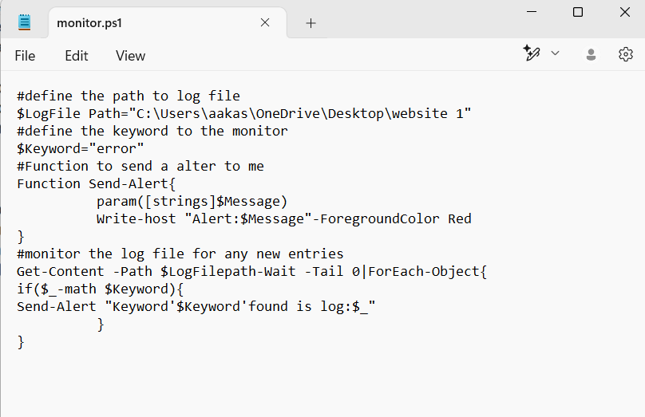

**Step 4:** Open Windows “POWESHELL” and run it as administrator.

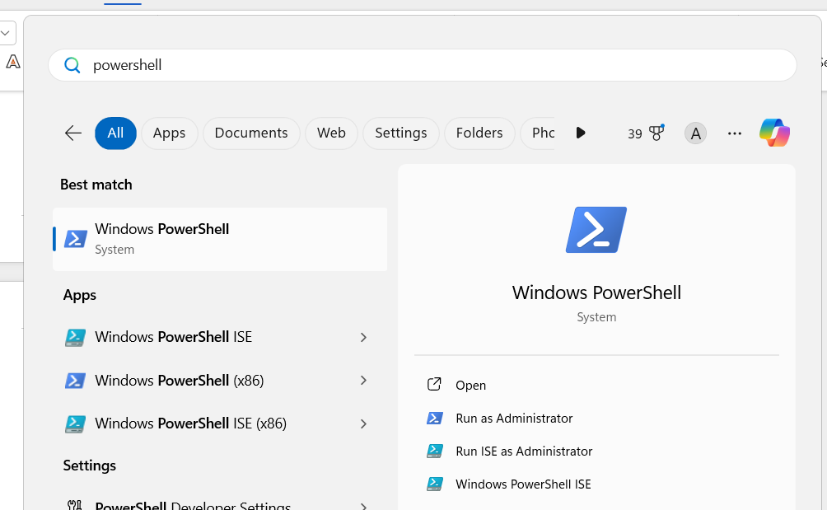

**Note: Run the following Powershell cmd.**

Set -ExecutionPolicy -Scope CurrentUser -ExecutionPolicy RemoteSigned and press Y to continue.



**Step 5:** Open the log folder.



**Step 6:** Run the following in the powershell .\monitor.ps1



**Step 7:** Add a new issue line to the logs.log file.

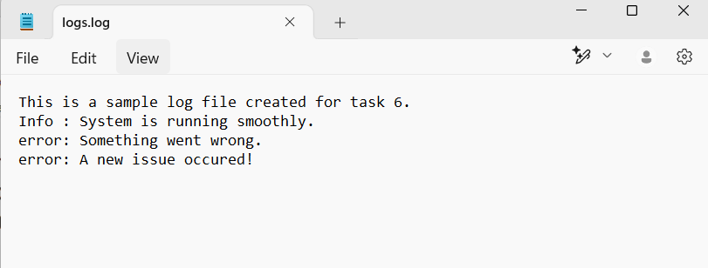

**Step 8:** You will get an Alert msg.



# THANK YOU!