

II.2314 / II.2414 - Advanced Databases and Big Data

FlightPriceX Analytics Platform using PySpark, Airflow, Elasticsearch and Kibana
Done by:
Aakash Muthuselvan
Jithesh Kumar Ravi

Table of Contents:

Abstract: 2
Introduction: 3
Technologies Used: 3
System Architecture: 4
Data Processing using PySpark: 5
ETL Automation using Apache Airflow: 6
Data Storage using Elasticsearch: 7
Dashboard Development using Kibana: 7
a) Key Performance Indicators (KPIs) 7
b) Visualizations 8
c) Interactive Filters 8
Results and Insights: 9
Advantages of the Proposed System: 9
Conclusion: 10

Abstract:
The airline industry generates a large amount of pricing data that changes frequently based on multiple factors such as airline, destination, booking date, travel class, and flight duration. Analyzing this data can help identify pricing trends and support better decision-making.
This project presents a complete Big Data Analytics Platform that processes flight price data using PySpark, automates workflows with Apache Airflow, stores data in Elasticsearch, and visualizes insights through Kibana dashboards. The project demonstrates how modern Big Data technologies can be integrated to transform raw data into meaningful business insights.

Introduction:
Flight ticket prices vary significantly depending on different travel conditions. Understanding these variations can help customers choose cost-effective travel options and help businesses analyze market trends.
The main objective of this project is to build an end-to-end data analytics pipeline capable of:
- Processing large flight datasets
- Automating data workflows
- Storing processed records efficiently
- Creating interactive dashboards
- Generating business insights
To achieve this, PySpark was used for data processing, Apache Airflow for workflow orchestration, Elasticsearch for data storage, and Kibana for dashboard development.

Technologies Used:
The following technologies were used in this project:

Technology | Purpose
Python | ETL Development
PySpark | Big Data Processing
Apache Airflow | Workflow Automation
Elasticsearch | Data Storage & Search Engine
Kibana | Data Visualization
Docker | Containerization
Flight Price Dataset | Data Source

System Architecture:
The project follows the architecture shown below:
Flight Price Dataset (CSV)
PySpark Data Processing

Apache Airflow ETL Pipeline

Elasticsearch

Kibana Dashboard

Workflow Description:
- Flight data is collected from a CSV dataset.
- PySpark reads and processes the dataset.
- Data cleaning and transformations are applied.
- Airflow automates the ETL execution.
- Processed records are loaded into Elasticsearch.
- Kibana connects to Elasticsearch and creates dashboards for analysis.

Data Processing using PySpark:
PySpark was used to handle data ingestion and preprocessing.
The dataset contains the following attributes:
- Airline
- Flight Number
- Source City
- Destination City
- Departure Time
- Arrival Time
- Travel Class
- Number of Stops
- Duration
- Days Left Before Departure
- Ticket Price
The following transformations were performed:
- Removal of invalid records
- Handling missing values
- Data type validation
- Feature preparation for analytics
Using PySpark improved scalability and made the project more aligned with Big Data processing practices.

ETL Automation using Apache Airflow:
Apache Airflow was used to automate the ETL workflow.
A DAG named:
flight_price_etl_pipeline
was created to execute the ETL process automatically.
The DAG performs the following tasks:
- Read the flight dataset.
- Process the data using PySpark.
- Load the processed records into Elasticsearch.
- Monitor task execution and status.
Airflow provides scheduling, monitoring, and logging capabilities, making the pipeline easier to manage and maintain.

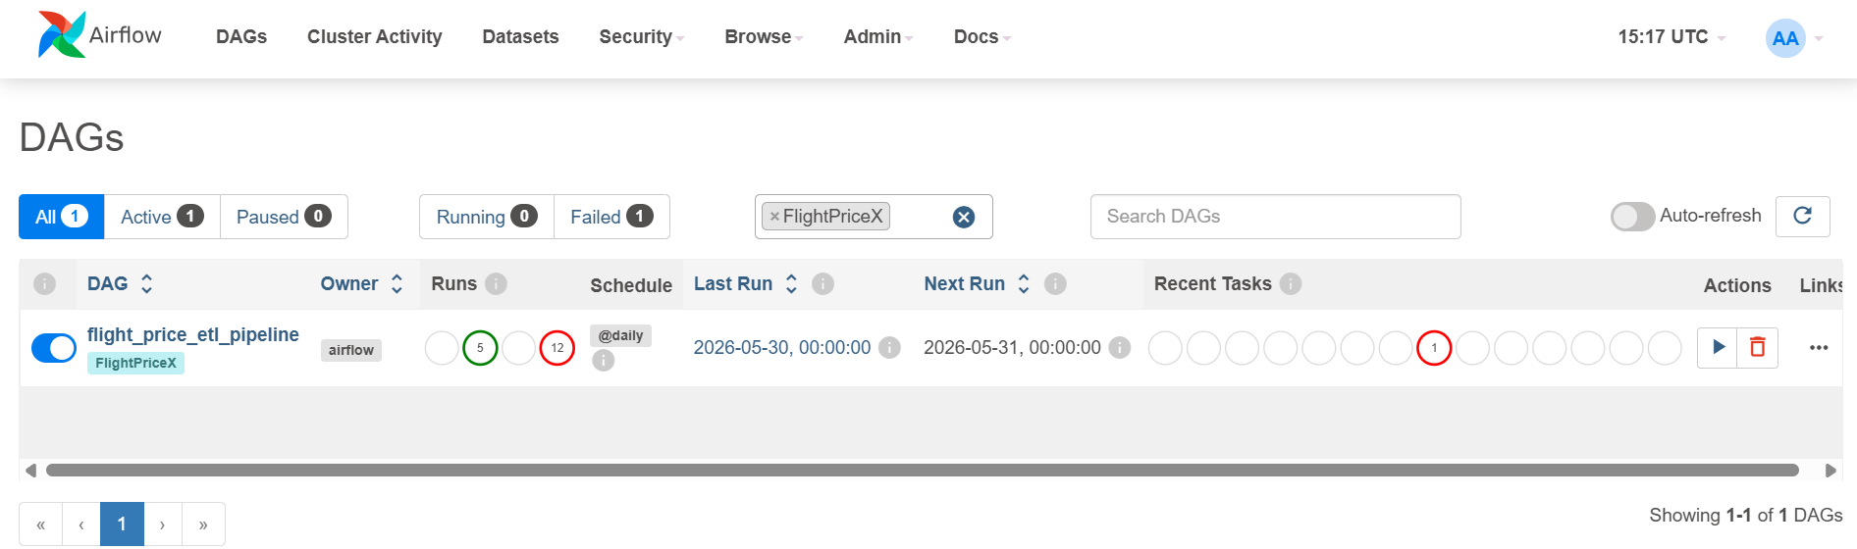

Data Storage using Elasticsearch:
After processing, the data is loaded into Elasticsearch.
Elasticsearch was chosen because:
- It provides fast search capabilities.
- It supports large datasets efficiently.
- It integrates seamlessly with Kibana.
- It allows real-time analytical queries.
More than 300,000 flight records were indexed and made available for dashboard visualization.
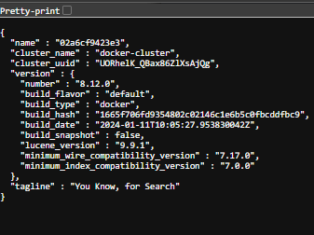s

Dashboard Development using Kibana:
Kibana was used to build an interactive dashboard for flight price analysis.
The dashboard contains:

Key Performance Indicators (KPIs)
- Average Ticket Price
- Total Flights Analyzed
- Highest Ticket Price

Visualizations
- Average Flight Price by Airline
- Average Ticket Price by Destination City
- Travel Class Distribution
- Booking Days Left vs Ticket Price
- Flight Duration vs Ticket Price
- Average Ticket Price by Number of Stops

Interactive Filters
- Airline Filter
- Destination Filter
- Travel Class Filter
These visualizations help users explore the dataset dynamically and identify important travel patterns.

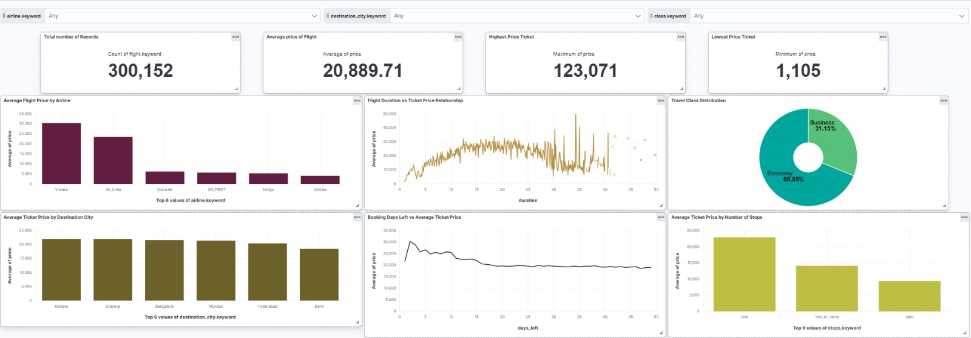

Results and Insights:
Several meaningful insights were obtained from the dashboard:
- Vistara had the highest average ticket prices among major airlines.
- Economy class represented the largest share of bookings.
- Ticket prices generally increased as the departure date approached.
- Direct flights were usually more expensive than flights with multiple stops.
- Longer flight durations often resulted in higher ticket prices.
These findings demonstrate how analytics can be used to understand airline pricing behavior.

Advantages of the Proposed System:

The developed system provides several advantages:
- Automated ETL execution through Airflow.
- Scalable data processing using PySpark.
- Efficient data storage using Elasticsearch.
- Interactive visual analytics through Kibana.
- Easy deployment using Docker containers.
- End-to-end Big Data workflow implementation.

Conclusion:
This project successfully developed a complete Flight Price Analytics Platform using modern Big Data technologies.
PySpark was used for data processing, Airflow automated the ETL workflow, Elasticsearch stored the processed records, and Kibana provided interactive dashboards for analysis.
The project demonstrates practical applications of Data Engineering, Workflow Automation, Big Data Processing, and Business Intelligence tools. It also highlights how data-driven insights can support decision-making in the airline industry.
Future enhancements may include real-time flight data streaming using Apache Kafka and advanced machine learning models for ticket price prediction.

