**Practical No.7**

**Aim :** Implement a basic IR system using Lucene.

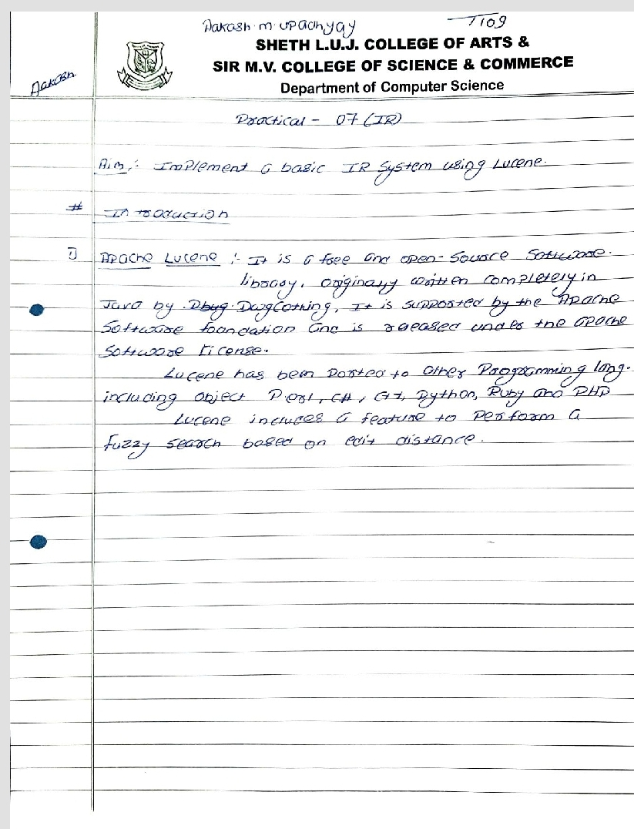

**Code:**

/*

* To change this license header, choose License Headers in Project Properties.

* To change this template file, choose Tools | Templates

* and open the template in the editor.

*/

package Lucene;

import java.io.IOException;

import org.apache.lucene.document.Document;

import org.apache.lucene.queryParser.ParseException;

import org.apache.lucene.search.ScoreDoc;

import org.apache.lucene.search.TopDocs;

public class LuceneTester1 {

String indexDir = "C:\\Users\\Aakash\\INDEX";

String dataDir = "C:\\Users\\Aakash";

Indexer indexer;

Searcher searcher;

public static void main(String[] args) {

LuceneTester1 tester;

try {

tester = new LuceneTester1();

System.out.println("Name:Aakash Upadhyay\nRoll No:T109");

tester.createIndex();

tester.search("Aakash");

}

catch (IOException e)

{

e.printStackTrace();

}

catch (ParseException e)

{

e.printStackTrace();

}

}

private void createIndex() throws IOException

{

indexer = new Indexer(indexDir);

int numIndexed;

long startTime = System.currentTimeMillis();

numIndexed = indexer.createIndex(dataDir, new TextFileFilter());

long endTime = System.currentTimeMillis();

indexer.close();

System.out.println(numIndexed+" File indexed, time taken: "

+(endTime-startTime)+" ms");

}

private void search(String searchQuery) throws IOException, ParseException

{

searcher = new Searcher(indexDir);

long startTime = System.currentTimeMillis();

TopDocs hits = searcher.search(searchQuery);

long endTime = System.currentTimeMillis();

System.out.println(hits.totalHits + " documents found. Time :" + (endTime - startTime));

for(ScoreDoc scoreDoc : hits.scoreDocs)

{

Document doc = searcher.getDocument(scoreDoc);

System.out.println("File: "+ doc.get(LuceneConstants.FILE_PATH));

}

searcher.close();

}

}

