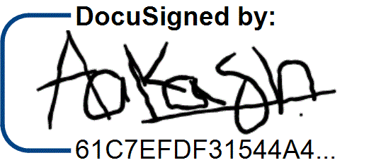

DocuSign Envelope ID: 27601CDA-DB26-4001-A4D0-224D5C42A8BB



**Date: 30th April 2021**

To,

Mr. Aakash Sharma,

H.No. C-483, Ward Number 1

Aggarwal Colony, Jalalabad,

Firozpur, Punjab-152024

Dear Aakash,

ANYCAST TECHNOLOGY PRIVATE LIMITED CIN: U74999HR2018PTC075117   
 1st Floor, Landmark Cyberpark, Sector 67 Gurugram 122018  
 +91-20-71533631 hello@oneimpression.io

**Subject: Your appointment with us as a “Software Engineer (Backend)”**

As per our recent discussion, we are pleased to inform you that you have been appointed as **a “Software Engineer (Backend)”** as per the terms and conditions discussed with you on. While we are seeking to have your employment commence with Anycast Technology Private Limited (One Impression) as soon as possible, this offer of employment is contingent upon your:

• Acceptance of this written offer of employment via this offer letter   
• Not being subject to any secrecy, confidentiality, non-compete or other agreement with a third party which would restrict or interfere with your ability to perform all responsibilities of the position   
• Your execution of Anycast Technology Private Limited’s standard Non-Disclosure Agreement   
•  
 Passage of a reasonable background check conducted by Anycast Technology Private Limited based on your completion of an employment application and furnishing professional references.

Below mentioned are the details of your salary structure for the offered position:

**Salary Structure**: Rs. 12,00,000/- per annum   
**Fixed Pay**: Rs. 11,50,000/- per annum   
**Yearly Retention Bonus** : Rs. 50,000/-

Your appointment will be effective from “**7th June 2021”** or a mutually accepted earlier date, failing which this offer letter stands canceled.

Note: Yearly Retention bonus is only applicable if you stay with the company for complete one year. The Bonus i.e. Rs. 50000 will be released after the completion of one year in One Impression. In case you plan to leave the organisation, before one year - the entire bonus, which is 50k, will be deductible.

Yours Faithfully,

|  |  |  |
| --- | --- | --- |
|  | **For ANYCAST TECHNOLOGY PRIVATE LIMITED** | **Accept** |
|  |
|  |  |  |
| **Jivesh Gupta** |
| 12-05-2021  **Date:** |
| **Director** |

Place: Gurgaon, Haryana

[www.oneimpression.io](http://www.oneimpression.io/)

NOTE: We own all copyrights in the text, image, photographs, video, audio, graphics, and other contents provided in this offer letter. Except as expressly stated in this offer letter, you are prohibited from copying, reproducing, modifying, distributing, displaying, performing or transmitting any of the contents of this offer letter for any purpose, and nothing otherwise stated or implies in the Services confers on you any license or right to do so. You may use the content contained in this offer letter for your own individual non-commercial and information purpose only. Any other use, including for any commercial purposes, is strictly prohibited without our express prior written consent.