1. Creating and Renaming Files/Directories
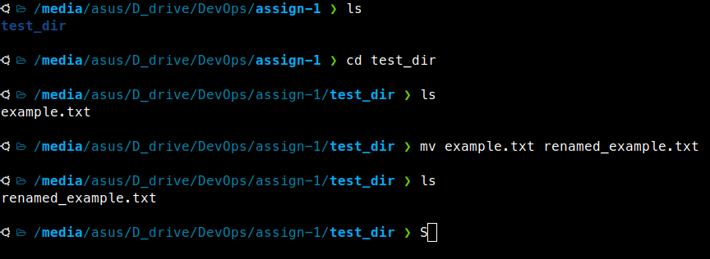
Step-1 : Created a test_dir using mkdir [make directory command].
mkdir test_dir
Step-2 : Created a blank file name example.txt using touch command.
touch example.txt
Step-3: Renamed the example.txt to renamed+example.tx using mv command.
mv example.txt renamed_example.txt
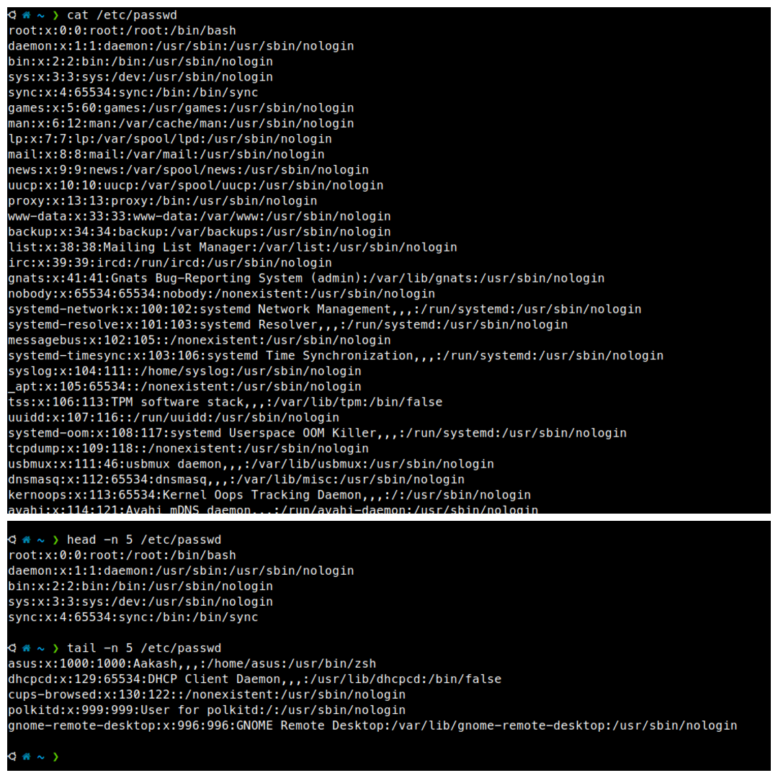
2. Viewing File Contents

Step-1 : Use cat to display the contents of /etc/passwd
cat /etc/passwd
Step-2 : Display the first 5 lines using head
head -n 5 /etc/passwd
Explanation:
- head shows the beginning of a file
- -n 5 means “show only the first 5 lines”

Step-3 : Display the last 5 lines using tail
tail -n 5 /etc/passwd
Explanation:
- tail shows the end of a file
- -n 5 means “show the last 5 lines”
3. Searching for patterns
cat /etc/passwd | grep -n root
Explanation:
  - cat will display the contents of etc/passwd.
  - grep -n root will show root is used in how many lines.
4. Zipping and Unzipping

Step 1 : Zip the directory

Compress the test_dir directory into a file named test_dir.zip
zip -r test_dir.zip test_dir
Explanation:
- zip → zip command
- -r → recursively include all files/subfolders
- test_dir.zip → output file
- test_dir → the folder you want to compress

Step 2 : Create a directory for unzipping

Unzip test_dir.zip into a new directory named unzipped_dir
Step 3 : Create that directory:
mkdir unzipped_dir
Step 4: Unzip into that directory
unzip test_dir.zip -d unzipped_dir
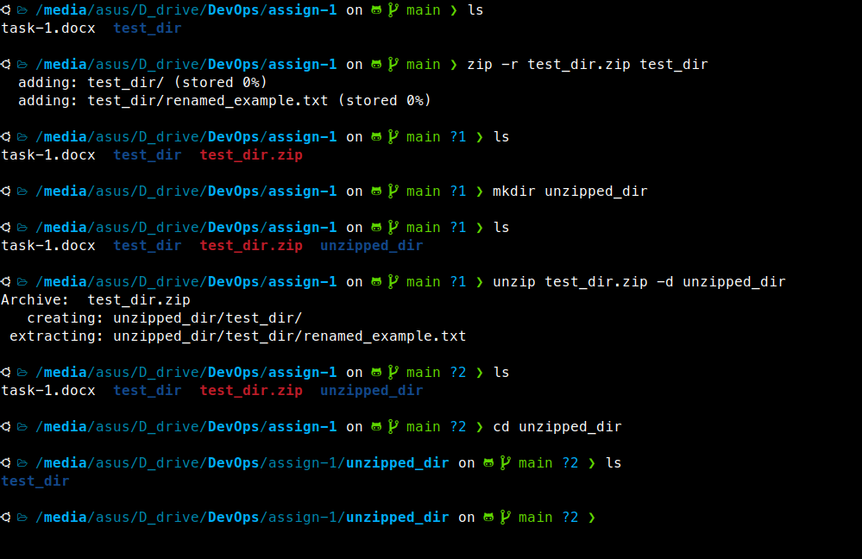
5. Downloading Files
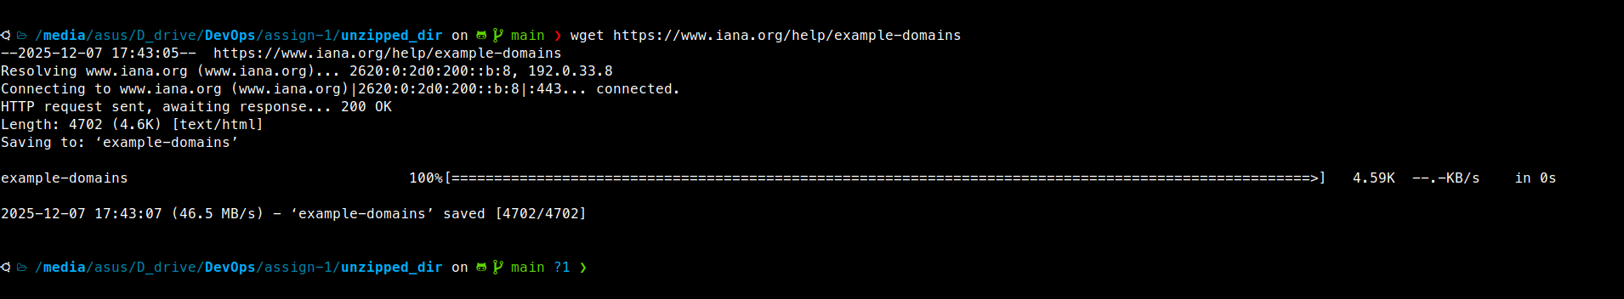
wget https://www.iana.org/help/example-domains
We can download any files to our system using wget.

6. Changing permissions
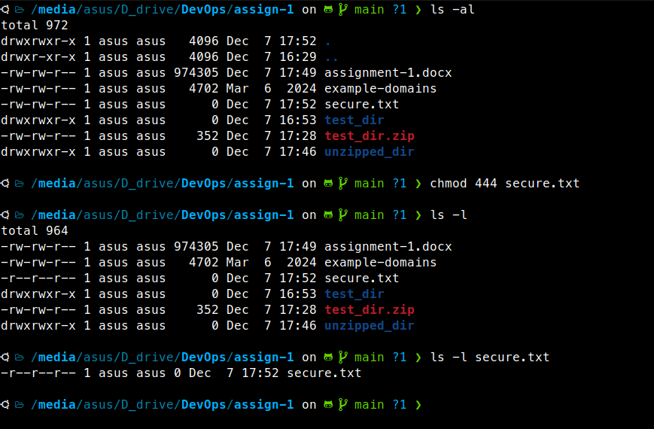
Step 1 : Create a secure.txt file
touch secure.txt
Step 2 : Change permissions to read-only for everyone
chmod 444 secure.txt
Step 3 : Verify the permission
ls -l secure.txt
7. Working with Environment Variables

