Flask Frontend–Backend Application with MongoDB Atlas
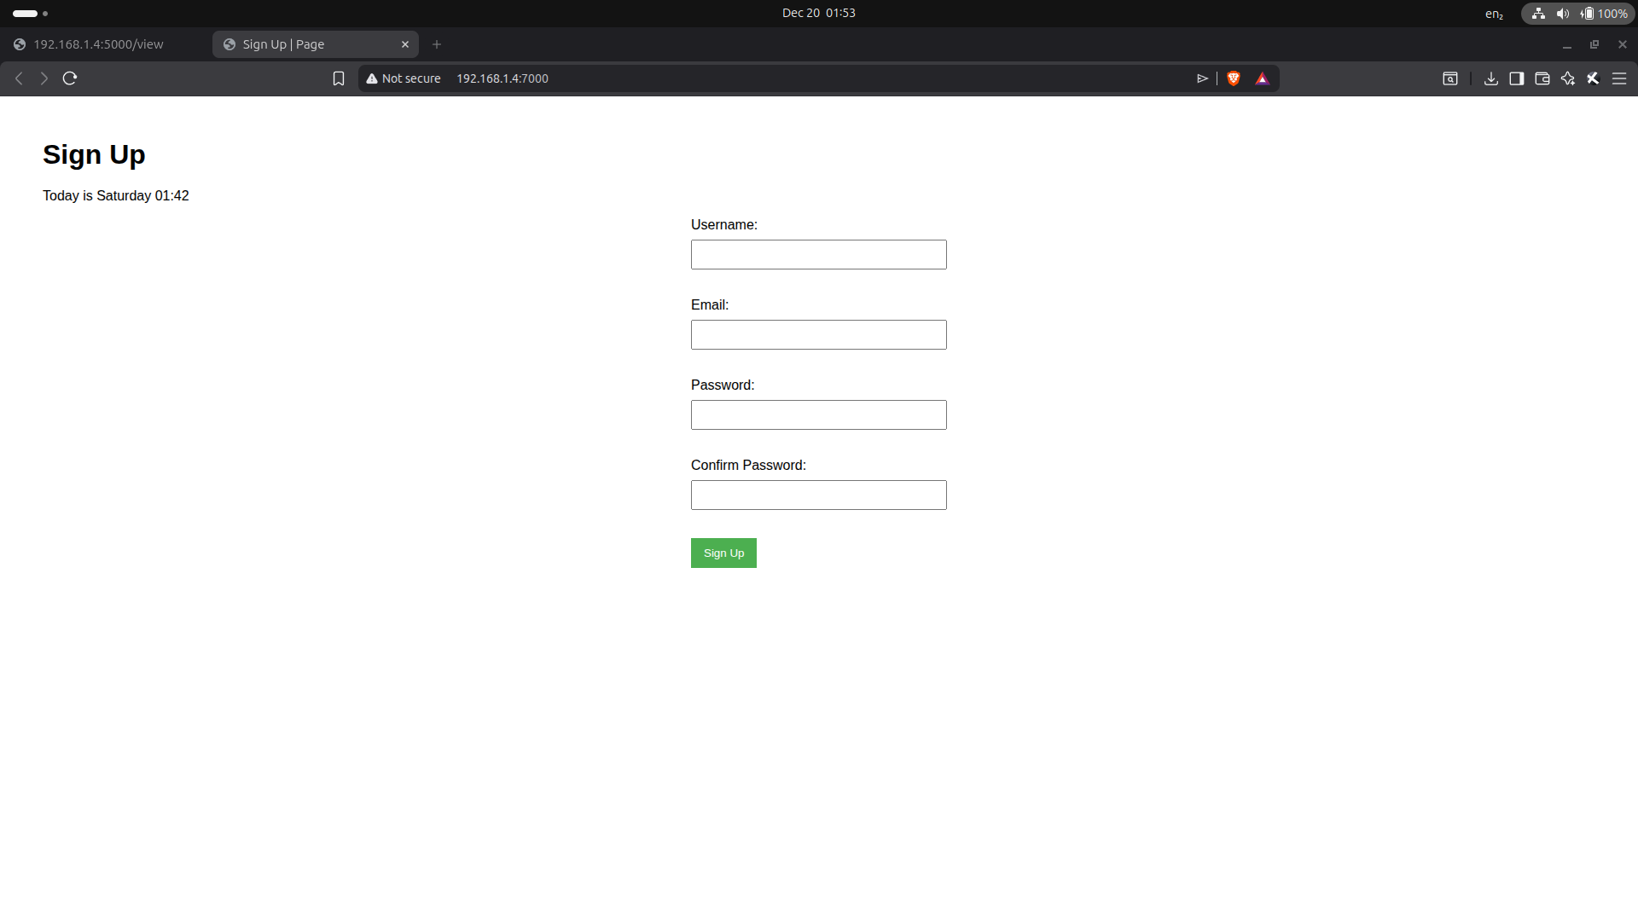
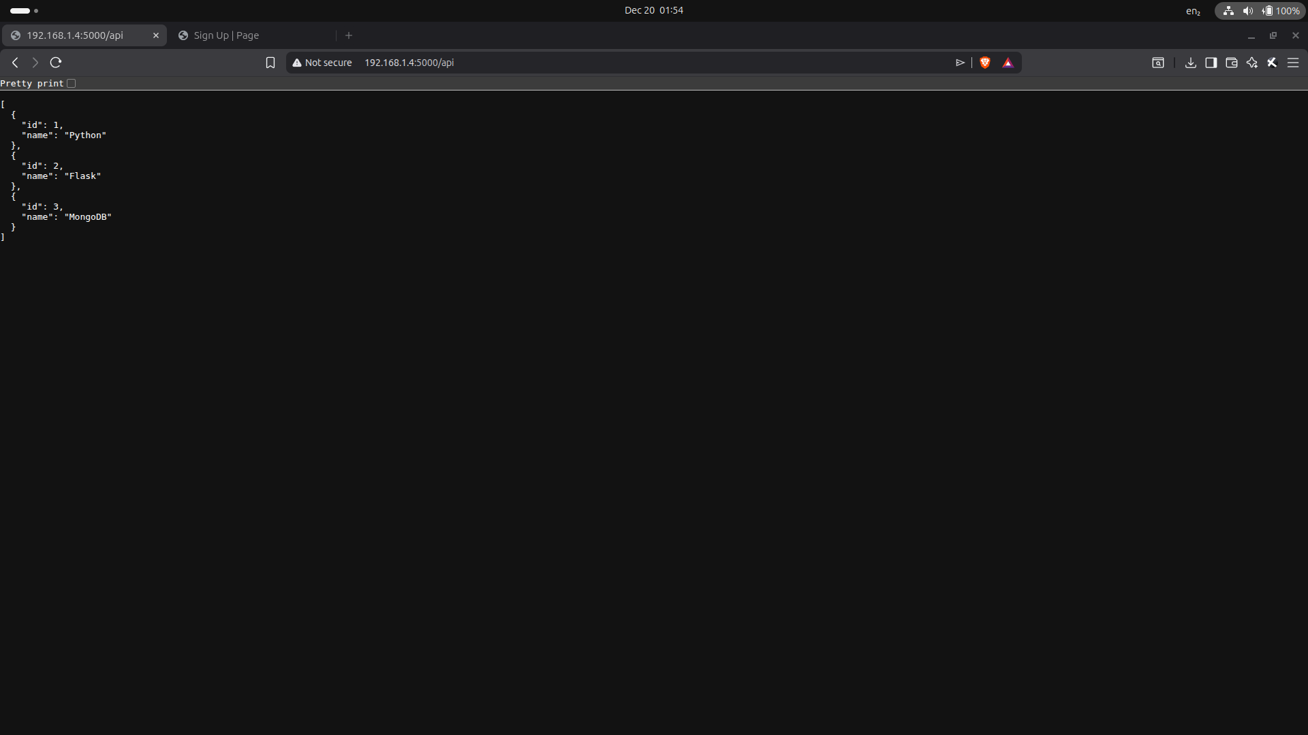
Frontend Page (index.html)

Backend Page (/api)

1. INTRODUCTION
This project demonstrates a frontend–backend web application using Flask.
The frontend handles UI and user interaction, while the backend manages APIs and MongoDB Atlas database operations.

2. PROJECT ARCHITECTURE
The application is divided into two services:
- Frontend (Port 7000): UI, form submission, error handling
- Backend (Port 5000): API routes, file reading, MongoDB insertion

3. BACKEND IMPLEMENTATION
The backend includes:
- data.json file to store static data
- /api route to read data from file and return JSON
- /submit route to validate form data and insert into MongoDB Atlas

4. API ROUTE
The /api route reads data from data.json and returns it as a JSON list, fulfilling the assignment requirement.

5. MONGODB INTEGRATION
MongoDB Atlas is connected using environment variables stored in a .env file for security.

6. FRONTEND IMPLEMENTATION
The frontend displays a signup form and sends data to the backend using HTTP POST requests.
- On success: redirects to success page
- On error: displays error on the same page

7. HTML TEMPLATES
index.html:
- Displays form
- Shows error message dynamically using Jinja
success.html:
- Displays success message after successful submission

8. EXECUTION STEPS
Start backend:
python app.py
Start frontend:
python app.py

9. EXPECTED OUTPUT
- /api returns JSON list
- Form submission inserts data into MongoDB
- Error shown on same page if validation fails
- Success page shown after correct submission

10. CONCLUSION
This project demonstrates clean separation of frontend and backend, REST API usage, MongoDB Atlas integration, and proper error handling.

GitHub Repository:
https://github.com/Aakash070802/DevOps-Assginments.git

