Assignment 2

1. Grade Check.
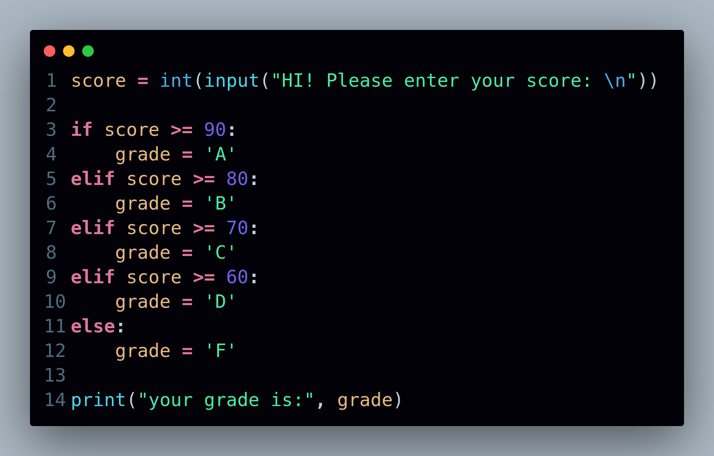

Grade Checker Explanation
- Python reads this line by line:
- If the score is 90 or above, it immediately prints "A" and stops checking further.
- If not, it checks whether the score is 80 or above.
- This continues down the ladder until one condition matches.
- If none of the conditions are true, the else block runs and prints "F".

2. Student Grades.
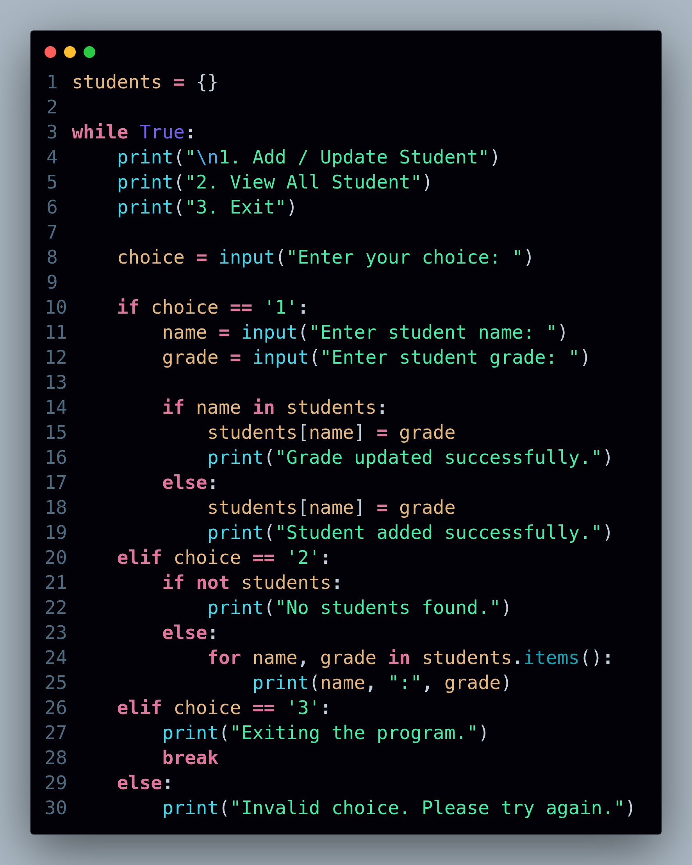
Student Grades Program Explanation
- A dictionary named students is used to store student names as keys and their grades as values.
- A while True loop is used to keep the program running until the user chooses to exit.
- A menu is displayed to the user with three options:
  - Add or update a student
  - View all student records
  - Exit the program
- If the user selects option 1:
  - The program asks for the student’s name and grade.
  - Using an if-else condition, it checks whether the student already exists in the dictionary.
  - If the student exists, the grade is updated.
  - If the student does not exist, a new entry is added.
- If the user selects option 2:
  - The program checks whether the dictionary is empty.
  - If empty, it prints a message saying no records are found.
  - Otherwise, it prints all student names with their grades.
- If the user selects option 3:
  - A message is displayed and the program terminates using break.
- If the user enters an invalid option:
  - An error message is displayed asking for a valid choice.
3. Write to a File.
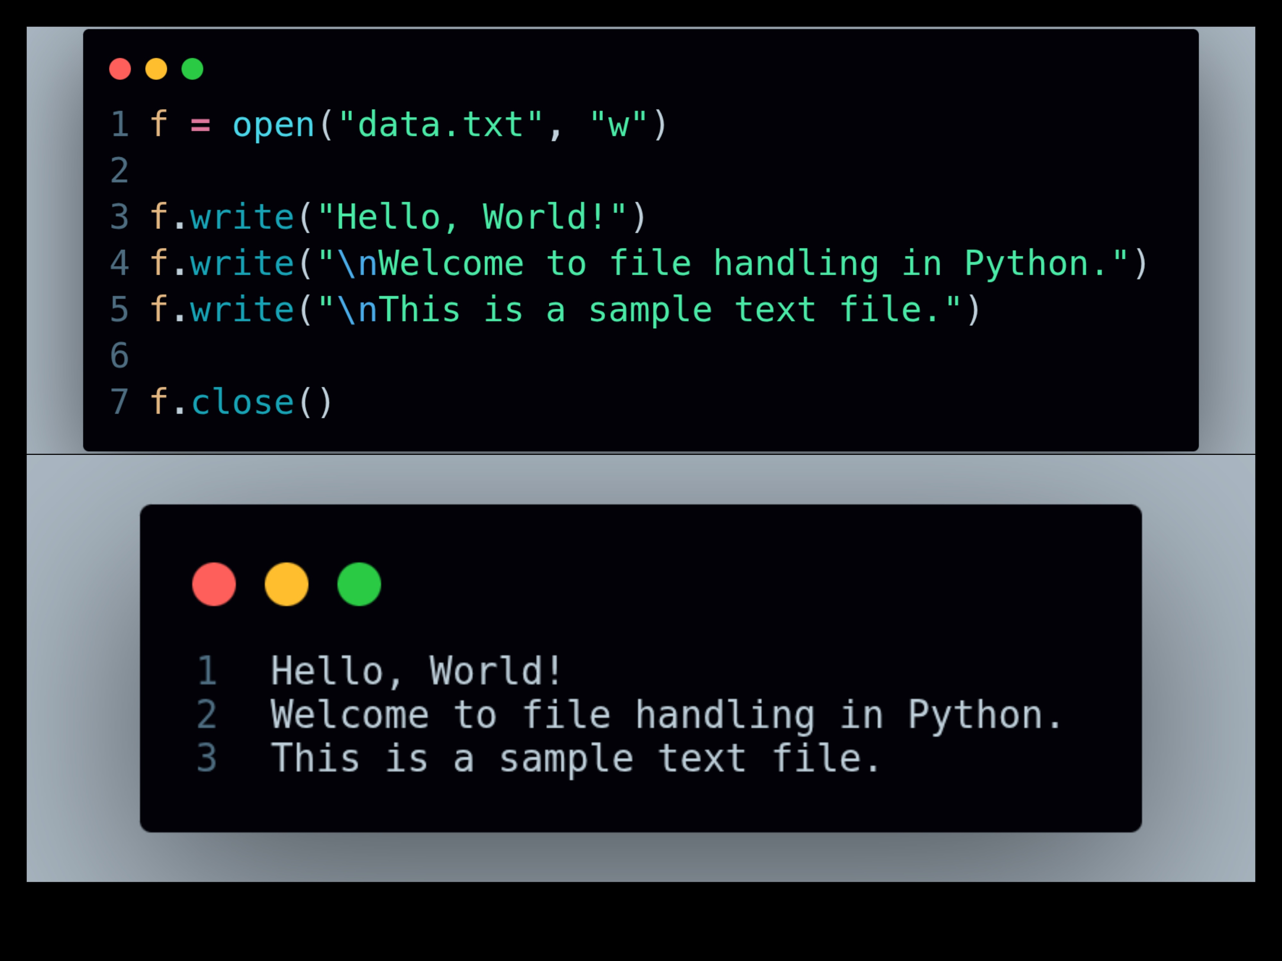

File Writing Program Explanation
- The open() function is used to open a file named data.txt in write mode ("w").
- If the file does not exist, Python automatically creates a new file.
- The write() method is used to write text into the file.
- \n is used to move the cursor to a new line while writing content.
- Multiple write() statements are used to add multiple lines of text.
- The close() method is used to save the changes and properly close the file.
- After execution, the text written using the program is stored inside data.txt.

4. Read from a file.
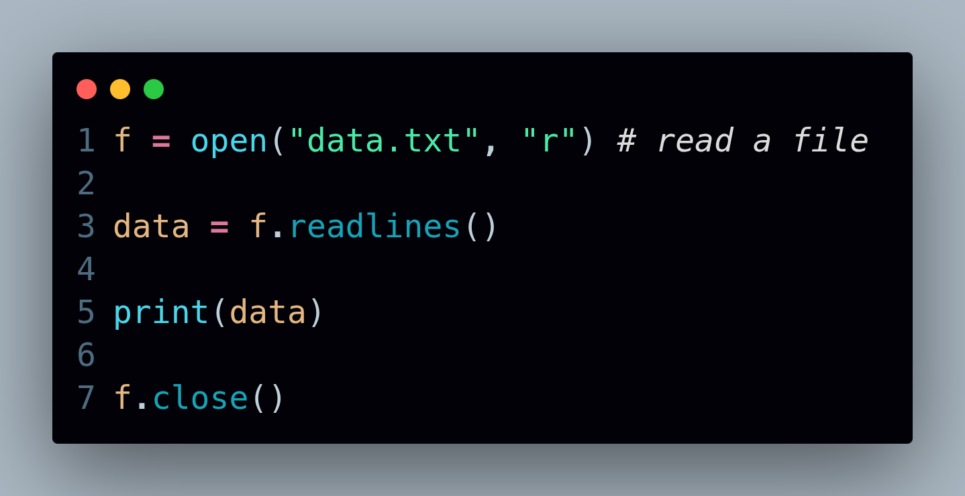

File Reading Program Explanation
- The open() function is used to open the file data.txt in read mode ("r").
- Read mode allows the program to access the contents of an existing file without modifying it.
- The readlines() method reads all lines from the file and stores them in a list.
- Each line of the file becomes an element inside the list.
- The print() function is used to display the file content on the screen.
- The close() method is used to properly close the file after reading.
Output:
['Hello, World!\n', 'Welcome to file handling in Python.\n', 'This is a sample text file.']
GitHub: https://github.com/Aakash070802/DevOps-Assginments.git

