1. Creating and Renaming Files/Directories
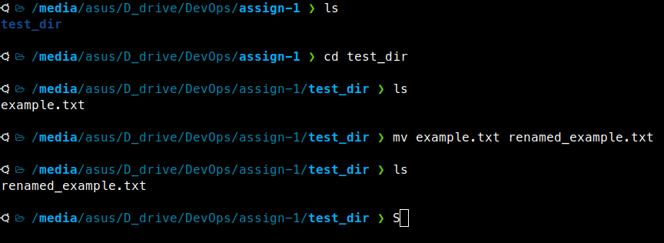
Step-1 : Created a test_dir using mkdir [make directory command].
mkdir test_dir
Step-2 : Created a blank file name example.txt using touch command.
touch example.txt
Step-3: Renamed the example.txt to renamed+example.tx using mv command.
mv example.txt renamed_example.txt
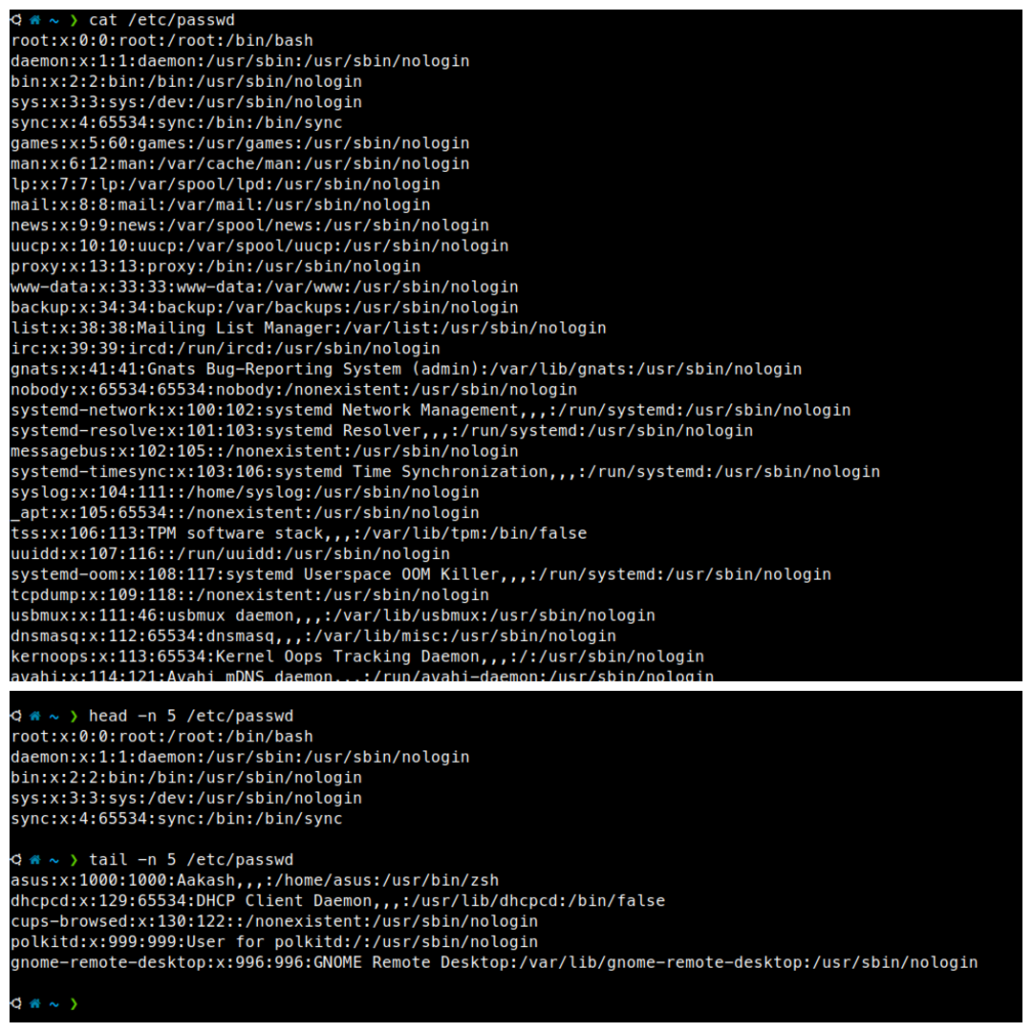
2. Viewing File Contents

Step-1 : Use cat to display the contents of /etc/passwd
cat /etc/passwd
Step-2 : Display the first 5 lines using head
head -n 5 /etc/passwd
Explanation:
- head shows the beginning of a file
- -n 5 means “show only the first 5 lines”

Step-3 : Display the last 5 lines using tail
tail -n 5 /etc/passwd
Explanation:
- tail shows the end of a file
- -n 5 means “show the last 5 lines”

