**FASHION RETAIL SALES SQL QUERIES**

**Key performance indicator**

1. Total revenue



**Daily Trend for Total Sales:**

1. Daily Trend for Total Order



Output:

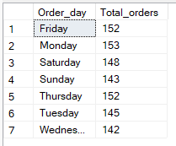

1. Monthly Trend for Orders 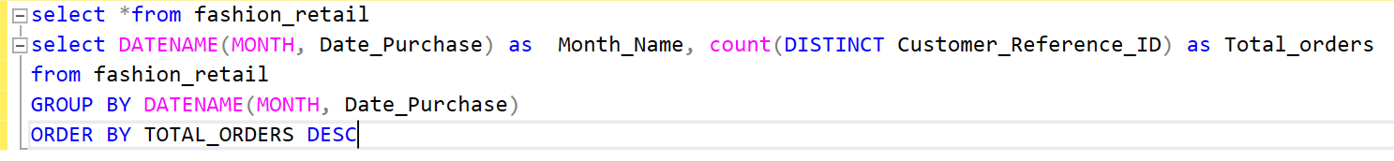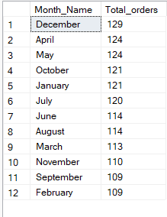
2. Percentage of Sales by Item Purchased

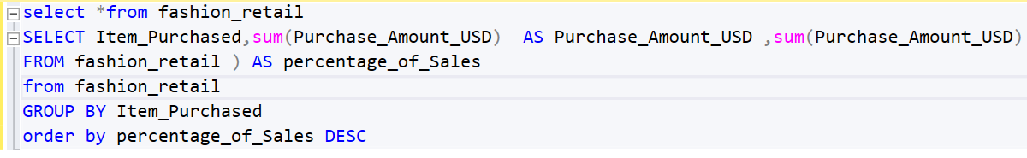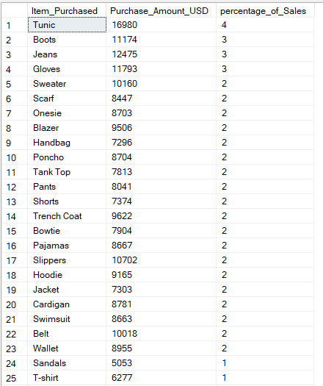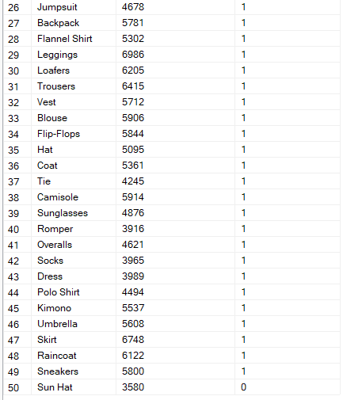

1. Review Rating by Item Purchased

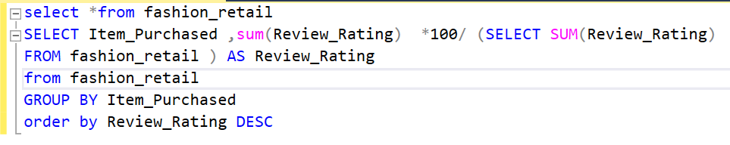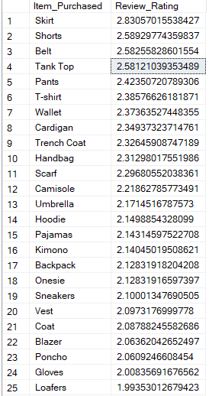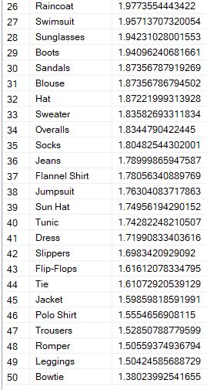

1. Top 5 Item Purchased

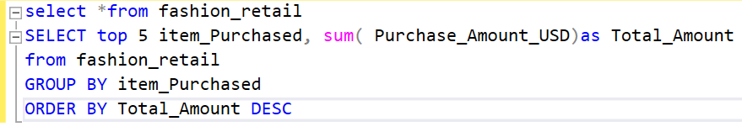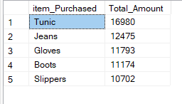

1. Top 5 Review Rating items purchased

