Application Security
Practical Exam

Practical No. 12

#!/usr/bin/python
import multiprocessing
import subprocess
import os

def pinger( job_q, results_q ):
DEVNULL = open(os.devnull,'w')
while True:
ip = job_q.get()
if ip is None: break

try:
subprocess.check_call(['ping','-c1',ip],
stdout=DEVNULL)
results_q.put(ip)
except:
pass

def main():
pool_size = 255

jobs = multiprocessing.Queue()
results = multiprocessing.Queue()

pool = [ multiprocessing.Process(target=pinger, args=(jobs,results))
for i in range(pool_size) ]

for p in pool:
p.start()

for i in range(1,255):
jobs.put('216.58.220.{0}'.format(i))

for p in pool:
jobs.put(None)

for p in pool:
p.join()

while not results.empty():
ip = results.get()
print(ip)

if __name__=='__main__':
main()

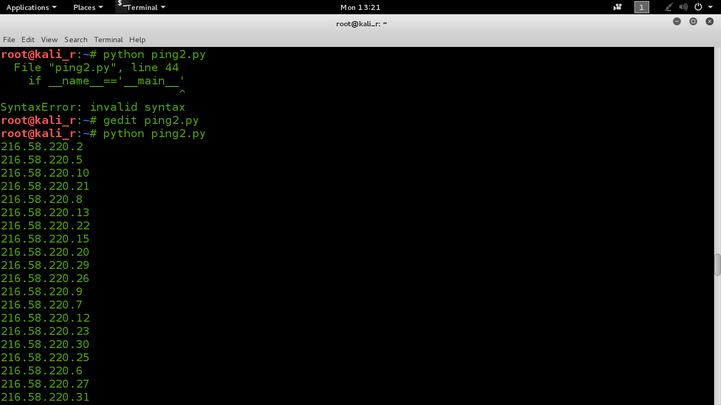
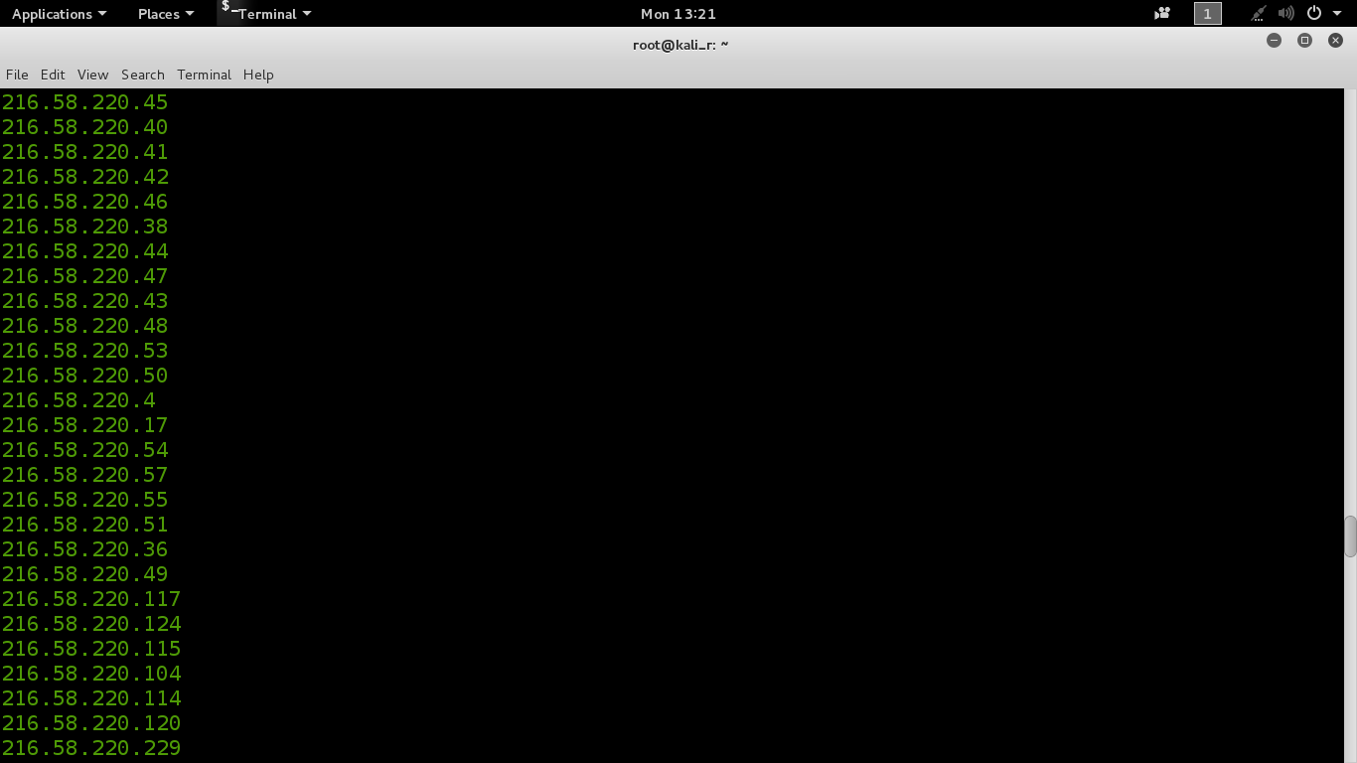

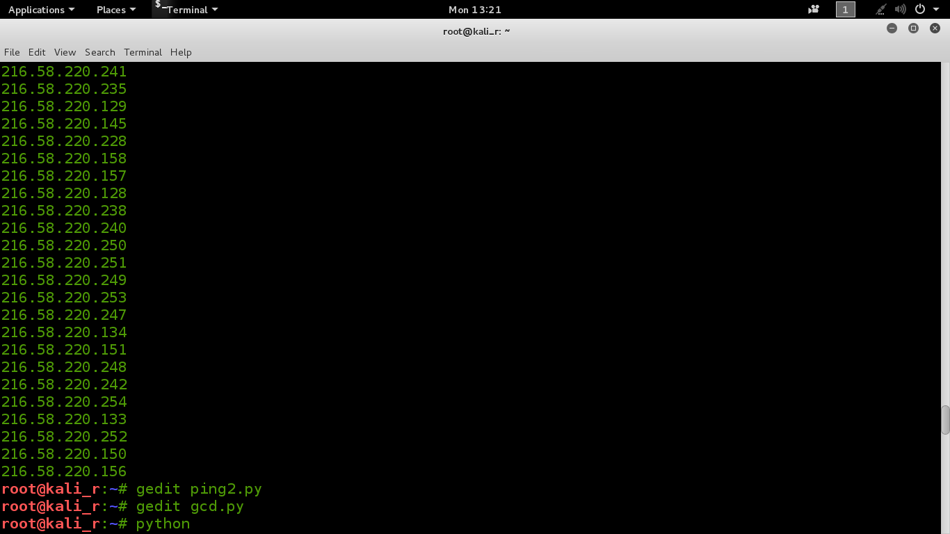

Practical No. 28

#!/usr/bin/python
import sys
def gcd (a,b):
if (b == 0):
return a
else:
return gcd (b, a % b)

def main():

A = [12,24,6,18]
res = A[0]
for c in A[1::]:
rse = gcd(res , c)
print res

if __name__=='__main__':
main()

