A PROJECT REPORT

ON

**Cricket Data Analytics**

IN ASSOCIATION WITH

## Pentagon Space Pvt. Ltd.

BY

Mr. Aakash Deepak Bendale

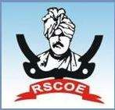

### SAVITRIBAI PHULE PUNE UNIVERSITY, PUNE MASTER IN COMPUTER APPLICATIONS

**RAJARSHI SHAHU COLLEGE OF ENGINEERING PUNE-411033 2024-2025**

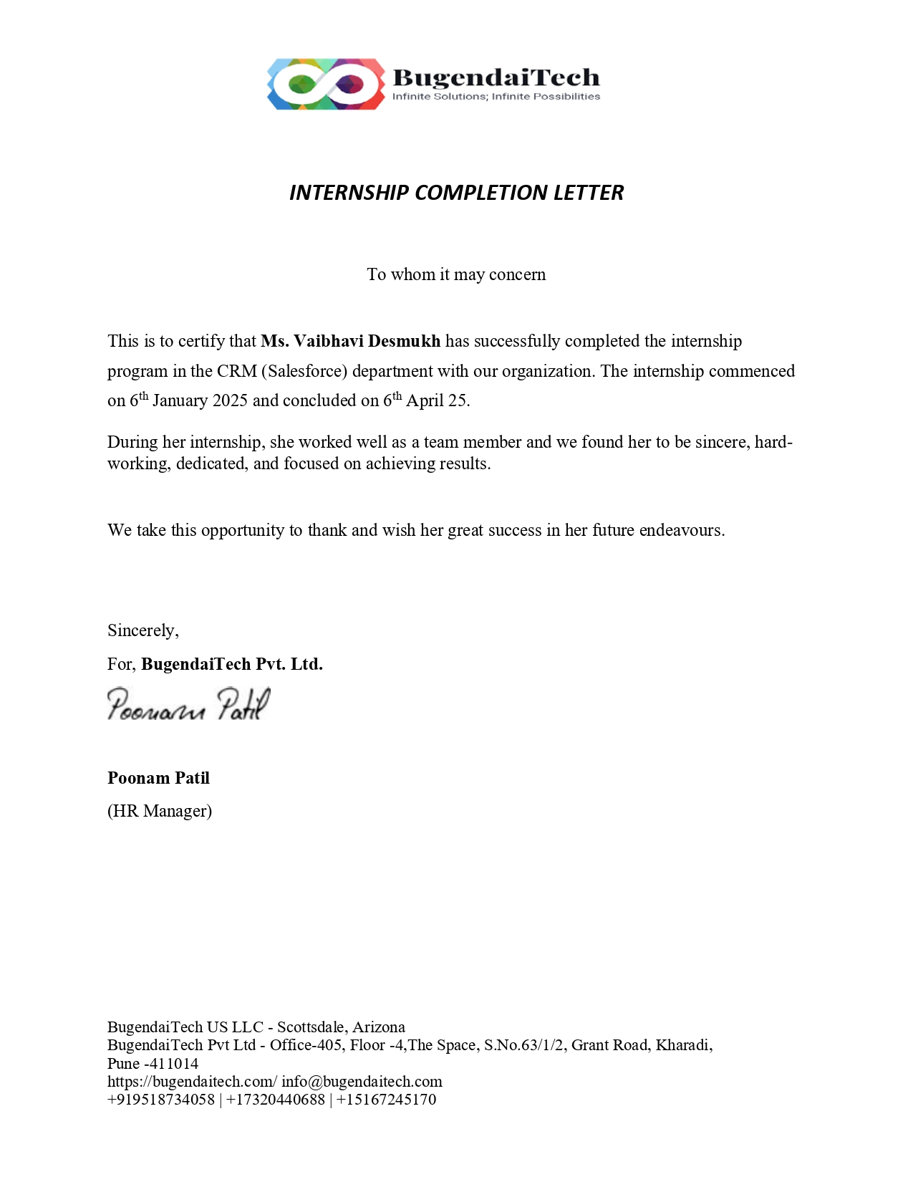

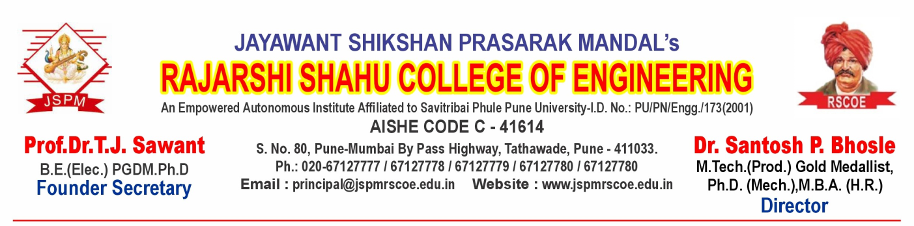

**Ref: RSCOE/MCA III/Project/2024-2025/5877 Date:22/4/25**

***CERTIFICATE***

This is to certify that **Mr. Aakash Deepak Bendale**, is a bonafide student of **JSPM’s Rajashri Shahu College of Engineering, Tathawade, Pune** has successfully completed the project work as prescribed by the Savitribai Phule Pune University, Pune, in the partial fulfillment of the **Master of Computer Application (MCA)** Program 2024- 2025.

The project work, titled as **“Cricket Data Analytics”**  has been carried out at the establishment of **Pentagon Space Pvt. Ltd**.

Exam No:

Project Guide H.O.D Director

**External Examiner:**

**Internal Examiner:**

**Date:**

**Place: Pune**

Sr. No. 80, Pune- Mumbai Bypass Highway, Tathawade, Pune- 411 033.

**Phone** : +91-020-229334344/4084/4347 **Telefax** : +91-020-22933424

**E-mail** : [rscoe@vsnl.net](mailto:rscoe@vsnl.net) **Website** : [www.jspmrscoe.edu.in](http://www.jspmrscoe.edu.in/)

**Declaration**

To

The Director,

Rajarshi Shahu College of Engineering, Tathawade,

Pune-33.

Respected Sir,

I, **Mr. Aakash Deepak Bendale** hereby declare that the project entitled “**Cricket Data Analytics**” developed and submitted under the guidance of  **Prof. Ragita Nair mam**, is my original work.

The system presented here is my own work and has not been duplicated from any other sources.

Thank You, Yours Sincerely,

Aakash D. Bendale

**Acknowledgement**

I would like to express my gratitude and sincere regards to the following people to whom I am grateful for their support and help without which I would not have been able to do this project entitled **“Cricket Data Analytics”.**

I would like to thank **Dr. Santosh Bhosle, Director**, R.S.C.O.E. for providing us with excellent facilities and valuable guidance.

I would like to express my profound and sincere gratitude to

**Dr. Rinku Dulloo, H.O.D.**, who has given all his co- operation and help to complete my project.

My special thanks to **Prof. Ragita Nair mam, Project Guide**, whose cooperation and keen interest coupled with valuable suggestion helped me in the completion of the project.

Last but not least, I am thankful to all **Teaching and Non- Teaching staff** of the college, whose names has not been mentioned here but have directly or indirectly, helped me in the completion of this project.

Aakash D. Bendale