DBMS:
Assignment 7
Rollback and Commit commands Create Teacher table with the following fields (Name, DeptNo, Date of joining, DeptName, Location, Salary)

( a ) Insert five records.
CODE:
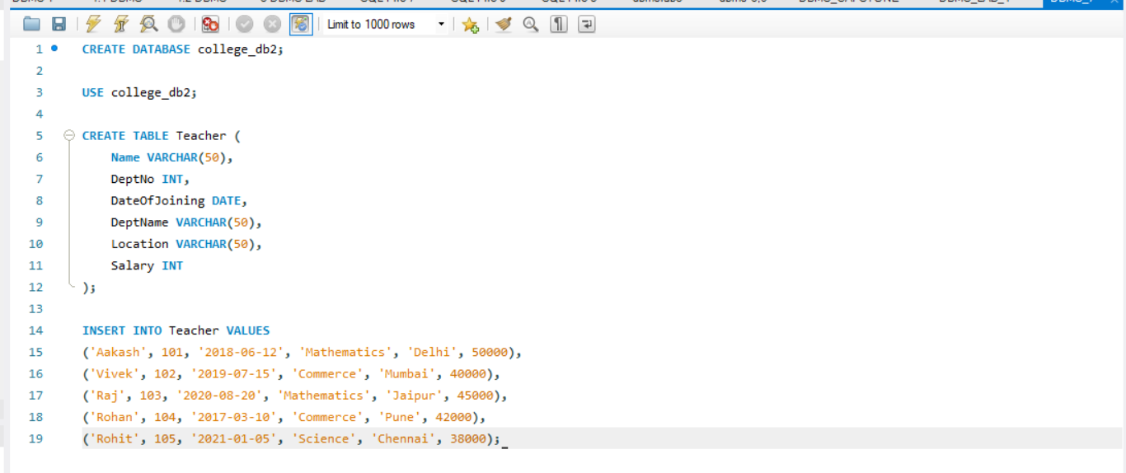

( b ) Give Increment of 25% salary for Mathematics Department .
CODE:
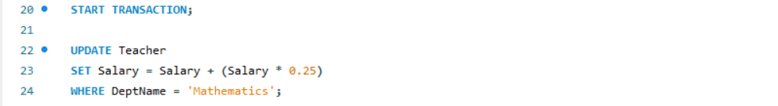

( c ) Perform Rollback command.
CODE:
(d)GiveIncrementof15%salaryforCommerce Department.
CODE:
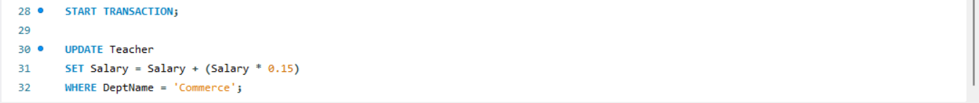

( e ) Perform commit command.
CODE:

OUTPUT:
