Lab Sheet 4

Lab Assignment: SQL User Management & Access Control

Title:
Implementation of User Creation, Deletion, and Privilege Management in SQL

Problem Statement
Design and execute SQL commands to create users, manage their access privileges, and remove users in a database system. This assignment focuses on database security and access control mechanisms.

Tasks

Part A: User Creation
- Create a new user named user1 with a password.
- Create another user user2 with limited access.

Part B: Granting Privileges
- Grant SELECT and INSERT privileges on a table Student to user1.
- Grant ALL privileges on a table Course to user2.
- Provide WITH GRANT OPTION to user1 and observe its effect.

Part C: Revoking Privileges
- Revoke INSERT permission from user1 on the Student table.
- Revoke all privileges from user2 on the Course table.

Part D: User Deletion
- Drop/Delete user user2 from the database.
- Attempt to login using deleted credentials and observe the result.

Part E: Additional Commands
- Display all users in the system.
- Show privileges assigned to a specific user.

CODE:

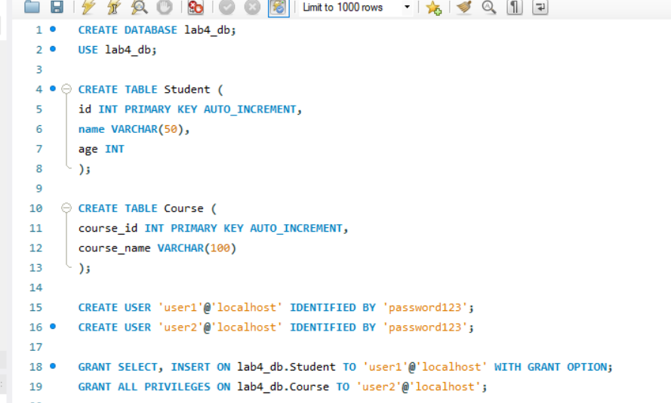
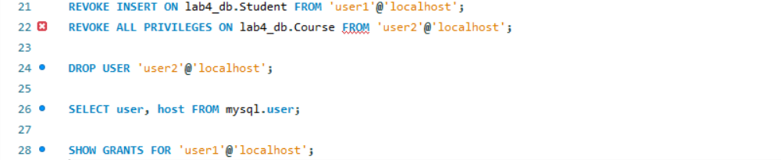

OUTPUT:
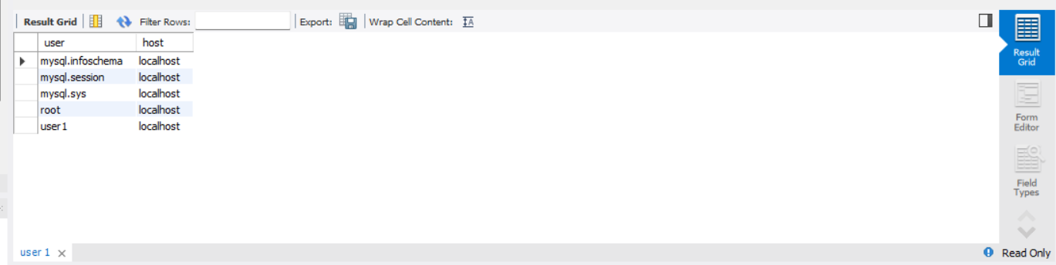
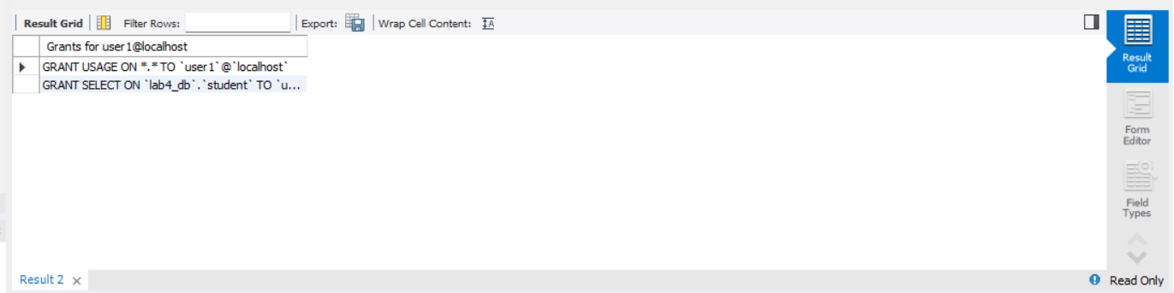

REPORT:

Title
Implementation of User Creation, Deletion, and Privilege Management in SQL

Objective
The objective of this lab assignment is to understand how database security is managed using SQL commands. It focuses on creating users, assigning privileges, revoking access, and deleting users.

Procedure

Part A: User Creation
Two users were created using SQL commands:
- user1 with a password
- user2 with a password
These users represent different levels of access in the database.

Part B: Granting Privileges
- user1 was granted SELECT and INSERT privileges on the Student table.
- user2 was granted ALL privileges on the Course table.
- The WITH GRANT OPTION was applied to user1, allowing this user to grant permissions to other users.

Part C: Revoking Privileges
- The INSERT privilege was revoked from user1, restricting their ability to add data.
- All privileges were revoked from user2 on the Course table, removing full access.

Part D: User Deletion
- The user user2 was deleted using the DROP USER command.
- When attempting to log in with deleted credentials, access was denied, confirming successful deletion.

Part E: Additional Commands
- All users in the system were displayed using system tables.
- Privileges assigned to user1 were checked using SHOW GRANTS.

Observations
- User creation allows controlled access to the database.
- Privileges can be finely controlled using GRANT and REVOKE.
- WITH GRANT OPTION enables delegation of permissions.
- Revoking privileges immediately affects user capabilities.
- Deleting a user removes all access rights permanently.

Conclusion
This assignment helped in understanding database security mechanisms. SQL provides powerful commands to manage user access and ensure data protection. Proper use of these commands ensures controlled and secure database operations.

