LAB ASSIGNMENT 5:

Assignment 5
(Exercise on retrieving records from the table)
EMPLOYEES (Employee_Id, First_Name, Last_Name, Email, Phone_Number, Hire_Date, Job_Id, Salary, Commission_Act, Manager_Id, Department_Id)
( a) Find out the employee id, names, salaries of all the employees
( b) List out the employees who works under manager 100
( c) Find the names of the employees who have a salary greater than or equal to 4800
( d) List out the employees whose last name is ‘AUSTIN’
( e) Find the names of the employees who works in departments 60,70 and 80 ( f ) Display the unique Manager_Id.

CODE:

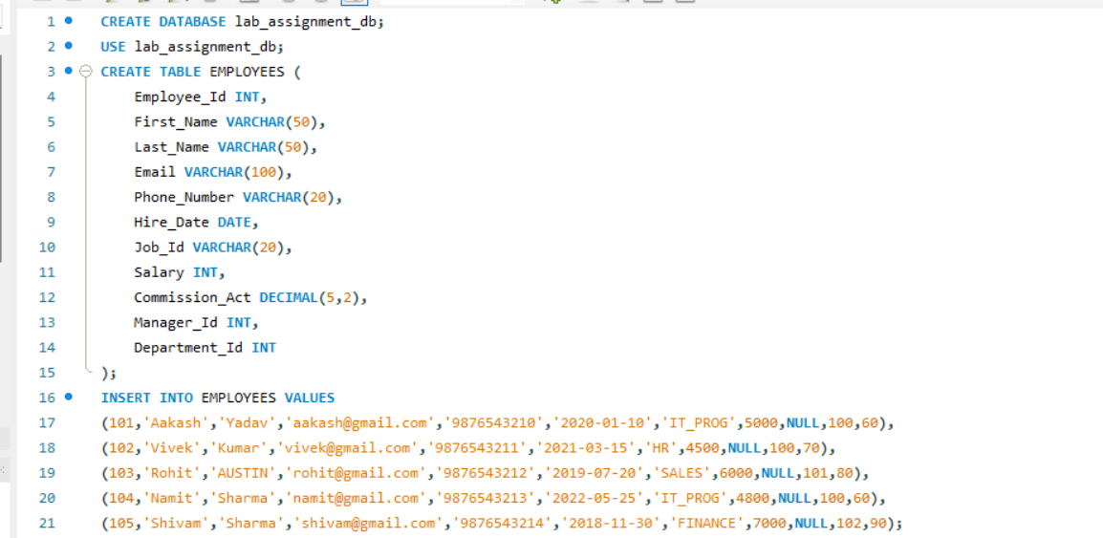

- Find out the employee id, names, salaries of all the employees.
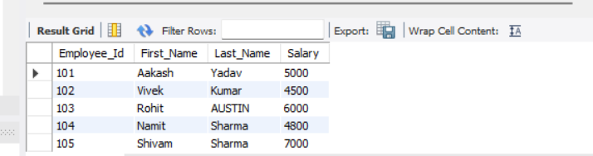
- List out the employees who works under manager 100

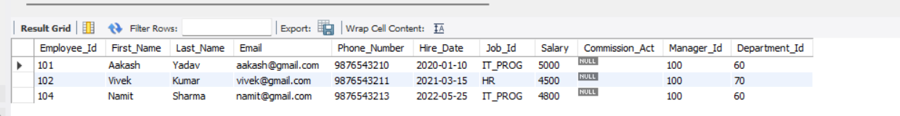
- Find the names of the employees who have a salary greater than or equal to 4800.

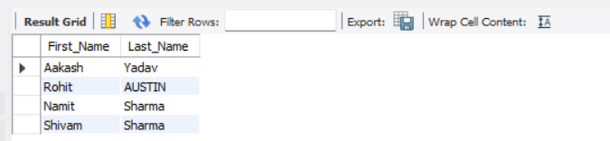
- List out the employees whose last name is ‘AUSTIN’.

- Find the names of the employees who works in departments 60, 70 and 80.

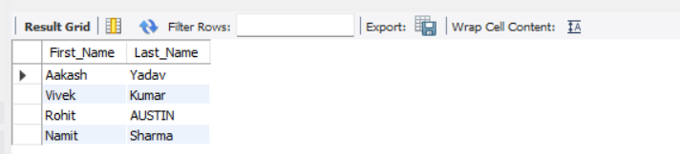
- Display the unique Manager_Id.

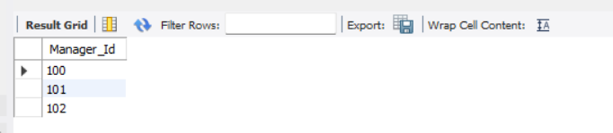

Assignment 6
(Exercise on updating records in table)
Create Client_master with the following fields (ClientNO, Name, Address, City, State, bal_due)
( a ) Insert five records.
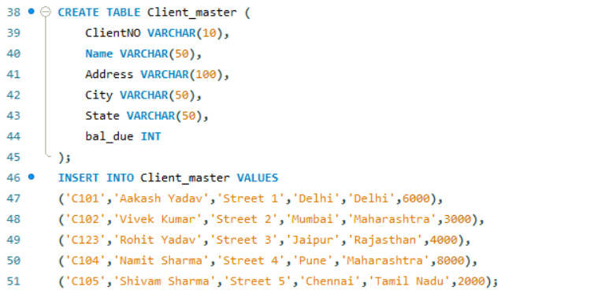
( b ) Find the names of clients whose bal_due> 5000 .
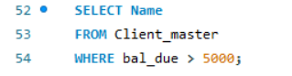
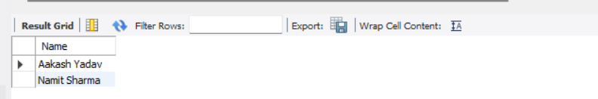
( c ) Change the bal_due of ClientNO “ C123” to Rs. 5100.

( d ) Change the name of Client_master to Client12.
( e ) Display the bal_due heading as “BALANCE”.

