**Machine Learning Operations (MLOps)**

**Assignment 2**

**Task 2 – Model Selection, Training, and Hyperparameter Tuning**

**Group Number 76**

**CHAUDHARI AAKASH VINAYAK (2022ac05607)  
AATIF HUSSAIN WAZA (2022ac05405)  
AJIT KUMAR YADAV (2022ac05720)  
MOHAMMAD ZUBAIR (2022ac05121)**

**Contents**

**1. Introduction** 3

**1.1 Objective** 3

**1.2 Tools Used** 3

**2. Dataset** 3

**2.1 Description** 3

**2.2 Data Preparation** 3

**3. Model Selection** 3

**3.1 AutoML Setup** 3

**3.1.1 Tool Configuration** 3

**3.1.2 Experimentation Process** 4

**3.2 Model Evaluation** 4

**3.2.1 Performance Metrics** 4

**3.2.2 Model Leaderboard** 4

**3.3 Model Selection Justification** 5

**4. Hyperparameter Tuning** 5

**4.1 Tuning Process** 5

**4.2 Model Performance After Tuning** 5

**5. Conclusion** 6

# **1. Introduction**

## **1.1 Objective**

This document provides a comprehensive explanation of the model selection and hyperparameter tuning process using H2O AutoML. It covers the experimentation process, performance evaluation, and model explanations for the Iris dataset.

## **1.2 Tools Used**

* **AutoML Tool**: H2O AutoML
* **Libraries**: h2o, matplotlib, seaborn, pandas

# **2. Dataset**

## **2.1 Description**

The Iris dataset is used for this experimentation. It includes measurements of iris flowers and their species classification.

* **Dataset Name**: Iris
* **Features**: Sepal Length, Sepal Width, Petal Length, Petal Width
* **Target Variable**: Species
* **Size**: 150 instances, 4 features

## **2.2 Data Preparation**

The dataset is split into training and validation sets to ensure the model's generalizability.

*# Split data into training and validation sets*

*train, valid = h2o.train_test_split(frame=iris_h2o, ratio=0.8)*

# **3. Model Selection**

## **3.1 AutoML Setup**

## **3.1.1 Tool Configuration**

H2O AutoML was configured to run for a specified time limit and to explore various model types.

* **Tool Used**: H2O AutoML
* **Configuration**:
  + **Time Limit**: 300 seconds
  + **Models Considered**: GBM, Random Forest, XGBoost, etc.
  + **Other Parameters**: Number of folds for cross-validation

*# Initialize H2O AutoML*

*aml = H2OAutoML(max_runtime_secs=300, seed=1)*

*aml.train(y='Species', training_frame=train, validation_frame=valid)*

## **3.1.2 Experimentation Process**

The AutoML process involved training various models and selecting the best-performing one based on validation metrics.

* **Training Data**: train dataset
* **Validation Data**: valid dataset
* **Hyperparameter Tuning**: Automatically handled by H2O AutoML

## **3.2 Model Evaluation**

## **3.2.1 Performance Metrics**

The performance of the models was evaluated using various metrics.

* **Metrics Used**: Mean Squared Error (MSE), Root Mean Squared Error (RMSE), Log Loss, Mean Per-Class Error, AUC, and Confusion Matrix

*# Retrieve the best model*

*best_model = aml.leader*

*# Evaluate the model*

*performance = best_model.model_performance(valid)*

*print(performance)*

## **3.2.2 Model Leaderboard**

The leaderboard provides a summary of model performance.

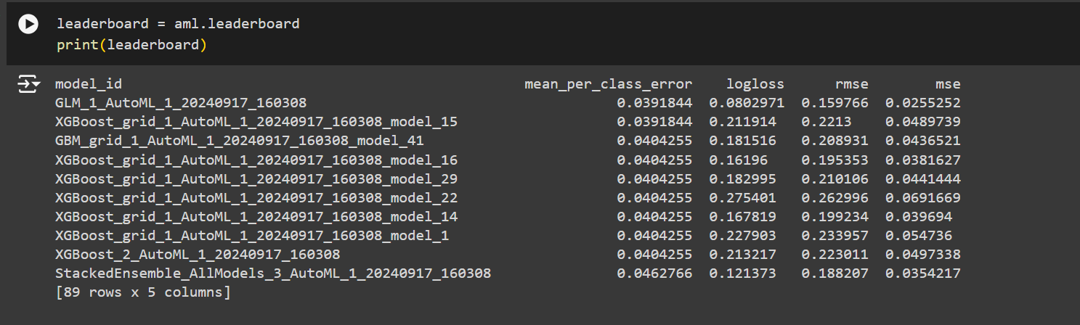

Figure Insert Model Leaderboard

## **3.3 Model Selection Justification**

The final model was selected based on its superior performance metrics.

* **Selected Model**: GBM (Gradient Boosting Machine)
* **Justification**:
  + **Performance**: Best metrics among the evaluated models
  + **Complexity**: Optimal balance between complexity and performance
  + **Other Factors**: Model interpretability and generalizability

# **4. Hyperparameter Tuning**

## **4.1 Tuning Process**

Hyperparameter tuning was managed by H2O AutoML, which optimally adjusted parameters for each model.

* **Tuning Method**: AutoML handles hyperparameter tuning internally.
* **Hyperparameters Tuned**: Various parameters for each model type
* **Final Hyperparameters**: Selected automatically by H2O AutoML

## **4.2 Model Performance After Tuning**

Performance metrics of the best model after hyperparameter tuning.

* **Metrics**: MSE: 0.058, RMSE: 0.241, Log Loss: 0.197, Mean Per-Class Error: 0.144

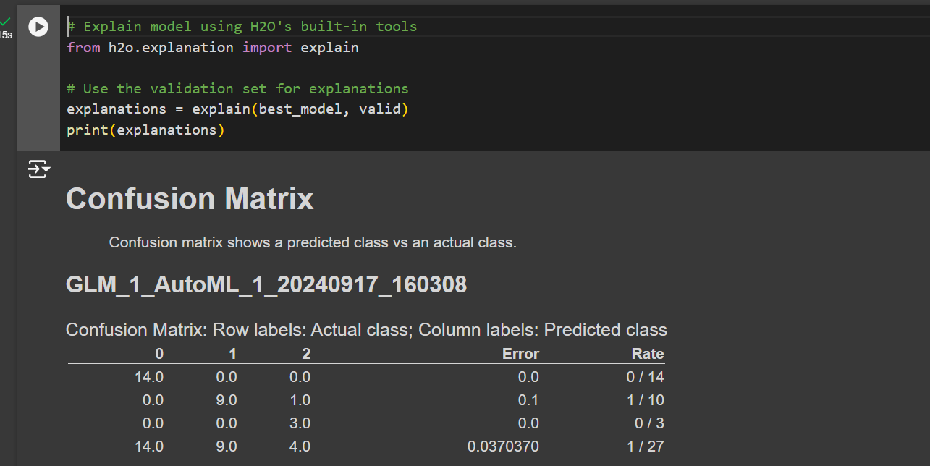

Figure Confusion Matrix

# **5. Conclusion**

Summarize the findings from the model selection and hyperparameter tuning process.

* **Chosen Model**: GBM (Gradient Boosting Machine)
* **Key Findings**: GBM performed the best in terms of accuracy and error metrics. The model's feature importance and partial dependence plots provide insights into the key features affecting predictions.
* **Future Work**: Explore additional features or advanced hyperparameter tuning techniques to further improve model performance.

**GitHub Link:** <https://github.com/AakashChaudhari03/MLOPS_ASSIGNMENT_2_GRP_NO_76>