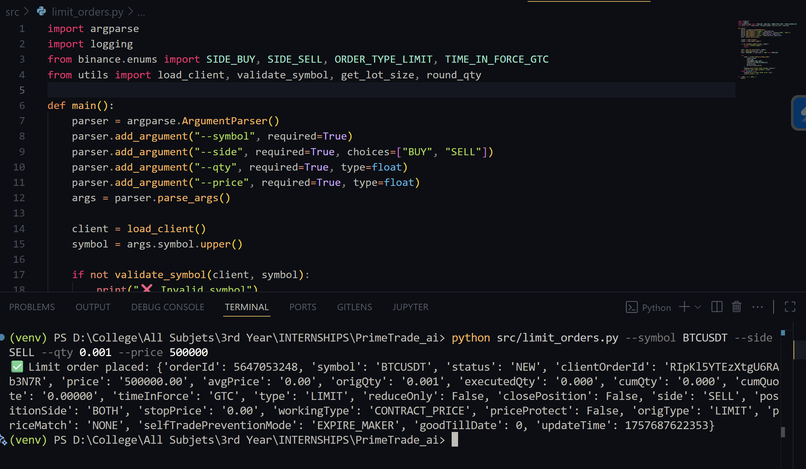

Command Run:
python src/market_orders.py --symbol BTCUSDT --side BUY --qty 0.01
Output Summary: Market order placed: {'symbol': 'BTCUSDT', 'status': 'FILLED', 'side': 'BUY', 'type': 'MARKET', ...}
Explanation:
- A Market Buy Order for 0.01 BTC was executed.
- status: 'FILLED' shows the order was completed instantly at the current market price.
- Market orders prioritize immediate execution over price, making them useful for quick entries or exits.

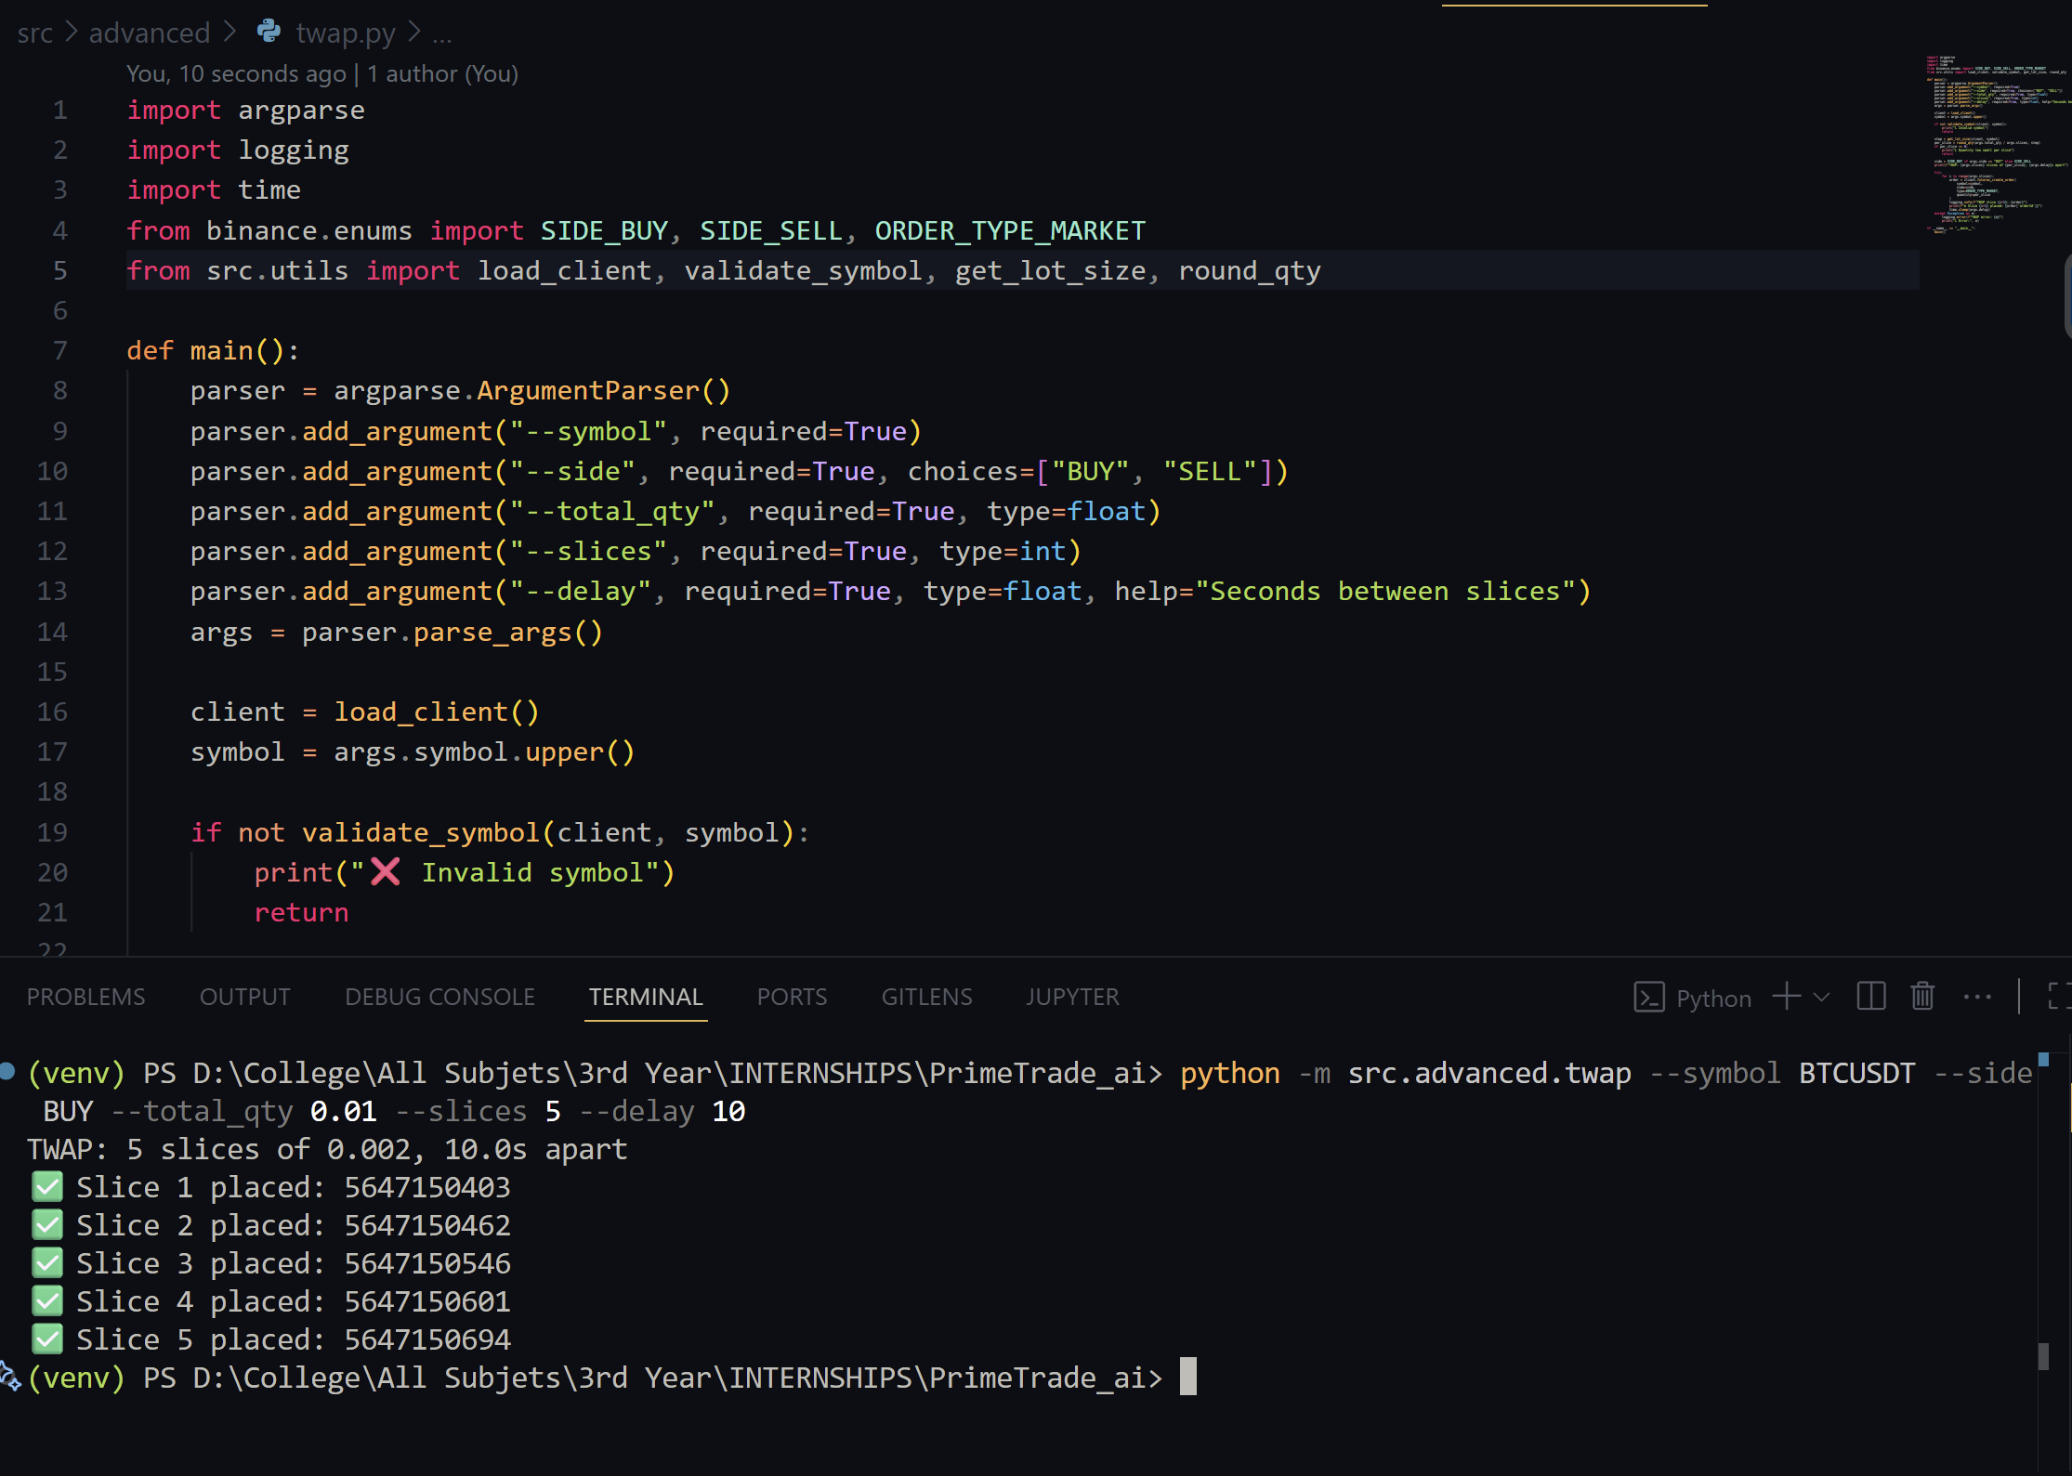

Command Run:
python src/limit_orders.py --symbol BTCUSDT --side SELL --qty 0.001 --price 50000
Output Summary:
-- Limit order placed: {'symbol': 'BTCUSDT', 'status': 'NEW', 'side': 'SELL', 'type': 'LIMIT', 'price': '50000.00', ...}
Explanation:
- A Limit Sell Order for 0.001 BTC at 50,000 USDT was placed.
- status: 'NEW' means the order is open and will only execute if the market price reaches 50,000.
- Limit orders provide control over the entry/exit price but do not guarantee execution.

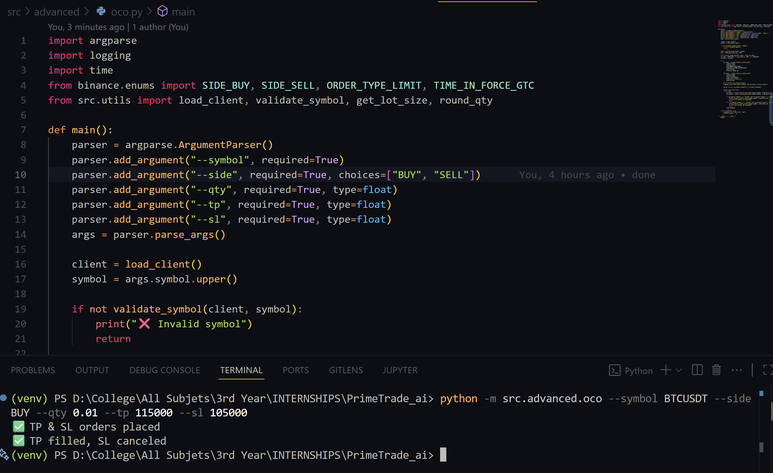

Command Run:
python -m src.advanced.oco --symbol BTCUSDT --side BUY --qty 0.01 --tp 115000 --sl 105000
Output Summary:
--TP & SL orders placed
Monitoring...
-- TP filled, SL canceled
Explanation:
- An OCO order was placed with two conditions:
  - Take-Profit (TP): Sell at 115,000 USDT.
  - Stop-Loss (SL): Sell if price drops to 105,000 USDT.
- If one order triggers, the other is automatically canceled (One Cancels the Other).
- This ensures automated risk management — either locking profit or cutting loss.

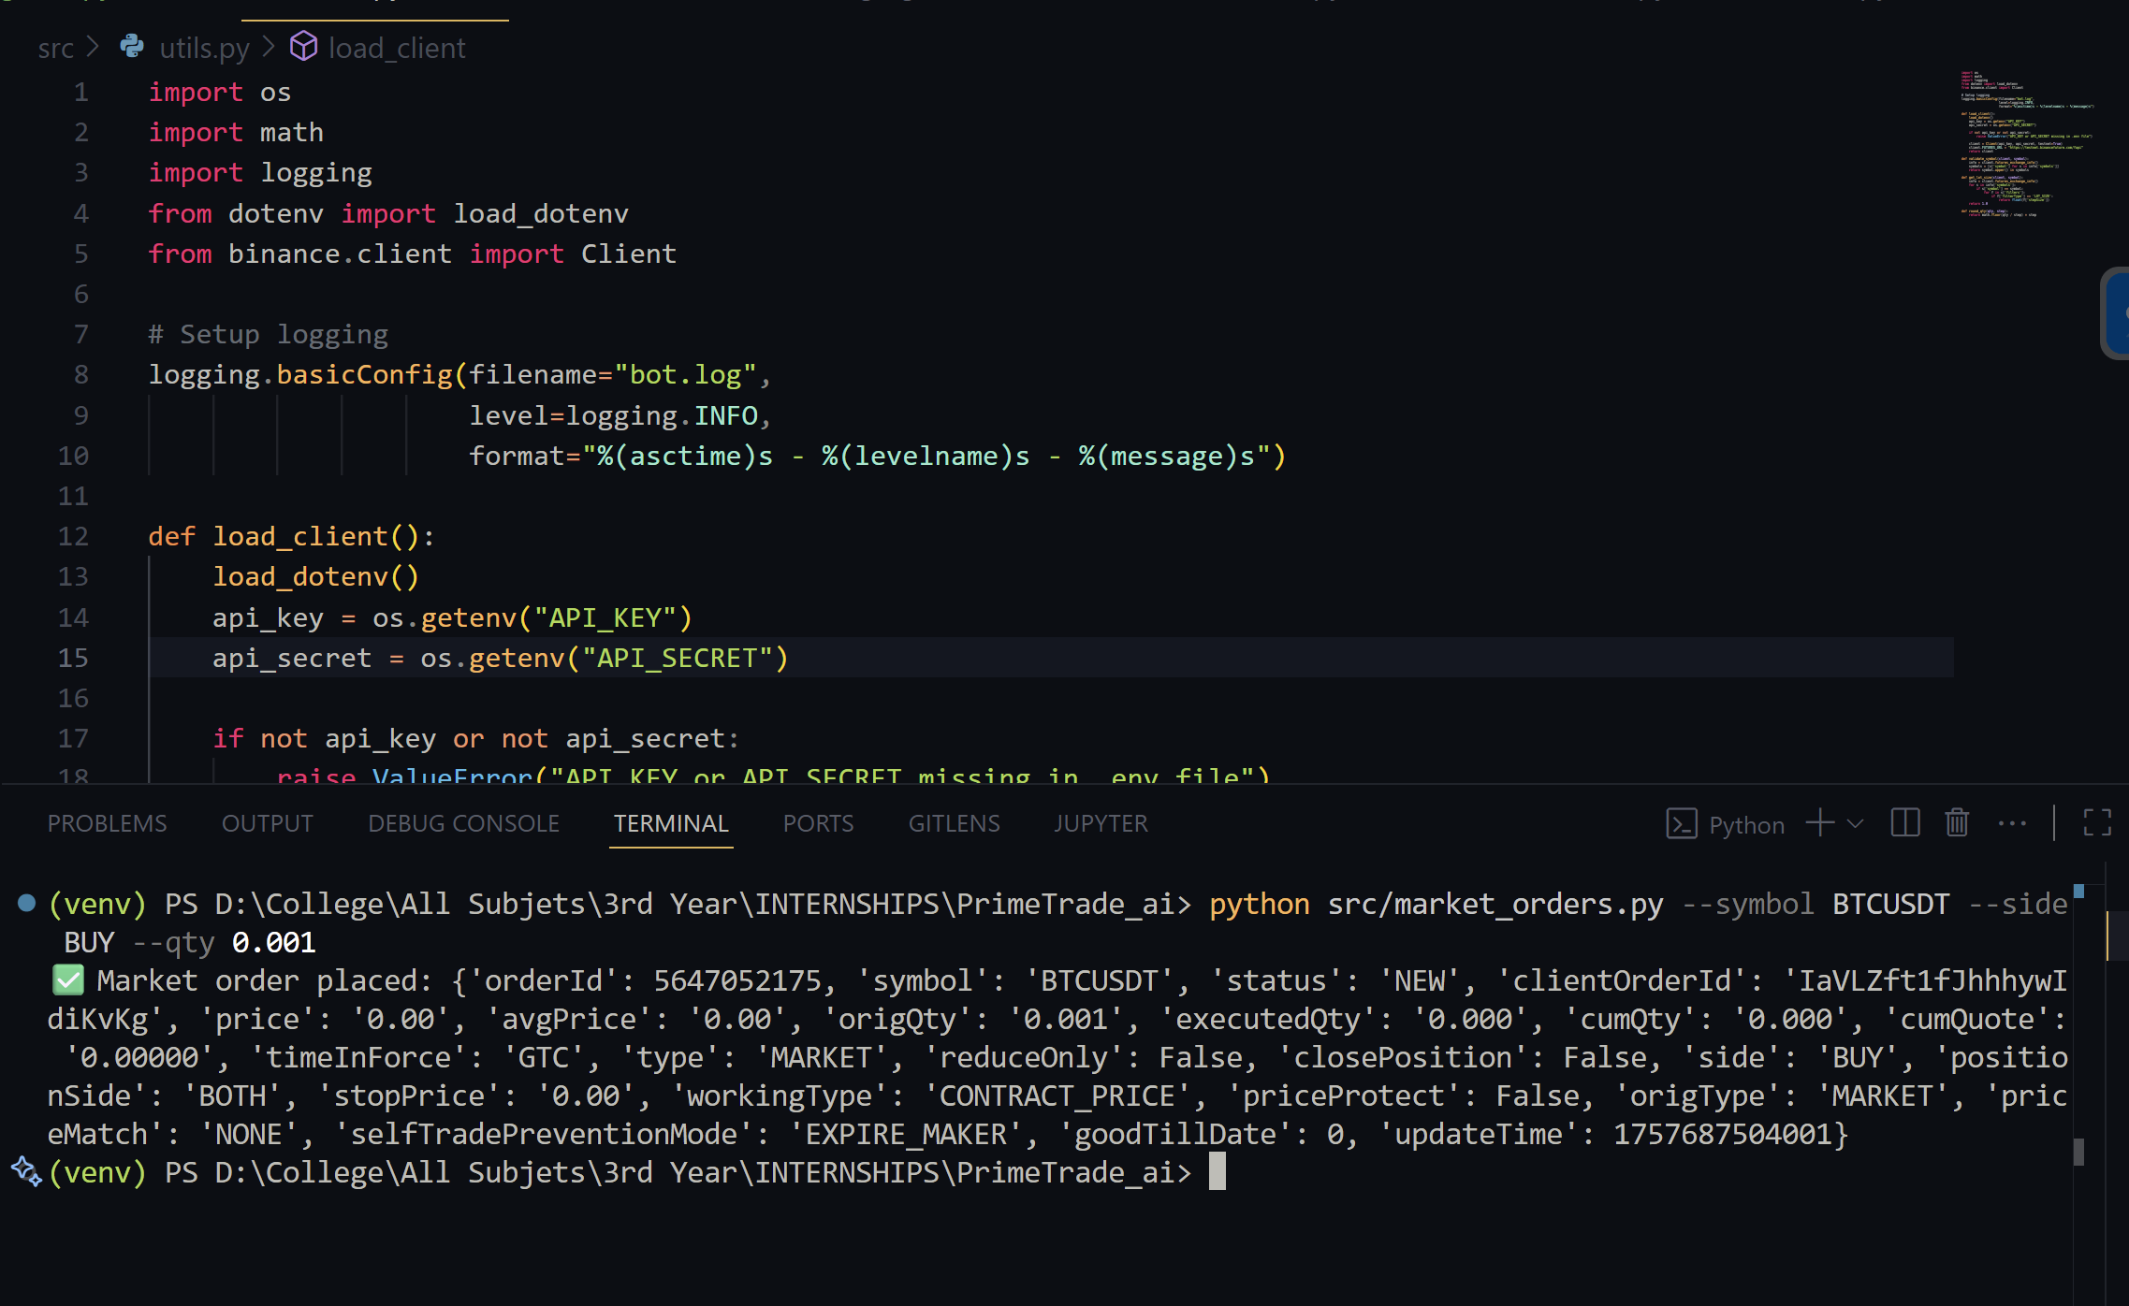

Command Run:
python -m src.advanced.twap --symbol BTCUSDT --side BUY --total_qty 0.01 --slices 5 --delay 10
Output Summary:
TWAP: 5 slices of 0.002, 10.0s apart
-- Slice 1 placed: orderId=5647150483
-- Slice 2 placed: orderId=5647150426
-- Slice 3 placed: orderId=5647150601
-- Slice 4 placed: orderId=5647150649
-- Slice 5 placed: orderId=5647150694
Explanation:
- A TWAP strategy split the total 0.01 BTC order into 5 smaller orders of 0.002 BTC each.
- Each order was placed 10 seconds apart, reducing market impact and smoothing out the average price.
- This demonstrates the bot’s capability for algorithmic execution strategies beyond simple trades.

