

Technical Safety Concept Lane Assistance

**Document Version: [Version]**

**Template Version 1.0, Released on 2017-06-21**



# Document history

**[Instructions: Fill in the date, version and description fields. You can fill out the Editor field with your name if you want to do so. Keep track of your editing as if this were a real world project.**

**For example, if this were your first draft or first submission, you might say version 1.0. If this is a second submission attempt, then you'd add a second line with a new date and version 2.0]**

|  |  |  |  |
| --- | --- | --- | --- |
| Date | Version | Editor | Description |
| 18/5/2018 | 1 | Aakash Gupta | First draft of Technical Safety Concept |
|  |  |  |  |
|  |  |  |  |
|  |  |  |  |
|  |  |  |  |

# 

# Table of Contents

**[Instructions: We have provided a table of contents. If the table of contents is not showing up correctly in your word processor of choice, please update it. The table of contents should show each section of the document and page numbers or links. Most word processors can do this for you. In** [**Google Docs**](https://support.google.com/docs/answer/116338?co=GENIE.Platform%3DDesktop&hl=en)**, you can use headings for each section and then go to Insert > Table of Contents.** [**Microsoft Word**](https://support.microsoft.com/en-us/help/285059/how-to-create-a-table-of-contents-by-marking-text-in-word) **has similar capabilities]**

Document history

Table of Contents

Purpose of the Technical Safety Concept

Inputs to the Technical Safety Concept

Functional Safety Requirements

Refined System Architecture from Functional Safety Concept

Functional overview of architecture elements

Technical Safety Concept

Technical Safety Requirements

Refinement of the System Architecture

Allocation of Technical Safety Requirements to Architecture Elements

Warning and Degradation Concept

# Purpose of the Technical Safety Concept

The purpose of the technical safety concept is to refine the functional safety requirements established in the functional safety concept into technical safety requirements. This is a crucial step before developing reliabel hardware and software. As part of product development technical safety concept involves:

* Turning functional safety requirements into technical safety requirements
* Allocating technical safety requirements to the system architecture

As a subsequent step technical safety requirements will be considered within software and hardware implementation.

# Inputs to the Technical Safety Concept

## Functional Safety Requirements

|  |  |  |  |  |
| --- | --- | --- | --- | --- |
| **ID** | **Functional Safety Requirement** | **ASIL** | **Fault Tolerant Time Interval** | **Safe State** |
| Functional  Safety  Requirement  01-01 | The Lane Departure Warning item shall ensure that the lane departure oscillating torque amplitude is below Max_Torque_Amplitude. | C | 50 ms | Vibration torque amplitude below Max_Torque_Amplitude. |
| Functional  Safety  Requirement  01-02 | The Lane Departure Warning item shall ensure that the lane departure oscillating torque frequency is below Max_Torque_Frequency. | C | 50 ms | Vibration frequency is below Max_Torque_Frequency. |
| Functional  Safety  Requirement  02-01 | The electronic power steering ECU shall ensure that the Lane Keeping Assistance torque is applied only Max_Duration. | B | 500 ms | Lane Keeping Assistance torque is zero. |

## Refined System Architecture from Functional Safety Concept

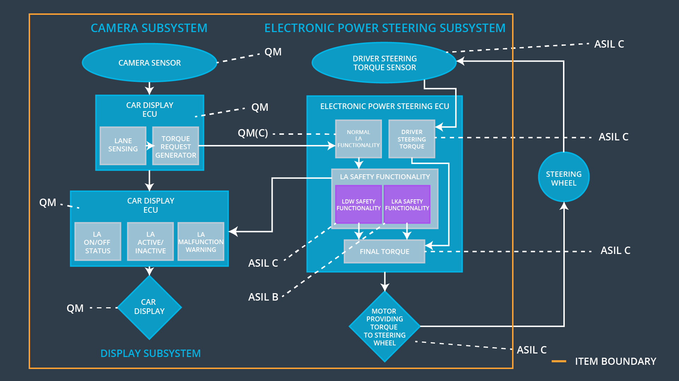

### 

### Functional overview of architecture elements

**[Instructions: Provide a description for each functional safety element; what is each element's purpose in the lane assistance item? ]**

|  |  |
| --- | --- |
| **Element** | **Description** |
| Camera Sensor | Capture road images and provide them to the Camera Sensor ECU. |
| Camera Sensor ECU - Lane Sensing | Software module detecting the lane line positions from the Camera Sensor images. |
| Camera Sensor ECU - Torque request generator | Software module calculating the necessary torque to be requested to the Electronic Power Steering ECU. |
| Car Display | Display warning for the driver. |
| Car Display ECU - Lane Assistance On/Off Status | Indicate the status of the Lane Assistance functionality (On/Off.) |
| Car Display ECU - Lane Assistant Active/Inactive | Indicate if the Lane Assistance functionality is properly functioning (Active/Inactive.) |
| Car Display ECU - Lane Assistance malfunction warning | Indicate a malfunction on the Lane Assistance functionality. |
| Driver Steering Torque Sensor | Measure the torque applied to the steering wheel by the driver. |
| Electronic Power Steering (EPS) ECU - Driver Steering Torque | Software module receiving the driver’s torque request from the steering wheel. |
| EPS ECU - Normal Lane Assistance Functionality | Software module receiving the Camera Sensor ECU torque request. |
| EPS ECU - Lane Departure Warning Safety Functionality | Software module ensuring the torque amplitude is below Max_Torque_Amplitude and torque frequency is below Max_Torque_Frequency. |
| EPS ECU - Lane Keeping Assistant Safety Functionality | Software module ensuring the Lane Keeping Assistance functionality application is not activate more than Max_duration time. |
| EPS ECU - Final Torque | Combine the torque request from the Lane Keeping and Lane Departure Warning functionalities and sends them to the Motor. |
| Motor | Applies the required torque to the steering wheels. |

# Technical Safety Concept

## Technical Safety Requirements

**Lane Departure Warning (LDW) Requirements:**

Functional Safety Requirement 01-01 with its associated system elements

(derived in the functional safety concept)

|  |  |  |  |  |
| --- | --- | --- | --- | --- |
| **ID** | **Functional Safety Requirement** | **Electronic Power Steering ECU** | **Camera ECU** | **Car Display ECU** |
| Functional  Safety  Requirement  01-01 | The lane keeping item shall ensure that the lane departure oscillating torque amplitude is below Max_Torque_Amplitude | X |  |  |

Technical Safety Requirements related to Functional Safety Requirement 01-01 are:

|  |  |  |  |  |  |
| --- | --- | --- | --- | --- | --- |
| **ID** | **Technical Safety Requirement** | **ASIL** | **Fault Tolerant Time Interval** | **Architecture Allocation** | **Safe State** |
| Technical  Safety  Requirement  01 | The Lane Departure Warning safety component shall ensure that the amplitude of the ‘LDW_Torque_Request’ sent to the ‘Final electronic power steering Torque’ component is below ‘Max_Torque_Amplitude.’ | C | 50 ms | LDW Safety | Lane Departure Warning torque to zero. |
| Technical  Safety  Requirement  02 | When a failure is detected by the Lane Departure Warning functionality, it shall deactivate the Lane Departure Warning feature and set ‘LDW_Torque_Request’ to zero. | C | 50 ms | LDW Safety | Lane Departure Warning torque to zero. |
| Technical  Safety  Requirement  03 | When the Lane Departure Warning is deactivated, the ‘LDW Safety’ software module shall send a signal to the Car Display ECU to turn on a warning signal. | C | 50 ms | LDW Safety | Lane Departure Warning torque to zero. |
| Technical  Safety  Requirement  04 | The validity and integrity of the data transmission for ‘LDW_Torque_Request’ signal shall be ensured. | C | 50 ms | LDW Safety | Lane Departure Warning torque to zero. |
| Technical  Safety  Requirement  05 | Memory test shall be conducted at start up of the EPS ECU to check for any memory problems | A | Ignition cycle | Data Transmission Integrity Check | LWD_Activation_Status is zero |

Functional Safety Requirement 01-2 with its associated system elements

(derived in the functional safety concept)

|  |  |  |  |  |
| --- | --- | --- | --- | --- |
| **ID** | **Functional Safety Requirement** | **Electronic Power Steering ECU** | **Camera ECU** | **Car Display ECU** |
| Functional  Safety  Requirement  01-02 | The lane keeping item shall ensure that the lane departure oscillating torque frequency is below Max_Torque_Frequency | X |  |  |

Technical Safety Requirements related to Functional Safety Requirement 01-02 are:

|  |  |  |  |  |  |
| --- | --- | --- | --- | --- | --- |
| **ID** | **Technical Safety Requirement** | **ASIL** | **Fault Tolerant Time Interval** | **Architecture Allocation** | **Safe State** |
| Technical  Safety  Requirement  01 | The Lane Departure Warning safety component shall ensure the frequency of the ‘LDW_Torque_Reques’ sent to the ‘Final electronic power steering Torque’ component is below ‘Max_Torque_Frequency.’ | C | 50 ms | LDW Safety | Lane Departure Warning torque to zero. |
| Technical  Safety  Requirement  02 | When a failure is detected by the Lane Departure Warning functionality, it shall deactivate the Lane Departure Warning feature and set ‘LDW_Torque_Request’ to zero. | C | 50 ms | LDW Safety | Lane Departure Warning torque to zero. |
| Technical  Safety  Requirement  03 | When the Lane Departure Warning is deactivated, the ‘LDW Safety’ software module shall send a signal to the Car Display ECU to turn on a warning signal. | C | 50 ms | LDW Safety | Lane Departure Warning torque to zero. |
| Technical  Safety  Requirement  04 | The validity and integrity of the data transmission for ‘LDW_Torque_Request’ signal shall be ensured. | C | 50 ms | LDW Safety | Lane Departure Warning torque to zero. |
| Technical  Safety  Requirement  05 | Memory test shall be conducted at start up of the EPS ECU to check for any memory problems | A | Ignition cycle | Data Transmission Integrity Check | LWD_Activation_Status is zero |

**Lane Keeping Assistance (LKA) Requirements:**

Functional Safety Requirement 02-1 with its associated system elements

(derived in the functional safety concept)

|  |  |  |  |  |
| --- | --- | --- | --- | --- |
| **ID** | **Functional Safety Requirement** | **Electronic Power Steering ECU** | **Camera ECU** | **Car Display ECU** |
| Functional  Safety  Requirement  02-01 | The lane keeping item shall ensure that the lane keeping assistance torque is applied for only Max_Duration | X |  |  |

Technical Safety Requirements related to Functional Safety Requirement 02-01 are:

|  |  |  |  |  |  |
| --- | --- | --- | --- | --- | --- |
| **ID** | **Technical Safety Requirement** | **ASIL** | **Fault Tolerant Time Interval** | **Allocation to Architecture** | **Safe State** |
| Technical  Safety  Requirement  01 | The Lane Keeping Assistance safety component shall ensure the duration of the lane keeping assistance torque is applied for less than Max_Duration | C | 500 ms | LKA Safety | Lane Keeping Assistance torque to zero. |
| Technical  Safety  Requirement  02 | When the Lane Keeping Assistance function deactivates, the ‘LKA Safety’ shall send a signal to the Car Display ECU to turn on a warning light. | C | 500 ms | LKA Safety | Lane Keeping Assistance torque to zero. |
| Technical  Safety  Requirement  03 | When a failure is detected, the Lane Keeping Assistance function shall deactivate and the ‘LKA_Torque_Request’ shall be zero. | C | 500 ms | LKA Safety | Lane Keeping Assistance torque to zero. |
| Technical  Safety  Requirement  04 | The validity and integrity of the data transmission for ‘LKA_Torque_Request’ signal shall be ensured. | C | 500 ms | LKA Safety | Lane Keeping Assistance torque to zero. |
| Technical  Safety  Requirement  05 | Memory test shall be conducted at start up of the EPS ECU to check for any memory problems | A | Ignition cycle | Data Transmission Integrity Check | Lane Departure Warning torque to zero. |

## Refinement of the System Architecture

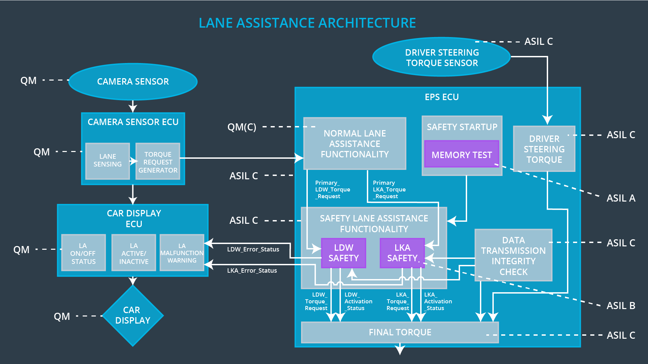

## Allocation of Technical Safety Requirements to Architecture Elements

**For LDW and LKA the technical requirements are mentioned in the tables above. All of these technical safety requirements are allocated to the Electronic Power Steering ECU.**

## Warning and Degradation Concept

WDC-01: lane departure warning function

WDC-02: lane keeping assistance function

|  |  |  |  |  |
| --- | --- | --- | --- | --- |
| **ID** | **Degradation Mode** | **Trigger for Degradation Mode** | **Safe State invoked?** | **Driver Warning** |
| WDC-01 | Turn off functionality | When oscillating time is greater than **Max_Allowed_Time** | Yes | Driver will see a warning light on the dashboard when the system malfunctions |
| WDC-02 | Turn off functionality | When oscillating toque amplitude is higher than **Max_Torque_Amplitude and** When oscillating toque frequency is more than **Max_Torque_Frequncy** | Yes | Driver will see a warning light on the dashboard when the system malfunctions |