

Functional Safety Concept Lane Assistance

**Document Version: [Version]**

**Template Version 1.0, Released on 2017-06-21**



# Document history

|  |  |  |  |
| --- | --- | --- | --- |
| Date | Version | Editor | Description |
| 16/5/2018 | 1 | Aakash Gupta | This is the first attempt to complete the document |
|  |  |  |  |
|  |  |  |  |
|  |  |  |  |
|  |  |  |  |

# Table of Contents

Document history

Table of Contents

Purpose of the Functional Safety Concept

Inputs to the Functional Safety Analysis

Safety goals from the Hazard Analysis and Risk Assessment

Preliminary Architecture

Description of architecture elements

Functional Safety Concept

Functional Safety Analysis

Functional Safety Requirements

Refinement of the System Architecture

Allocation of Functional Safety Requirements to Architecture Elements

Warning and Degradation Concept

# Purpose of the Functional Safety Concept

On the Functional Safety Concept documents the system high level requirements are identified. These requirements are allocated to different parts of the item architecture. Technical safety requirements will be derived from these safety concepts. Instruction on how to validate and verify the requirements are presented as well.

# Inputs to the Functional Safety Concept

## Safety goals from the Hazard Analysis and Risk Assessment

1. **Lane Departure Warning:**

**Problem:**

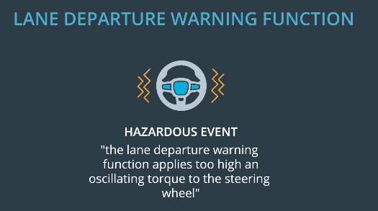

**Safety Goal:**

**The oscillating steering torque from the lane departure warning function shall be limited.**

1. **Lane Keeping Assistance:**

**Safety Goal:**

**The lane keeping assistance function shall be time limited and the additional steering torque shall end after a given time interval so that the driver cannot misuse the system for autonomous driving.**

**OPTIONAL:**

|  |  |
| --- | --- |
| **ID** | **Safety Goal** |
| Safety_Goal_01 | The lane keeping assistance function should only be activated if driver has at least one hand on steering and it should not just deactivate if driver leaves both the hands for 1-2 seconds. |

## Preliminary Architecture

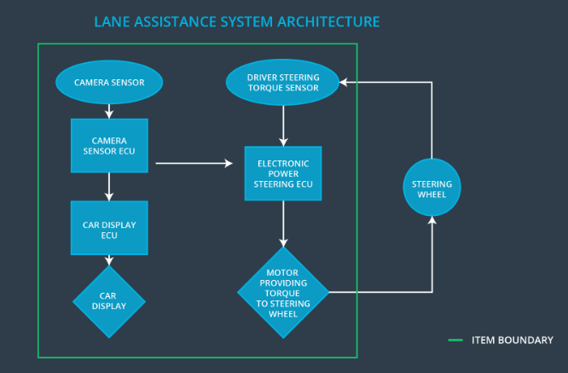

Here, item is the lane assistance system.

The item boundary is drawn to include three sub-systems:

* Camera system
* Electronic Power Steering system
* Car Display system

### Description of architecture elements

**[Instructions: Provide a description for each of the item elements; what is each element's purpose in the lane assistance item? ]**

|  |  |
| --- | --- |
| **Element** | **Description** |
| Camera Sensor | Keeps track of the lane and  detects lane departures. |
| Camera Sensor ECU | Has the hardware and software required for deep learning or for computer vision techniques like the Hough transform. |
| Car Display | Displays warning light on display dashboard. It can also be used to display lane departure status. |
| Car Display ECU | Drive the Car Display component to show the Lane Keeping Assistance warning and Lane Departure Assistance status. |
| Driver Steering Torque Sensor | Measure torque applied to steering wheel by the driver. |
| Electronic Power Steering ECU | Send signal to motor for turning the steering wheel by calculating from the values received from Driver Steering Torque Sensor and from lane keeping and warning system. |
| Motor | Apply the torque to steering wheel according to the Electronic Power Steering ECU. |

# Functional Safety Concept

The functional safety concept consists of:

* Functional safety analysis
* Functional safety requirements
* Functional safety architecture
* Warning and degradation concept

## Functional Safety Analysis

**[Instructions: Fill in the functional safety analysis table below.]**

|  |  |  |  |
| --- | --- | --- | --- |
| **Malfunction ID** | **Main Function of the Item Related to Safety Goal Violations** | **Guidewords (NO, WRONG, EARLY, LATE, MORE, LESS)** | **Resulting Malfunction** |
| Malfunction_01 | Lane Departure Warning (LDW) function shall apply an oscillating steering torque to provide the driver a haptic feedback | MORE | The Lane Departure Warning function applies an oscillating torque with very high torque frequency (above **Max_Torque_Frequncy)** |
| Malfunction_02 | Lane Departure Warning (LDW) function shall apply an oscillating steering torque to provide the driver a haptic feedback | MORE | The Lane Departure Warning function applies an oscillating torque with very high torque amplitude (above **Max_Torque_Amplitude)** |
| Malfunction_03 | Lane Keeping Assistance (LKA) function shall apply the steering torque when active in order to stay in ego lane | NO | The Lane Keeping Assistance function is not limited in time duration which lead to misuse as an autonomous driving function |

## Functional Safety Requirements

Lane Departure Warning (LDW) Requirements:

|  |  |  |  |  |
| --- | --- | --- | --- | --- |
| **ID** | **Functional Safety Requirement** | **ASIL** | **Fault Tolerant Time Interval** | **Safe State** |
| Functional  Safety  Requirement  01-01 | The lane keeping item shall ensure that the lane departure oscillating toque amplitude is below **Max_Torque_Amplitude** | C | 50 ms | Vibration torque amplitude below **Max_Torque_Amplitude** |
| Functional  Safety  Requirement  01-02 | The lane keeping item shall ensure that the lane departure oscillating toque frequency is below **Max_Torque_Frequency** | C | 50 ms | Vibration torque amplitude below **Max_Torque_Frequency** |

Reference for above table:

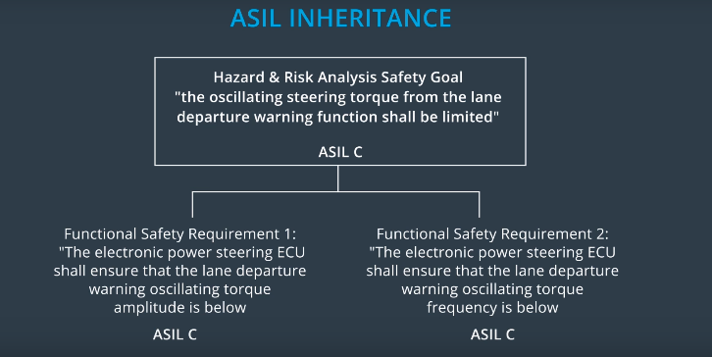

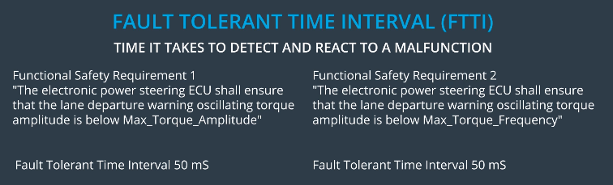

Lane Departure Warning (LDW) Verification and Validation Acceptance Criteria:

|  |  |  |
| --- | --- | --- |
| **ID** | **Validation Acceptance**  **Criteria and Method** | **Verification Acceptance**  **Criteria and Method** |
| Functional  Safety  Requirement  01-01 | To validate that we chose a reasonable value we can conduct test how drivers react to different torque amplitudes. Hence proving that we chose an appropriate value. | When the torque amplitude crosses the limit, the lane assistance output is set to zero within the 50 ms fault tolerant time interval. We can do a software test inserting a fault into the system and see if system turns off. |
| Functional  Safety  Requirement  01-02 | To validate that we chose a reasonable value we can conduct test how drivers react to different torque frequencies. Hence proving that we chose an appropriate value. | When the torque frequency crosses the limit, the lane assistance output is set to zero within the 50 ms fault tolerant time interval. We can do a software test inserting a fault into the system and see if system turns off. |

**[Instructions: Fill in the functional safety requirements for the lane keeping assistance]**

Lane Keeping Assistance (LKA) Requirements:

|  |  |  |  |  |
| --- | --- | --- | --- | --- |
| **ID** | **Functional Safety Requirement** | **ASIL** | **Fault Tolerant Time Interval** | **Safe State** |
| Functional  Safety  Requirement  02-01 | The electronic power steering ECU shall ensure that the Lane Keeping Assistance torque is applied only Max_Duration. | B | 500ms | Lane Keeping Assistance torque is zero. |

Lane Keeping Assistance (LKA) Verification and Validation Acceptance Criteria:

|  |  |  |
| --- | --- | --- |
| **ID** | **Validation Acceptance**  **Criteria and Method** | **Verification Acceptance**  **Criteria and Method** |
| Functional  Safety  Requirement  02-01 | Validate the Max_Duration chosen not allow the driver to use the car as self-driving car. | Verify the system does deactivate if the Lane Keeping Assistance torque application exceeded Max_Duration. |

## Refinement of the System Architecture

## 

## Allocation of Functional Safety Requirements to Architecture Elements

|  |  |  |  |  |
| --- | --- | --- | --- | --- |
| **ID** | **Functional Safety Requirement** | **Electronic Power Steering ECU** | **Camera ECU** | **Car Display ECU** |
| Functional  Safety  Requirement  01-01 | To validate that we chose a reasonable value we can conduct test how drivers react to different torque amplitudes. Hence proving that we chose an appropriate value. |  |  |  |
| Functional  Safety  Requirement  01-02 | To validate that we chose a reasonable value we can conduct test how drivers react to different torque frequencies. Hence proving that we chose an appropriate value. |  |  |  |
| Functional  Safety  Requirement  02-01 | The electronic power steering ECU shall ensure that the Lane Keeping Assistance torque is applied only Max_Duration. |  |  |  |

## 

## Warning and Degradation Concept

WDC-01: lane departure warning function

WDC-02: lane keeping assistance function

|  |  |  |  |  |
| --- | --- | --- | --- | --- |
| **ID** | **Degradation Mode** | **Trigger for Degradation Mode** | **Safe State invoked?** | **Driver Warning** |
| WDC-01 | Turn off functionality | When oscillating time is greater than **Max_Allowed_Time** | Yes | Driver will see a warning light on the dashboard when the system malfunctions |
| WDC-02 | Turn off functionality | When oscillating toque amplitude is higher than **Max_Torque_Amplitude and** When oscillating toque frequency is more than **Max_Torque_Frequncy** | Yes | Driver will see a warning light on the dashboard when the system malfunctions |