

Functional Safety Concept Lane Assistance

**Document Version: [Version]**

**Template Version 1.0, Released on 2017-06-21**



# Document history

|  |  |  |  |
| --- | --- | --- | --- |
| Date | Version | Editor | Description |
| 16/5/2018 | 1 | Aakash Gupta | This is the first attempt to complete the document |
|  |  |  |  |
|  |  |  |  |
|  |  |  |  |
|  |  |  |  |

# Table of Contents

Document history

Table of Contents

Purpose of the Functional Safety Concept

Inputs to the Functional Safety Analysis

Safety goals from the Hazard Analysis and Risk Assessment

Preliminary Architecture

Description of architecture elements

Functional Safety Concept

Functional Safety Analysis

Functional Safety Requirements

Refinement of the System Architecture

Allocation of Functional Safety Requirements to Architecture Elements

Warning and Degradation Concept

# Purpose of the Functional Safety Concept

**[Instructions: Answer what is the purpose of a functional safety concept?]**

**#PENDING**

# Inputs to the Functional Safety Concept

## Safety goals from the Hazard Analysis and Risk Assessment

1. **Lane Departure Warning:**

**Problem:**

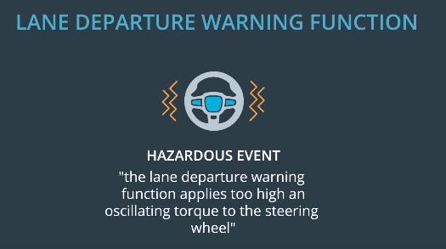

**Safety Goal:**

**The oscillating steering torque from the lane departure warning function shall be limited.**

1. **Lane Keeping Assistance:**

**Safety Goal:**

**The lane keeping assistance function shall be time limited and the additional steering torque shall end after a given time interval so that the driver cannot misuse the system for autonomous driving.**

**OPTIONAL:**

|  |  |
| --- | --- |
| **ID** | **Safety Goal** |
| Safety_Goal_01 | The lane keeping assistance function should only be activated if driver has at least one hand on steering and it should not just deactivate if driver leaves both the hands for 1-2 seconds. |

## Preliminary Architecture

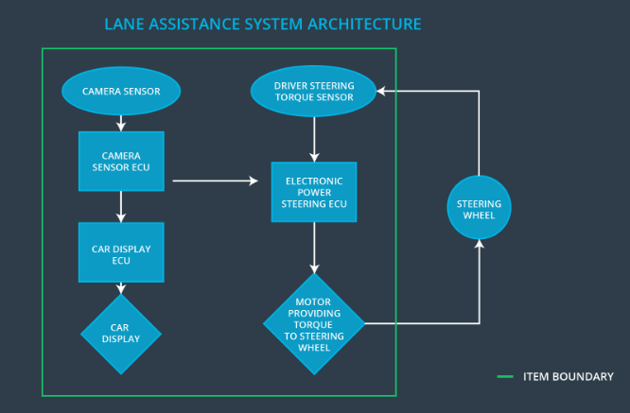

Here, item is the lane assistance system.

The item boundary is drawn to include three sub-systems:

* Camera system
* Electronic Power Steering system
* Car Display system

### Description of architecture elements

**[Instructions: Provide a description for each of the item elements; what is each element's purpose in the lane assistance item? ]**

|  |  |
| --- | --- |
| **Element** | **Description** |
| Camera Sensor | Keeps track of the lane and  detects lane departures. |
| Camera Sensor ECU | Has the hardware and software required for deep learning or for computer vision techniques like the Hough transform. |
| Car Display | Displays warning light on display dashboard. It can also be used to display lane departure status. |
| Car Display ECU | Drive the Car Display component to show the Lane Keeping Assistance warning and Lane Departure Assistance status. |
| Driver Steering Torque Sensor | Measure torque applied to steering wheel by the driver. |
| Electronic Power Steering ECU | Send signal to motor for turning the steering wheel by calculating from the values received from Driver Steering Torque Sensor and from lane keeping and warning system. |
| Motor | Apply the torque to steering wheel according to the Electronic Power Steering ECU. |

# Functional Safety Concept

The functional safety concept consists of:

* Functional safety analysis
* Functional safety requirements
* Functional safety architecture
* Warning and degradation concept

## Functional Safety Analysis

**[Instructions: Fill in the functional safety analysis table below.]**

|  |  |  |  |
| --- | --- | --- | --- |
| **Malfunction ID** | **Main Function of the Item Related to Safety Goal Violations** | **Guidewords (NO, WRONG, EARLY, LATE, MORE, LESS)** | **Resulting Malfunction** |
| Malfunction_01 | Lane Departure Warning (LDW) function shall apply an oscillating steering torque to provide the driver a haptic feedback |  |  |
| Malfunction_02 | Lane Departure Warning (LDW) function shall apply an oscillating steering torque to provide the driver a haptic feedback |  |  |
| Malfunction_03 | Lane Keeping Assistance (LKA) function shall apply the steering torque when active in order to stay in ego lane |  |  |

## Functional Safety Requirements

**[Instructions: Fill in the functional safety requirements for the lane departure warning ]**

Lane Departure Warning (LDW) Requirements:

|  |  |  |  |  |
| --- | --- | --- | --- | --- |
| **ID** | **Functional Safety Requirement** | **ASIL** | **Fault Tolerant Time Interval** | **Safe State** |
| Functional  Safety  Requirement  01-01 |  |  |  |  |
| Functional  Safety  Requirement  01-02 |  |  |  |  |

Lane Departure Warning (LDW) Verification and Validation Acceptance Criteria:

|  |  |  |
| --- | --- | --- |
| **ID** | **Validation Acceptance**  **Criteria and Method** | **Verification Acceptance**  **Criteria and Method** |
| Functional  Safety  Requirement  01-01 |  |  |
| Functional  Safety  Requirement  01-02 |  |  |

**[Instructions: Fill in the functional safety requirements for the lane keeping assistance]**

Lane Keeping Assistance (LKA) Requirements:

|  |  |  |  |  |
| --- | --- | --- | --- | --- |
| **ID** | **Functional Safety Requirement** | **ASIL** | **Fault Tolerant Time Interval** | **Safe State** |
| Functional  Safety  Requirement  02-01 |  |  |  |  |

Lane Keeping Assistance (LKA) Verification and Validation Acceptance Criteria:

|  |  |  |
| --- | --- | --- |
| **ID** | **Validation Acceptance**  **Criteria and Method** | **Verification Acceptance**  **Criteria and Method** |
| Functional  Safety  Requirement  02-01 |  |  |

## Refinement of the System Architecture

**[Instructions: Include the refined system architecture. Hint: The refined system architecture should include the system architecture from the end of the functional safety lesson including all of the ASIL labels.]**

## Allocation of Functional Safety Requirements to Architecture Elements

**[Instructions: Mark which element or elements are responsible for meeting the functional safety requirement. Hint: Only one ECU is responsible for meeting all of the requirements.]**

|  |  |  |  |  |
| --- | --- | --- | --- | --- |
| **ID** | **Functional Safety Requirement** | **Electronic Power Steering ECU** | **Camera ECU** | **Car Display ECU** |
| Functional  Safety  Requirement  01-01 |  |  |  |  |
| Functional  Safety  Requirement  01-02 |  |  |  |  |
| Functional  Safety  Requirement  02-01 |  |  |  |  |

## Warning and Degradation Concept

**[Instructions: Fill in the warning and degradation concept.]**

|  |  |  |  |  |
| --- | --- | --- | --- | --- |
| **ID** | **Degradation Mode** | **Trigger for Degradation Mode** | **Safe State invoked?** | **Driver Warning** |
| WDC-01 |  |  |  |  |
| WDC-02 |  |  |  |  |