**Program No. 2**

Objective:- WAP for Addition, Multiplication and Subtraction of Complex Number

#include<stdio.h>

#include<conio.h>

typedef struct Complex

{

double real;

double imag;

} Complex;

Complex C_Addition(Complex z1,Complex z2);

Complex C_Subtraction(Complex z1,Complex z2);

Complex C_Multiplication(Complex z1,Complex z2);

main()

{

Complex z,z1,z2,z3,z4;

printf("Enter the first complex number=");

getch();

printf("\nEnter the first complex number real part=");

scanf("%lf",&z1.real);

printf("Enter the first complex number imag part=");

scanf("%lf",&z1.imag);

printf("\n");

printf("Enter the second complex number=");

getch();

printf("\nEnter the second complex number real part=");

scanf("%lf",&z2.real);

printf("Enter the second complex number imag part=");

scanf("%lf",&z2.imag);

z=C_Addition(z1,z2);

printf("\n");

printf("Sum of complex number=");

getch();

printf("\nSum of complex number real part=%lf",z.real);

getch();

printf("\nSum of complex number imag part=%lf",z.imag);

z3=C_Multiplication(z1,z2);

printf("\n");

printf("\nMultiplication of complex number=");

getch();

printf("\nMultiplication of complex number real part=%lf",z3.real);

getch();

printf("\nMultiplication of complex number imag part=%lf",z3.imag);

z4=C_Subtraction(z1,z2);

printf("\n");

printf("\nSubtraction of complex number=");

getch();

printf("\nSubtraction of complex number real part=%lf",z4.real);

getch();

printf("\nSubtraction of complex number imag part=%lf",z4.imag);

}

Complex C_Addition(Complex z1,Complex z2)

{

Complex z;

z.real=z1.real+z2.real;

z.imag=z1.imag+z2.imag;

return z;

}

Complex C_Multiplication(Complex z1,Complex z2)

{

Complex z3;

z3.real=(z1.real*z2.real-z1.imag*z2.imag);

z3.imag=(z1.imag*z2.real+z2.imag*z1.real);

return z3;

}

Complex C_Subtraction(Complex z1,Complex z2)

{

Complex z4;

z4.real=z1.real-z2.real;

z4.imag=z1.imag-z2.imag;

return z4;

}

Output:-

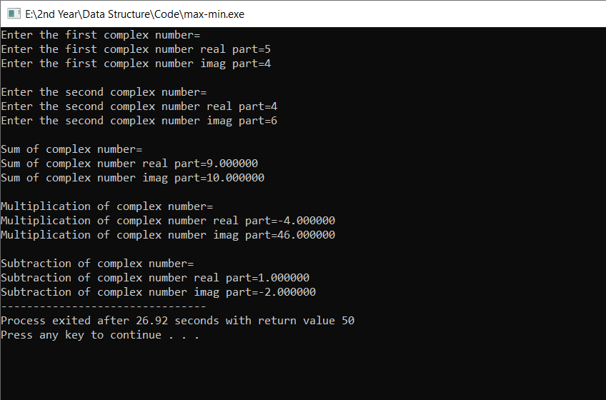

Addition, Multiplication and Subtraction of Complex Number