**Program No. 3**

Objective:- WAP for converting decimal number to binary number

#include<stdio.h>

void Aakash_Binary();

main()

{

printf("Enter The Decimal Number=");

Aakash_Binary();

}

void Aakash_Binary()

{

int num,B[20],count=0,i;

scanf("%d",&num);

while(num>0)

{

B[count]=num%2;

num=num/2;

count++;

}

printf("\n Binary Digits=");

for(i=(count-1);i>=0;i--)

printf("%d",B[i]);

}

Output:-

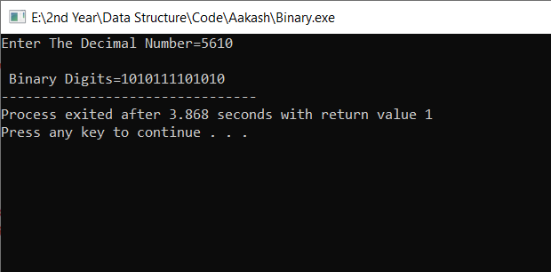

Converting decimal number to binary number