**Program No. 1**

Objective:- WAP for finding maximum and minimum element of an array of nth size

#include<stdio.h>

main()

{

int a[100],i,max,min,n;

printf("Enter the array size=");

scanf("%d",&n);

for(i=0;i<n;i++)

scanf("%d",&a[i]);

max=a[0],min=a[0];

for(i=1;i<n;i++)

{if(a[i]>max)

max=a[i];

else

min=a[i];}

printf("Maximum value=%d",max);

printf("\nMinimum value=%d",min);

}

Output:-

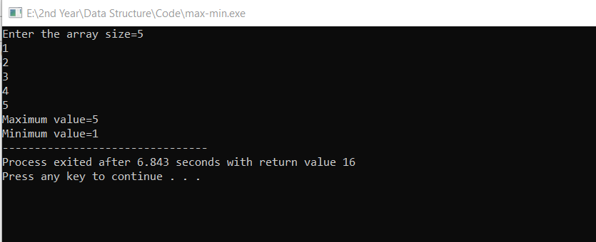

Finding maximum and minimum element of an array of nth size