**Program No. 9**

Objective:-WAP for addition of Two Polynomials Numbers

#include<stdio.h>

#include<malloc.h>

#include<conio.h>

struct poly{

int coeff;

int exp;

struct poly *connect;

};

struct poly *P=NULL,*Q=NULL,*poly=NULL;

void create(struct poly *poly)

{

char ch;

do

{

poly->connect=(struct poly*)malloc(sizeof(struct poly));

printf("\n Enter coefficient part:");

scanf("%d",&poly->coeff);

printf("\n Enter exponent part:");

scanf("%d",&poly->exp);

poly=poly->connect;

poly->connect=NULL;

printf("\nDo you want to add more terms=(y/n):");

ch=getch();

}

while(ch=='y' || ch=='Y');

}

void printpolynomial(struct poly *poly)

{

while(poly->connect!=NULL)

{

printf("%d-x^%d",poly->coeff,poly->exp);

poly=poly->connect;

if(poly->connect!=NULL)

printf("+");

}

}

void polyadd(struct poly *P,struct poly *Q,struct poly *poly)

{

while(P->connect && Q->connect)

{

if(P->exp>Q->exp)

{

poly->exp=P->exp;

poly->coeff=P->coeff;

P=P->connect;

}

else if(P->exp<Q->exp)

{

poly->exp=Q->exp;

poly->coeff=Q->coeff;

Q=Q->connect;

}

else

{

poly->exp=P->exp;

poly->coeff=P->coeff+Q->coeff;

P=P->connect;

Q=Q->connect;

}

poly->connect=(struct poly *)malloc(sizeof(struct poly));

poly=poly->connect;

poly->connect=NULL;

}

while(P->connect || Q->connect)

{

if(P->connect)

{

poly->exp=P->exp;

poly->coeff=P->coeff;

P=P->connect;

}

if(Q->connect)

{

poly->exp=Q->exp;

poly->coeff=Q->coeff;

Q=Q->connect;

}

poly->connect=(struct poly *)malloc(sizeof(struct poly));

poly=poly->connect;

poly->connect=NULL;

}

}

main()

{

char ch;

do{

P=(struct poly *)malloc(sizeof(struct poly));

Q=(struct poly *)malloc(sizeof(struct poly));

poly=(struct poly *)malloc(sizeof(struct poly));

printf("\nEnter 1st Polynomial Number:");

create(P);

printf("\n\nEnter 2nd Polynomial Number:");

create(Q);

printf("\n\n1st Polynomial Number:");

printpolynomial(P);

printf("\n\n2nd Polynomial Number:");

printpolynomial(Q);

polyadd(P,Q,poly);

printf("\n\nAdded polynomial:");

printpolynomial(poly);

printf("\n\nDo you want to add more Polynomial Number:");

ch=getch();

}

while(ch=='y' || ch=='Y');

}

**Output:-**

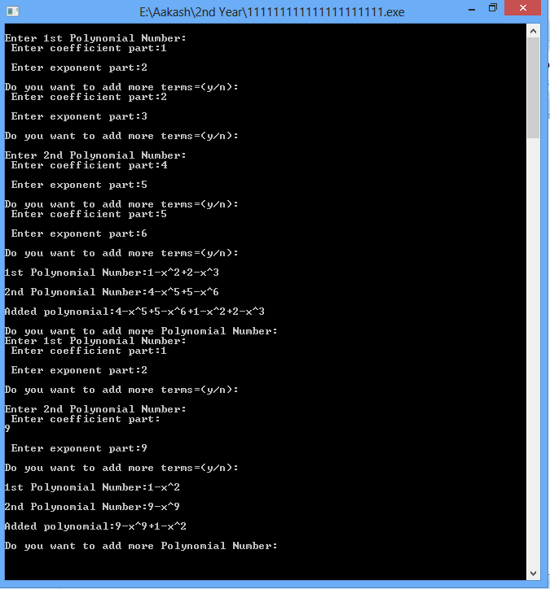

Addition of Two Polynomials Numbers