**Program No. 12**

Objective:-WAP for formation of Queue

#include<stdio.h>

#include<conio.h>

#include<stdlib.h>

int front=-1;int rear=-1;int item;int size,queue[100];

void enqueue()

{

if(front==0&&rear==size)

{

printf("\n\n----------");

printf("\nOverflow!!");

printf("\n----------\n");

}

else if((front==-1)&&(rear==-1))

{

rear=front=0;

printf("\nEnter item:");

scanf("%d",&item);

queue[rear++]=item;

}

else

{

printf("\nEnter item:");

scanf("%d",&item);

queue[rear++]=item;

}

}

void dequeue()

{

if(rear==front)

{

printf("\nYour queue is Empty!!");

exit;

}

else

{

front++;

printf("\n\nElement is Dequeued from Queue=%d",front);

}

}

void display()

{

int i;

printf(" \n");

for(i=front;i<size;i++)

{

printf("%10d",queue[i]);

}

}

void main()

{

char choice;

printf("-----------------------------------");

printf("\nEnter the Maximum size of Queue=\n");

printf("-----------------------------------\n");

scanf("%d",&size);

do

{

enqueue();

display();printf("\nrear=%d && front=%d",rear,front);

printf("\n\nDo you want to add further item in the Queue=");

choice=getch();

}

while(choice=='Y'||choice=='y');

display();

printf("\n\n----------------------------------");

printf("\nYour Dequeue operation Begins=");

printf("\n----------------------------------\n");

do

{

dequeue();

display();printf("\nrear=%d && front=%d",rear,front);

printf("\n\nDo you want to delete further item in the Queue=");

choice=getch();

}

while(choice=='Y'||choice=='y');

display();

}

Output:-

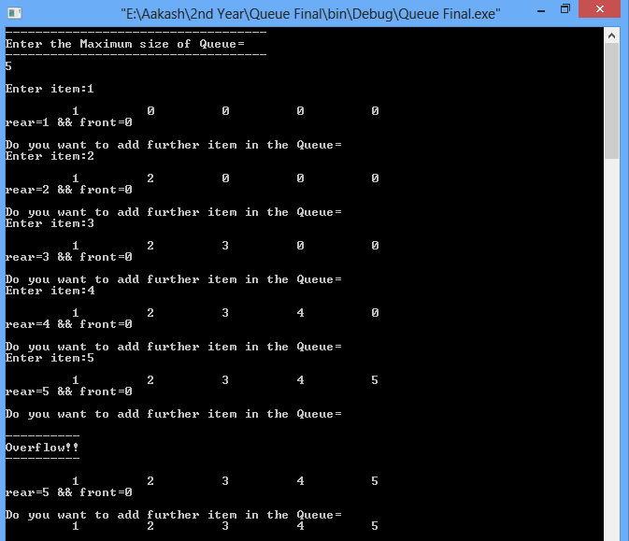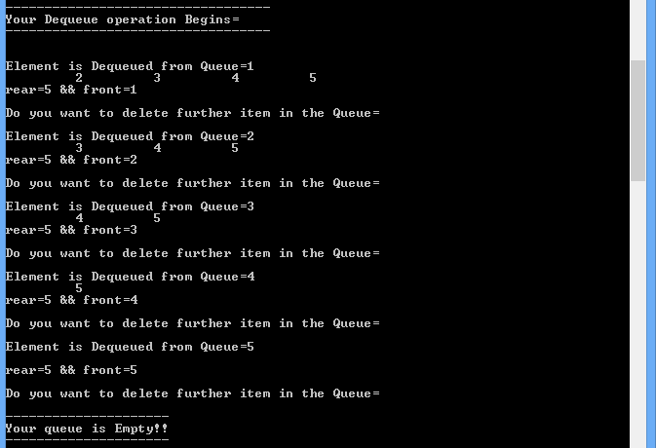

Operation performed on Queue