**Program No. 14**

Objective:-WAP related to Searching

#include<stdio.h>

int mid=0,key,l,u,flag=0,a[20],n,i,j,c;

int binary(int n)

{

l=0;

u=n-1;

printf("\n\nEnter the key=\n");

scanf("%d",&key);

while(flag!=0 && l<=u)

{

mid=floor((l+u)/2);

if(a[mid]==key)

{

return mid;

}

else if(a[mid]<key)

{

l=mid+1;

}

else if(a[mid]>key)

{

u=mid-1;

}

}

return -1;

}

int search(int arr[], int n, int x)

{

int i;

for (i = 0; i < n; i++)

if (arr[i] == x)

return i;

return -1;

}

void main()

{

int result,arr[50],i,s,x,n;

printf("Enter the value between (1-2)=\n");

printf("\n\nFor Linear Search Press 1:");

printf("\n\nFor Binary Search Press 2:\n");

scanf("%d",&n);

printf("\n");

switch(n)

{

case 1:

{

printf("Enter the size of array=\n");

scanf("%d",&s);

printf("Enter the element in array=\n");

for(i=0;i<s;i++)

{

scanf("%d",&arr[i]);

}

printf("Enter the element you want to search in array=\n");

scanf("%d",&x);

int n = sizeof(arr) / sizeof(arr[0]);

int result = search(arr, n, x);

(result == -1) ? printf("\nElement is not present in array")

: printf("\nElement is present at index %d", result);

return 0;

break;

}

case 2:

{

printf("Enter the size of array=\n");

scanf("%d",&s);

printf("Enter the element in array=\n");

for(i=0;i<s;i++)

{

scanf("%d",&arr[i]);

}

printf("Enter the element you want to search in array=\n");

scanf("%d",&x);

int n = sizeof(arr) / sizeof(arr[0]);

int result = search(arr, n, x);

(result == -1) ? printf("\nElement is not present in array")

: printf("\nElement is present at index %d",

result);

break;

}

}

}

Output:-

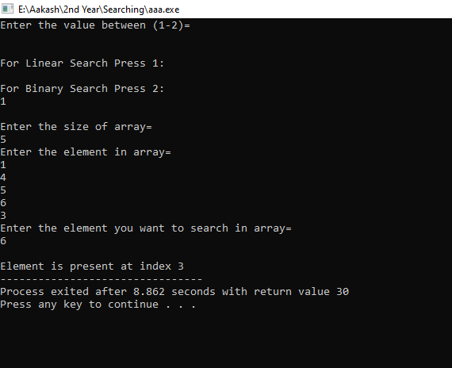

Operation performed on Searching