**Program No. 15**

Objective:-WAP related to Sorting

#include <stdio.h>

#include <math.h>

void SelectionSort(int arr[],int s)

{

int i, key, j, flag;

for (i= 0; i<(s-1); i++)

{

key=i;

for (j=i+1; j<s; j++)

{

if (arr[key]>arr[j])

key=j;

}

if(key!=i)

{

flag=arr[i];

arr[i] = arr[key];

arr[key]=flag;

}

}

}

void InsertionSort(int arr[],int s)

{

int i, key, j;

for (i=1; i<=s-1; i++)

{

j=i;

while (j>0 && arr[j-1]>arr[j])

{

key=arr[j];

arr[j] = arr[j-1];

arr[j-1] = key;

j--;

}

}

}

int main()

{

int arr[50],i,s,j,n,c,a[20];

printf("Enter the value between (1-3)=\n");

printf("\n\nFor Bubble Sort Press 1:");

printf("\n\nFor Insertion Sort Press 2:");

printf("\n\nFor Selection Sort Press 3:\n");

scanf("%d",&n);

printf("\n");

switch(n)

{

case 1:

{

printf("\nEnter the Size in the Array=\n");

scanf("%d",&n);

printf("\nEnter the Value in the Array=\n");

for(i=0;i<n;i++)

{

scanf("%d",&a[i]);

}

for(i=1;i<n;i++)

{

for(j=1;j<=(n-i);j++)

{

if(a[j]>a[j+1])

{

c=a[j];

a[j]=a[j+1];

a[j+1]=c;

}

}

}

printf("Your Sorted Array is=");

for(i=0;i<n;i++)

{

printf("\n%d",a[i]);

}

break;

}

case 2:

{

printf("Enter the size of array=\n");

scanf("%d",&s);

printf("Enter the element in array=\n");

for(i=0;i<s;i++)

{

scanf("%d",&arr[i]);

}

InsertionSort(arr,s);

printf("Now! Array is in sorted order=\n");

for (i=0;i<s;i++)

{

printf("%d ",arr[i]);

printf("\n");

}

return 0;

break;

}

case 3:

{

printf("Enter the size of array=\n");

scanf("%d",&s);

printf("Enter the element in array=\n");

for(i=0;i<s;i++)

{

scanf("%d",&arr[i]);

}

SelectionSort(arr,s);

printf("Now! Array is in sorted order=\n");

for (i=0;i<s;i++)

{

printf("%d ",arr[i]);

printf("\n");

}

return 0;

break;

}

}

}

Output:-

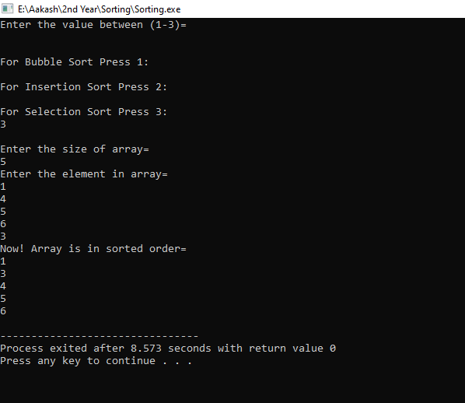

Operation performed on Sorting