**Program No. 4**

Objective:- WAP for Sparse Matrix

#include<stdio.h>

main()

{

int a[10][10],b[10][10],k=0,m,n,i,j;

printf("Enter the row of matrix=");

scanf("%d",&m);

printf("Enter the column of matrix=");

scanf("%d",&n);

printf("Enter the element of matrix=");

for(i=0;i<m;i++)

{

for(j=0;j<n;j++)

{

scanf("%d",&a[i][j]);

}

}

printf("\nOriginal Matrix=\n");

for(i=0;i<m;i++)

{

for(j=0;j<n;j++)

{

printf("\t%d",a[i][j]);

}

printf("\n");

}

//sparse matrix logic

for(i=0;i<m;i++)

{

for(j=0;j<n;j++)

{

if(a[i][j]>0)

{

b[k+1][0]=i+1;

b[k+1][1]=j+1;

b[k+1][2]=a[i][j];

k++;

}

}

}

b[0][0]=m;

b[0][1]=n;

b[0][2]=k;

printf("\nSparse Matrix=\n");

for(i=0;i<=k;i++)

{

for(j=0;j<3;j++)

{

printf("\t%d ",b[i][j]);

}

printf("\n");

}

}

Output:-

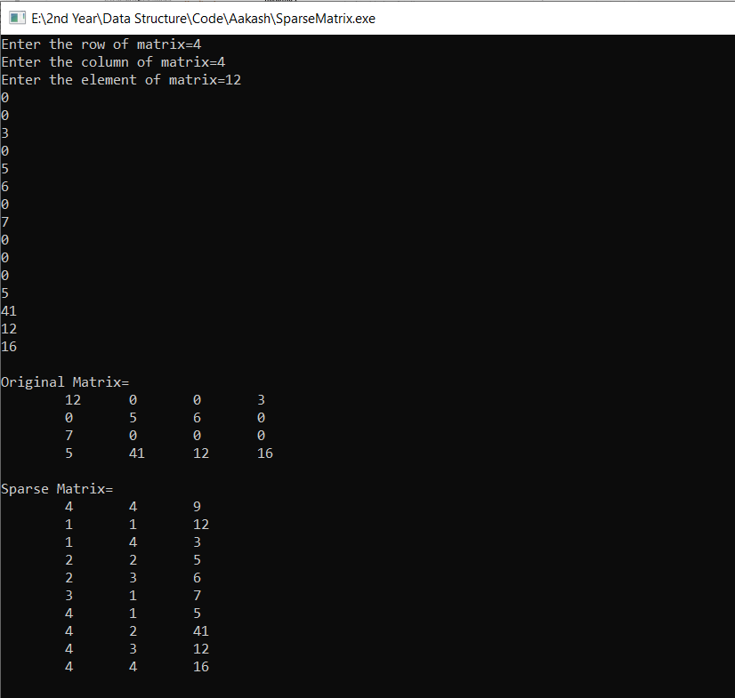

Sparse Matrix