**Program No. 10**

Objective:-WAP for formation of Stack

#include <stdio.h>

#include <stdlib.h>

#include<conio.h>

int TOP=-1,size,stack[20];

void push()

{

int item;

if(TOP>=size)

{

printf("\nStack is full/overload");

}

else

{

printf("\nEnter an item=");

scanf("%d",&item);

stack[++TOP]=item;

printf("\nIteam inserted in stack");

}

}

void printstack()

{

int i;

if(TOP==-1)

{

printf("Stack is empty/underflow");

}

else

{

for(i=0;i<=TOP;i++)

{

printf("\n%d\n",stack[i]);

}

}

}

void pop()

{

int item;

if(TOP<0)

printf("Underflow is going on");

else

{

item=stack[TOP];

TOP=TOP-1;

}

}

void main()

{

char choice;

int stack[size],i;

printf("\nEnter the size of the stack=");

scanf("%d",&size);

do

{

push();

printf("\nDo you want add futher stack=\n");

choice=getch();

}

while(choice=='Y'||choice=='y');

printf("\nPrinted stack=");

printstack();

printf("\nStack after deletion=");

pop();

printstack();

}

Output:-

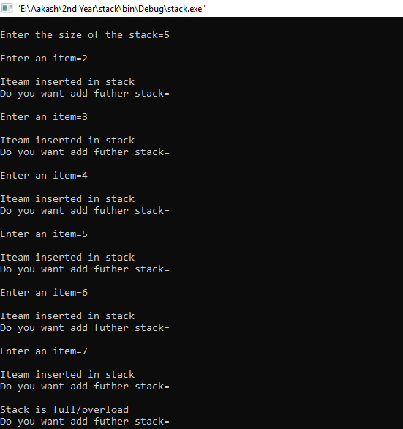

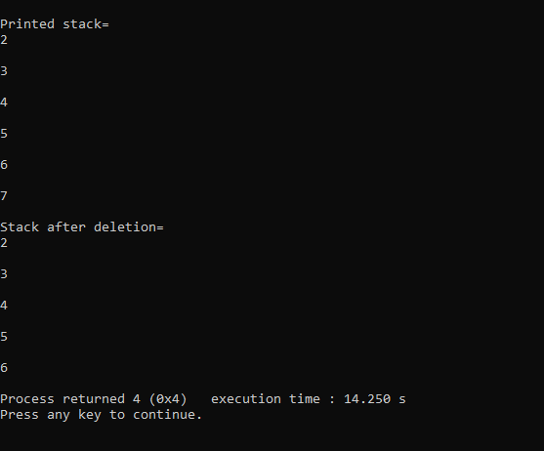

Operation performed on Stack