**Program No. 11**

Objective:-WAP for solving problem of Tower of Hanoi

#include <stdio.h>

#include <stdlib.h>

void Tower(int n,char A,char B,char C)

{

if(n==1)

{

printf("\n%c->%c",A,C);

}

else

{

Tower(n-1,A,C,B);

printf("\n%c->%c",A,C);

Tower(n-1,B,A,C);

}

}

void main()

{

int n;

char Beg='A',End='C',Aux='B';

printf("Enter the DISK you want to put on Hanoi Tower=\n");

scanf("%d",&n);

Tower(n,Beg,Aux,End);

}

Output:-

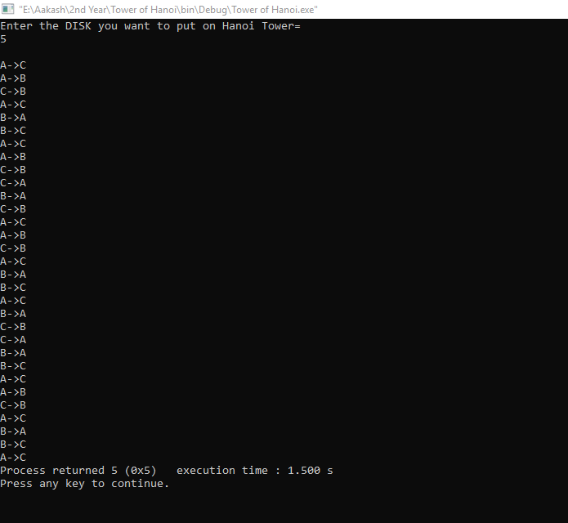

Problem of Tower of Hanoi