Idea Proposal

Names: Alexis Kareem, Patel Aakash Akhilesh, Patel Ayush

Topic: PaceFlex (Android application)

1. What is/are the problem/s you want to solve? Why is it important?

* We hope to provide a monthly spending average with this app. The application will keep tabs on all of the student's expenditures and notify them if the limit is exceeded. People plan to spend money on everyday routines, some of which are unnecessary. They will be able to see these unnecessary expenditures thanks to the app, which will also help them cut costs and save money.

1. Who are the users you are targeting?

* In order to manage their finances for meals, transportation, and other expenses, Pace University undergraduate students will use the financial planner.

1. How will this app solve the tackled problem/s? Provide a vision statement.

* Sam, a Pace University undergraduate, has a budget of $5,000–$6,000 for the spring 2023 semester. He will need to choose a meal plan from the Auxiliary Meal Plans program, which will quickly display all of the meal plans available. In addition, it will assist in demonstrating monthly spending of Flex Dollars at various rates for university shops so that he may control his expenditure.

1. What are the major features of the app?

* User-friendly Interface: PaceFlex app may have a user-friendly interface and design that caters to the preferences of students. It may offer a visually appealing layout, intuitive navigation, and a seamless user experience, specifically tailored for students, making it easy and engaging to use.
* Student-specific Features: PaceFlex app may include features such as tracking student-specific expenses like tuition fees, textbooks, and part-time job income. This makes it unique compared to other financial planning apps that may not cater specifically to the financial needs and challenges of students.
* Focus on Student Financial Planning: PaceFlex app is specifically designed for students, addressing their unique financial planning needs and challenges. It focuses on helping students manage their expenses, track unnecessary expenditures, and stay within their spending limits, with features tailored to their student lifestyle.
* Spending Limit Notifications: PaceFlex app sends notifications to users when their spending limit is exceeded. This proactive approach helps students stay on track with their budget and avoid overspending, setting it apart from other apps that may not provide such notifications.

1. What similar apps exist on the market? (at least 2 apps with names, screenshots, links, descriptions and how different they are from what you want to do)

* Mint
* Link: <https://play.google.com/store/apps/details?id=com.mint&hl=en>
* Description: Mint is a popular personal finance app that helps students manage their money, budget, and track expenses. It offers a wide range of features, including budgeting tools, bill reminders, goal tracking, and investment tracking. Mint also provides users with a holistic view of their financial health, including credit scores and net worth. It is available on both web and mobile platforms, and it supports integration with various financial institutions for automatic transaction tracking.
* Screenshots:
* 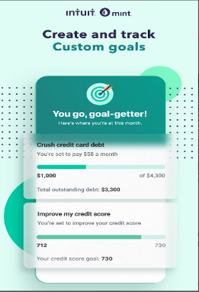 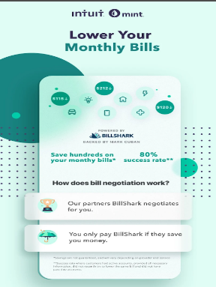
* PocketGuard
* Link: <https://play.google.com/store/apps/details?id=com.pocketguard.android.app>
* Description: PocketGuard is a budgeting and expense-tracking app that lets students link their bank accounts, credit cards, and loans for a real-time view of their finances. It provides budgeting tools, bill reminders, spending categories, and features like "In My Pocket" to track available spending after bills and savings. A pro version offers custom categories, unlimited goals, and bill tracking for enhanced budget management.
* Screenshots:
* 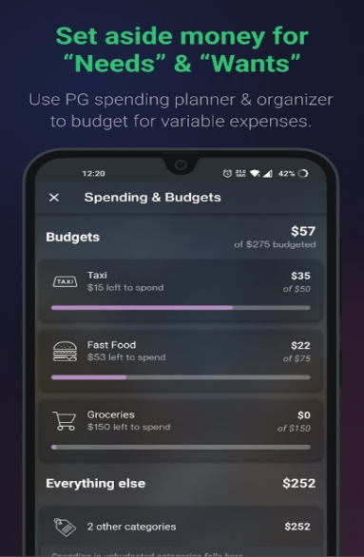 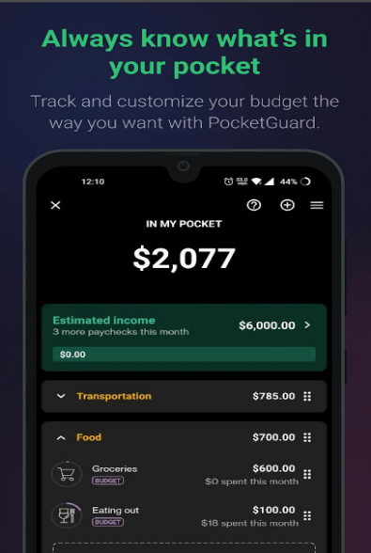
* While Mint and PocketGuard focus on personal finance management in general, Pace Flex is for student financial planning and may have specific features tailored for students, such as tracking and managing meal plans, semester-wise budgeting, and flex dollars spending throughout the campus, providing tips for budgeting while in school, and offering resources for financial literacy targeted towards students. Pace Flex will also have a unique interface and design that caters to the needs and preferences of students, making it user-friendly and engaging for this specific demographic.

1. How is your app unique?

* Tailored for Students: Pace Flex app is specifically designed for students, taking into consideration their unique financial needs and challenges. It may include features such as tracking student-specific expenses like meal plans, and on-campus spending of flex dollars, an easy-to-manage interface only for pace students, and providing tips for budgeting and saving money while in school.
* Pace Flex app will have a user-friendly interface and design that caters to the preferences of pace university students, making it engaging and easy to use. The app may have a visually appealing layout, intuitive navigation, and a seamless user experience, specifically tailored for pace university students.

1. What are the risks associated with the development of this app? Why wouldn’t it be delivered completely (scope), on time and on budget? Identify 3 to 5 risks that are relevant in your case.

* Technical difficulties: Creating a complex program like Pace Flex may require connecting with numerous data sources, putting in place advanced spending analysis algorithms, and guaranteeing data security. Technical difficulties including flaws in the program, compatibility problems, and integration difficulties could extend the development cycle and raise development expenses.
* Changes in Requirements: The development schedule and budget may be impacted by changes in the project's requirements or scope creep, which is the tendency for the project's scope to go beyond what was originally planned. Regular modifications to the specifications or scope may necessitate more work during the development process, which would cause delays and higher expenses.
* User Acceptance and Adoption: The adoption and acceptance of the Pace Flex app by users may determine its success. The overall success of the app and budget overruns may be impacted if the app doesn't match the demands or expectations of the target users or if user adoption and engagement are problematic.

1. What is your (personal) goal with this project? (build portfolio/resume, get experience in mobile app dev …)

* Aakash Akhilesh Patel -> Get experience in mobile app development.
* Alexis Kareem -> Get experience in mobile app development.
* Patel Ayush -> get experience in mobile app development.