**Citi-Bike-Analytics**

By

Aakash Rahman

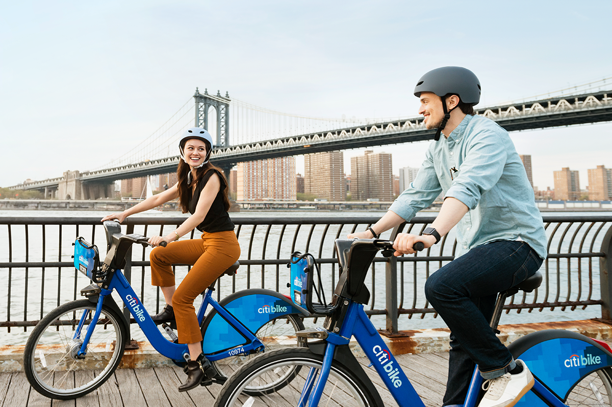

Click here to see the visualities in Tableau

<https://public.tableau.com/profile/aakash.rahman#!/vizhome/TableauHW-City-Bike-Analytics-Aakash/CitiBikeAnalyst>

**Data Source:** <https://www.citibikenyc.com/system-data>

The Analysis for Citi Bike program in which responsible for overseeing the largest bike sharing program for 100,000+ data points in the United States in order to generate business insights in terms of visualize the peak time in both summer and winter period and the top start location in Jersey City, New Jersey.

I used Jersey City, NJ locations

Below are few visualizations:

|  |  |
| --- | --- |
|  |  |

|  |  |
| --- | --- |
|  |  |
|  |  |

### During the analysis, I found the current major Citi-Bike riders fall into young male group between 18 -20 but number of female raiders increases over time as they are showing interest to start riding during the weekend.

|  |  |
| --- | --- |
|  |  |

### As the temperature gets cold as winter begins, people tend not to ride as well because of the lack of comfort individuals face when riding in low temperatures. Therefore, at some point the ridership does not grow. However, the total amount of annual member have been kept increased over time in 2020

|  |  |
| --- | --- |
|  |  |

Map Visualization in Jersey City, New Jersey:

|  |  |
| --- | --- |
|  |  |

I used

Microsoft Excels

Tableau