Assignment 1

Analysis and Design Document

Car Rental System

(using GAIA methodology)

Project Group 1

Jacob Idoko

Aakash Sorathiya

Table of Contents

**1** **System Specifications** 3

1.1 Problem Statement 3

1.2 System Description 3

1.3 Assumptions 4

1.4 Requirements 4

1.5 Wishlist (Not Implemented) 4

**2** **System Analysis** 5

2.1 Role Model 5

2.2 Role Schema 5

2.3 Interaction Model 7

**3** **System Design** 8

3.1 Agent Model 8

3.2 Services Model 9

3.3 Acquaintance Model 10

**4** **Multi-Agent System Architecture** 11

**5** **Agent Description** 12

5.1 Customer Agent 12

5.2 Verification Agent 12

5.3 Registration Agent 12

5.4 Reservation Agent 12

5.5 Vehicle Management Agent 12

5.6 Payment Agent 12

5.7 Data Manager 12

# **System Specifications**

## Problem Statement

* The car rental industry has seen a shift towards digital solutions, requiring a more efficient and user-friendly system for managing rentals.
* Customers need a convenient way to browse, book, and manage car rentals online.
* Car rental companies need to optimize their fleet management and streamline the rental process.
* There's a need for a system that can handle various aspects of car rental, including reservations, payments, and vehicle tracking.

## System Description

* The proposed Car Rental System (CRS) is a multi-agent system designed to facilitate the process of renting cars.
* The system allows customers to register, browse available vehicles, make reservations, and manage their rentals.
* It also helps rental companies manage their fleet, track vehicle status, and process payments.

INTERNET

Interface/GUI

Customer

Data

Storage

*Registration Web Services*

*Payment*

*Web Services*

*Reservation*

*Web Services*

## Assumptions

* The system maintains customer data, vehicle data, and rental transaction data.
* A Customer has two options:
  + A registered customer can log in using their email and password to access the system.
  + An unregistered customer can create a new account by entering their details.
* The customer can access the system to:
  + Browse available vehicles.
  + Make reservations.
  + Manage existing rentals.
  + Make payments.
* The Fleet Manager manages the vehicle inventory and availability.
* The Rental Agent processes reservations and handles customer inquiries.
* The Payment Processor handles all financial transactions.

## Requirements

* The CRS shall provide access to the list of available vehicles.
* The CRS shall allow customers to make and manage reservations.
* The CRS shall process payments securely.
* The CRS shall register, de-register, and update customer data.
* The CRS shall keep track of vehicle availability and maintenance schedules.

## Wishlist (Not Implemented)

* The CRS shall integrate with external mapping services to provide location-based recommendations.
* The CRS shall implement a loyalty program for frequent customers.
* The CRS shall provide real-time tracking of rented vehicles.
* The CRS shall offer a mobile app for on-the-go rentals and management.

# **System Analysis**

## Role Model

We have identified the following roles for our multi-agent Car Rental System:

* Verification
* Registration
* Vehicle Management
* Reservation Handling
* Payment Processing

## Role Schema

|  |  |  |
| --- | --- | --- |
| Role Schema | | **Verification** |
| Description | | Verifies customer identity |
| Protocols and Activities | | AuthenticateCustomer |
| Permissions | | read customerdata  write customerdata |
| Responsibilities | Liveness | authenticate = (Authenticate, Customer) |
| Safety | successful authentication of a customer |

|  |  |  |
| --- | --- | --- |
| Role Schema | | **Registration** |
| Description | | Registers/Deregisters a customer |
| Protocols and Activities | | RegisterCustomer  DeregisterCustomer  UpdateCustomerData |
| Permissions | | read customerdata  write customerdata |
| Responsibilities | Liveness | register = (Register, Customer)  deregister = (De-register, Customer)  update = (Update.CustomerData, Customer) |
| Safety | successful register/de-register a customer  keep the data storage updated |

|  |  |  |
| --- | --- | --- |
| Role Schema | | **Vehicle Management** |
| Description | | Manages vehicle inventory and availability |
| Protocols and Activities | | AddVehicle  RemoveVehicle  UpdateVehicleStatus |
| Permissions | | read vehicledata  write vehicledata |
| Responsibilities | Liveness | add = (Add.Vehicle, Vehicle)  remove = (Remove.Vehicle, Vehicle)  update = (Update.VehicleStatus, Vehicle) |
| Safety | maintain accurate vehicle inventory  keep the data storage updated |

|  |  |  |
| --- | --- | --- |
| Role Schema | | **Reservation Handling** |
| Description | | Manages customer reservations |
| Protocols and Activities | | CreateReservation  CancelReservation  ModifyReservation |
| Permissions | | read reservationdata  write reservationdata  read vehicledata |
| Responsibilities | Liveness | create = (Create.Reservation, Reservation)  cancel = (Cancel.Reservation, Reservation)  modify = (Modify.Reservation, Reservation) |
| Safety | ensure reservation integrity  update vehicle availability accordingly |

|  |  |  |
| --- | --- | --- |
| Role Schema | | **Payment Processing** |
| Description | | Handles financial transactions |
| Protocols and Activities | | ProcessPayment  IssueRefund |
| Permissions | | read paymentdata  write paymentdata |
| Responsibilities | Liveness | process = (Process.Payment, Payment)  refund = (Issue.Refund, Refund) |
| Safety | secure transaction processing  maintain accurate financial records |

## Interaction Model

|  |  |  |  |
| --- | --- | --- | --- |
| **Protocol** | **RegisterCustomer** | **DeregisterCustomer** | **AuthenticateCustomer** |
| Purpose/  Parameters | Register a customer | Deregister a customer | Authenticate a customer |
| Initiator | Customer | Customer | Customer |
| Receiver | Registration | Registration | Verification |
| Responding Protocol | Customer registration successful | Customer de-registration successful | Customer authenticated successfully |

|  |  |  |  |  |
| --- | --- | --- | --- | --- |
| **Protocol** | **CreateReservation** | **CancelReservation** | **ProcessPayment** | **UpdateVehicleStatus** |
| Purpose/  Parameters | Create a new reservation | Cancel an existing reservation | Process a rental payment | Update vehicle availability |
| Initiator | Customer | Customer | Customer | Vehicle Management |
| Receiver | Reservation Handling | Reservation Handling | Payment Processing | Data Manager |
| Responding Protocol | Reservation created successfully | Reservation cancelled successfully | Payment processed successfully | Vehicle status updated successfully |

# **System Design**

## Agent Model

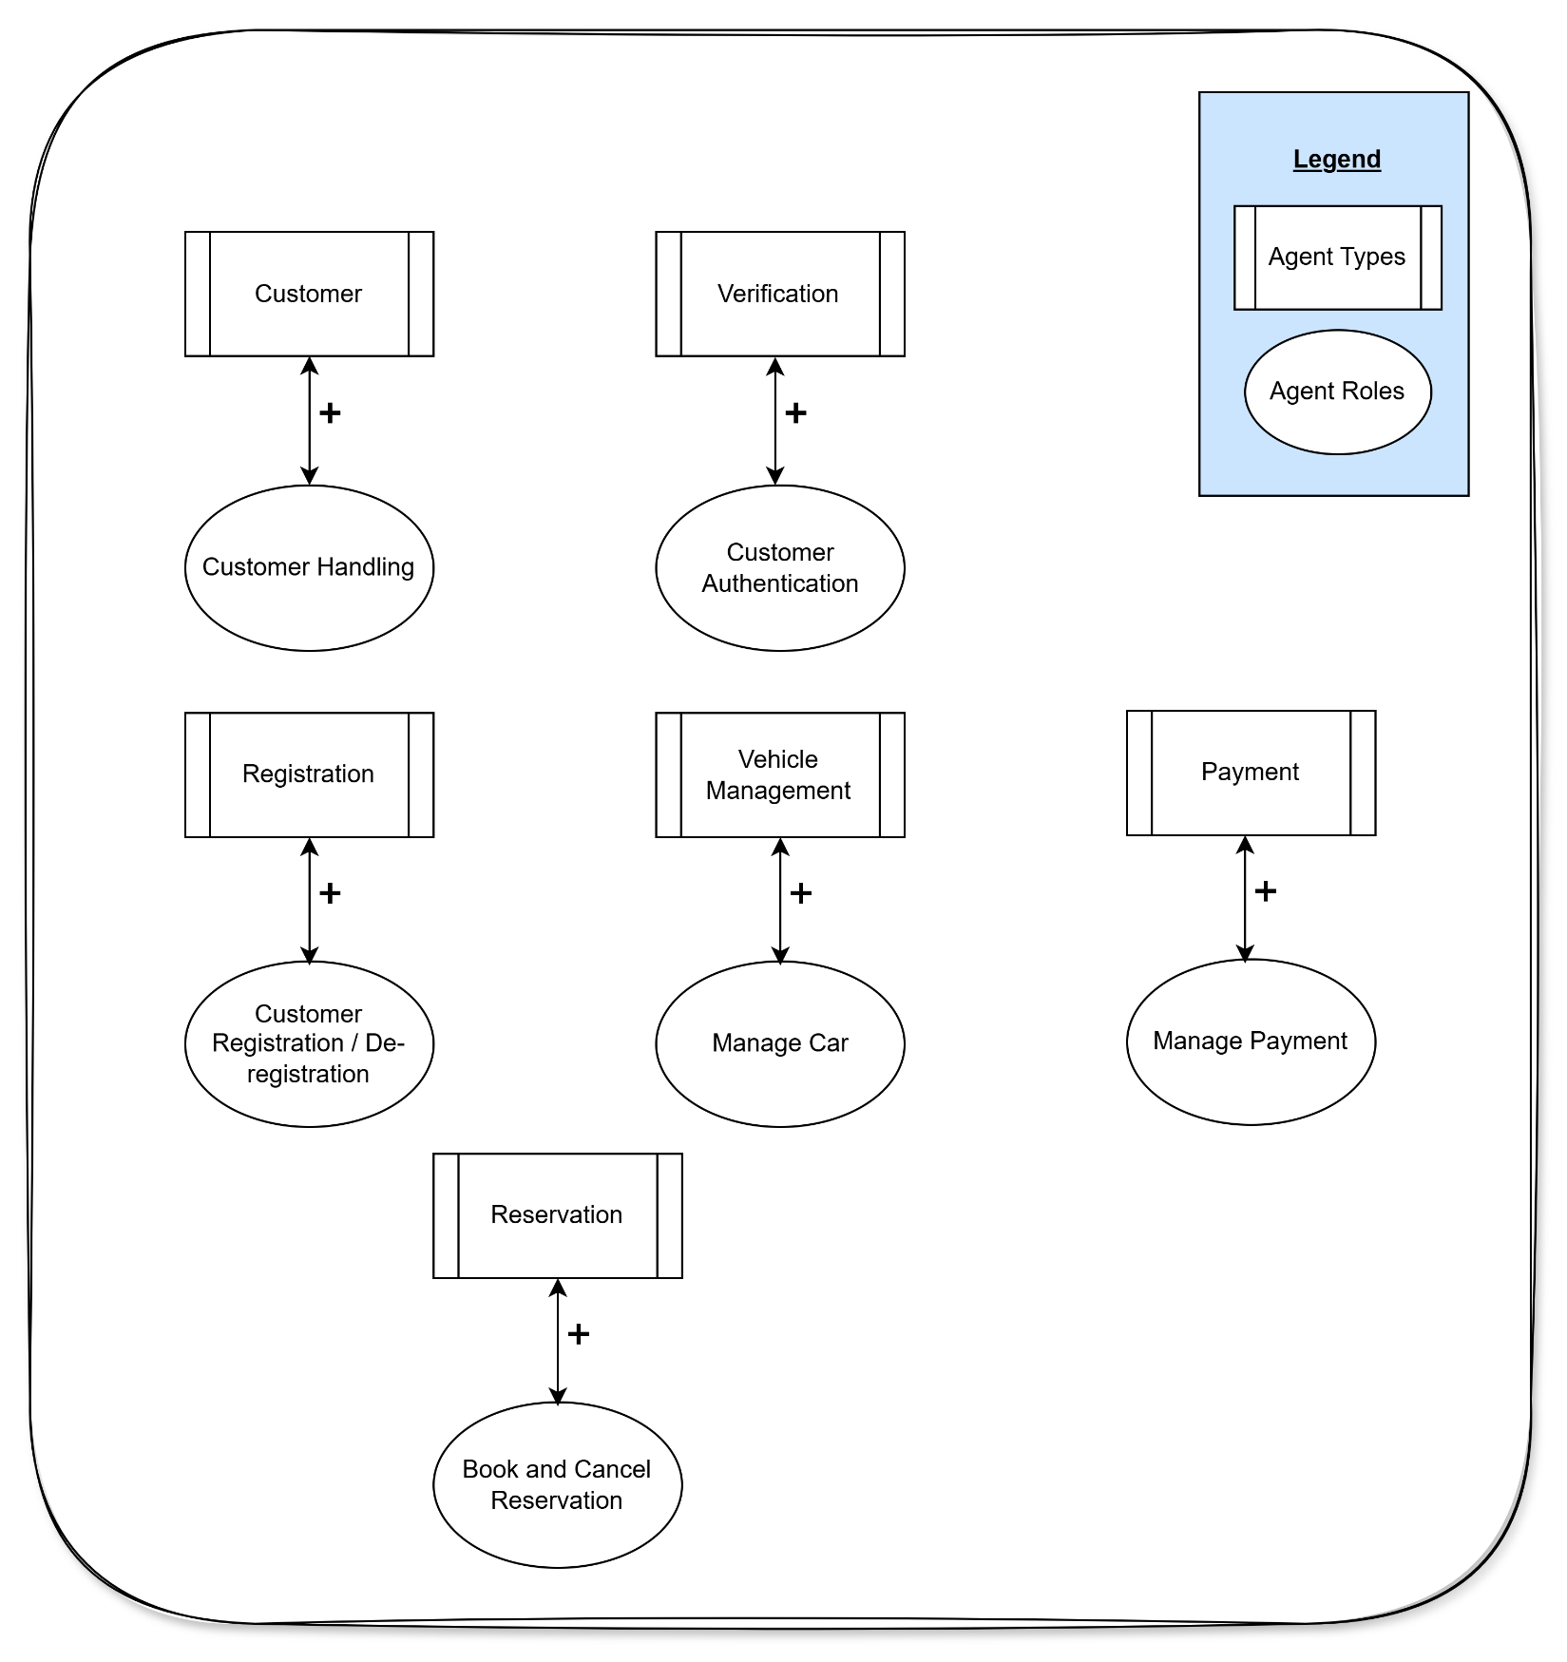

## Services Model

|  |  |  |  |  |
| --- | --- | --- | --- | --- |
| **Service** | **Inputs** | **Outputs** | **Pre-conditions** | **Post-conditions** |
| Customer Authentication | Customer credentials | Authentication status | Launch the Customer GUI | Send a request to the data storage to verify customer data |
| Vehicle Reservation | Vehicle details, rental period | Reservation confirmation | Go to the Reservation GUI | Send a request to update vehicle availability and create reservation record |
| Payment Processing | Payment details | Payment confirmation | Go to the Payment GUI | Send a request to process payment and update financial records |
| Vehicle Management | Vehicle details | Vehicle status update | Access Vehicle Management GUI | Send a request to update vehicle data in storage |

## Acquaintance Model

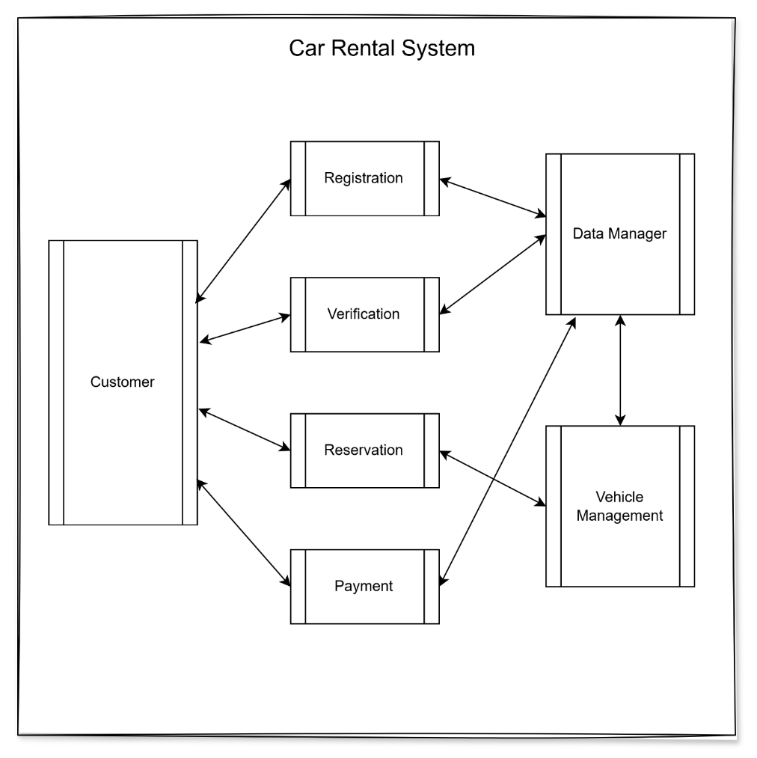

# **Multi-Agent System Architecture**

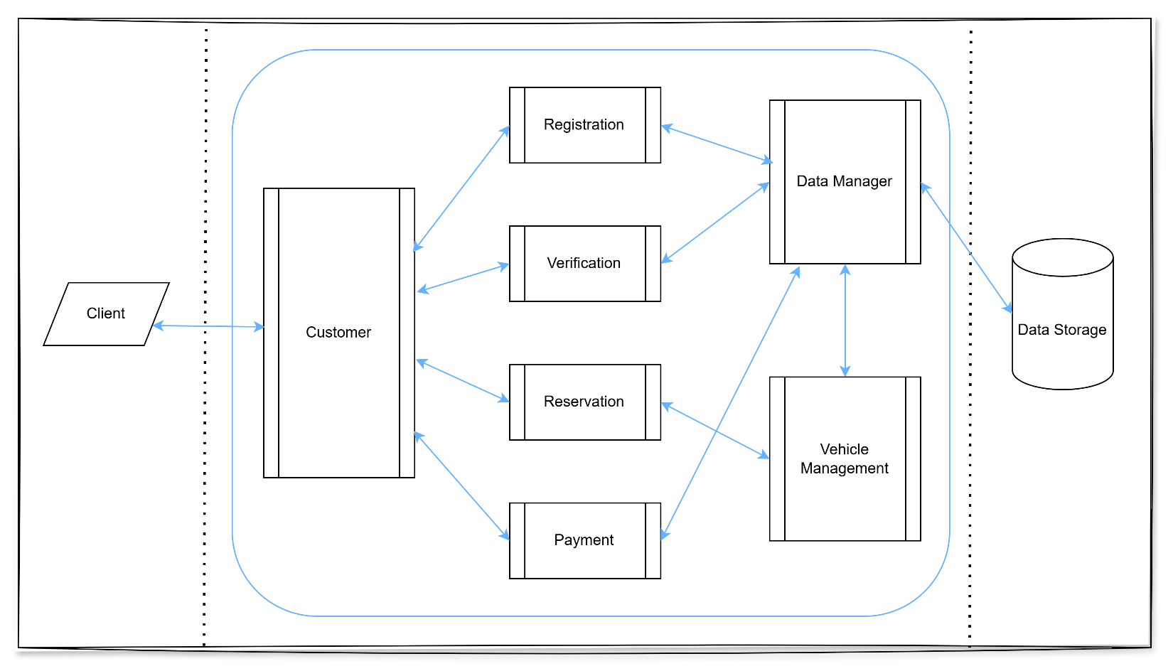

The CRS is designed as a multi-agent system where various agents interact to provide a comprehensive rental service:

* The Customer Agent serves as the primary interface for users, handling all customer interactions and relaying requests to appropriate specialized agents.
* The Verification and Registration Agents manage customer accounts and authentication.
* The Reservation Agent coordinates with the Vehicle Management Agent to handle bookings and ensure vehicle availability.
* The Payment Agent securely processes all financial transactions.
* All agents communicate with the Data Manager to maintain consistent and up-to-date system information.

# **Agent Description**

## Customer Agent

* Acts as the main point of contact for customers through the web interface or mobile app.
* Coordinates with other agents to fulfill customer requests (authentication, registration, reservations, payments).
* Provides a unified interface for all customer interactions with the system.

## Verification Agent

* Handles customer authentication processes.
* Communicates with the Data Manager to verify customer credentials and maintain security.

## Registration Agent

* Manages customer account creation, updates, and deletion.
* Ensures customer data integrity and consistency in the system.

## Reservation Agent

* Processes reservation requests, modifications, and cancellations.
* Coordinates with the Vehicle Management Agent to check and update vehicle availability.

## Vehicle Management Agent

* Maintains the vehicle inventory and tracks vehicle status (available, rented, under maintenance).
* Updates vehicle information and availability in real-time.

## Payment Agent

* Handles all financial transactions, including rental payments and refunds.
* Ensures secure and accurate processing of payments.

## Data Manager

* Central repository for all system data.
* Provides data access and update capabilities to all other agents, ensuring data consistency across the system.