2000

17 SD

AGILE Manifesto = 2001

**Key feature of agile**

* Individual and interaction over processes and tool
* Working software over comprehensive documentation
* Customer collaboration over contract negotiation
* Responding to change over following a plan

**12 Principle**

1. Customer satisfaction
2. Welcome change
3. Frequent delivery
4. Working Together
5. Motivated Team
6. Face-to-Face
7. Working Software
8. Constant Pace
9. Good Design
10. Simplicity
11. Self-Organization
12. Reflect & Adjust

Agile

Agile is a mindset

**Scrum Kanban Xp ScrumBan**



Requirements => Design => Develop=> Test=> Deploy => Review

Dev UAT PROD



Weight Routing

10% traffic

USA =>

Agile SDLC Model

Iterative and Incremental

Process adaptability and customer satisfaction

SCRUM

Hirotaka & Ken

1986 & 1995



Light Weight

Simple To understand

Difficult to master

Address complex and adaptive problem

Productively and Creatively deliver products

Product Backlog

Backlog Planning

Sprint Planning

Sprint

Daily Scrum

Completed Increment

Retrospective

* Product is developed in sprints
* People work as a single team
* Constantly deliver functioning products(Plan, Act, Do, check)
* Continuous customer feedback

Empirical process control theory

* Transparency
* Inspection
* Adaptation

Scrum Values

* Commitments
* Focus
* Courage
* Openness
* Respect

SCRUM TEAM

Product Owner=> Key Stakeholder

Scrum Master

Development Team

Product Owner

* Managing product backlog
* Progressing the value of work done
* Guiding team to achieve the best goal and missions
* Product backlog is visible transparent and clear
* Manage Economics
* Groom the product backlog
* Participate in planning
* Collaborate with development team and stakeholders both

**Scrum Master**

Help team members to follow scrum theories, rules and practices

**Scrum master with product owner**

* Find effective product backlog management techniques
* Understanding & practicing agility
* Facilitating scrum events as requested

**Scrum master with development team**

* Coach development team when scrum not fully adopted
* Help create high value products

**Scrum master with Organization**

* Help stakeholders and employees implement scrum practices
* Causing changes that increases the productive of the scrum team

Coach

Servant leader

Process authority

**Development Team**

Professional who do the work of delivering a potentially increments of product

* Self-Organizing team
* Cross Functional
* Team members doesn’t have individual title

**Scrum Events**

Scrum Sprint

Scrum Planning

Daily scrum meeting

Sprint Review(Scrum team and stakeholders)

Sprint Retrospective( Scrum Team)

**Scrum Sprint**

1. Timeboxed
2. Establish a WIP(Work in progress)
3. Forces Prioritizations
4. Demonstrate progress
5. Avoid unnecessary perfections
6. Short duration
7. Fast Feedback

**Sprint Planning**

1. What can be delivered in this sprint iteration
2. How will the work needed to deliver be achieved

**Scrum Artifacts**

* Product Backlog
* Sprint Backlog
* Burndown charts
* Product increments

**Scrum Execution**

Product Backlogs 🡺 Sprint planning 🡺 Sprint 🡺 SprintReview 🡺 sprint Retrospective

**Scrum of scrums**

Scrum of scrums is used to refer meeting after the daily scrumssss

Scrum Board

* ToDo
* In Progress
* Test
* Done

ACP

ASM

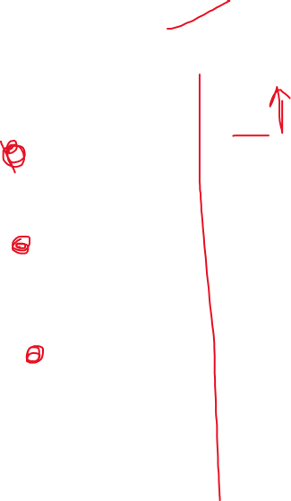

Maintence

Design

Implementation

Verification

Requirements