**Project Name : Rebag**( Ecommerce website)

**Overview :**

Ecommerce or electric commerce refers to the buying and selling of goods and services via electronic channels, primarily the Internet . Internet is the rapidest growing media during the past decade. Especially, online shopping is a rapidly growing e-commerce area. Online stores are usually available 24 hours a day, and many consumers have Internet access both at work and at home. A successful web store is not just a good looking website with dynamic technical features, listed in many search engines.

**Home Page :**



**Login Page :**

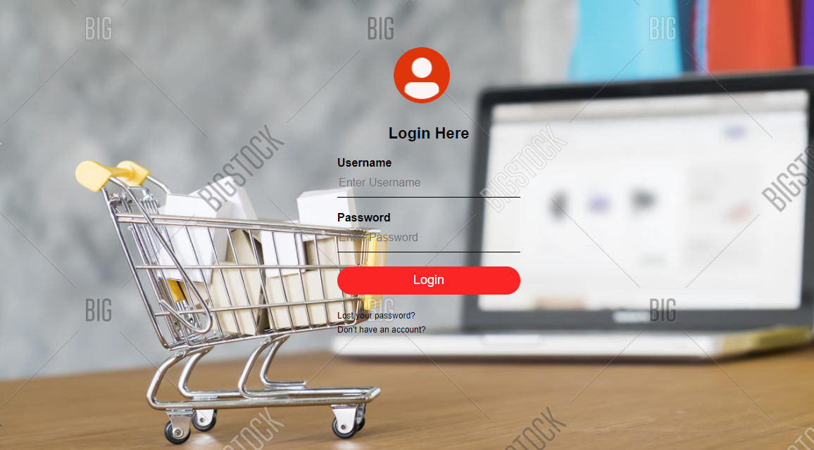

**Technology Used:**

Front-End:

1. Html
2. Css
3. Bootstrap
4. React

Dynamic:

1. Javascript
2. Ci/cd with AWS
3. Login and logout(oauth and jwt)

Database:

1. Mongodb
2. Json Data

Code Compiler:

1. Visual studio code
2. Git bash
3. Git hub
4. Node js.

**Goals:**

1. Home Page
2. Login Page
3. Cart
4. Product Page
5. Checkout Page
6. Customer Details Page
7. Login and Logout Page