Second Project

**Project Name**: InfinityGreen

**Overview:**

*A InfinityGreen is online plant store in this page, we propose online plant shopping and the scope of plants and garden items which are accessible for buy from our site as per the terms. An understanding for us to offer you Goods is made on these terms when we acknowledge a request made by you by means of our Web Site. We will affirm acknowledgment of your request on-screen.*

**Home Page:** 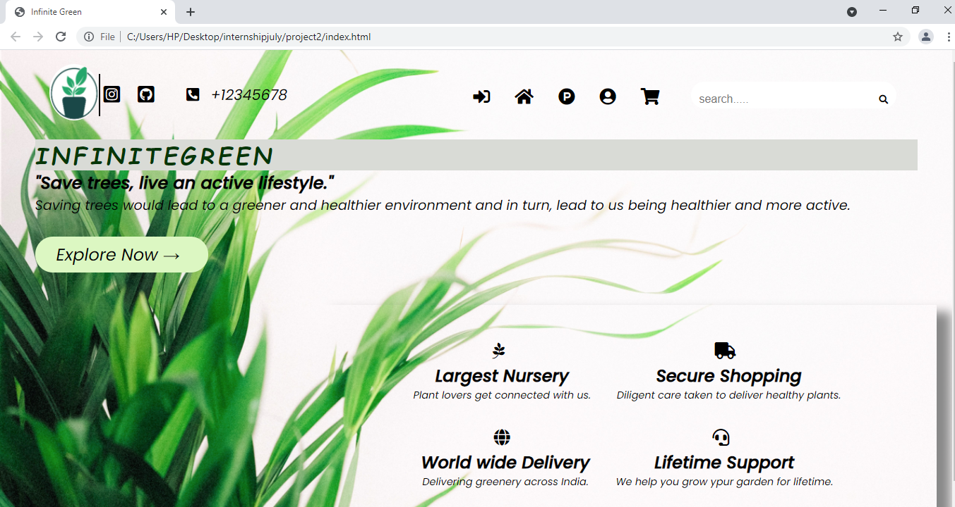

**Login Page:**

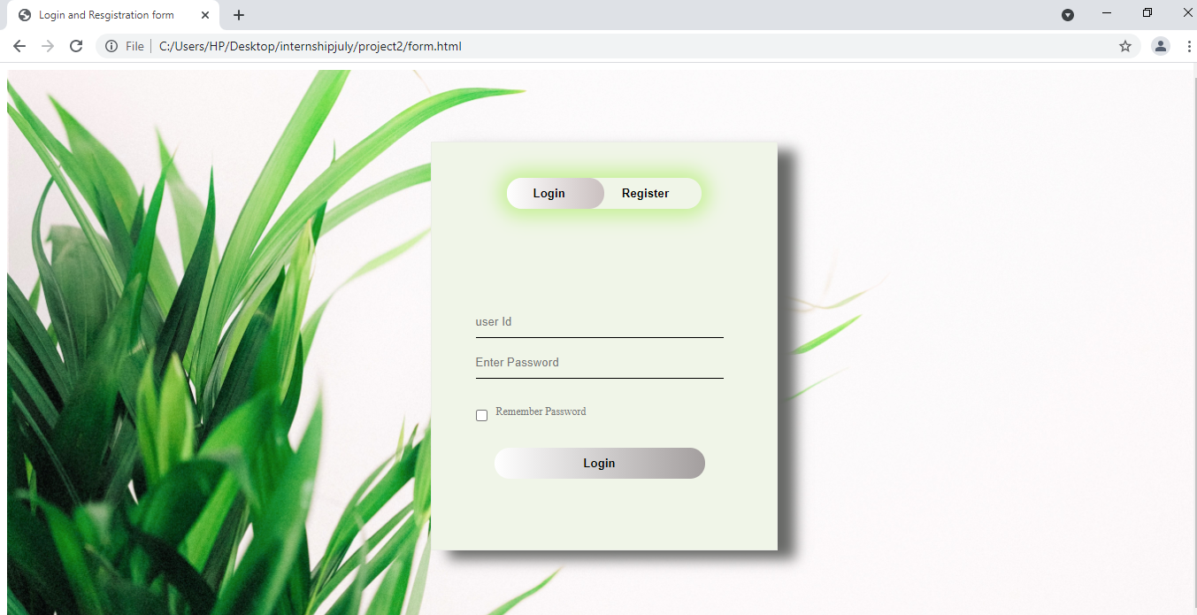

**Registration Page:**

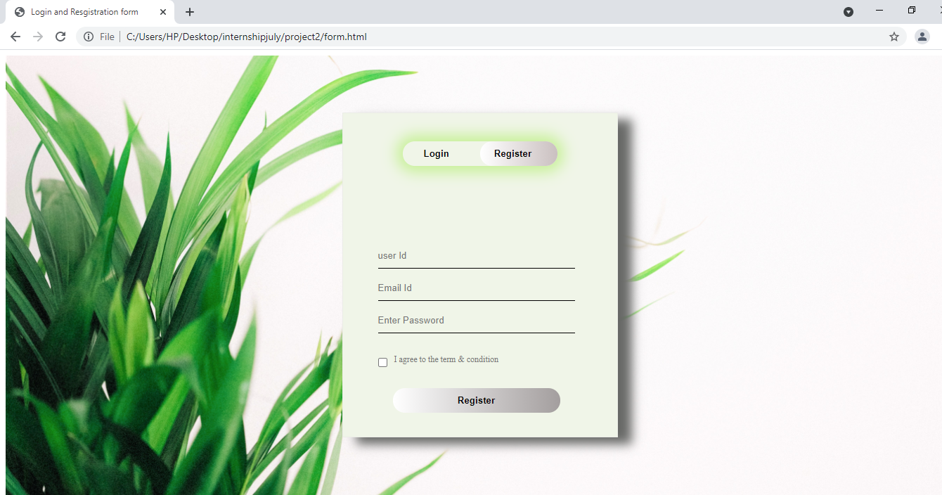

**Goals:**

* *Login Page*
* *Home Page*
* *Product Page*
* *Contact Page*
* *Add to cart*
* *Check out page*
* *Customer detail page*

**Technologies used:**

**Front-End:**

1. *Html*
2. *CSS*
3. *Bootstrap*
4. *React*

**Dynamic:**

1. *Javascript*
2. *ci/cd with AWS*
3. *Login and Logout*

**Database:**

1. *Mongodb*
2. *Json Data*

**Code compilers:**

1. *Visual studio code*
2. *Git bash*
3. *Git hub*
4. *Node js*