**HW5: Interaction Design Iteration 2**

**Group Members:**

* Aakash Tanaji Jadhav - G01395243
* Aniket Anil Raut - G01387118
* Shubham Milind Kasar – G01384017
* Gandhar Anirudha Khandagale - G01394026

**Website link** : -<https://aakashjadhav2000.github.io/Shopping-Site-Updated/>

**Usability Issues:**

* **Search Functionality:**

Inaccessible and ineffective search functionality that fails to provide relevant results, hampering the ability to quickly find specific products or information. The absence of price information on product listings makes it challenging for users to evaluate costs before making purchase decisions. Lack of a "Buy Now" option for direct purchases, necessitating additional steps to complete a purchase.

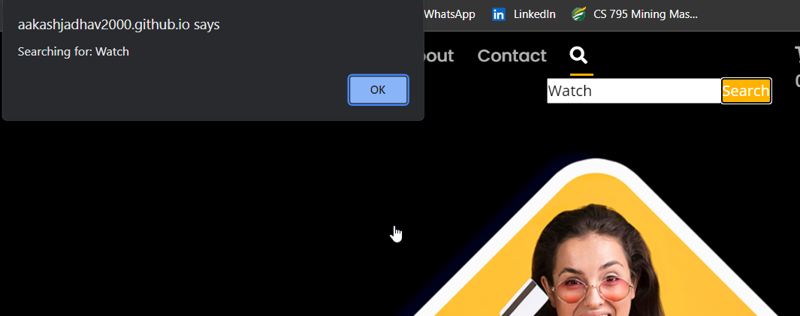

**Actions:**

Users used to have trouble finding products when doing searches. But this problem has been resolved with a recent version that improves the search capabilities. Now, the system correctly gets the related products when users input particular keywords like "watch," "samsung," "iphone," "hoodie," "shoes," "asus," and "predator." This improvement in user experience was made possible by the addition of a keyword-based search logic that can identify and react to these often-used terms. This ensures that consumers always receive appropriate search results.

* **Shopping Cart Experience:**

Separate listings for duplicate products in the cart instead of updating the quantity, leading to confusion and a lack of understanding regarding the contents of the cart. Missing product and total prices in the cart, making it difficult for users to gauge their expenses.

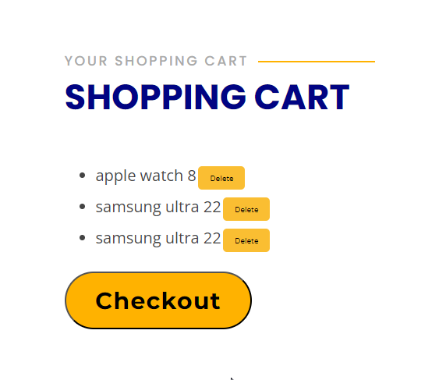

**Actions:**

When there were duplicate products, the shopping cart system used to show separate listings rather than combining them and changing the quantity. Due to this design issue, users were left perplexed and unclear about the precise contents of the cart. In addition, individuals attempting to estimate their overall cost encountered difficulties due to the cart interface's absence of apparent product and total prices. The system has been redesigned to address these usability problems. Currently, the cart automatically combines user entries and adjusts the quantity when users add several units of the same product. In addition, the costs of individual products as well as the total amount are shown clearly, which makes it easier for users to comprehend what they need to buy and improves their overall shopping experience.

* **Newsletter Subscription and Un-subscription:**

Inconsistent newsletter subscription process with missing confirmation emails, creating uncertainty regarding subscription status. Difficulty in unsubscribing from the newsletter due to lack of a clear option to do so, which can lead to user dissatisfaction.



**Actions:**

In the past, there were irregularities in the newsletter subscription mechanism, frequently resulting in users not receiving confirmation emails following their subscription. They were unclear about their subscription status as a result of this error. It was also difficult to unsubscribe from the newsletter; there was no clear way to do so, which could have annoyed and disappointed users. The newsletter system has been completely redesigned to address these problems. Users now receive an email confirmation as soon as they subscribe, guaranteeing that their membership status is transparent. Additionally, a simple and straightforward unsubscribe option has been included, enabling users to quickly and easily opt out whenever they choose. This improves consumer happiness and trust in the platform.

