Vehicle Service Management System

Subject: Principles of Software Engineering

Course Instructor: Dr.P.Thendral

**1.Scope of the Project :**

**“**The Vehicle Service Management System” is web based application which helps customers

to register for a vehicle service.It also helps customers to view previous services and purchases of spare parts

made in an automobile shop.By using the above information, the products are sold by the salesperson, the bills

for the purchases made by the customers are generated by the salesperson . The service person can do

registration for the customer who needs service as well as can properly provide the service for the customer who

is already registered for the service through the application by giving their details.The administrator will manage

the employees and view the records of the service centre and automobile shop.

**1.Scope of the Project :**

“The Vehicle Service Management System” is web based application which helps customers

to register for a vehicle service.It also helps customers to view previous services and purchases of spare parts

made in an automobile shop.By using the above information, the products are sold by the salesperson, the bills

for the purchases made by the customers are generated by the salesperson . The service person can do

registration for the customer who needs service as well as can properly provide the service for the customer who

is already registered for the service through the application by giving their details.The administrator will manage

the employees and view the records of the service centre and automobile shop.

**2.Use case Diagram**

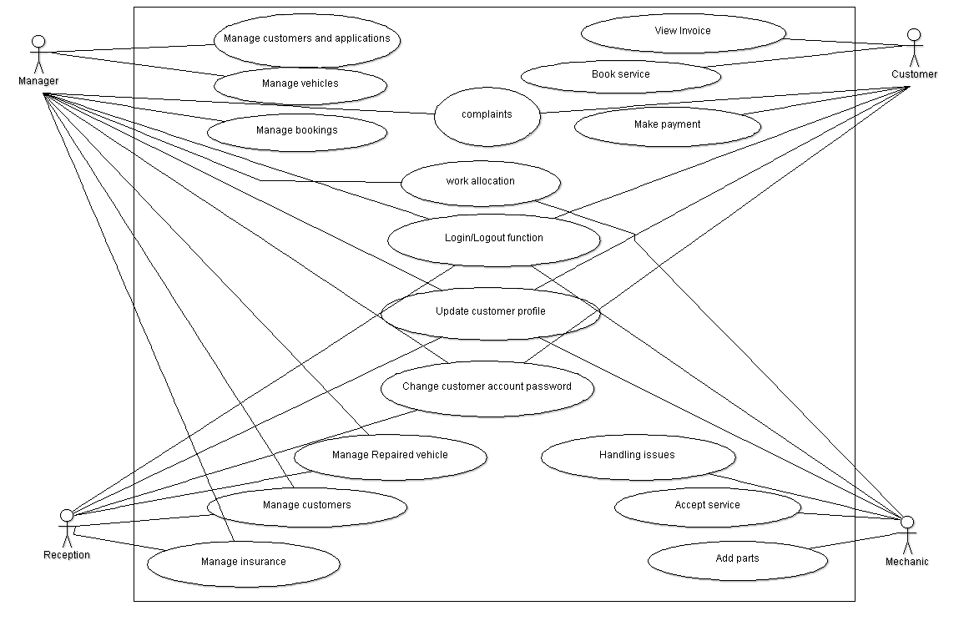

**2.Use Case Diagram**



**3.Activity Diagram**

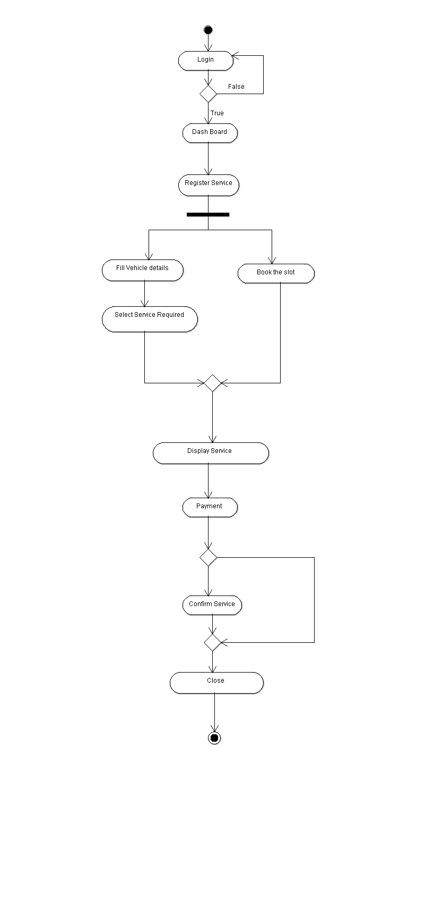

**5.State Transistion Diagram**

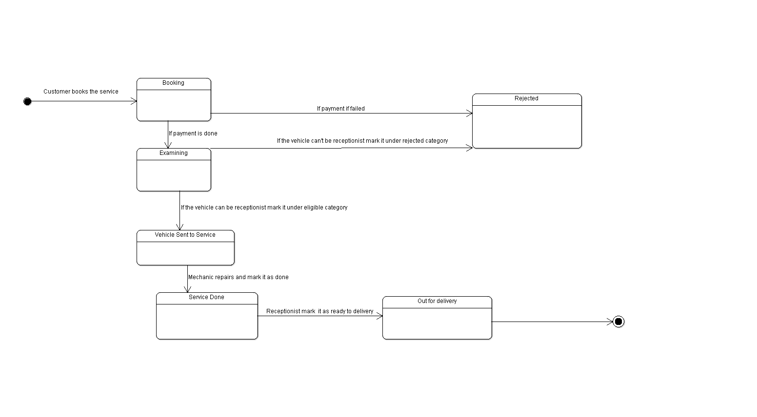

**5.State Transition Diagram**



**6.Class Diagram**

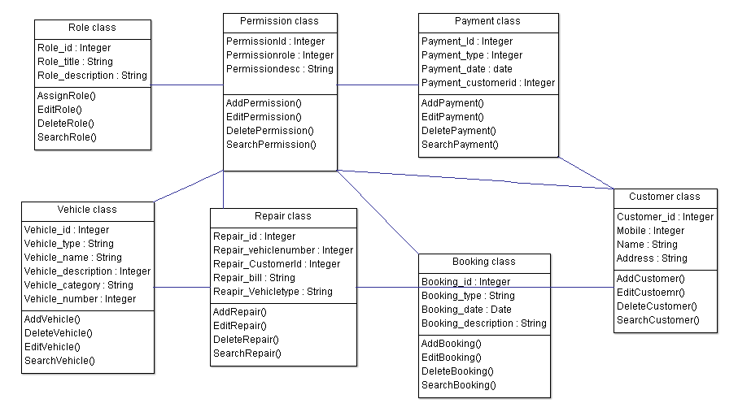

**6.Class Diagram**

**7.Functional Requirements:**

* The user can able to register through the desktop application.
* The customer can able to register for Vehicle service.
* The customer can able to view their previous purchase made in the automobile shop.
* The salesperson will prepare or make bills for the purchases and vehicle services.
* The serviceperson will register a service and do the service(Register a service).
* Sending vehicle service Completion E-mail/SMS.
* The administrator will manage the employees and can view the works done by them(Managing employee).

**8.Non-Functional Requirements:**

* GUI of the portal.
* Revoke insurance if aftermarket parts are fitted.
* Confirmation SMS to customer.
* Feedback of service.
* Display stages of vehicle.
* Home delivery of vehicle.