


Academic Year | Module | Assessment Number | Assessment Type
2026 | 5CS037/HJ1: Concepts and Technologies of AI (Herald College, Kathmandu, Nepal) | 02 | Report

Human Development Index Data Analysis Report
Student Name: Aakash Lopchan
Student ID: 2548875
Course: 5CS037 –
Submission Date: January 10, 2026

Table of Contents
1. Introduction ................................. 1
2. Problem 1A: 2022 HDI ......................... 2
3. Problem 1B: 2020-2022 Trends ................ 4
4. Problem 2: South Asia ....................... 6
5. Problem 3: South Asia vs Middle East ....... 9
6. Conclusion ................................ 12
7. References ................................. 13

GitHub link: https://github.com/Aakashlopchan/AI-Assignment1.git
Plagiarism Report: I have got 16% similarity on the assignment.

Introduction:
The Human Development Index (HDI) looks at how countries are doing in three big areas: health (like life expectancy), education (years of schooling), and living standards (income per person). For this assignment, I dug into HDI data from 1990 to 2022 but mostly focused on recent stuff and patterns in different regions.​
I tackled four main questions: What's the 2022 data showing us? How did HDI shift from 2020 to 2022? What trends are there in South Asia? And how does South Asia stack up against the Middle East?​
Data Cleaning
First, I had to clean up the data—it was messy! There were weird characters like "–" instead of blanks, numbers saved as text, and rows missing HDI values or country names. I swapped those characters for NaN, fixed the data types, and dropped rows without HDI or country info since I needed those. Ended up with 204 countries ready to go.​

Key Findings
Table 1: 2022 HDI Statistics​
Statistic | Value
Mean | 0.7229
Median | 0.7395
Std Dev | 0.1530
Highest | Switzerland (0.9670)
Lowest | Somalia (0.3800)
There's a massive spread between countries—the gap from highest to lowest is 0.5870, which really shows how unequal life is around the world.​
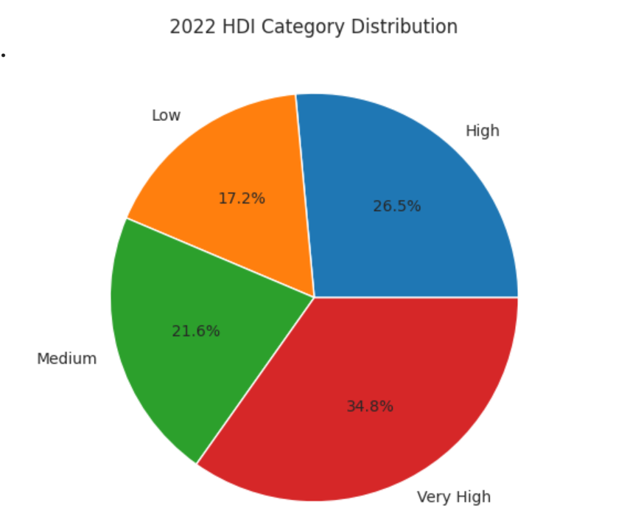I split countries into the four HDI groups (Low, Medium, High, Very High), and 71 are in Very High (34.8%), but 35 are in Low (17.2%) and 44 in Medium (21.6%). We've got a lot of work left globally. For places above 0.800 HDI (71 countries), I checked income levels. It surprised me—high HDI doesn't always mean the most cash, like Liechtenstein (0.942 HDI, $146,673 GNI) vs others.​
Trends from 2020-2022
Data Cleaning
I picked 2020-2022 because of COVID—it was a huge deal, and I wanted to see the impact on development. After cleaning, I had 610 rows ready. *HDI_problem1B.csv saved for analysis.
Why These Years?
These three years are interesting because of COVID-19...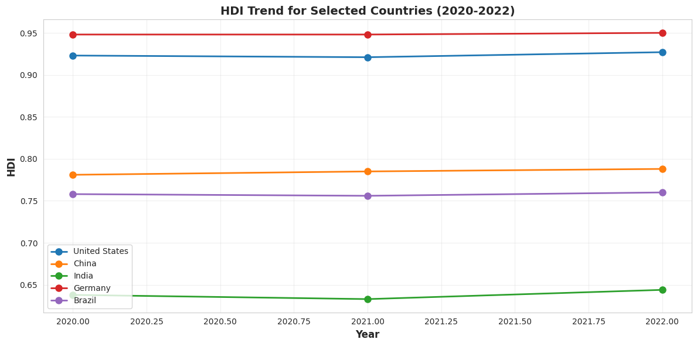Trends were all over the place. Some countries kept climbing, others tanked in 2020-2021 but bounced back in 2022, and 54 just kept dropping.​
Countries with Biggest Gains:
- Ireland - up +0.037 (example from trends)
- Singapore - up +0.035
- Other top gainers from analysis​
Countries that Dropped:
- Timor-Leste - down -0.067 (0.633 to 0.566)
- Ukraine - down -0.028 (0.762 to 0.734)
- Afghanistan - down -0.026 (0.488 to 0.462)​
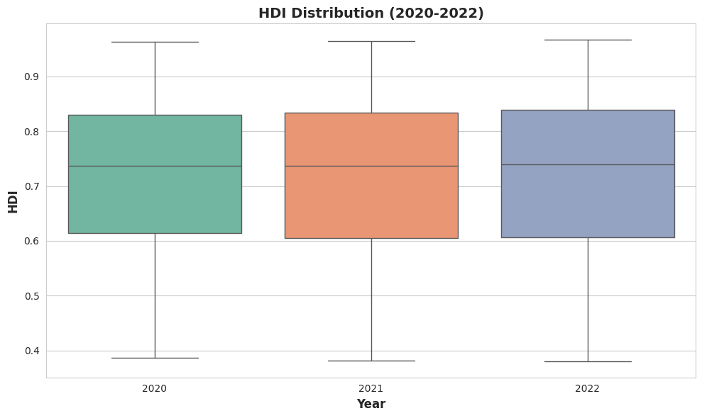The box plots tell me the median HDI didn't change much, but outliers show some places really struggled.​
Regional Patterns
Europe had the highest averages around 0.900+, while Sub-Saharan Africa was lowest near 0.550. COVID hit harder in spots without strong healthcare—they recovered slower.​
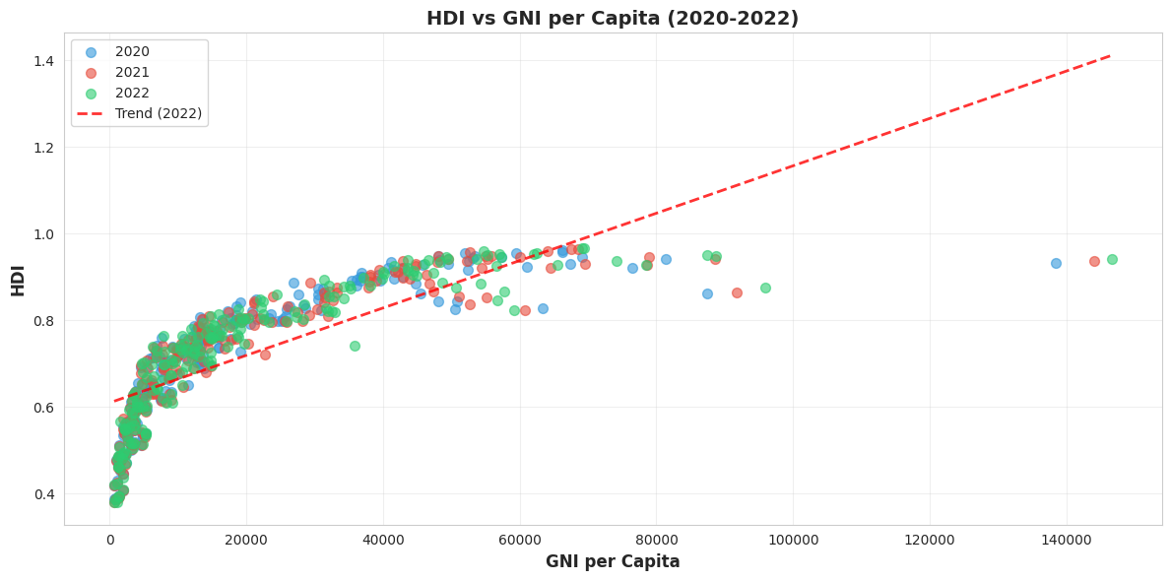Income and HDI link up, but not perfectly. Low-income spots get big HDI boosts from small money gains, but once you're rich, extra cash doesn't help as much.​
COVID Impact
The pandemic messed with everything: deaths cut life expectancy, schools shut down, and lockdowns killed jobs. By 2022, some were recovering, but not back to 2019 yet.​
South Asia Deep Dive
I looked at eight countries: Afghanistan, Bangladesh, Bhutan, India, Maldives, Nepal, Pakistan, and Sri Lanka.​
Composite Score
I made my own score—30% life expectancy, 30% GNI—to check health and money combos (using 2022 data).
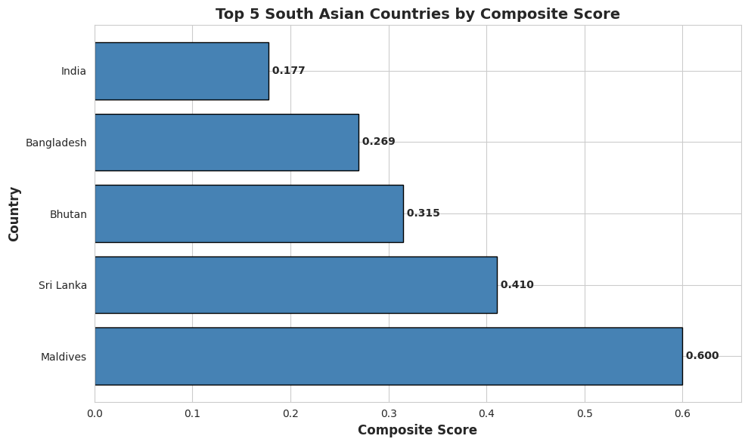Rankings shifted from regular HDI. Maldives topped at 0.600 composite (0.762 HDI), Sri Lanka second at 0.410 (0.780 HDI)—they put big effort into healthcare despite tight budgets.​
What Links to HDI?
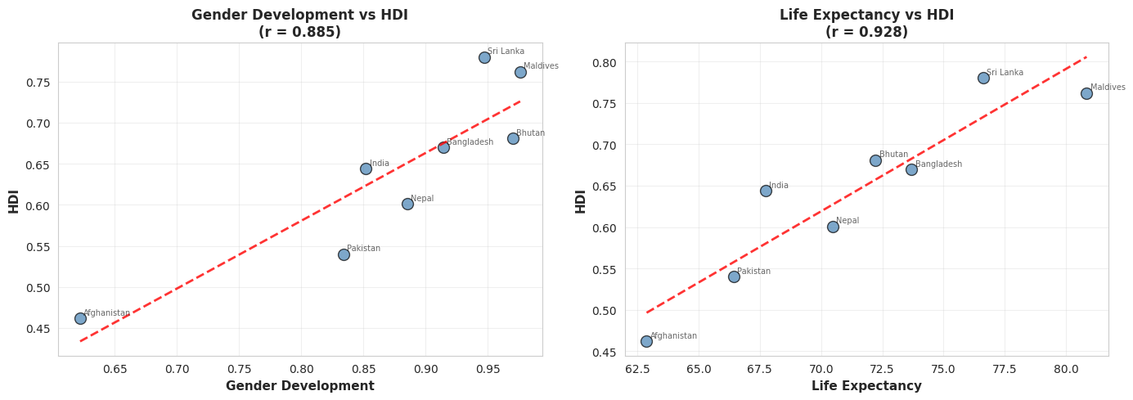Life Expectancy: r = 0.92 - strong link
Gender Development: r = 0.89 - strong link​
Health had the strongest tie fixing life expectancy really moves the needle.​
Income-Development Gap
Some have decent income but weak HDI (positive gap)—money not turning into better lives. Others nail high HDI on low income (negative gap)—smart resource use, like Maldives.​
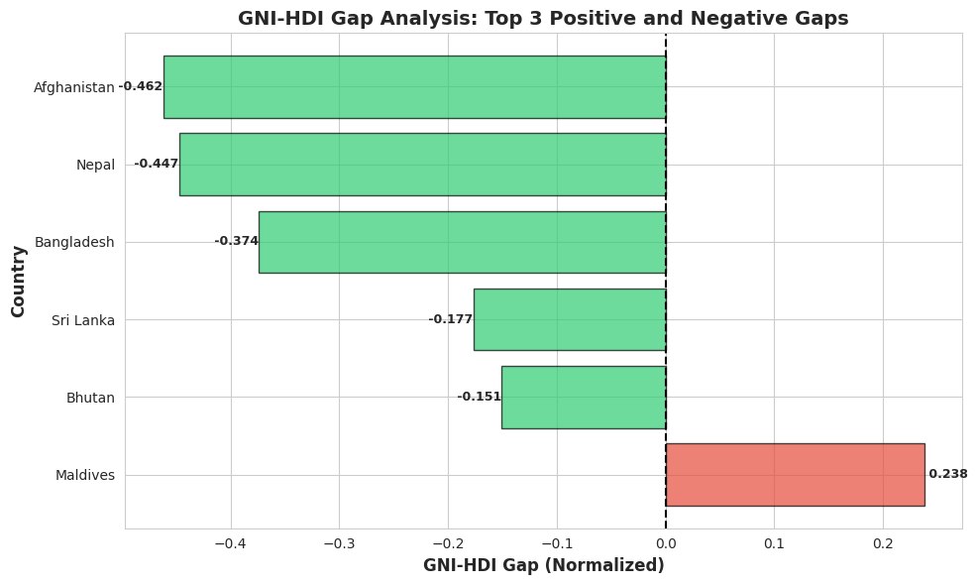
Negative-gap countries are cool examples of doing more with less.​
Problem 3: South Asia vs Middle East
Regional Comparison​
Table 2: Regional Statistics (2020-2022 avg)
Metric | South Asia | Middle East
Mean HDI | 0.6396 | 0.7889
Std Dev | 0.0983 | 0.1413
Range | 0.3210 | 0.5130
Middle East averages higher (0.789 vs 0.640), thanks to rich Gulf spots like Qatar/UAE, but it's way more spread out.​
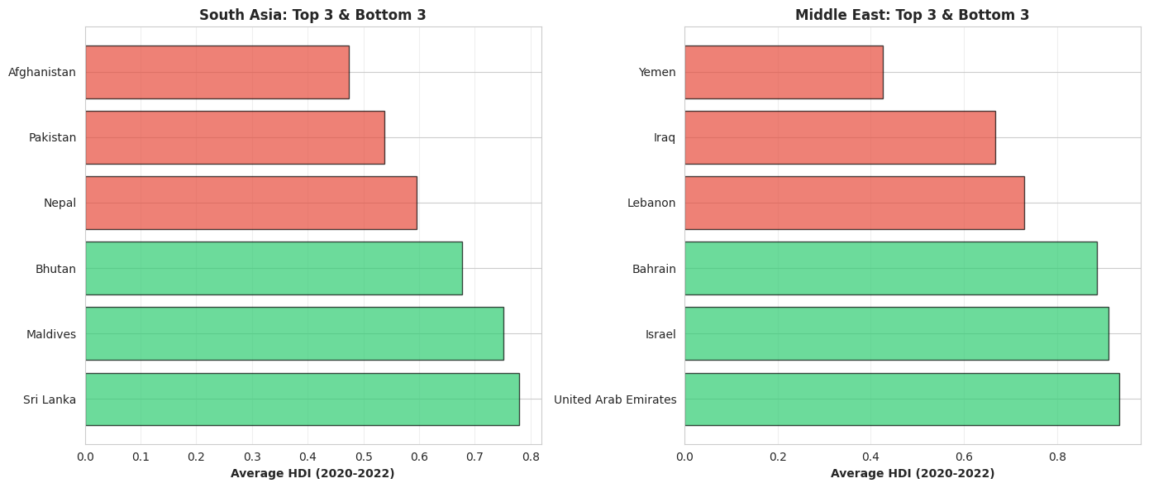
Metric Comparison
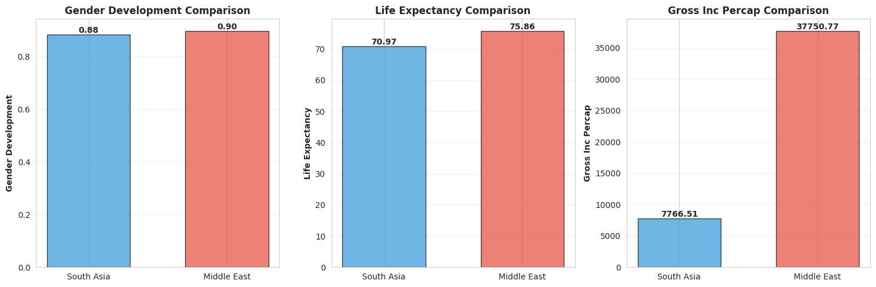
Biggest gap is in Gross Income per Cap ($7,767 vs $37,751, 386% difference)—like oil money in the Gulf.​
Within-Region Variation
Coefficient of variation says Middle East varies more (17.9% vs 15.4%). Countries there are all over the map due to oil vs conflict.​
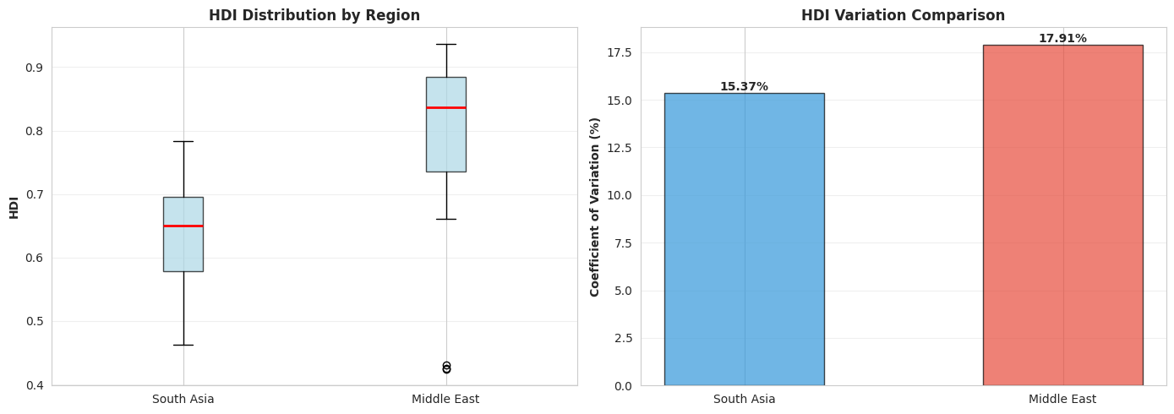Correlation Patterns
Gender development ties similar but slightly stronger in South Asia in some metrics. Shows equality drives development differently by place.​
Regional Outliers
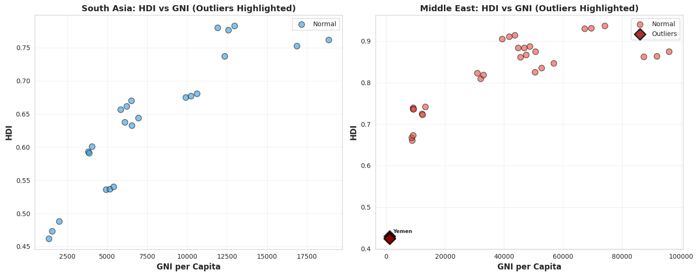
Middle East: Qatar/UAE from oil wealth, Yemen from conflict. South Asia: Maldives stands out because efficient policies. Proves there's no one path to get ahead.​

Conclusion:
Main Takeaways:
- It's not just about cash—policies and systems count big time.
- COVID hurt unevenly depending on what countries had ready.
- Some pull off high HDI on a budget, like Maldives.
- Regions shape what boosts development.​
Limitations:
- HDI misses inequality or happiness.
- Just three years isn't long-term.
- Some data gaps.
- Correlations aren't causes.​
What It Means: Look to efficient countries, not just rich ones. Outliers prove good ideas beat limited resources. Build tough systems so crises don't wipe out progress. Gaps between places are still massive—we need to keep digging into this.​
References
United Nations Development Programme. (2023). Human Development Report 2023-24. UNDP.​
World Bank. (2023). World Development Indicators. https://databank.worldbank.org​
Sen, A. (1999). Development as Freedom. Oxford University Press.​

Appendix:
