WEEK 2 TASK REPORT
Hands-on Practice in Mechanical Design: Modelling, Tolerancing and Documentation of a 90° Flanged Pipe Elbow
Mechanical Design Intern, YuvaIntern
Prepared by | Aakash Kumar Pandey
Task | Week 2: Hands-on Practice in Mechanical Design (SolidWorks, GD&T, design)
Date | 29 October 2026
Software | SolidWorks Design Standard 2026 SP4.1 (Academic)
Part and drawing | Part id0.6; drawing “model01 drafting”, A3, scale 1:5

1. Objective and Summary
The task asks for a guided, real-world style exercise using SolidWorks, GD&T and design, with the steps documented. For this exercise I took an existing SolidWorks part, a 90° flanged pipe elbow (part id0.6), and developed it from a dimensioned model into a manufacturing-ready package: material selection, a design-for-manufacturing (DFM) review, GD&T and size tolerancing, supporting calculations and a documented A3 drawing.
Every decision in this report is backed by a number or a worked calculation, and each section states why the choice was made, so the approach can be followed and checked.
Table 1. Summary of the exercise
Item | Result
Part | 90° flanged pipe elbow; two square flanges 360 × 360 × 50 mm; 4 × Ø30 holes per flange; bore Ø210; OD Ø290; bend R260
Material | AISI 1020 plain carbon steel (assigned in SolidWorks)
Calculated mass | ≈ 247 kg (hand calculation, Section 4.3)
Wall thickness | 40 mm in the model; minimum needed at 1 MPa with a safety factor of 3 is 0.9 mm (Section 5.2)
Improvement proposed | 10 mm wall: ≈ 111 kg (−55%), hoop stress 11.0 MPa (Section 5.3)
GD&T | Datums A to D; flatness 0.1; perpendicularity 0.2; position Ø1.0 at MMC; bore Ø210 H8; holes Ø30 H12
Assembly margin | 2.0 mm at worst case (3.0 mm allowed, 1.0 mm used; Section 7.4)
Deliverables | This report and the A3 drawing (PNG and PDF)

2. Design Brief, Geometry and Assumptions
The elbow turns a flanged pipe run through 90°. Each end has a square flange with four bolt holes for a gasketed bolted joint. The geometry below is taken from the SolidWorks model and its dimensioned drawing.
Table 2. Geometry from the SolidWorks model
Parameter | Value | Note
Flange square side | 360 mm | Both flanges
Flange thickness | 50 mm | Both flanges
Bolt hole spacing (square pattern) | 260 mm | 4 holes per flange
Bolt hole diameter | Ø30 mm | Through
Spot-face diameter | Ø60 mm | Around each hole
Bore diameter | Ø210 mm | Through both flanges and the body
Pipe outside diameter | Ø290 mm
Bend radius | R260 mm | 90° bend
Straight length | 150 mm | Each side of the bend
Corner radius / fillets | R20 / R10 | Flange corners / blends

Where the model does not state a value, the following assumptions are used. They are listed so that every calculation can be traced and re-run if a value changes.
Table 3. Assumptions
ID | Assumption | Basis and effect
A1 | Design pressure 1 MPa | Assumed for the wall check; replace with the real duty if it differs
A2 | M27 bolts in Ø30 clearance holes | Ø30 is the ISO 273 medium-series clearance hole for M27; used in the floating-fastener calculation
A3 | AISI 1020: density 7,870 kg/m³, yield ≈ 350 MPa, tensile ≈ 420 MPa | Typical published as-rolled values; confirm against the material certificate or the SolidWorks library
A4 | Safety factor 3 | Design choice for the check
A5 | 150 mm straights run from each flange’s inner face to the bend; R260 is the centreline radius | Affects the mass estimate only

3. Step-by-Step Modelling Process in SolidWorks
Model id0.6 was built in SolidWorks Design Standard 2026 SP4.1 (Academic). The feature tree, in build order, is: Sweep1, Boss-Extrude1, Cut-Extrude1, Boss-Extrude3, Cut-Extrude3, Cut-Extrude4, Fillet2, Fillet3, Cut-Extrude5 and Chamfer2, with the material AISI 1020 assigned. The table groups these into the working steps and gives the reason behind each.
Table 4. Modelling steps
Step | Feature(s) | What it creates | Why this way (best practice)
1 | Material: AISI 1020 | Assigns density and strength data to the part | Set first so mass properties and any later analysis use the right material
2 | Sweep1 | The curved pipe body along the 90° path (R260) | One sweep gives a constant section and a smooth bend; the path drives the shape
3 | Boss-Extrude1, Boss-Extrude3 | The two 360 × 360 × 50 mm square flanges | One extrude per flange, so each thickness can be edited on its own
4 | Cut-Extrude1, 3, 4, 5 | Ø210 bore, 4 × Ø30 bolt holes per flange, Ø60 spot faces | Cuts follow the solid features, so they remove material from the finished shape
5 | Fillet2, Fillet3 | R10 blends and R20 flange corners | Radii are added late to keep sketches simple and avoid rebuild errors
6 | Chamfer2 | Edge break | Removes a sharp edge, as required by the “break sharp edges” note

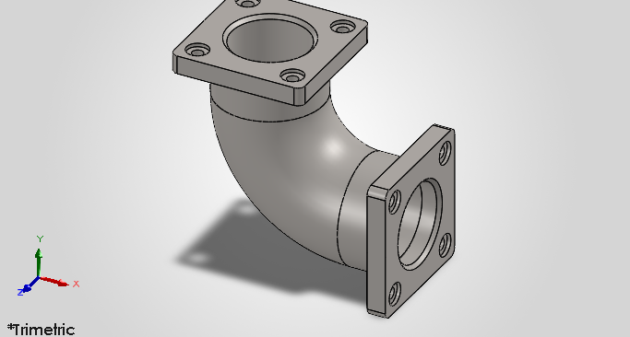
Figure 1. Trimetric view of the finished elbow (part id0.6) in SolidWorks, showing the two square flanges, the bolt holes with spot faces, and the 90° bend.
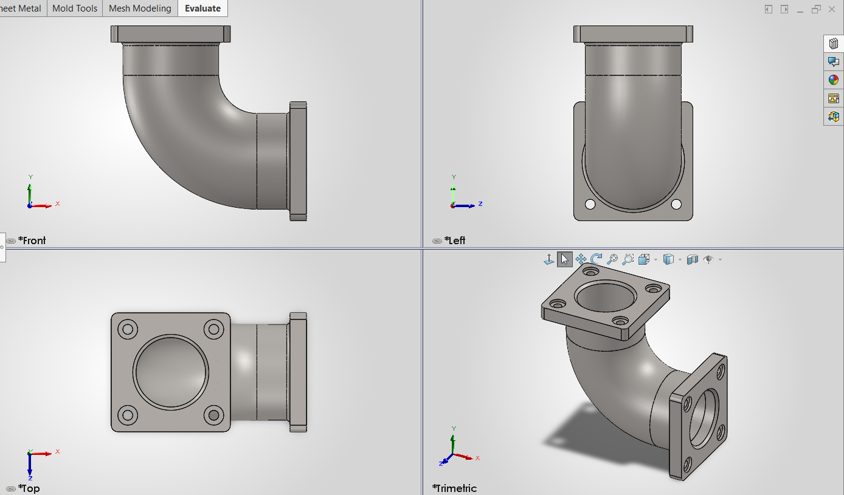
Figure 2. Working setup: the feature tree (left) and the standard views of id0.6 in SolidWorks Design Standard 2026 SP4.1. AISI 1020 appears in the tree as the assigned material.

4. Material Selection

4.1 Candidate materials
Four candidates were compared for a flanged elbow that must be machined on its flange faces, bolted, and possibly welded. The strength and density figures are typical published values; the mass column applies the density ratio to the AISI 1020 estimate for the same geometry.
Table 5. Material comparison
Property | AISI 1020 (as rolled) | Grey cast iron (A48 Class 30) | Stainless 304 (annealed) | Aluminium 6061-T6
Density (kg/m³) | 7,870 | ≈ 7,150 | ≈ 8,000 | ≈ 2,700
Yield strength (MPa) | ≈ 350 | No distinct yield | ≥ 205 | ≈ 276
Tensile strength (MPa) | ≈ 420 | ≥ 207 | ≥ 515 | ≈ 310
Machinability | Good | Good, brittle chips | Fair (work hardens) | Very good
Weldability | Excellent | Poor | Good | Fair, needs care
Corrosion resistance | Low, needs a coating | Moderate | High | High
Relative cost | Low | Low | High | Medium
Mass for this geometry | ≈ 247 kg | ≈ 225 kg | ≈ 251 kg | ≈ 85 kg

4.2 Weighted decision
Each material was scored from 1 (poor) to 5 (excellent) against five criteria. The weights reflect this part: it is machined and bolted, so cost and manufacturability matter most. The scores are design judgements based on the comparison in Section 4.1.
Table 6. Weighted scoring (maximum 5.00)
Material | Strength (25%) | Manufact. (25%) | Corrosion (15%) | Cost (25%) | Weight (10%) | Score
AISI 1020 | 4 | 5 | 2 | 5 | 3 | 4.10
Grey cast iron | 2 | 3 | 3 | 5 | 3 | 3.25
Stainless 304 | 3 | 3 | 5 | 2 | 3 | 3.05
Aluminium 6061-T6 | 3 | 4 | 4 | 3 | 5 | 3.60

Decision: AISI 1020. It scores highest (4.10) and was already assigned in the model. It is ductile, weldable (so a welded-flange route stays open), easy to machine on the flange faces and low in cost. Its yield strength of about 350 MPa is far above the stress in this part (Section 5.2). Its weakness is corrosion, so the part needs paint or zinc coating, and stainless 304 should be chosen instead if the fluid is corrosive.

4.3 Mass estimate (worked example)
The mass is found by adding the volume of the pipe body to the volume of the two flanges, using the assumptions in Table 3.
Table 7. Mass calculation for AISI 1020
Quantity | Calculation | Result
Pipe cross-section area | π/4 × (290² − 210²) | 31,416 mm²
Centreline length of the body | 150 + (π/2 × 260) + 150 | 708.4 mm
Pipe body volume | 31,416 × 708.4 | 22,255,264 mm³
One flange volume | [360² − 4(1 − π/4)·20² − π/4·210²] × 50 − 4 × π/4·30² × 50 | 4,589,657 mm³
Total volume | 22,255,264 + 2 × 4,589,657 | 31,434,578 mm³ = 0.03143 m³
Mass | 0.03143 × 7,870 | ≈ 247.4 kg

The estimate leaves out the R10 blends, the chamfer and the spot-face depth. These change the result by well under 1% unless the spot faces are very deep. A mass of this size needs crane handling, so lifting provisions should be planned.

5. Engineering Calculations and Design Analysis

5.1 Derived geometry
Table 8. Derived geometry
Quantity | Formula | Value
Wall thickness | (290 − 210) / 2 | 40 mm
Bolt circle diameter | 260 × √2 | 367.7 mm
Hole centre to bore axis | Bolt circle / 2 | 183.85 mm
Edge distance (hole centre to flange edge) | (360 − 260) / 2 | 50 mm
Material between hole edge and bore | 183.85 − 105 − 15 | 63.85 mm
Gap from hole edge to pipe OD | 183.85 − 145 − 15 | 23.85 mm
Gap from spot-face edge to pipe OD | 183.85 − 145 − 30 | 8.85 mm
Spot-face clearance round an M27 washer (OD 50) | (60 − 50) / 2 | 5 mm

The 50 mm edge distance is more than three times the hole radius, which leaves ample material at the flange edge. The 8.85 mm gap between the spot face and the pipe OD is tight and is taken up again in Section 6.

5.2 Wall thickness check under internal pressure
The allowable stress is the yield strength divided by the safety factor: 350 / 3 = 116.7 MPa. For a thin wall, the minimum thickness at 1 MPa is t = P·D / (2σ) = 1 × 210 / (2 × 116.7) = 0.90 mm. The model’s 40 mm wall is therefore about 44 times thicker than pressure alone requires.
Because 40 mm is not a thin wall, the thick-wall (Lamé) hoop stress at the bore was also checked: σ = P (ro² + ri²) / (ro² − ri²) = 1 × (145² + 105²) / (145² − 105²) = 3.21 MPa. Against a yield of 350 MPa this is a factor of 109. The wall is set by handling and manufacturing, not by pressure.

5.3 Improvement proposal: thinner wall
Keeping the Ø210 bore and flanges unchanged, the pipe OD is reduced from Ø290 to Ø230, giving a 10 mm wall. This is still more than eleven times the 0.90 mm pressure minimum.
Table 9. Effect of reducing the wall to 10 mm
Quantity | Current (40 mm wall) | Proposed (10 mm wall) | Change
Pipe OD | Ø290 | Ø230 | −60 mm
Pipe cross-section area | 31,416 mm² | 6,912 mm² | −78%
Calculated mass | 247.4 kg | 110.8 kg | −136.6 kg (−55.2%)
Lamé hoop stress at 1 MPa | 3.21 MPa | 11.02 MPa | Still low
Safety factor on yield (350 MPa) | 109.2 | 31.8 | Still above 30
Gap, spot-face edge to pipe OD | 8.85 mm | 38.85 mm | +30 mm

The thinner wall removes more than half the mass and also opens the tool clearance at the bolt heads from 8.85 mm to 38.85 mm. Before adopting it, the bend and flange-to-pipe junction should be checked by finite element analysis under pressure and bolt preload, and a corrosion allowance and the casting or welding minimum thickness should be agreed with the manufacturer. These checks are outside the scope of this exercise.

6. Design for Manufacturability (DFM) Review
The elbow can be made by sand casting followed by machining, or by fabrication (a standard bend with welded flanges). The review below lists what each observation means for cost and quality, and the action taken or recommended.
Table 10. DFM observations and actions
Observation | Why it matters | Action
40 mm wall and 50 mm flange (ratio 1.25) meet at the junction | Thick sections cool slowly in a casting and can leave shrinkage porosity; they also need heavy weld preparation | Reduce the wall (Section 5.3); keep the R10 blend at the junction
Spot-face edge only 8.85 mm from the pipe OD | Limits access for the spot-facing cutter and for the socket or spanner on the bolt head | A 10 mm wall raises the gap to 38.85 mm
Flange faces need Ra 3.2 and flatness 0.1 | Cast or flame-cut faces cannot reach this | Leave a machining allowance on both faces (value agreed with the foundry)
Perpendicularity 0.2 between the two flange faces | Hard to hold if each face is machined in a separate set-up | Machine both faces in one fixture where possible
Holes toleranced Ø30 H12 | IT12 is achievable by drilling, so no reaming is needed | Use plain drilling; control location with the position tolerance instead
Bores toleranced Ø210 H8 | IT8 needs boring or reaming, which adds cost | Apply H8 only to the bores that act as datums (B and D)
No draft angle shown on the drawing | Cast surfaces need draft so the pattern can be withdrawn | If cast, add draft (typically 1° to 3°) on unmachined surfaces
Mass of about 247 kg | Cannot be handled by hand | Plan crane lifting; a lighter wall also helps

Table 11. Manufacturing route comparison
Route | Strengths | Weaknesses
Sand casting + machining | Suits medium to large batches; one-piece part with a smooth bend | Pattern cost; thick sections risk porosity; machining allowance needed
Fabrication (bend + welded flanges) | No pattern; AISI 1020 welds well; good for one-off parts | Welding distortion can spoil flange flatness and perpendicularity; more inspection

7. GD&T and Tolerancing

7.1 Datum scheme
The elbow has two mating interfaces at 90° to each other. Each flange must match its own mating flange, so each gets its own datum frame, and the perpendicularity tolerance ties the two frames together.
Table 12. Datum reference frame
Datum | Feature | Reason
A | Flange 1 mating face | Primary datum: the face that seals against the gasket and mating flange; it fixes the part in the mounting plane
B | Ø210 bore axis, flange 1 | Secondary datum: centres the part on the pipe axis and locates the hole pattern with A
C | Flange 2 mating face | Primary datum for the second flange; its orientation to A is controlled by perpendicularity
D | Ø210 bore axis, flange 2 | Locates the flange 2 hole pattern with C

7.2 Callouts and their purpose
Table 13. GD&T callouts on the drawing
Feature | Callout | Value | Purpose
Flange 1 face (A) | Flatness | 0.1 mm | Gasket seal; datum quality
Flange 2 face (C) | Flatness; perpendicularity to A | 0.1 mm; 0.2 mm | Seal; accuracy of the 90° turn
Bores Ø210 (B, D) | Size H8 | 210.000 to 210.072 | Datum axes; centring
4 × Ø30 holes, flange 1 | Position at MMC to A | B | Ø1.0 (M) | Bolts line up with the mating flange
4 × Ø30 holes, flange 2 | Position at MMC to C | D | Ø1.0 (M) | As above, for flange 2
Hole size | H12 | 30.000 to 30.210 | Drilled hole
Ø60 spot face | Size | ±0.5 mm | Seat for bolt head and washer
Flange faces | Surface finish | Ra 3.2 µm | Gasket seating; Ra 12.5 elsewhere

7.3 Size tolerances and where they come from
Fits come from ISO 286-1 and the general linear tolerances from ISO 2768-m for the relevant size range. The flatness and perpendicularity values are tighter than the general geometrical tolerances of ISO 2768-K, so they are called out explicitly.
Table 14. Size tolerances
Dimension | Tolerance | Basis
Bore Ø210 | H8: +0.072 / 0 | IT8 = 72 µm for 180 to 250 mm
Hole Ø30 | H12: +0.210 / 0 | IT12 = 210 µm for 18 to 30 mm
Flange thickness 50 | ±0.3 | ISO 2768-m, 30 to 120 mm
Flange width 360, straight 150, OD Ø290 | ±0.5 | ISO 2768-m, 120 to 400 mm
Bend radius R260 | ±1.0 | ISO 2768-m, radii over 6 mm

7.4 Worked examples
Floating fastener. Both flanges have clearance holes, so the bolt floats. The largest position tolerance that still lets the bolt fit is T = H − F, where H is the smallest hole (30.000 mm) and F is the largest bolt (27 mm for M27): T = 30 − 27 = 3.0 mm. The drawing specifies Ø1.0 mm, which is 33% of that limit. This keeps the flanges well aligned without paying for a very tight tolerance.
MMC bonus. With the (M) modifier, the position tolerance grows as the hole gets larger. A hole made at the largest size of Ø30.210 allows Ø1.0 + 0.210 = Ø1.21 mm. Parts that would fail a fixed Ø1.0 zone can pass when the hole is oversize, which lowers scrap without hurting the fit.
Assembly margin. If both flanges have holes at the worst-case position (each off by up to Ø1.0), the holes can be offset by at most 1.0 mm. Against the 3.0 mm clearance, that leaves 3.0 − 1.0 = 2.0 mm of margin.
Bore limits. For Ø210 H8 the lower limit is 210.000 mm and the upper limit is 210.000 + 0.072 = 210.072 mm.

7.5 Inspection plan
Table 15. How each characteristic would be checked
Characteristic | Method | Note
Flatness 0.1 on flange faces | Surface plate and dial indicator, or CMM | Measure across the whole face
Perpendicularity 0.2 to A | CMM, or square and indicator on a surface plate | Both faces in one setup
Bore Ø210 H8 | Bore gauge or go/no-go plug gauge | Check both bores
Hole position Ø1.0 (M) | CMM, or a fixed functional gauge | A functional gauge suits MMC
Surface finish Ra 3.2 | Roughness comparator or profilometer | Flange faces only

8. Drawing Documentation
The drawing was developed in two stages. The first stage was a dimensioned SolidWorks drawing of the elbow (Figure 3). It showed the shape but was not ready for manufacture. The second stage added what a manufacturer needs (Figure 4 and the detail views that follow). The final drawing was prepared from the model’s dimensions as a documented manufacturing drawing; the tolerances and GD&T on it are my proposals for this exercise. The 3D view of the part is in Figure 1.
Table 16. Stage 1 compared with the final drawing
Aspect | Stage 1 drawing | Final drawing
Title block | Name, size and scale only | Title, drawing number, material, scale, size, mass, finish, tolerance, drawn by, date
Tolerances | None | Size tolerances from ISO 286-1 and ISO 2768-m
GD&T | None | Datums A to D; flatness; perpendicularity; position at MMC
Views | Three orthographic views and an isometric | Section A-A showing the wall; plan view with the cutting-plane line; flange 2 face view
Hole notes | Diameters only | 4X Ø30 H12 with position, and the Ø60 spot face
Notes | None | General notes, basic-dimension convention, surface finish, fastener assumption

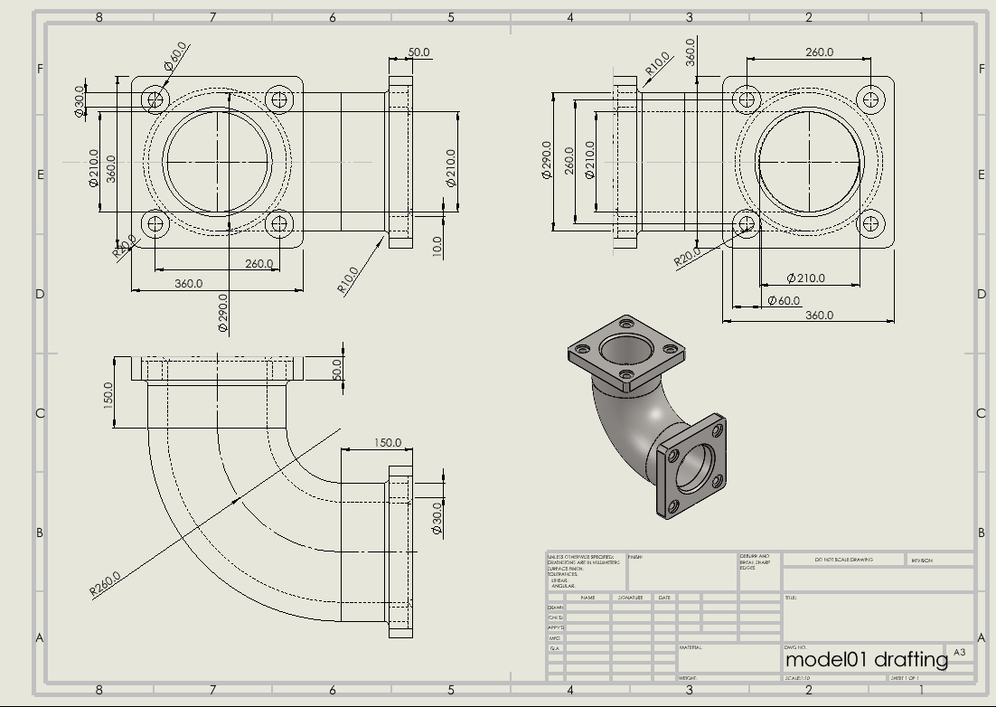
Figure 3. Stage 1: the dimensioned SolidWorks drawing (model01 drafting) before tolerances, GD&T and a complete title block were added.

8.1 Final A3 Manufacturing Drawing
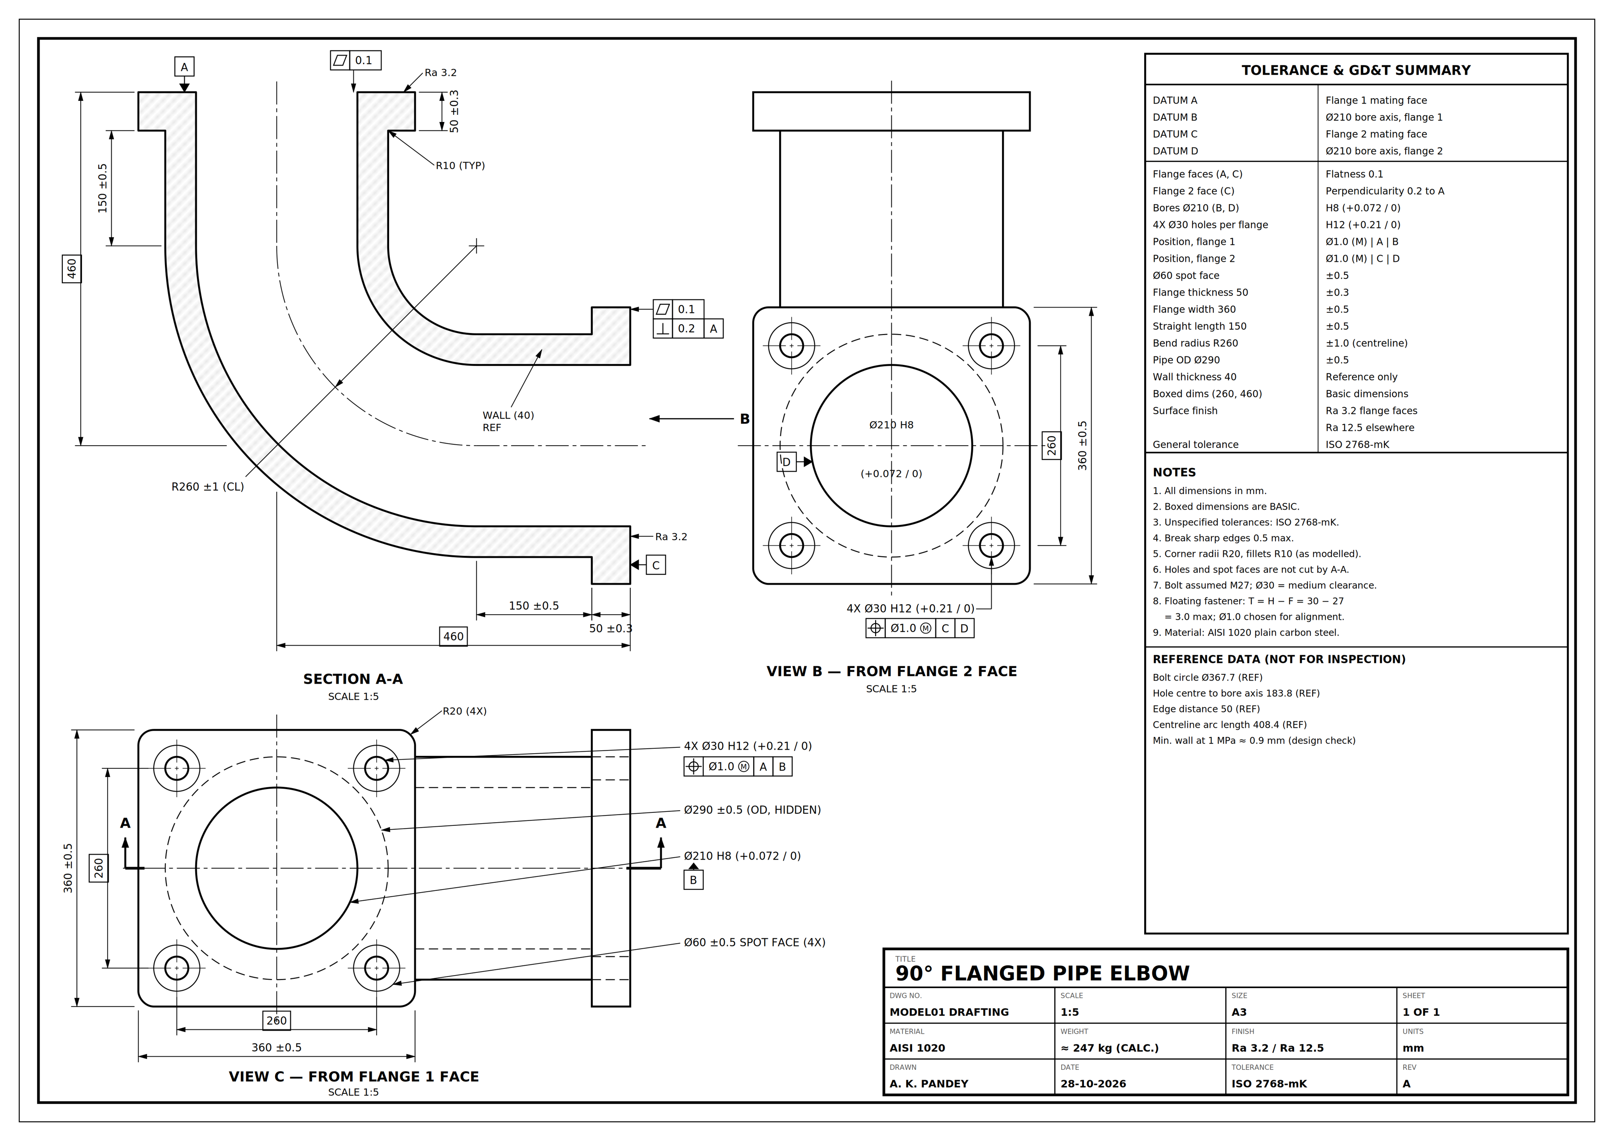
Figure 4. Final drawing: Section A-A, flange 1 face view (C), flange 2 face view (B), tolerance and GD&T summary, notes and title block. A3 sheet, scale 1:5, dimensions in mm.

8.2 Detail views
The views below are enlarged from the final drawing so the dimensions, tolerances and GD&T frames can be read.
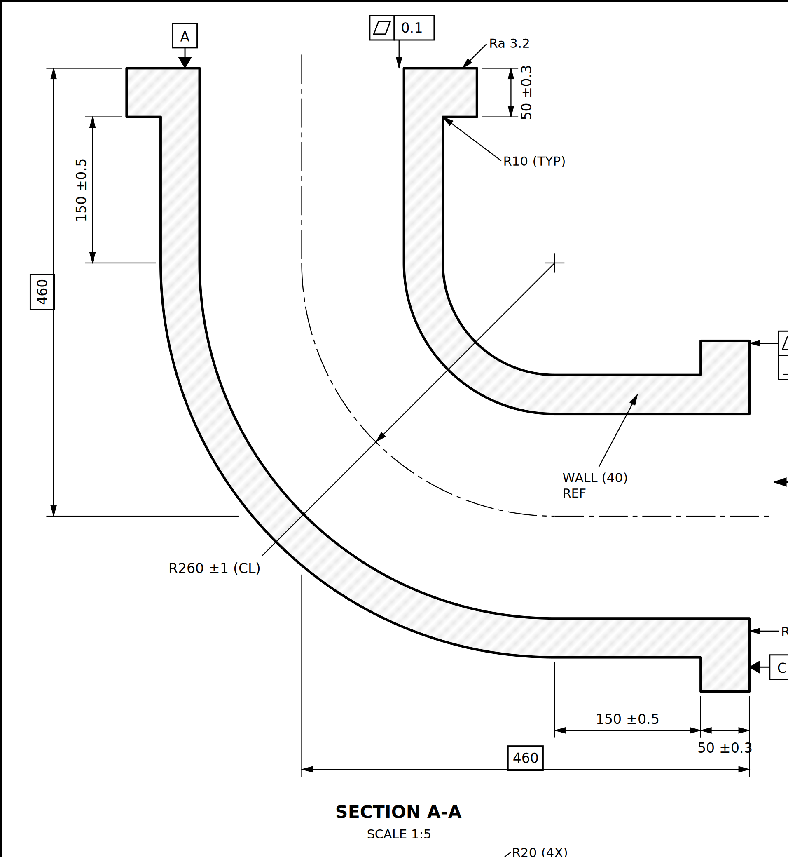
Figure 5. Section A-A: the hatched 40 mm wall, flange thickness 50 ±0.3, straight length 150 ±0.5, bend R260 ±1, basic dimension 460, datums A and C, flatness 0.1 and perpendicularity 0.2.
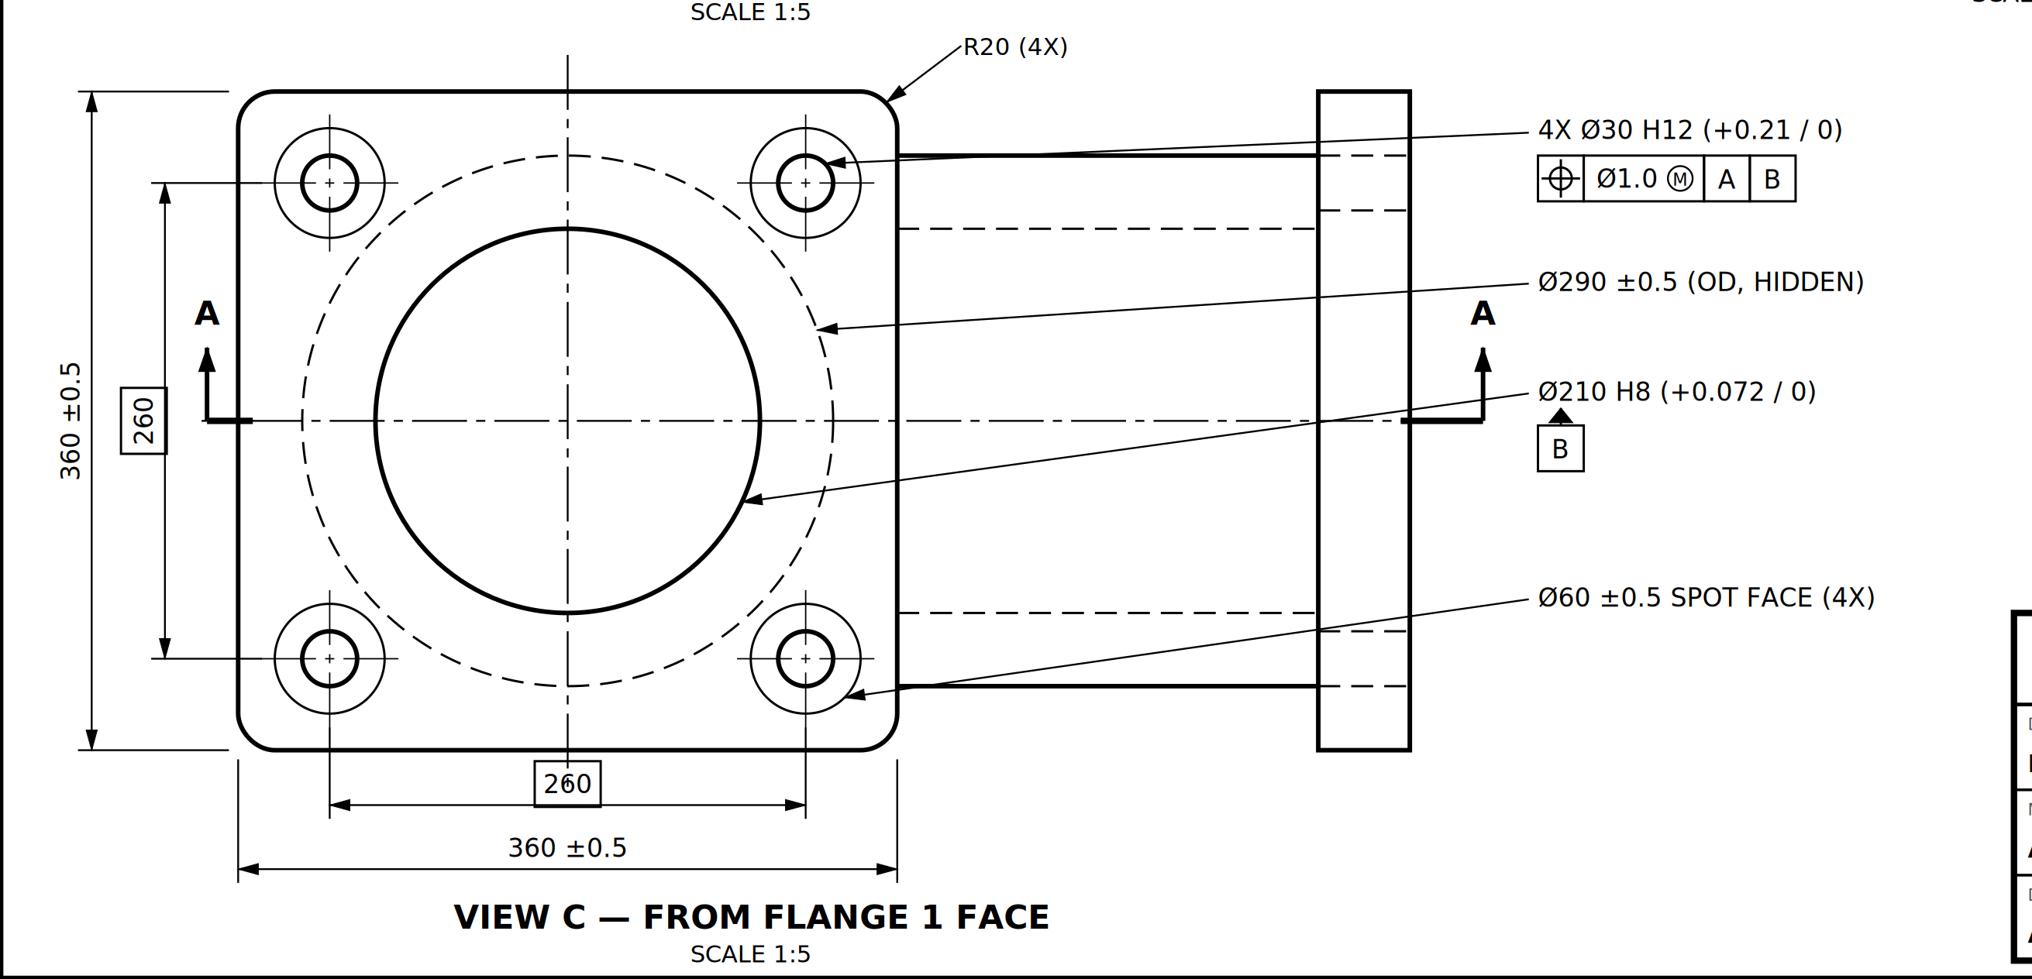
Figure 6. View C, looking at the flange 1 face: 4X Ø30 H12 holes with position Ø1.0 (M) to A | B, Ø60 spot faces, Ø210 H8 bore (datum B), hidden Ø290 outline, basic 260 hole spacing and 360 ±0.5 flange width.
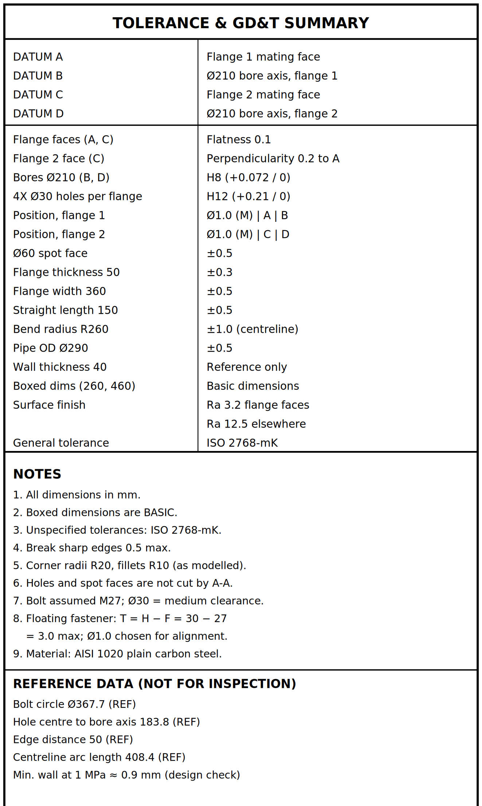
Figure 7. Tolerance and GD&T summary, notes and reference data from the drawing.

8.3 Drawing best-practice checklist
Table 17. Drawing checklist
Practice | How the drawing meets it
Standard sheet and scale | A3 landscape, scale 1:5, units stated as mm
Complete title block | Title, drawing number, material, mass, finish, tolerance, drawn by, date
Datums from function | A to D chosen from the mating faces and bores (Section 7.1)
Basic dimensions boxed | 260 hole spacing and 460 overall dimension
No redundant or unclear dimensions | Wall shown as a reference value only; reference data kept in a separate block
Section view where the inside matters | Section A-A shows the bore and the 40 mm wall
General tolerances stated | ISO 2768-mK note and title block entry
Surface finish stated | Ra 3.2 on flange faces, Ra 12.5 elsewhere

9. Week 1 Feedback and How This Report Addresses It
The Week 1 review asked for more specific data, worked examples and original analysis, with more depth on GD&T, DFM and material selection. The table shows where each point is answered.
Table 18. Feedback tracker
Week 1 feedback | What this report does | Where
Specific data and concrete numbers | Dimensions, tolerances, material properties and a mass are stated throughout | Sections 2 to 7
Worked examples | Mass estimate, wall thickness, Lamé stress, floating fastener, MMC bonus, bore limits | 4.3, 5.2, 7.4
Original analysis | The 40 mm wall is 44 times what pressure needs; a 10 mm wall saves about 137 kg and improves bolt access | 5.2, 5.3
GD&T principles | Datum scheme with reasons, callouts, size tolerances and inspection plan | Section 7
DFM | Observation, reason and action for each issue; casting and fabrication compared | Section 6
Material selection | Four materials compared and scored; AISI 1020 chosen with its weakness stated | Section 4

10. Challenges, Lessons and Next Steps

Challenges found in the design review
- Over-built wall. The 40 mm wall carries about 3 MPa of hoop stress at 1 MPa pressure, so most of the 247 kg is unnecessary.
- Tight bolt access. The Ø60 spot face lies only 8.85 mm from the pipe OD.
- Cost against function. The tolerances had to be tight enough for alignment (Ø1.0 position, H8 bore) but not so tight that they add machining cost (H12 holes drilled, not reamed).
- Incomplete first drawing. It had no tolerances, no datums and an empty title block, so it could not be manufactured from.

Lessons
- Choose datums from how the part works, then add tolerances to features that need them.
- Support each statement with a number; it makes the design checkable.
- Check manufacturability while the design is still easy to change.

Next steps
- Verify the hand-calculated mass against SolidWorks Mass Properties and run DFMXpress on the model.
- Validate the 10 mm wall proposal by finite element analysis under pressure and bolt preload.
- If the part is cast, add draft angles and a machining allowance and prepare a casting drawing.

11. Conclusion
The exercise took a flanged pipe elbow from a dimensioned model to a documented, manufacturable design. AISI 1020 was selected with a weighted comparison, the mass was estimated at about 247 kg, and a datum-based GD&T scheme was applied with a worked assembly margin of 2.0 mm. The design review found that the 40 mm wall is far thicker than pressure requires; a 10 mm wall would save about 137 kg and improve tool access. The final A3 drawing and this report document each step and the reason behind it.

References and standards
- ISO 286-1: limits and fits (IT grades, H8 and H12 values).
- ISO 2768-1 and ISO 2768-2: general tolerances (class m for linear sizes, class K for geometry).
- ISO 273: clearance holes for bolts (medium series for M27).
- ASME Y14.5: GD&T conventions, including the floating-fastener formula and the MMC modifier.
- Typical published material data for AISI 1020, grey cast iron, stainless 304 and aluminium 6061-T6; confirm against the material certificate before manufacture.

