MECHANICAL DESIGN INTERN - WEEK 2
Hands-on Practice in Mechanical Design
Design-for-Manufacture Study of a Flanged 90° Branch Body (Part ID: id0.8)
SolidWorks 2026 | GD&T (ASME Y14.5) | Design for Manufacture
Intern | Aakash Kumar Pandey
Programme | Yuva Intern - Mechanical Design Intern (20-Oct-2026 to 15-Dec-2026)
Institution | B.Tech Mechanical Engineering, IKGPTU
Part / Drawing No. | id0.8
Date | 30 October 2026

1. Objective and Scope
The Week 2 task applies SolidWorks, GD&T and design fundamentals to Part id0.8, a flanged 90° branch body modelled in SolidWorks. The component has a vertical cylindrical main body, top and bottom flanges, and a horizontal side branch terminating in a flange. Its geometry resembles a valve or piping body; however, its exact service application and pressure rating have not been established. The objective is to develop a preliminary manufacturing package by documenting the model dimensions and mass properties, evaluating material and process options, and proposing drawing controls using GD&T. Calculations and assumptions are identified so that they can be checked before manufacturing release.
Deliverables: this report, the A3 manufacturing drawing (PDF), the SolidWorks part file, and a GitHub repository containing all of them.

2. Part Description and Modelling Approach
Part id0.8 is a flanged 90° branch body comprising a vertical cylindrical main body, a Ø250 mm top flange, a Ø220 mm bottom mounting flange and a Ø220 mm side-branch flange. The branch flange face is located 150 mm from the main axis. A stepped bore (Ø76, Ø92, Ø114 and Ø158 mm) passes through the main body, while a Ø108 mm side neck contains a Ø76 mm bore. The overall height is 270 mm. AISI 1020 is assigned in the current SolidWorks model for the reported mass-property calculation; this assignment does not by itself establish the final production material.

2.1 Feature tree (from SolidWorks)
Feature | Purpose
Revolve-Thin1 (Sketch4) | Thin revolved profile that creates the body, hub and flange envelope about the vertical axis
Cut-Extrude9, 10, 11 | Bolt holes and recesses on the flange faces and neck
Plane1 + Boss-Extrude1 (Sketch11) | Reference plane at the branch axis; extrusion that builds the side neck
Boss-Extrude2 | Branch flange
Cut-Extrude12 (Sketch17) | Branch bore and branch bolt-hole pattern
Fillet1 | Blend between the hub and the body (R26 in the drawing)

The tree also contains an Equations folder (driven dimensions) and shows Solid Bodies(2). The model therefore requires a geometry review to establish whether the two bodies are intended to be separate components or should be merged. Do not merge or delete a body without checking the design intent. Before release, confirm that the manufacturing model contains the intended solid bodies and recalculate mass properties for the final configuration. The reported mass should be treated as provisional until this check is complete.
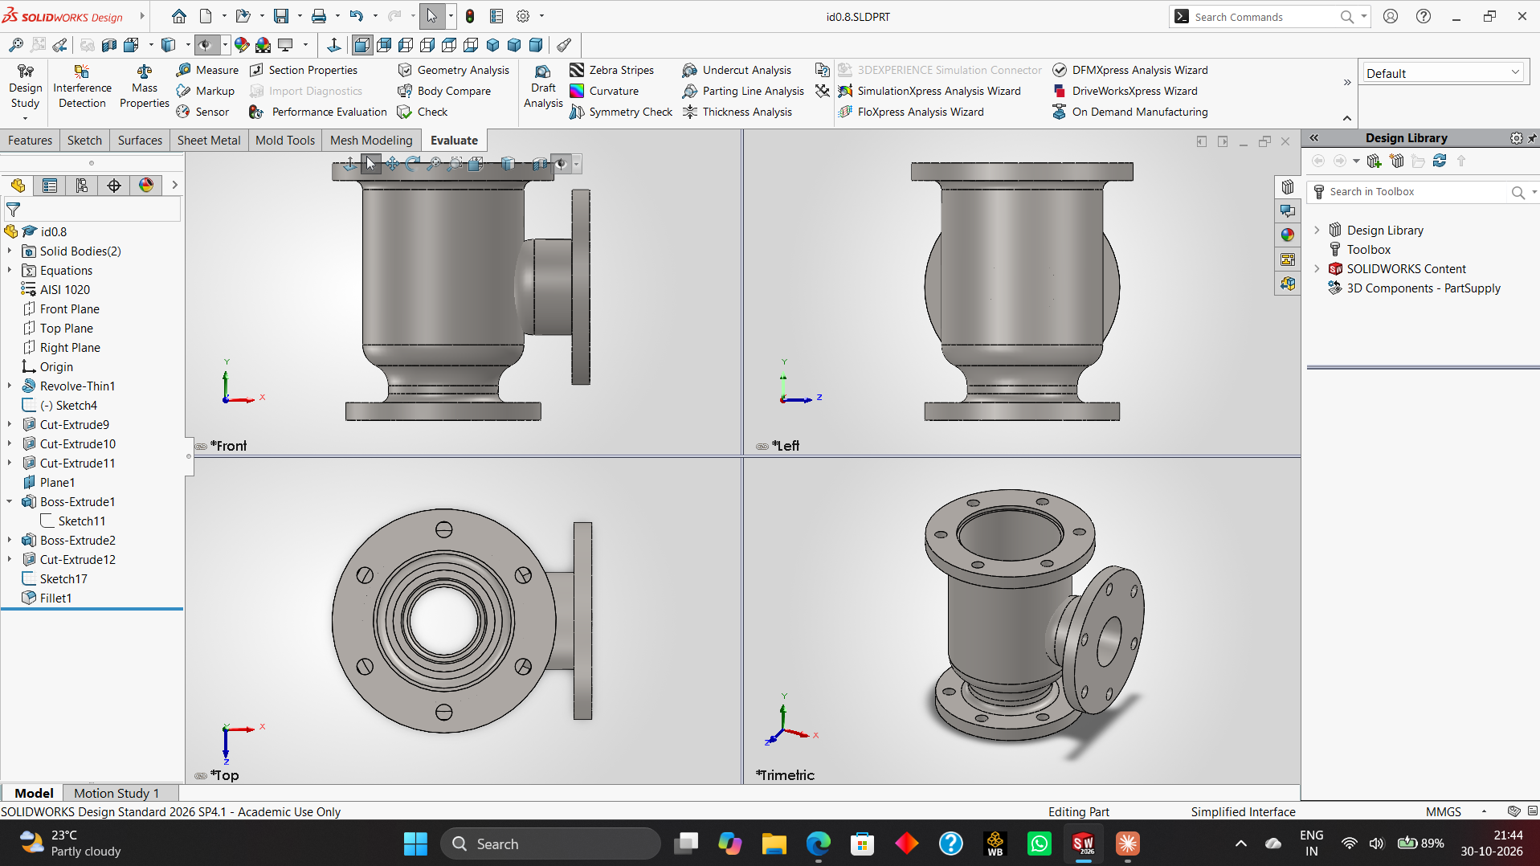
Figure 1 - id0.8 in SolidWorks: feature tree and Front / Left / Top / Trimetric views

3. Key Dimensions
Feature | Value (mm) | Note
Overall height | 270 | Bottom face to top flange face
Top flange | Ø250 x 20 thick | 6 holes Ø18 on PCD Ø204
Bottom flange | Ø220 x 20 thick | 4 holes Ø18 on PCD Ø180 (mounting face = Datum A)
Body outer / main bore | Ø182 / Ø158 | Wall = (182-158)/2 = 12 mm
Hub outer / bores | Ø124 / Ø114, Ø92, Ø76 | Hub wall = (124-92)/2 = 16 mm; Ø76 = Datum B
Branch neck / bore | Ø108 / Ø76 | Neck wall = (108-76)/2 = 16 mm
Branch flange | Ø220 x 20 thick | Face 150 from axis (Datum C); 4 holes Ø18.5 on PCD Ø180
Blend radius | R26 | Hub-to-body fillet

4. Mass Properties and Weight Calculation
SolidWorks Evaluate > Mass Properties returned the following for configuration Default, with density 0.0079 g/mm³ (7.9 g/cm³) using the AISI 1020 material assigned in the model. These values are provisional pending the two-body and final-material checks:
Property | Value
Volume | 4,400,286.91 mm³
Surface area | 537,981.91 mm²
Mass | 34,762.27 g = 34.76 kg
Centre of mass (X, Y, Z) | 28.38, 141.74, 0.00 mm
Principal moments of inertia | Px = 331,827,458 | Py = 404,916,899 | Pz = 503,968,526 g.mm²

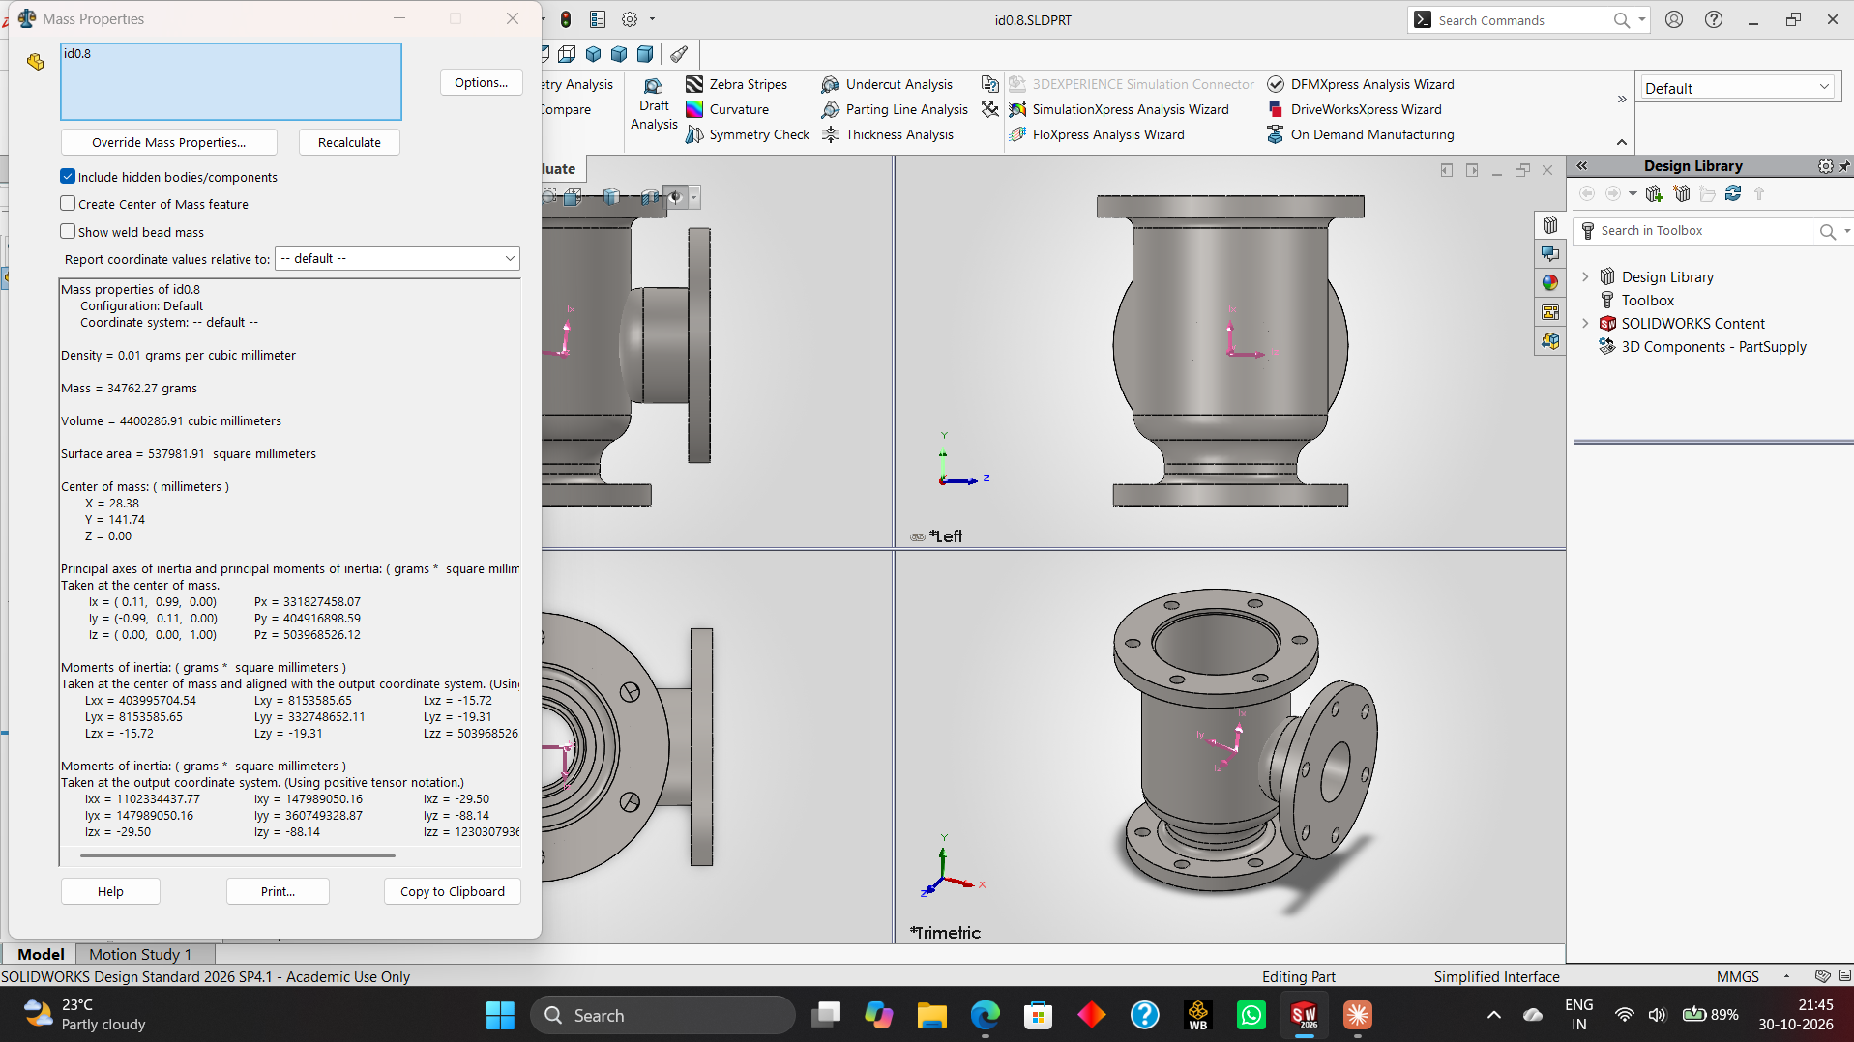
Figure 2 - SolidWorks Mass Properties for id0.8

4.1 Worked check of the mass
Mass = volume x density = 4,400,286.91 mm³ x 0.0079 g/mm³ = 34,762 g = 34.76 kg, which matches SolidWorks. The centre of mass sits 141.74 mm above the base on a 270 mm part, i.e. 52 % of the height, which is expected because the heavy top flange and the side branch add mass high on the body. X = 28.38 mm shows the offset toward the branch, so the part must be supported on its base flange during machining and handled with a lifting eye or sling because it weighs 34.76 kg.

4.2 Raw casting weight
A casting must carry machining stock. Assuming 3 mm on the three flange faces and 2 mm on the stepped bores:
- Flange face area = pi/4(250²-158²) + 2 x pi/4(220²-76²) = 29,478 + 2 x 33,475 = 96,428 mm²; stock = 96,428 x 3 = 289,284 mm³
- Stepped bore area = pi x (76x20 + 92x35 + 114x40) = 29,216 mm²; stock = 29,216 x 2 = 58,432 mm³
- Extra mass = (289,284 + 58,432) x 0.0079 = 2,747 g = 2.75 kg
- Raw casting mass ≈ 34.76 + 2.75 = 37.5 kg (finished-to-raw ratio 92.7 %). Gating and risers are extra and are not counted.

5. Material Selection
Because the body is a pressure-containing, bolted flange part, the candidates were compared on mass for the same CAD volume of 4,400,287 mm³ and on suitability:
Material | Density (g/cm³) | Mass (kg) | Assessment
Cast steel ASTM A216 WCB | 7.90 | 34.76 | Selected candidate: castable carbon steel; confirm grade properties and service suitability
Grey cast iron (grade 250) | 7.20 | 31.68 | Cheapest, but brittle; poor for impact and pressure surges
Ductile iron 65-45-12 | 7.10 | 31.24 | Good alternative; lighter, yield 310 MPa, lower weldability
Stainless steel CF8M | 8.00 | 35.20 | Needed only for corrosive media; much higher cost
Aluminium A356-T6 | 2.68 | 11.79 | Lightest, but low stiffness and flange creep under bolt load

Preliminary material decision: ASTM A216 Grade WCB cast steel is a candidate for a cast component. It is not interchangeable with wrought AISI 1020 and should not be described as its equivalent. AISI 1020 is the material currently assigned in SolidWorks and is used only for the present mass estimate. Before release, assign the selected WCB grade (or its verified material data) in the CAD model and update the mass properties. Confirm the required grade, heat treatment, mechanical properties, corrosion allowance and applicable pressure-service requirements with the design specification.

6. Manufacturing Process
Step | Operation | Machine / method | Key detail
1 | Pattern + sand casting | Foundry | CT10 (ISO 8062), 2° draft, cored bores
2 | Fettling and heat treatment | Grind, furnace | Normalise + stress relieve
3 | Turn flange faces, OD and stepped bore | CNC lathe, chuck on top flange | Faces Ra 3.2, bores Ra 1.6
4 | Bore and face branch flange | HMC or VMC with fixture / angle plate | Branch face 150 from axis, perpendicular to base
5 | Drill and spot-face bolt holes | VMC | 6 + 4 + 4 = 14 holes
6 | Deburr, inspect, test | CMM, dye-penetrant, hydro test | Position and flatness verification

6.1 Worked machining calculations
Turning the top flange face (carbide insert, cutting speed 150 m/min, feed 0.2 mm/rev): spindle speed N = 1000 x Vc / (pi x D) = 1000 x 150 / (pi x 250) = 191 rpm. The face is cut from Ø250 to Ø158 (radial length 46 mm), so one pass takes 46 / (0.2 x 191) = 1.2 min. With 3 mm stock (rough 2 mm, finish 1 mm), the facing time is about 2.4 min.
Drilling a Ø18 hole (HSS drill, 25 m/min, 0.2 mm/rev): N = 1000 x 25 / (pi x 18) = 442 rpm and feed rate = 88 mm/min. Through the 20 mm flange the cut time is 20 / 88 = 0.23 min; adding about 0.3 min for positioning and retract gives roughly 0.5 min per hole, or about 7 min for all 14 holes.

7. Strength Check (Illustrative)
This is an illustrative, simplified thick-cylinder check only. It assumes an internal pressure of 1.0 MPa (10 bar), an inner radius of 79 mm (Ø158 bore) and an outer radius of 91 mm (Ø182 outside diameter). Using the Lamé equation, the estimated inner-wall hoop stress is approximately 7.1 MPa. Comparing this value with 250 MPa gives a nominal ratio of approximately 35; this is not a validated design factor of safety because the material grade, casting quality, stress concentrations, branch intersection, flange loads, bolt preload and design code have not been established. At 1.5 MPa, the corresponding simplified hoop stress is approximately 10.7 MPa. This calculation does not establish a safe working pressure or certify the component. A code-based pressure design, material certification, inspection plan and appropriate FEA or testing are required before service.

8. Design for Manufacture Observations
- Section thickness: flange 20 mm against body wall 12 mm gives a ratio of 1.67; the flange-to-body junction is a hot spot, so the R26 fillet and a gradual blend reduce shrinkage porosity risk.
- Minimum wall: 12 mm is well above the 6-8 mm practical minimum for sand-cast steel, so the casting will fill reliably.
- Machining allowance is limited to flange faces and mating bores; the rest stays as-cast (Ra 12.5) to save cost.
- Hole-to-wall spacing: with holes Ø18 on PCD Ø204, the radial gap from hole edge to the Ø182 body is (204/2 - 9) - 91 = 2 mm, which leaves little room for a spot-face or a washer. I will check this against the nut and washer size and consider a larger PCD or a thicker rim.
- Solid Bodies(2) in the model: merge into one body before releasing the file.

9. GD&T Strategy
Datum A is the bottom flange underside because the part bolts down on it. Datum B is the Ø76 bore axis because it locates the flow axis. Datum C is the branch flange face, which fixes rotation about B. This order follows how the part is fixtured: seat on A, centre on B, orient on C.
Feature | Control | Reason
3 flange faces | Flatness 0.05 | Gasket sealing
Top flange face | Parallelism 0.10 | A | Pipe alignment
Branch flange face | Perpendicularity 0.10 | A | Branch must be square to the base
Ø158 bore | Coaxiality Ø0.10 | B | Wall thickness and flow
Branch bore axis | Position Ø0.20 | A | B | Basic dimension 150
6 x Ø18 holes (PCD Ø204) | Position Ø0.50 (M) | A | B | Bolt assembly
4 x Ø18 holes (bottom, PCD Ø180) | Position Ø0.50 (M) | A | B | Mounting
4 x Ø18.5 holes (branch, PCD Ø180) | Position Ø0.50 (M) | C | B | Pipe connection

9.1 Worked bolt-hole tolerance example
For an M16 bolt through a Ø18 hole (floating fastener), the allowable position tolerance is T = H - F = 18 - 16 = 2.0 mm. I specified Ø0.50 mm, which keeps 75 % of the clearance in reserve for the mating flange. With the hole size limits Ø18.0 to Ø18.3, position is Ø0.50 at MMC (Ø18.0); at LMC (Ø18.3) the bonus tolerance is 0.3 mm, so the total allowed is Ø0.80 mm. A fixed (threaded) fastener would use T = (H - F)/2 = 1.0 mm, which is still above the Ø0.50 specified.
Proposed general tolerances: ISO 2768-mK for applicable machined features and ISO 8062 CT10 for cast features. Confirm that the selected editions, tolerance classes and applicability are appropriate for the drawing and foundry capability.

10. Drawing Documentation
The A3 drawing is reported as using first-angle projection at a scale of 1:2.5. It contains a front section view A-A, a left-side view, a top view and an isometric view, together with hidden lines, centre lines, dimensions, surface-finish symbols, GD&T frames, a GD&T summary table, notes and a title block. Before release, verify that the projection method and symbol on the drawing agree, and that all dimensions, datums, tolerances, material designation and mass match the final SolidWorks model. The stated 34.76 kg mass is provisional because the model currently reports two solid bodies and uses AISI 1020.
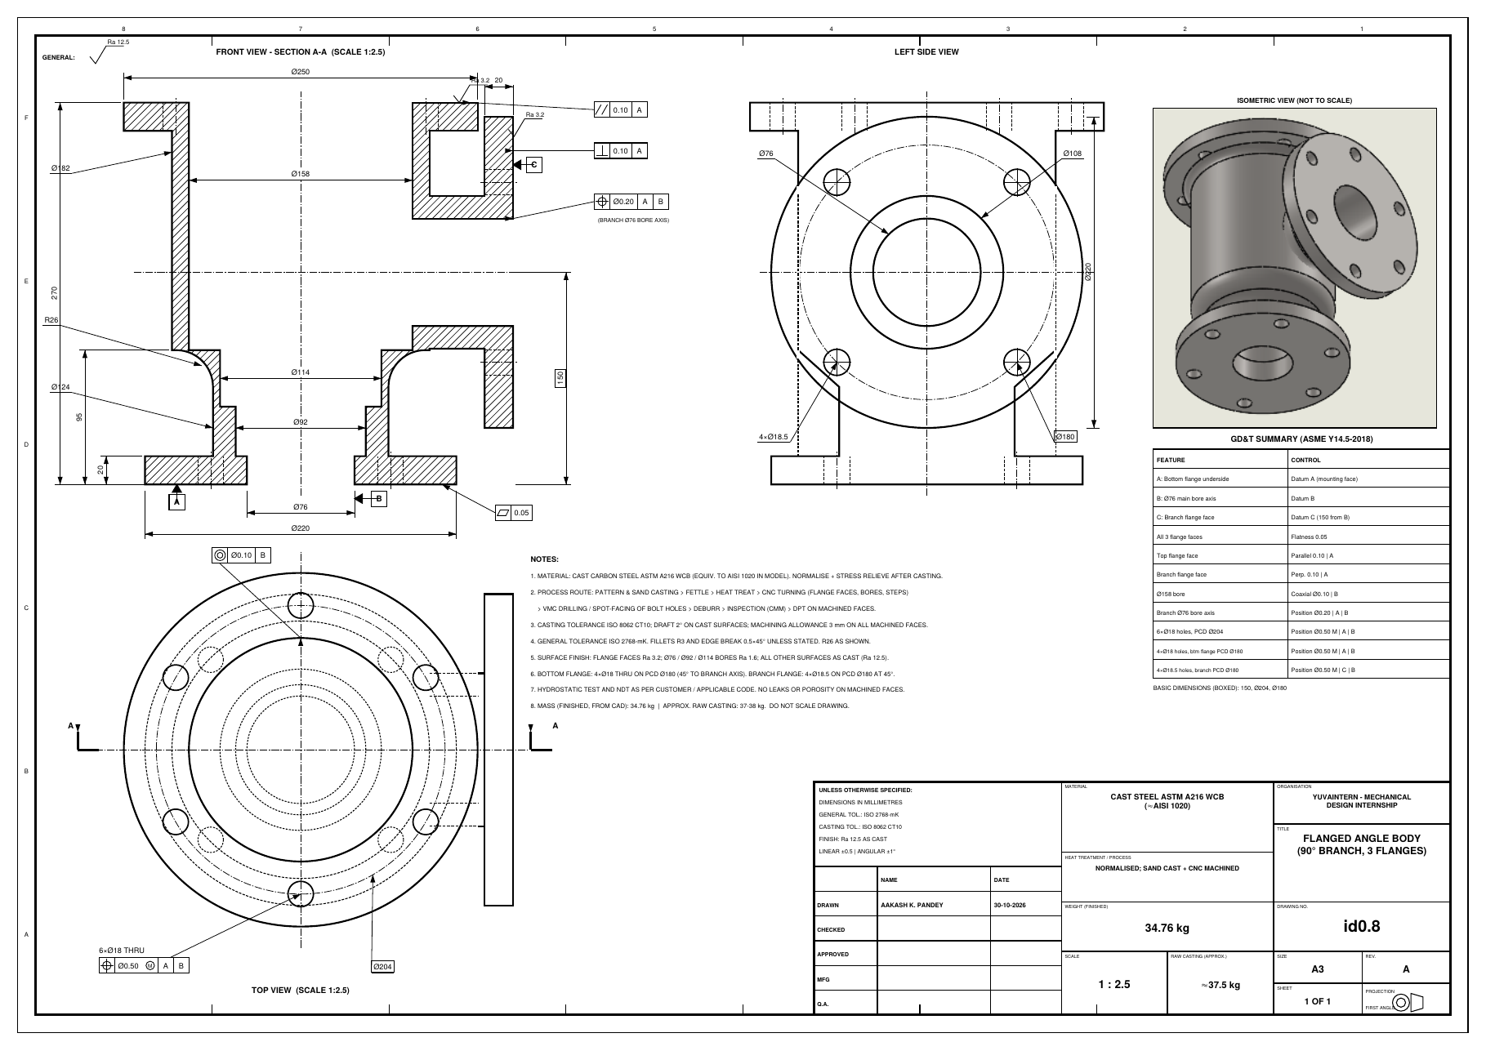
Figure 3 - A3 manufacturing drawing of id0.8 with GD&T, hidden lines and title block

11. Results and Learning
- Current CAD mass estimate: 34.76 kg using AISI 1020 density; estimated raw casting mass: approximately 37.5 kg under the stated machining-stock assumptions. Both values require confirmation after final material assignment and body validation.
- ASTM A216 WCB is the preliminary cast-steel candidate. Its mass comparison uses an assumed density and does not establish equivalence to AISI 1020; confirm material properties and update the CAD model before release.
- The estimated machining time for the main flange face and 14 holes is approximately 10 minutes based on the stated cutting parameters; it excludes setup, tool changes, inspection and handling.
- The GD&T scheme follows the way the part is fixtured and checked.
- The design check found a tight hole-to-wall gap (2 mm) and a second solid body to fix.
Next steps: determine whether the two solid bodies should be merged or remain separate; verify bolt-hole edge distances with actual fasteners, nuts and washers; complete the casting draft and parting-line study; confirm the selected casting grade; then update mass properties and verify the drawing before manufacturing release.

12. References
- ASME Y14.5-2018, Dimensioning and Tolerancing
- ISO 2768-1 General tolerances; ISO 8062-3 Casting tolerances
- ASTM A216/A216M, Standard Specification for Carbon Steel Castings (Grade WCB)
- SolidWORKS 2026 Mass Properties and Drawing documentation
- Shigley, Mechanical Engineering Design (thick-wall cylinders)

