YUVA INTERN — MECHANICAL DESIGN INTERNSHIP
Week 4 Task: Capstone & Presentation
Design, 3D Modelling and Engineering Documentation of a
Four-Cylinder, Four-Stroke I.C. Engine Assembly
Capstone Project Report and Portfolio Summary
Submitted by | Aakash Kumar Pandey
Programme | B.Tech Mechanical Engineering (2024–2028), IKGPTU
Internship | Mechanical Design Intern, Yuva Intern (20 Oct – 15 Dec 2026)
Software | SOLIDWORKS Design Standard 2026 SP4.1
Project scope | 7 part designs, 1 exploded assembly, 8 A3 drawing sheets
Date of submission | 31 October 2026

Contents
Section | Title
1 | Executive Summary and Portfolio Snapshot
2 | Objectives and Compliance with the Week 4 Brief
3 | Engine Layout and Working Principle
4 | Bill of Materials and Component Functions
5 | Part-by-Part Design Description
6 | Assembly Modelling
7 | Engineering Drawings and Documentation
8 | Engineering Analysis (Original Work)
9 | Design Review: Findings and Proposed Improvements
10 | Presentation Summary (Key Slides in Brief)
11 | Reflection and Lessons Learned
12 | Skills Demonstrated, Limitations and Future Work
13 | Conclusion
A | Appendix A: Engineering Drawing Sheets (1–8)
B | Appendix B: Calculation Sheet and Assumptions

1. Executive Summary and Portfolio Snapshot
This report presents my Week 4 capstone project for the Mechanical Design Intern programme: the complete 3D design and documentation of an inline four-cylinder, four-stroke internal combustion (I.C.) engine assembly. The project was modelled entirely in SOLIDWORKS and consists of seven unique components (crankshaft, cylinder cover block, pistons, connecting rods, rod caps, piston pins and piston rings) that make up 33 individual parts in the assembly. Every component has its own dimensioned A3 drawing with a title block, material, surface area and mass, and the whole assembly is documented in an exploded view with a numbered bill of materials (BOM).
Beyond modelling, the capstone includes an original engineering audit of my own design. By cross-checking the mass values printed on the drawings against analytical volumes, I found that five of the seven drawings report mass at a default density of 1 g/cm³ instead of the assigned material density. I corrected the assembly mass from 39.98 kg to 48.21 kg (+20.6 %), compared fits between mating parts, and ran an indicative load check on the piston pin and connecting-rod small end. The findings are turned into a concrete list of design improvements (Section 9) so that the next revision can be released for manufacture.

Project at a glance
Item | Detail
Engine type | Inline 4-cylinder, 4-stroke reciprocating engine (CAD model)
Cylinder bore | Ø85 mm, cylinder pitch 114 mm, block length 465 mm
Unique components | 7 (33 physical parts: 1 + 1 + 4 + 4 + 4 + 4 + 12)
Drawings produced | 8 sheets, A3, scales 1:1 to 1:3 (exploded view 1:2)
Materials used | Titanium alloy, aluminium alloy (1060), ductile iron, cast iron
Assembly mass | 39.98 kg as drawn; 48.21 kg after correction (audit in Section 8)
Tools | SOLIDWORKS 2026 (part, assembly, drawing, mass properties)

2. Objectives and Compliance with the Week 4 Brief
The Week 4 task asks for a completed capstone that demonstrates Mechanical Design skills, polished work, a short presentation and a reflection on what was learned. The table below maps each requirement to the part of this report that fulfils it.
Week 4 requirement | How it is met | Where
Complete a capstone project that shows Mechanical Design skills | Full 4-cylinder engine: 7 parts, assembly, 8 drawings, materials, mass audit | Sections 4–8, Appendix A
Polish the work | Design review of my own drawings with corrected masses, fit analysis and a list of fixes | Sections 8–9
Prepare a short presentation | Slide-by-slide presentation summary (8 slides) ready to present | Section 10
Reflect on what you learned | Personal reflection tied to concrete project evidence | Section 11
Deliverable: finished capstone with presentation or portfolio-ready summary | This report plus the portfolio snapshot and drawing set | Sections 1, 10, Appendix A

Project objectives
- Model all major engine components as accurate, parametric SOLIDWORKS parts with realistic dimensions that relate to one another (bore, ring groove, pin and bearing sizes).
- Build a working assembly that shows how the components fit together, and document it with an exploded view and BOM.
- Produce manufacturing-style A3 drawings for every part, with views, dimensions, scale, material and mass.
- Verify the design with calculations and critically review it, instead of only drawing it.

3. Engine Layout and Working Principle
The model represents an inline four-cylinder engine: four pistons in a single row share one crankshaft, and each piston is joined to the crankshaft by a connecting rod. In a four-stroke engine each cylinder completes a cycle in two crankshaft revolutions through four strokes: intake, compression, power and exhaust. The piston converts the gas pressure on its crown into a linear force; the connecting rod carries that force to the crankshaft, which converts the reciprocating motion into rotation.
The crankshaft in the model has its outer throws (cylinders 1 and 4) on one side and the middle throws (cylinders 2 and 3) opposite them. This is visible in the Left view of Figure 2, where the outer pistons sit at one end of their stroke while the middle pistons are at the other. This flat-plane arrangement is the conventional layout of an inline four, because the two moving pairs cancel each other’s primary inertia forces. The model covers the reciprocating assembly (piston, rings, pin, rod, cap, crankshaft) and the cylinder cover block; valves, camshaft, intake and exhaust systems and the sump are outside the scope of this capstone and are listed under future work.

4. Bill of Materials and Component Functions
Table 1 lists the components as they appear in the BOM of the exploded drawing, together with the engineering name that describes their actual function. Three drawing labels differ from standard terminology and are reconciled here: the item labelled “pin” (12 off) is the piston ring; “cranck fit lock” is the piston (gudgeon) pin; and “crank half part” is the bottom half (cap) of the connecting-rod big end, one per rod.
Item | Label on drawing | Engineering name | Material | Qty | Function
1 | Crank | Crankshaft | Titanium alloy | 1 | Converts piston motion to rotation; carries flange for flywheel
2 | piston | Piston | Aluminium alloy (1060) | 4 | Transmits gas pressure to the rod; carries 3 rings
3 | pin | Piston ring | Cast iron | 12 | Seals combustion gas (3 rings per piston)
4 | connecting rod | Connecting rod | Ductile iron | 4 | Links piston to crankshaft
5 | crank half part | Rod big-end cap | Ductile iron | 4 | Clamps big end around the crank journal
6 | cranck fit lock | Piston (gudgeon) pin | Cast iron | 4 | Hinges piston to rod small end
7 | cover of i.c engine | Cylinder cover block | Aluminium alloy | 1 | Houses 4 bores and supports the crankshaft
Table 1: Bill of materials with functional names (source: exploded assembly drawing, Sheet 1)

5. Part-by-Part Design Description
Each part below is described with its principal dimensions exactly as dimensioned on its drawing sheet (all lengths in mm), the design intent behind it, and its mass properties as reported by SOLIDWORKS.

5.1 Crankshaft (Sheet 2, Titanium alloy)
The crankshaft is the largest moving component. It carries a flywheel flange at one end with eight Ø10 holes for bolting, nine webs of 15 mm thickness, journals and crank pins between the webs, and a plain output stub of 80 mm length at the other end.
Parameter | Value (from drawing)
Principal dimensions | R80, Ø72, Ø55, Ø54, Ø36, Ø32
Flange holes | 8 × Ø10 on the flange face, 33° spacing callout
Web / flange thickness | 15
Web pitch | 38 and 46
Output stub length | 80
Surface area / mass (drawing) | 356 910.42 mm² / 23 455.55 g

5.2 Connecting rod (Sheet 3, Ductile iron)
The rod uses a tapered shank with a lightening slot to cut weight without losing buckling stiffness, a split big end (rod half plus cap) so it can be assembled around the crank journal, and a cylindrical small end for the piston pin. The shank width is 20 mm with a 6° taper, and the slot is 90 mm long with R8 ends.
Parameter | Value (from drawing)
Overall length / shank length | 201 / 150
Small end | Ø45 outer, Ø33 bore
Big end | R36 and R27 bore steps, R40 outer, 30 high, 76 wide, 38 deep
Lightening slot | 90 long, R8 ends, 4 deep each side
Surface area / mass (drawing) | 37 558.45 mm² / 137.42 g

5.3 Piston (Sheet 4, Aluminium alloy 1060)
The piston is a hollow-skirt design with a slightly domed crown (5 mm rise), three ring grooves, and relieved skirt sides (R10 and R40 cut-outs, 50 wide) that let the crank counterweights clear the piston at bottom dead centre while keeping the thrust faces intact. The 4.30 mm ring groove width equals the ring thickness on the ring drawing, and the Ø79 groove root equals the ring inner diameter, which shows the two parts were modelled to match.
Parameter | Value (from drawing)
Outer diameter / height | Ø85 / 90
Ring groove root diameter | Ø79 (groove width 4.30)
Crown dome rise | 5
Pin bore | Ø38, centred 27 from skirt base
Internal bore / skirt relief | Ø76 / 50 wide, R10 and R40
Surface area / mass (drawing) | 61 325.07 mm² / 124 g

5.4 Rod big-end cap (Sheet 5, Ductile iron)
The cap completes the split big end of the connecting rod. It is 76 mm wide and 38 mm long with a Ø72 outer bore and Ø54 inner step, two Ø9 bolt holes in R9 slotted lugs, and a 60 mm overall height with R10 and R3 blends that reduce stress concentration at the lug roots.
Parameter | Value (from drawing)
Envelope | 76 × 38 × 60
Bore diameters | Ø72 and Ø54
Bolt holes | 2 × Ø9 in R9 lugs
Blends | R10, R3; 25 and 20 chamfer steps
Surface area / mass (drawing) | 19 007.06 mm² / 80.84 g

5.5 Piston (gudgeon) pin (Sheet 6, Cast iron)
A plain cylinder of Ø34 × 82 mm with R2 edge rounds. Its length of 82 mm exceeds the 76 mm small-end width so that the pin is retained across the piston bosses.
Parameter | Value (from drawing)
Diameter / length | Ø34 / 82
Edge rounds | R2
Surface area / mass (drawing) | 10 315.92 mm² / 73.40 g

5.6 Cylinder cover block (Sheet 7, Aluminium alloy)
The block is a thin-walled (10 mm) hollow casting 465 mm long with four Ø85 bores at 114 mm pitch, a stepped tapered top section, R40 and R5 blends, and Ø36 holes in the end walls for the crankshaft stub. The 114 mm pitch leaves a 29 mm web between neighbouring bores, and the end margins are (465 − 3 × 114 − 85) / 2 = 19 mm.
Parameter | Value (from drawing)
Overall length | 465
Top width / wall thickness | 120 / 10
Bores | 4 × Ø85 (R42.50), pitch 114
End holes | Ø36
Surface area / mass (drawing) | 1 289 918.97 mm² / 14 817 g

5.7 Piston ring (Sheet 8, Cast iron; labelled “pin”)
A flat ring of Ø85 outer and Ø79 inner diameter and 4.30 mm thickness. Three rings per piston give 12 in total. The outer diameter equals the bore, and the inner diameter equals the piston groove root.
Parameter | Value (from drawing)
OD / ID / thickness | Ø85 / Ø79 / 4.30
Surface area / mass (drawing) | 3 761.11 mm² / 3.32 g

6. Assembly Modelling
The assembly (Assem1.SLDASM) was built by inserting each part and positioning it with mates relative to the origin and reference planes, with a separate set of reference axes and planes created to place the four cylinder positions (Axis3–Axis10 and PLANE13–PLANE19 in the feature tree). Rods are assembled to their caps and pins, pistons to the pins, and the rod-and-piston sub-assemblies to the crank throws. Figure 1 shows the standard four-view layout (Front, Left, Top and Trimetric) of the finished assembly with the block shown transparent.
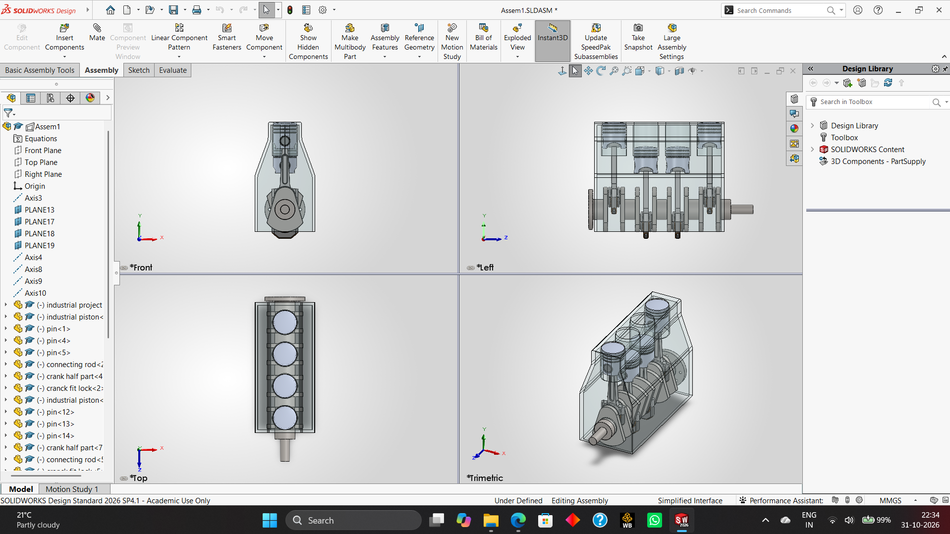
Figure 1: SOLIDWORKS assembly window showing the feature tree and the Front, Left, Top and Trimetric views (block displayed transparent)
Two checks were made in the views. In the Top view the four pistons are centred in four equally spaced bores, confirming the 114 mm pitch. In the Left view the outer pair and the middle pair of pistons sit at opposite ends of their travel, confirming the 180° crank phasing between the pairs. The exploded view in Figure 2 shows the assembly sequence and the numbered BOM.
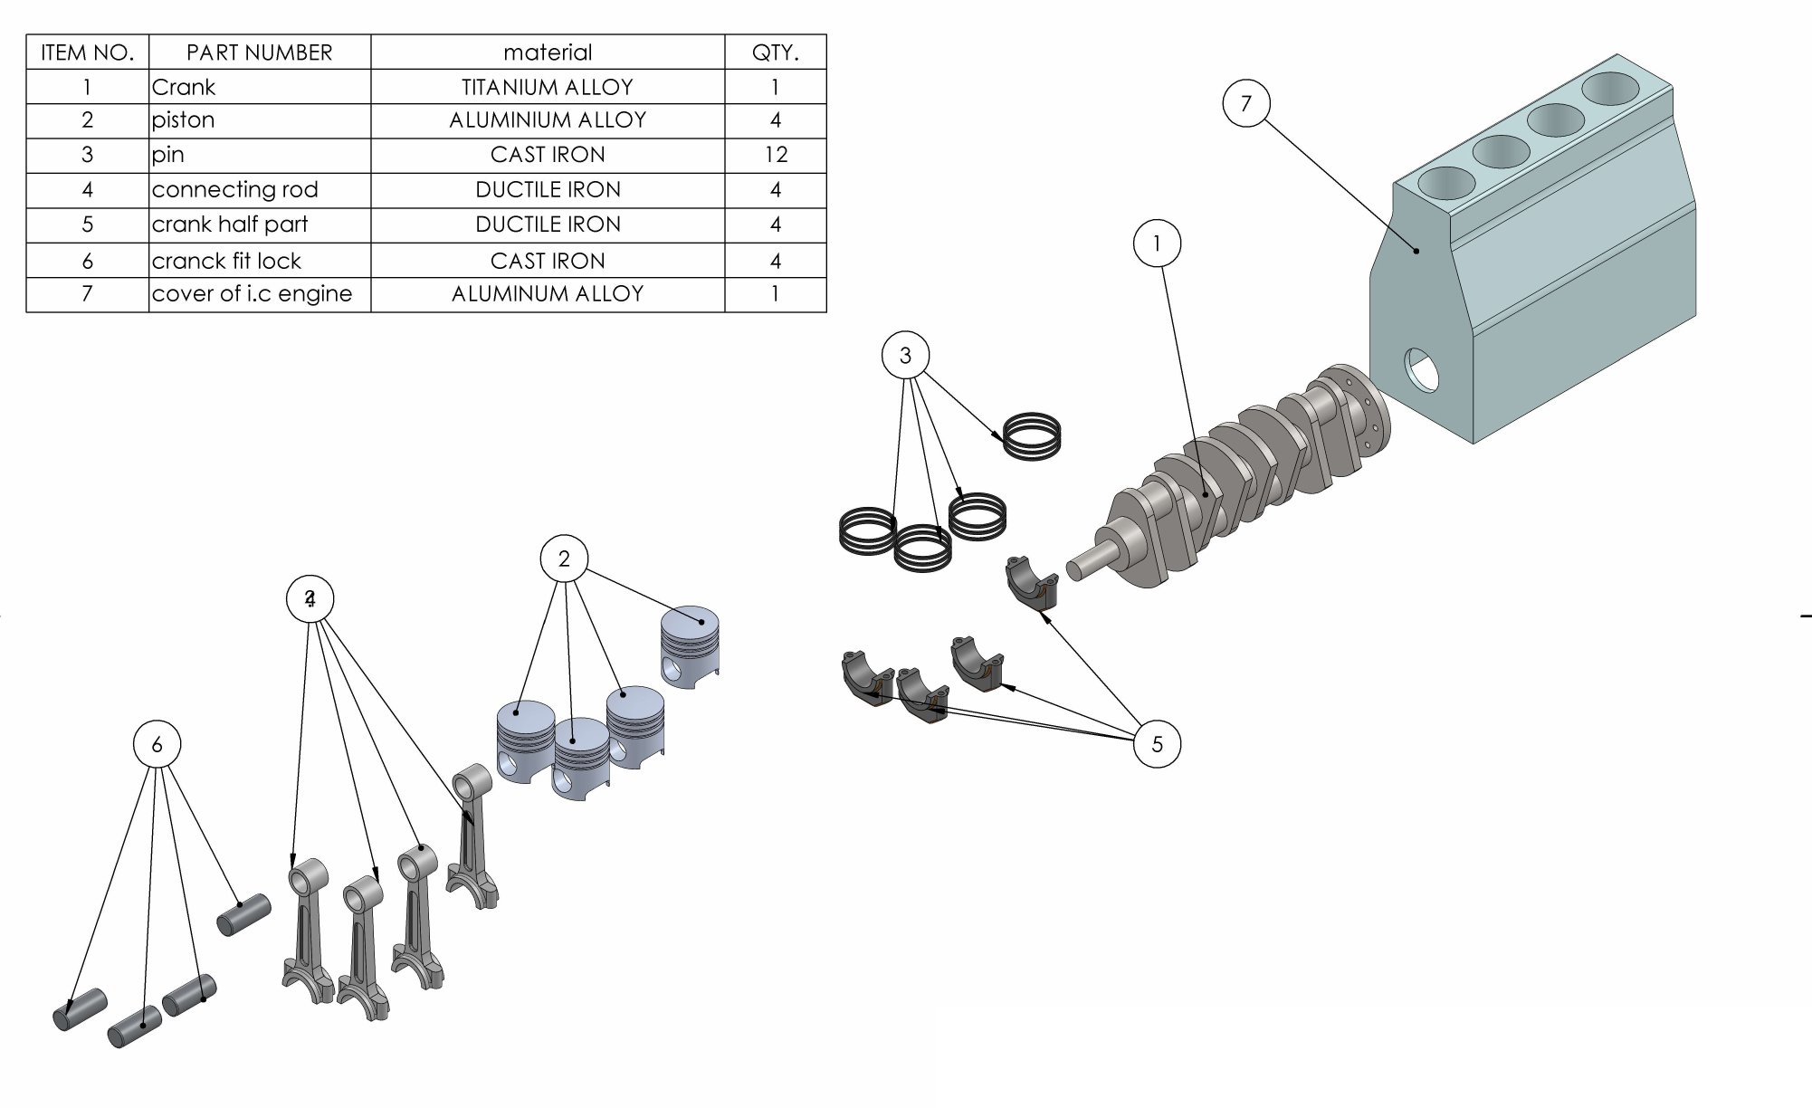
Figure 2: Exploded assembly with balloons and bill of materials (Sheet 1, scale 1:2)

7. Engineering Drawings and Documentation
Every component has a dedicated A3 drawing in millimetre units (MMGS) with a title block that lists drawing number, title, material, scale, sheet, date, weight and surface area, and the author name. Table 2 summarises the drawing set; the full sheets are reproduced in Appendix A.
Sheet | Drawing | Views shown | Scale | Date
1 | I.C Engine (exploded assembly) | Isometric exploded, BOM, balloons | 1:2 | 20/08/2026
2 | 1. Crank | Front, side, isometric | 1:3 | 20/08/2026
3 | 2. Connecting rod | Front, side, bottom, isometric | 1:1.5 | 20/08/2026
4 | 3. Piston | Front, side, bottom, detail B (2:1), isometric | 1:1 | 21/06/2026
5 | 4. Crank half part (cap) | Front, side, bottom, isometric | 1:1 | 20/08/2026
6 | 5. Crank fit lock (pin) | Front, side, isometric | 1:0.5 (2:1) | 20/08/2026
7 | 6. Cover block | Front, side, top, isometric | 1:1 | 20/08/2026
8 | 7. Pin (piston ring) | Front, side, isometric | 1:1 | 20/08/2026
Table 2: Drawing register
The drawings use orthographic projection with centre lines, a detail view (Detail B on the piston at 2:1 to show the ring grooves), and mass properties taken directly from SOLIDWORKS. These drawings are my documentation deliverable; Section 9 lists the additions (tolerances, GD&T and revised mass values) that bring them to release standard.

8. Engineering Analysis (Original Work)

8.1 Mass audit: finding and correcting a data error
While compiling the mass values from the eight drawings I noticed that several of them looked too light for the materials assigned. I tested this with analytical geometry instead of trusting the software output.
Worked example (piston ring). Volume = π/4 × (85² − 79²) × 4.30 = π/4 × 984 × 4.30 = 3 323 mm³ = 3.32 cm³. The drawing reports 3.32 g. A cast-iron ring at 7.2 g/cm³ would weigh 23.9 g, so the reported value corresponds to a density of exactly 1.00 g/cm³ — the SOLIDWORKS default when no material is applied.
Second check (piston pin). Volume = π/4 × 34² × 82 = 74.4 cm³ before the R2 edge rounds (about 74.3 cm³ after). The drawing reports 73.40 g, again about 1.0 g/cm³ (within 1.3 %), whereas cast iron would give about 528 g.
Cross-check for the other parts. A thin-wall plausibility check (V/A ratio, i.e. volume divided by surface area, which is roughly half the wall thickness) supports the same conclusion for the piston, rod and cap, while the crankshaft and block pass: the crankshaft at 4.5 g/cm³ gives V/A = 14.6 mm, consistent with Ø54–72 journals, and the 10 mm-wall block at 2.7 g/cm³ gives a wall of about 8.5 mm, consistent with the 10 mm wall in the drawing. At density 1 the piston, rod and cap values give thicknesses of 2–4 mm, which also matches their geometry.
Conclusion: pistons, rods, caps, pins and rings were weighed with density 1 g/cm³. Table 3 corrects them with the density of the material shown in each title block (SOLIDWORKS library values: aluminium 1060 = 2.70, ductile iron = 7.10, cast iron = 7.20 g/cm³).
Part | Qty | Material | Density (g/cm³) | Mass shown (g) | Corrected (g) | Total corrected (g)
Crankshaft | 1 | Titanium alloy | 4.50 | 23 455.55 | 23 455.55 | 23 455.55
Cover block | 1 | Aluminium alloy | 2.70 | 14 817.00 | 14 817.00 | 14 817.00
Piston | 4 | Aluminium 1060 | 2.70 | 124.00 | 334.80 | 1 339.20
Connecting rod | 4 | Ductile iron | 7.10 | 137.42 | 975.68 | 3 902.73
Rod cap | 4 | Ductile iron | 7.10 | 80.84 | 573.96 | 2 295.86
Piston pin | 4 | Cast iron | 7.20 | 73.40 | 528.48 | 2 113.92
Piston ring | 12 | Cast iron | 7.20 | 3.32 | 23.90 | 286.85
Total assembly | 33 |  |  | 39 975.03 |  | 48 211.11
Table 3: Mass audit. Corrected mass = reported volume (reported mass ÷ 1 g/cm³) × assigned density
The correction raises the total assembly mass from 39.98 kg to 48.21 kg (+20.6 %). The crankshaft in titanium is the dominant item at 48.7 % of the corrected total, which is discussed under material selection in Section 9. Figure 3 shows the effect of the correction on each part and the resulting mass distribution.
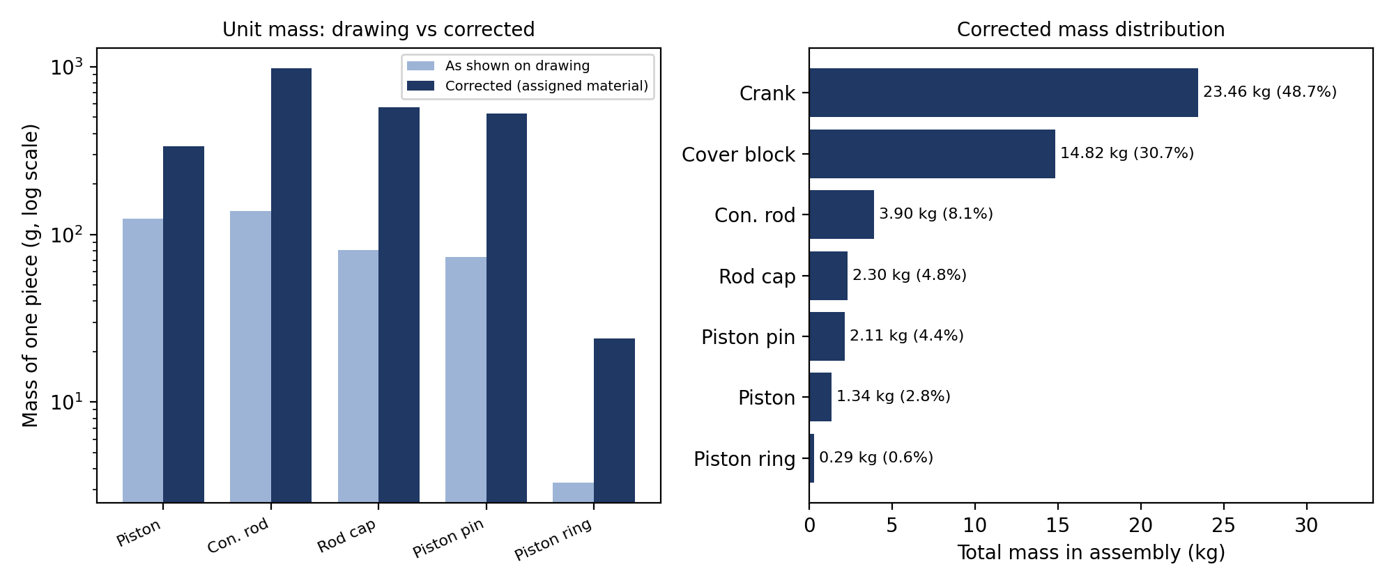
Figure 3: Mass drawn versus mass corrected (left) and corrected mass distribution of the assembly (right)

8.2 Fit and interface check
Mating dimensions were collected from the drawings and compared. The goal is to find where nominal values coincide (needing a tolerance and clearance in real manufacture) and where they conflict.
Interface | Dimensions read from drawings | Observation
Piston ↔ cylinder bore | Piston Ø85; bore Ø85 (R42.50) | Zero clearance in CAD. A running clearance is needed on the skirt.
Ring ↔ groove (radial) | Ring ID Ø79; groove root Ø79 | Zero radial clearance. Needs a small allowance.
Ring ↔ groove (axial) | Ring 4.30; groove 4.30 | Zero axial clearance. Rings need freedom to move in the groove.
Pin ↔ rod small end | Pin Ø34; small-end bore Ø33 | 1 mm interference: dimensions conflict, the bore must be Ø34.
Pin ↔ piston boss | Pin Ø34; boss bore Ø38 | 4 mm diametral clearance: too loose, the bore must be Ø34.
Pin length ↔ small end | Pin 82; small end about 76 | Pin is 6 mm longer than the small end, giving retention in the piston bosses.
Crank stub ↔ block hole | Stub Ø36; block end hole Ø36 | Same nominal size. A clearance fit is needed.
Rod cap ↔ rod big end | Cap 76 × 38; big end 76 × 38; Ø72 / Ø54 bores | Widths and bores match, so the cap and rod mate correctly.
Table 4: Mating-dimension check across drawings

8.3 Indicative load check on the piston pin and rod small end
A first-order check shows whether the pin-and-small-end joint is in a reasonable range. The inputs are a design assumption, not measured data: peak combustion pressure p = 5 MPa (a typical value for a naturally aspirated petrol engine), inertia loads neglected, and the connecting rod small-end length taken as 76 mm from the side view on Sheet 3.
Quantity | Calculation | Result
Piston crown area | π/4 × 85² | 5 674.5 mm²
Peak gas force | F = p × A = 5 × 5 674.5 | 28.37 kN
Pin shear (two shear planes) | τ = F / (2 × π/4 × 34²) = 28 372 / 1 816 | 15.6 MPa
Small-end bearing pressure | pₛ = F / (d × L) = 28 372 / (33 × 76) | 11.3 MPa
Table 5: Indicative load check (assumed peak gas pressure 5 MPa)
The pin shear stress of 15.6 MPa is far below the shear strength of cast iron, so the pin is not a shear risk. The bearing pressure of 11.3 MPa lies in the range that is usually accepted for a lubricated small-end bush (roughly 10–15 MPa), so it is acceptable but has little margin. This is why the small end is the part that should be checked first with FEA in a later revision, and why a bronze bush and the corrected Ø34 bore are recommended in Section 9.

9. Design Review: Findings and Proposed Improvements
Reviewing my own design critically is part of professional design practice. The table lists each finding, its impact and the corrective action I propose for revision B.
# | Finding | Impact | Proposed action
1 | Mass of 5 of 7 parts uses density 1 g/cm³ | Assembly mass understated by 8.2 kg | Assign the library material in each part file and regenerate drawings
2 | Pin Ø34 vs rod bore Ø33 vs piston bore Ø38 | Parts cannot be assembled as drawn | Set both bores to Ø34; use H7 bore and g6 pin
3 | Zero-clearance fits (bore, ring axial and radial) | Parts would seize if made to nominal | Apply tolerances in Table 6
4 | No tolerances or GD&T on drawings | Not releasable for manufacture | Add size tolerances, geometric tolerances, surface finish
5 | Drawing labels and sheet numbers inconsistent | Confusing documents | Rename “pin” to piston ring, “fit lock” to piston pin; fix “SHEET x OF y”
6 | Crankshaft in titanium alloy | Costly and not typical for production; 23.5 kg | Use forged steel (e.g. 42CrMo4) for production, or SG iron for low cost
7 | Assembly status “Under Defined” in SOLIDWORKS | Some components can still move freely | Add the remaining mates; then run a motion study of the slider-crank
Table 6a: Design review findings and corrective actions

Proposed tolerances and GD&T (starting point for revision B)
The values below are proposals based on ISO 286 standard fits and common engine practice. They are intended for the drawing revision; they have not been applied yet.
Feature | Proposed size tolerance | Proposed geometric / finish control
Cylinder bore Ø85 | H7 (+0.035 / 0) | Cylindricity 0.01; honed finish Ra 0.4 µm
Piston pin Ø34 | g6 (−0.009 / −0.025) | Cylindricity 0.005; Ra 0.2 µm
Rod small-end bore Ø34 | H7 (+0.025 / 0) | Parallelism to big-end bore 0.02 over length
Rod big-end bore Ø72 | H7 (+0.030 / 0) with cap fitted | Cylindricity 0.01; Ra 0.8 µm
Piston ring groove 4.30 | Width +0.05 / +0.08 (axial clearance) | Flatness of groove faces 0.02
Crank stub Ø36 | g6 (−0.009 / −0.025) | Runout to main axis 0.03
Table 6b: Proposed size tolerances and GD&T
With a Ø34 H7 bore (+0.025 / 0) and a Ø34 g6 pin (−0.009 / −0.025), the minimum clearance is 0.009 mm and the maximum is 0.050 mm, which is a free running fit suitable for a lubricated pin.

Manufacturing process proposals
- Cover block: sand or low-pressure die cast aluminium, then CNC finish machining and honing of the four bores.
- Pistons: forged or cast aluminium, with ring grooves and pin bore machined after casting.
- Connecting rod and cap: forged or cast ductile iron; machine the big-end bore with the cap fitted and bolted.
- Pins and rings: turned and ground from cast iron (pin: centreless ground to the g6 size).

10. Presentation Summary (Key Slides in Brief)
The brief asks for a short presentation or a portfolio-ready summary. The content below is an eight-slide outline that can be presented in about five minutes, each slide drawn from this report.
Slide | Title | Key message
1 | Project title | Four-cylinder I.C. engine: 3D design and documentation in SOLIDWORKS
2 | Objective and scope | 7 components, 33 parts, 8 A3 drawings, with design review
3 | How the engine works | Piston → rod → crank converts gas pressure into rotation; flat-plane inline-four layout
4 | Components and BOM | Seven items with materials and quantities (Table 1)
5 | Assembly and exploded view | Figures 1 and 2
6 | Engineering drawings | Dimensioned A3 sheets for every part (Appendix A)
7 | Analysis results | Mass corrected from 39.98 to 48.21 kg; 11.3 MPa small-end bearing pressure; fit conflicts found
8 | Lessons and next steps | Tolerances and GD&T, correct materials, full mates, FEA and motion study

11. Reflection and Lessons Learned
The most valuable result of this capstone was not the model itself but the review that followed. Drawing seven parts and an assembly taught me the SOLIDWORKS workflow, but checking my own work against hand calculations is what showed me how a design can look complete and still be wrong. The mass audit is a good example: the software reported a number for every part, and every number looked plausible until I recalculated the piston ring volume by hand and found that it matched a density of 1 g/cm³ rather than cast iron. That taught me not to trust a value only because it came from a CAD system.
The second lesson was about relationships between parts. Each part was drawn on its own sheet, so conflicts between them (a Ø33 bore for a Ø34 pin, a Ø38 boss for the same pin) only became visible when I laid the dimensions side by side in Table 4. In industry such conflicts are caught by tolerance stack-ups and design reviews, and I now see why GD&T and fits are central to design work and not an optional extra. The same applies to the zero-clearance fits at the cylinder, rings and grooves: a CAD model that assembles perfectly can still be impossible to manufacture and run.
Third, I learned to document with a reader in mind. Inconsistent labels (“pin” for a ring, “fit lock” for a pin) and sheet numbers make a drawing set harder to use. A clear BOM, correct names and honest notes about what is and is not finished are part of the engineering deliverable. Finally, I learned the value of being upfront about limitations: the assembly still has under-defined mates, and the crankshaft material is not a realistic production choice. Listing these as next steps makes the project more credible, not less.
For my career goal of becoming a Mechanical Design or CAD Engineer, this project connects the earlier weeks of the internship (foundations, hands-on practice in modelling, drafting and GD&T) into one complete workflow: model, assemble, document, analyse, review.

12. Skills Demonstrated, Limitations and Future Work

Skills demonstrated
Skill | Evidence in this project
Parametric solid modelling | Seven parts with consistent dimensional relationships (e.g. Ø79 groove root = ring ID)
Assembly design | 33-part assembly with reference planes and axes; exploded view
Engineering drawing | 8 A3 sheets with multiple views, detail view, dimensions, title blocks, BOM
Material selection | Four materials assigned; production alternatives proposed
Design analysis | Mass audit, fit check, gas-force, pin shear and bearing pressure calculations
GD&T and tolerancing | Proposed ISO 286 fits and geometric controls for revision B
Technical documentation | This report, with traceable numbers and stated assumptions

Limitations
- The assembly is shown as Under Defined in SOLIDWORKS: not every component is fully constrained, so a motion study has not yet been run.
- The drawings do not yet carry size tolerances, geometric tolerances or surface-finish symbols.
- The load check in Section 8.3 uses an assumed gas pressure and ignores inertia loads; it is an indicative check, not a validated stress analysis.
- Valves, camshaft, flywheel, bearings, bolts and the sump are not modelled.

Future work
- Release revision B: correct the materials and bores, add tolerances and GD&T, and fix labels and sheet numbering.
- Fully define the assembly and run a SOLIDWORKS motion study of the slider-crank mechanism to find piston travel and velocity.
- Perform FEA in Ansys on the connecting rod and the small end under the gas and inertia loads.
- Add the flywheel, main bearings, fasteners and a valve train to move from a reciprocating assembly to a complete engine.

13. Conclusion
The capstone delivers a complete CAD package for a four-cylinder, four-stroke engine: seven designed components, a 33-part assembly with an exploded view and BOM, and eight A3 drawings. Beyond the modelling, a mass audit corrected the assembly mass from 39.98 kg to 48.21 kg, a fit review found three conflicting interface dimensions, and a first-order load check showed a small-end bearing pressure of 11.3 MPa and a pin shear stress of 15.6 MPa at an assumed 5 MPa peak gas pressure. A prioritised improvement list and proposed tolerances define how the design will be brought to release standard. The project shows the full workflow of a mechanical design engineer: model, assemble, document, analyse and review.

Appendix B: Calculation Sheet and Assumptions

B.1 Corrected mass
Corrected mass of one piece = (mass on drawing ÷ 1 g/cm³) × density of assigned material. Densities (SOLIDWORKS material library): titanium 4.50, aluminium 1060 2.70, ductile iron 7.10, cast iron 7.20 g/cm³. Crankshaft and block were left unchanged because their reported values are consistent with the assigned density (V/A check, Section 8.1).

B.2 Gas force and joint checks
- Piston area A = π × 85² / 4 = 5 674.5 mm².
- Peak gas force F = 5 N/mm² × 5 674.5 mm² = 28 372 N (assumed peak pressure 5 MPa).
- Pin shear area in double shear = 2 × π × 34² / 4 = 1 815.8 mm², so τ = 28 372 / 1 815.8 = 15.6 MPa.
- Small-end projected area = 33 × 76 = 2 508 mm², so p = 28 372 / 2 508 = 11.3 MPa.

B.3 Block geometry
- Web between bores = 114 − 85 = 29 mm. End margin = (465 − 3 × 114 − 85) / 2 = 19 mm.

B.4 Fits
- Ø34 H7/g6: hole +0.025 / 0; shaft −0.009 / −0.025. Minimum clearance = 0 − (−0.009) = 0.009 mm; maximum = 0.025 − (−0.025) = 0.050 mm.

B.5 Assumptions
- All dimensions are read from the drawings in this report; no values were measured from other sources.
- Small-end length of 76 mm is read from the side view of Sheet 3; inertia and bending effects are neglected.
- Proposed tolerances in Section 9 are suggestions for revision B and are not yet shown on the drawings.

Appendix A: Engineering Drawing Sheets
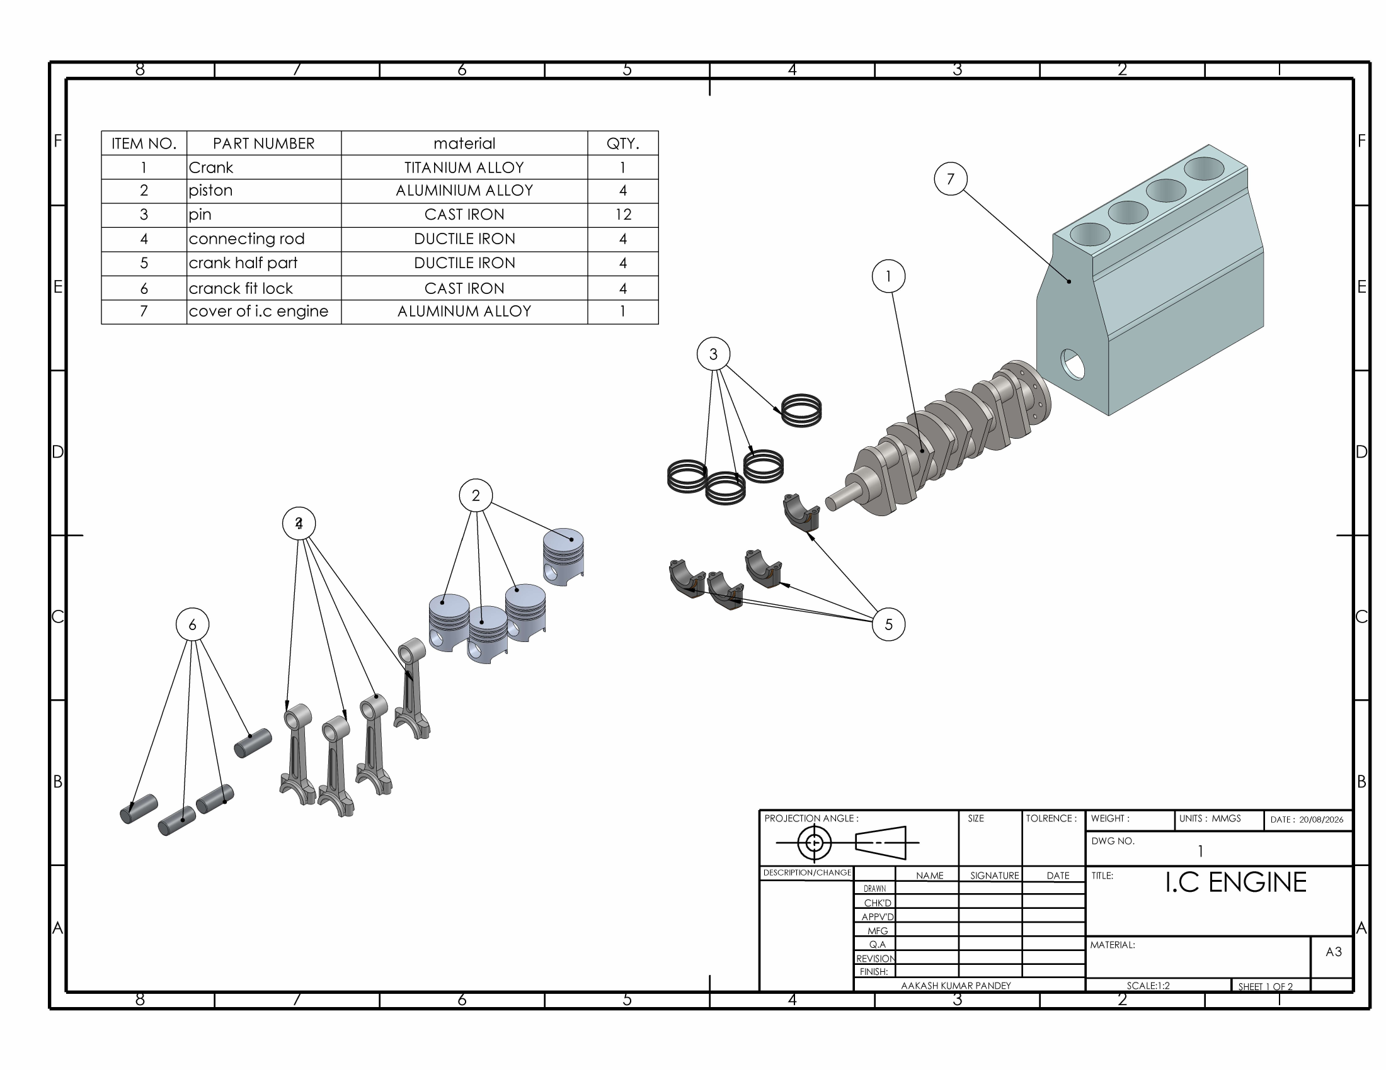
Sheet 1: I.C Engine exploded assembly (A3, 1:2)
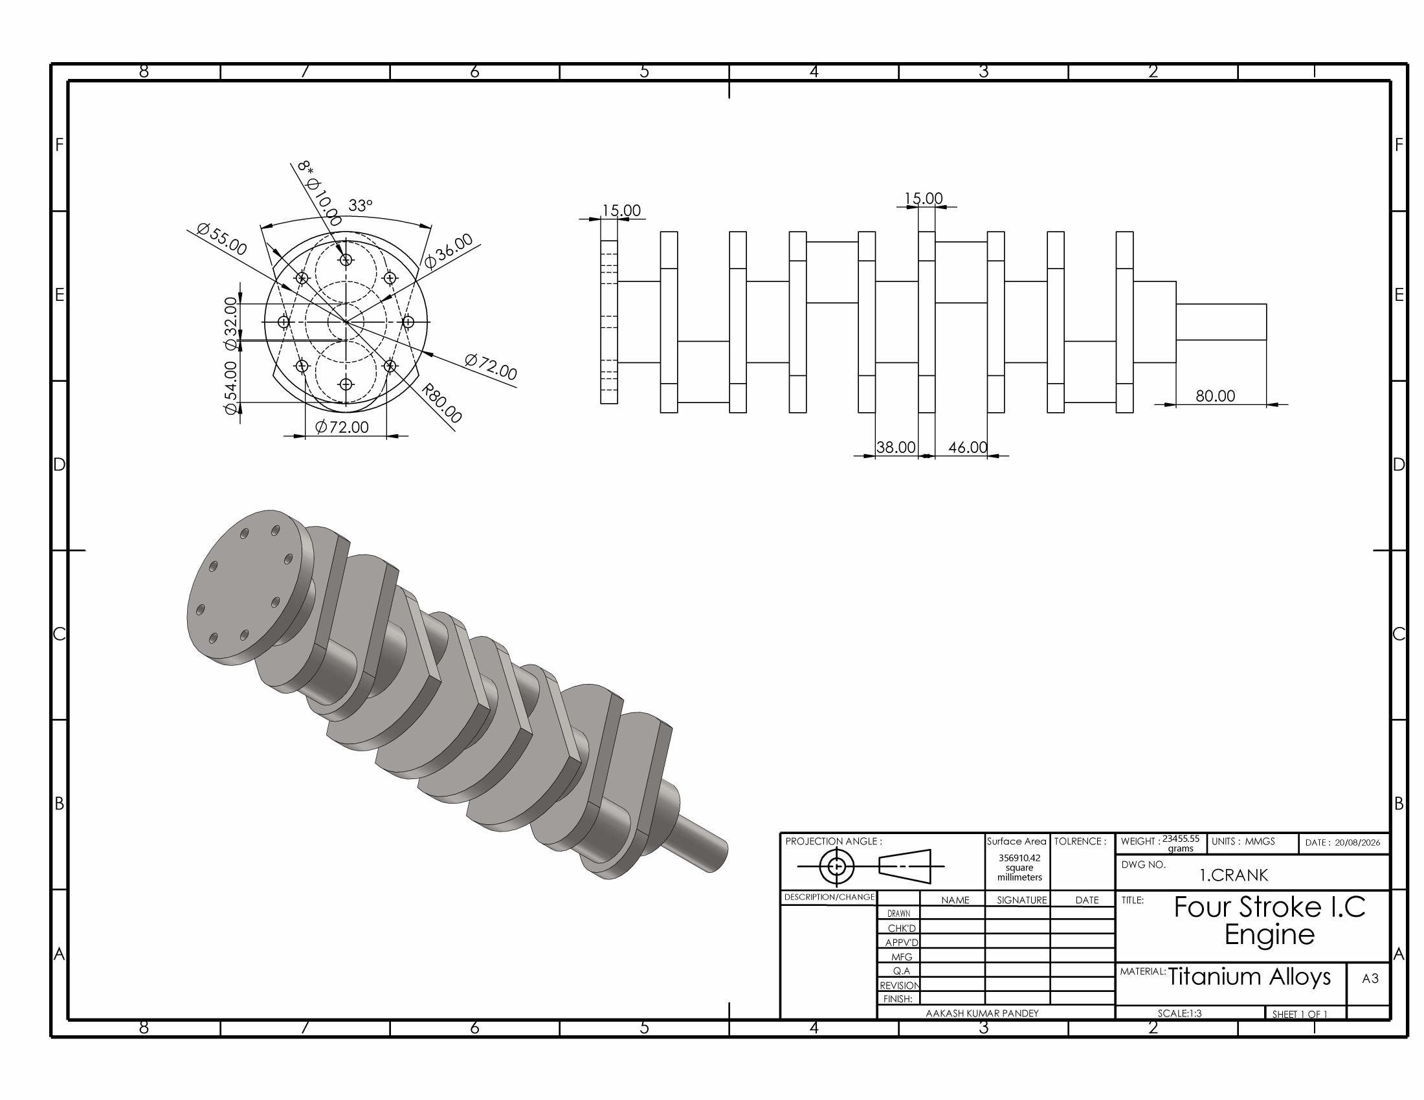
Sheet 2: Crankshaft (A3, 1:3, titanium alloy)
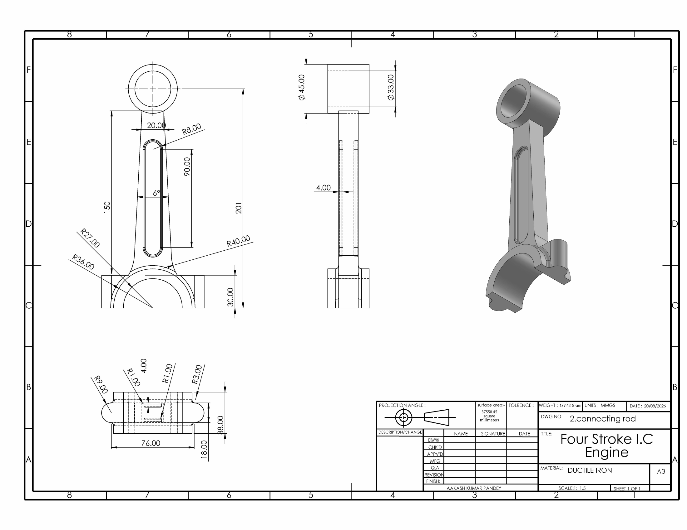
Sheet 3: Connecting rod (A3, 1:1.5, ductile iron)
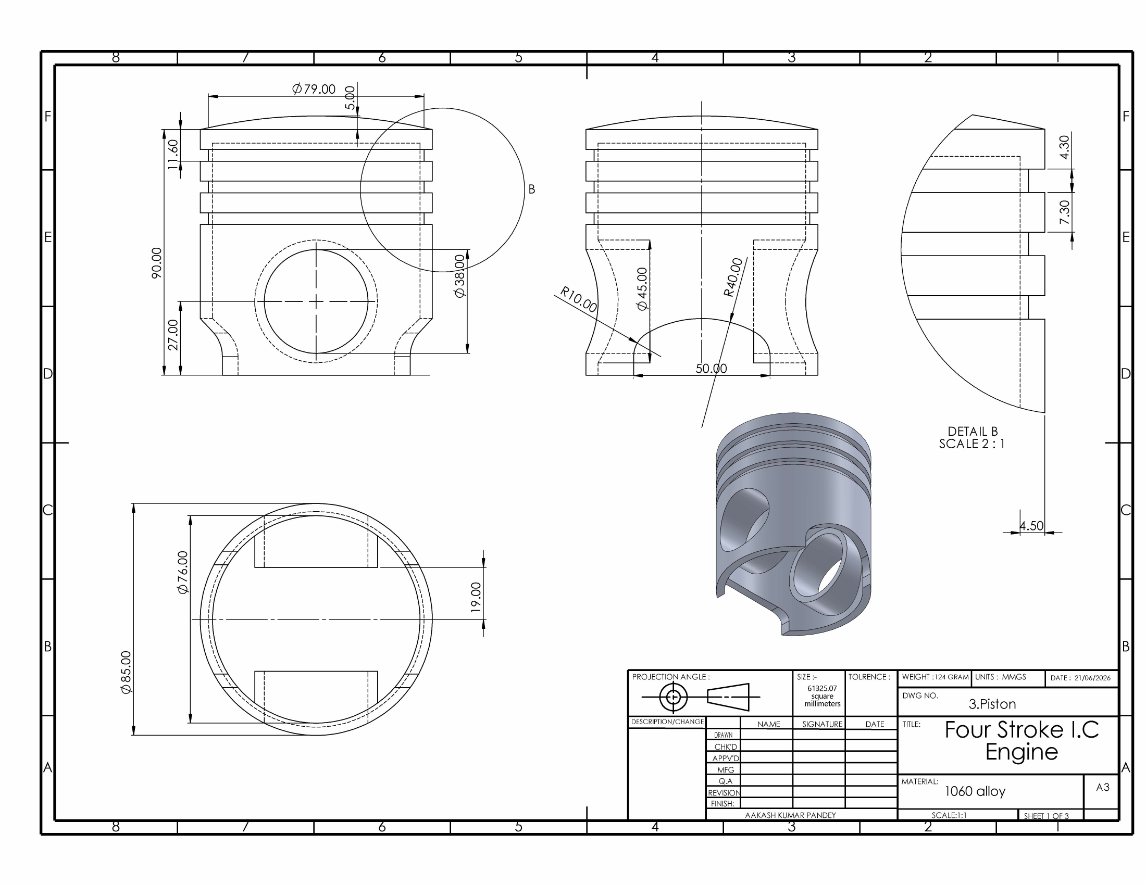
Sheet 4: Piston (A3, 1:1, aluminium 1060)
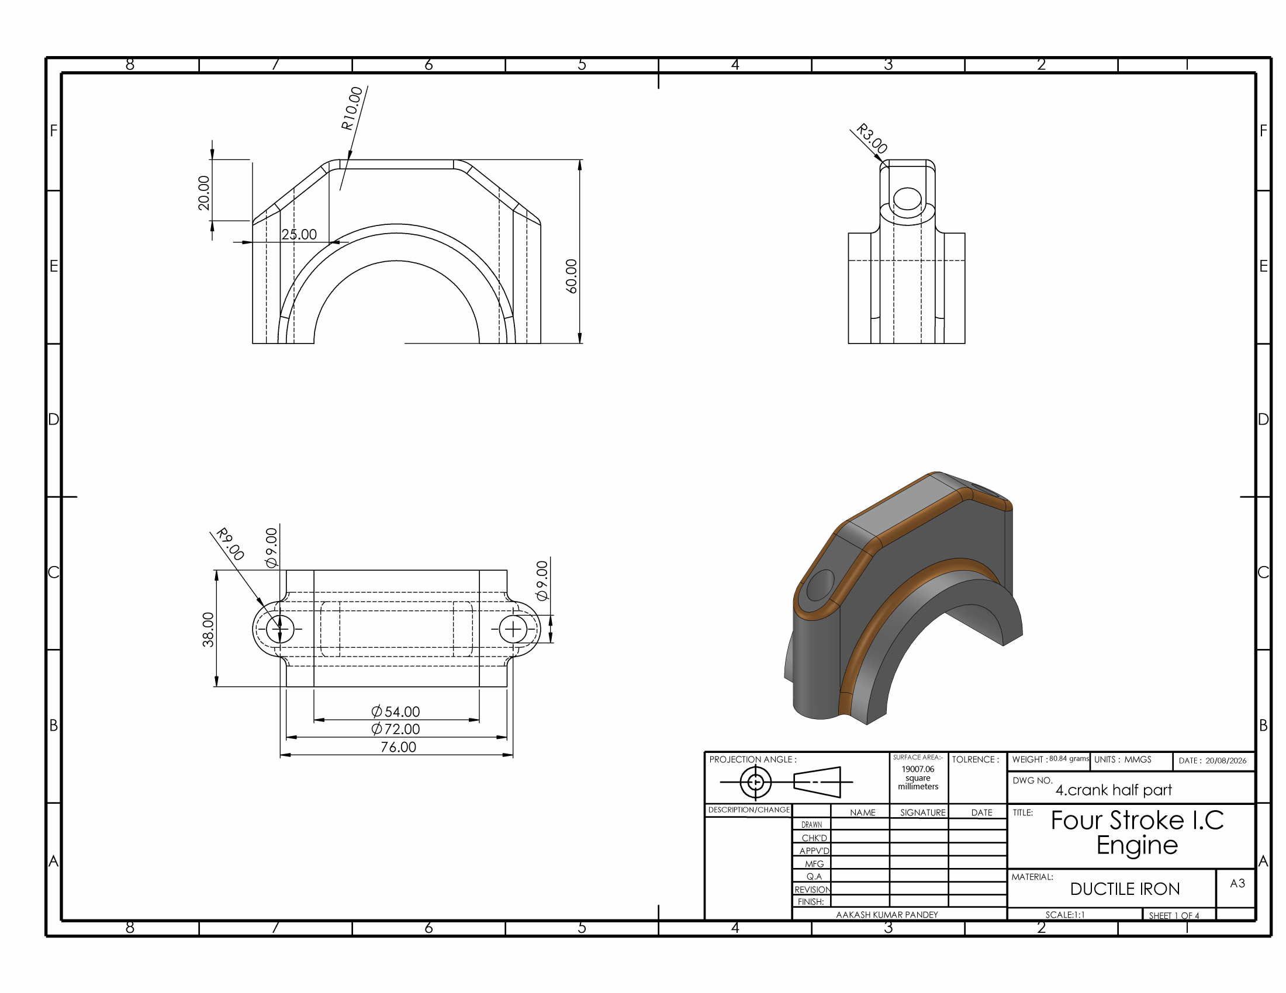
Sheet 5: Rod big-end cap, labelled “crank half part” (A3, 1:1, ductile iron)
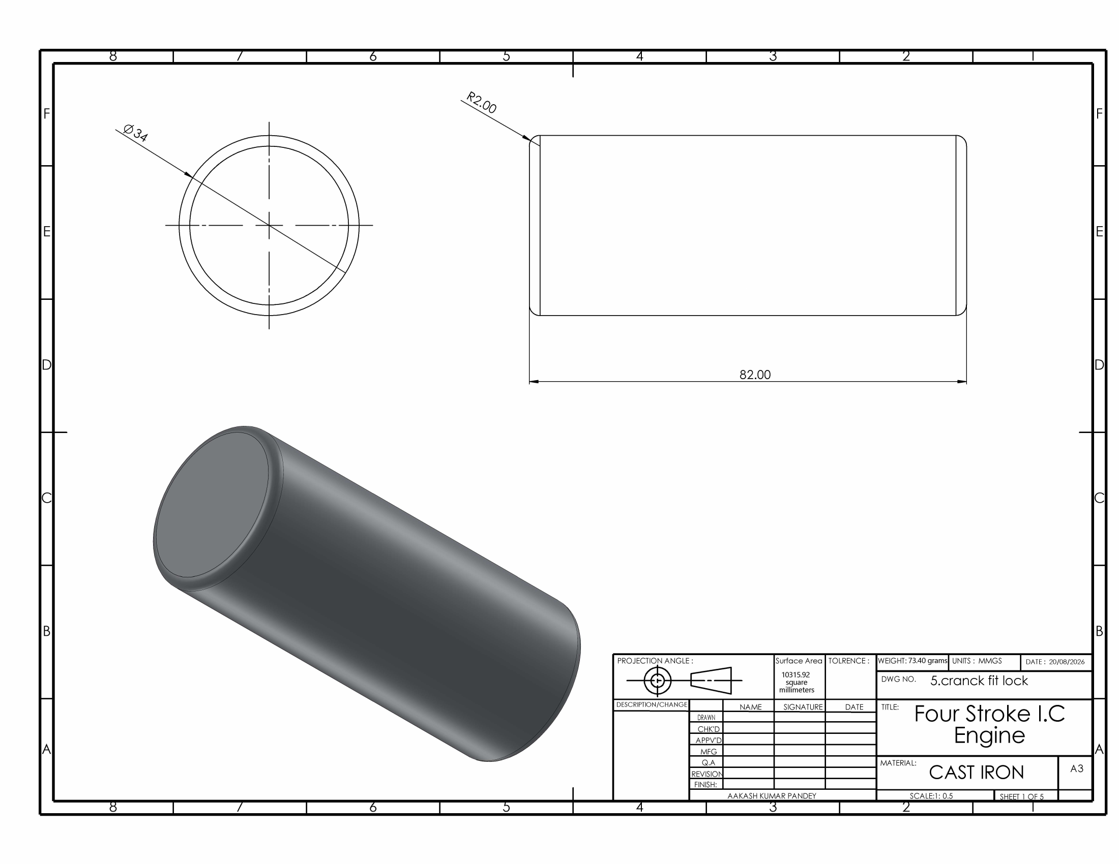
Sheet 6: Piston pin, labelled “cranck fit lock” (A3, 2:1, cast iron)
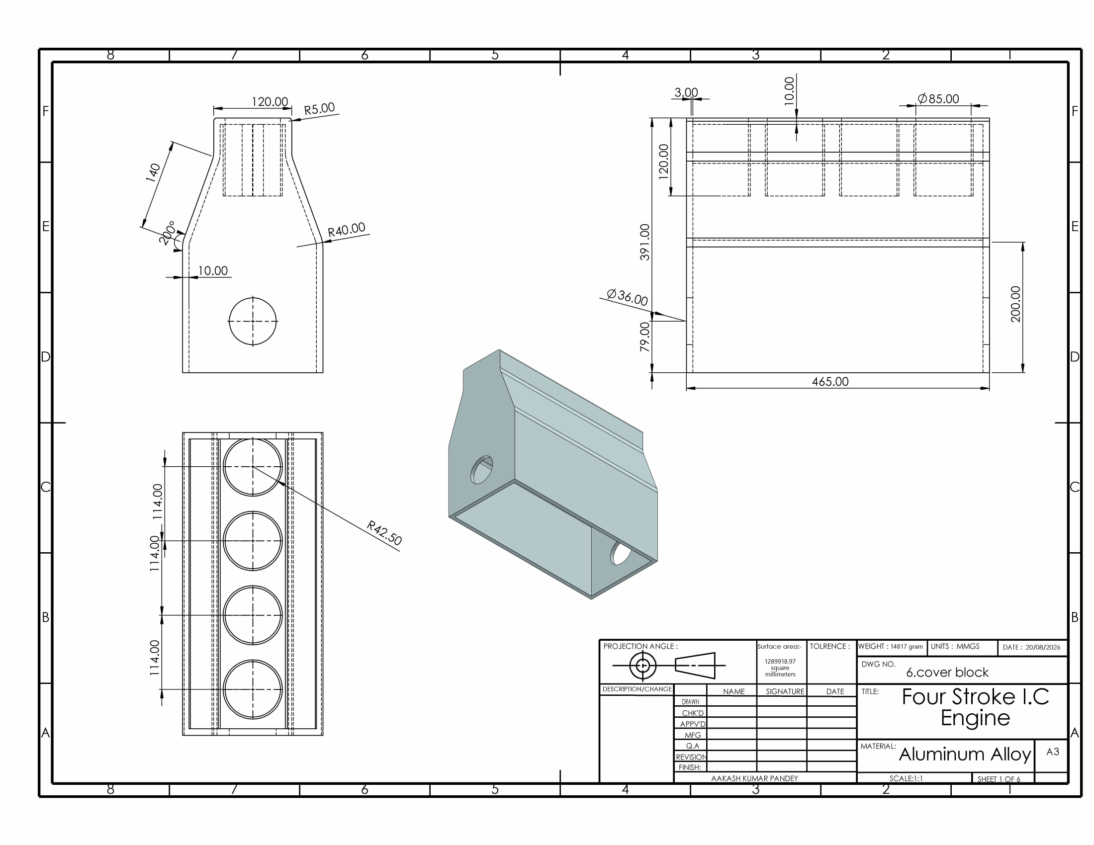
Sheet 7: Cylinder cover block (A3, 1:1, aluminium alloy)
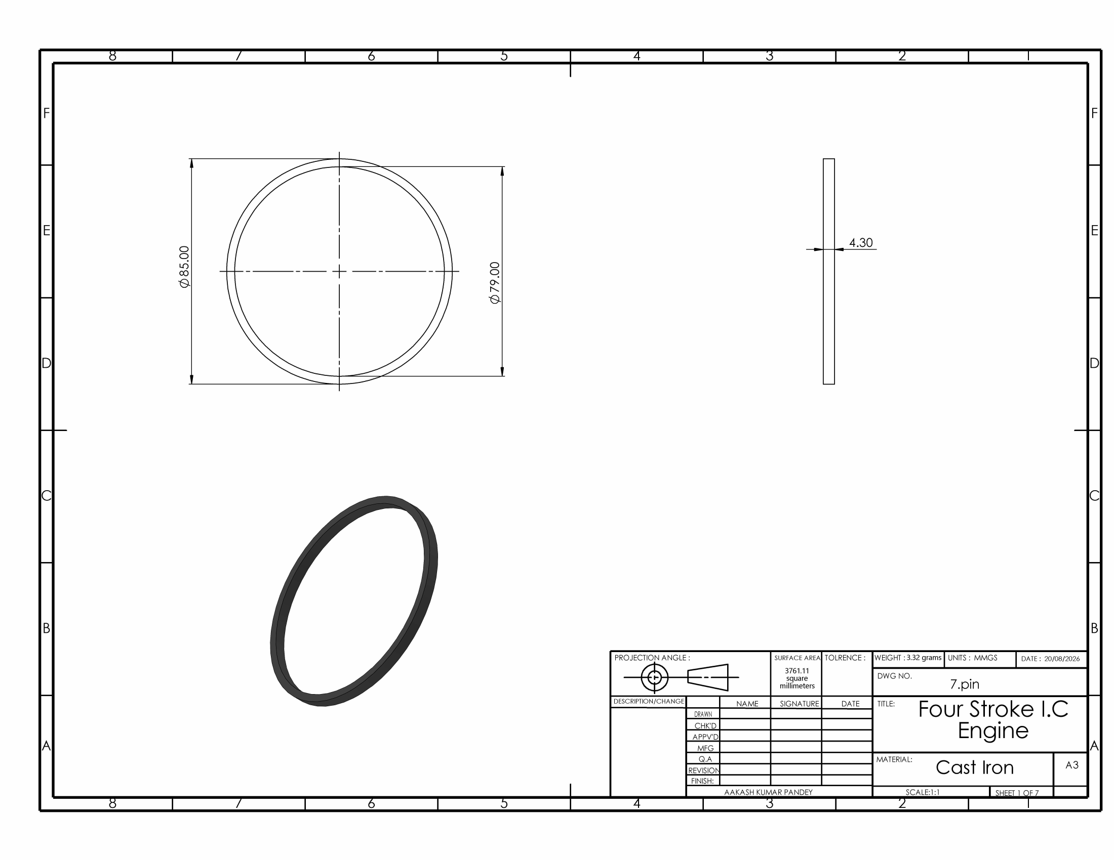
Sheet 8: Piston ring, labelled “pin” (A3, 1:1, cast iron)

